W I C H I T A S T A T E U N I V E R S I T Y · W . F R A N K B A R T O N S C H O O L O F B U S I N E S S
Week 1 Module: Draw.io ERD Starter
MIS 600: Database Management Systems · Fall 2026 · Asynchronous Week · Wednesday, Aug 19
What: In-Class Exercise 1 (completed online) | Points: 9, in the In-Class Exercises category
Due: Tuesday, Aug 25, 11:59 PM | Submit: Blackboard, one Word document (.docx)
Tool: Draw.io at app.diagrams.net (free, no account needed)
First in-person class: Wednesday, Aug 26, 7:05 PM, Woolsey Hall 220

Welcome to MIS 600
We do not meet in person this week. Instead, you have two small jobs you can do from home, the library, or anywhere with a browser: read the syllabus, and draw your very first database diagram. Together they take about an hour, maybe ninety minutes if you watch the video. Our first face-to-face class is Wednesday, August 26, at 7:05 PM in Woolsey Hall 220, and my goal for this week is simple: I want you walking into that room already knowing what an E-R diagram looks like and how to make one.
Task 1: Read the Syllabus (Yes, All of It)
I know most syllabi go unread. Please read this one. It explains how your grade is built, why there is no late work, and how the automatic drop policy protects you when life happens. When you finish, you will confirm it by ending your submission with this exact sentence:
"I have read and understood the MIS 600 syllabus, including the grading structure, the automatic drop policy, and the no-late-work policy."
Type it in the Blackboard text box or put it right on your diagram page. Either works.
Task 2: Meet Draw.io
What it is
Draw.io (also called diagrams.net) is the diagramming tool we will use all semester. It runs in your browser at app.diagrams.net. There is nothing to install and no account to create. You open the site, tell it where to save your files (your own device is fine), and start drawing.
Why is it free? (Visio costs money, so what's the catch?)
Good instinct to ask. Microsoft Visio, the classic corporate diagramming tool, requires a paid license and is not part of your student Office 365 bundle. Draw.io costs nothing, and there is genuinely no catch. Here is how that works:
- The editor is open source. The code sits publicly on GitHub, where anyone can read it and contribute to it.
- The company makes its money elsewhere. The Draw.io team sells paid versions built into corporate platforms like Atlassian Confluence and Jira. Those licenses pay the bills, and the standalone editor stays free for the rest of us.
- Your files never touch their servers. Diagrams save to storage you choose, so there are no user accounts to run and nothing to subscribe to.
And here is the part that matters for your career: the notation is the skill, not the software. Everything you learn in Draw.io transfers straight to Visio or Lucidchart if a future employer hands you one of those.
Learn the basics (about 30 minutes)
Pick whichever of these fits how you learn:
- Official Draw.io E-R diagram guide: https://drawio-app.com/blog/entity-relationship-diagrams-with-draw-io/
- Video walkthrough by Dr. Soper: https://www.youtube.com/watch?v=lAtCySGDD48
Then try the quickstart:
- Open app.diagrams.net, choose "Device" when asked where to save, and create a blank diagram.
- Click "More Shapes" at the bottom left and enable the "Entity Relation" shape library.
- Drag a rectangle onto the canvas for each entity and double-click it to type the entity name and its attributes.
- Hover over an entity edge until directional arrows appear, then drag to another entity to draw a relationship line; double-click the line to give it a verb-phrase name.
- When finished, use File, then Export As, then PNG to save your diagram as an image.
Before You Draw: Look at These Three Diagrams
I pulled these from our Chapter 2 materials. Do not try to decode every symbol; we will cover all of it properly in Weeks 3 and 4. For now, just notice three things: entities are rectangles named with singular nouns, relationships are lines labeled with verb phrases, and the little crow’s-foot symbol at the end of a line means "many." These three are just for looking; the diagram you will actually copy is in the next section.
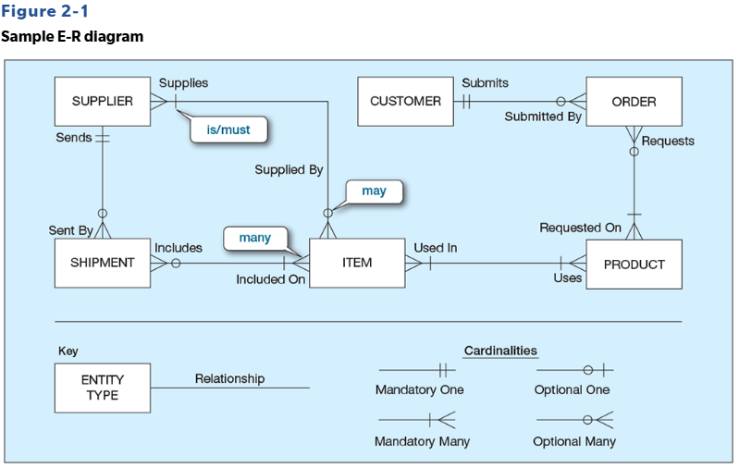
Figure 1. A complete sample E-R diagram (Pine Valley Furniture). The key at the bottom decodes the cardinality symbols. Source: Hoffer, Topi, Venkataraman, and Bala, Modern Database Management, 14th ed. (course textbook).
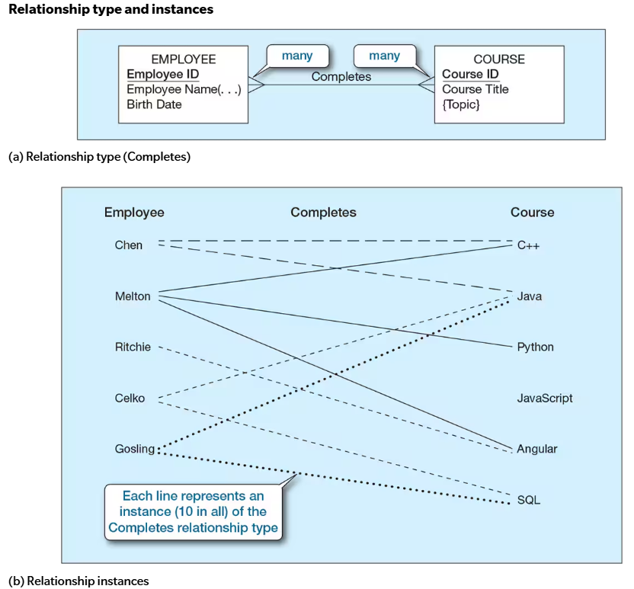
Figure 2. A relationship type (Completes) and its instances. Note the underlined Employee ID and Course ID: those are identifiers, what you will mark as primary keys. Source: course textbook.
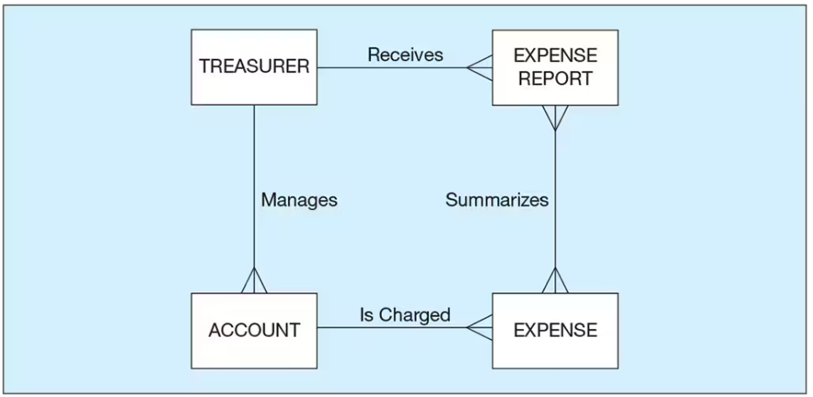
Figure 3. A compact ERD with verb-phrase relationships. Your submission will be even simpler than this. Source: course textbook.
The Assignment: Copy This Diagram
Here it is. This is the diagram you are going to rebuild in Draw.io:
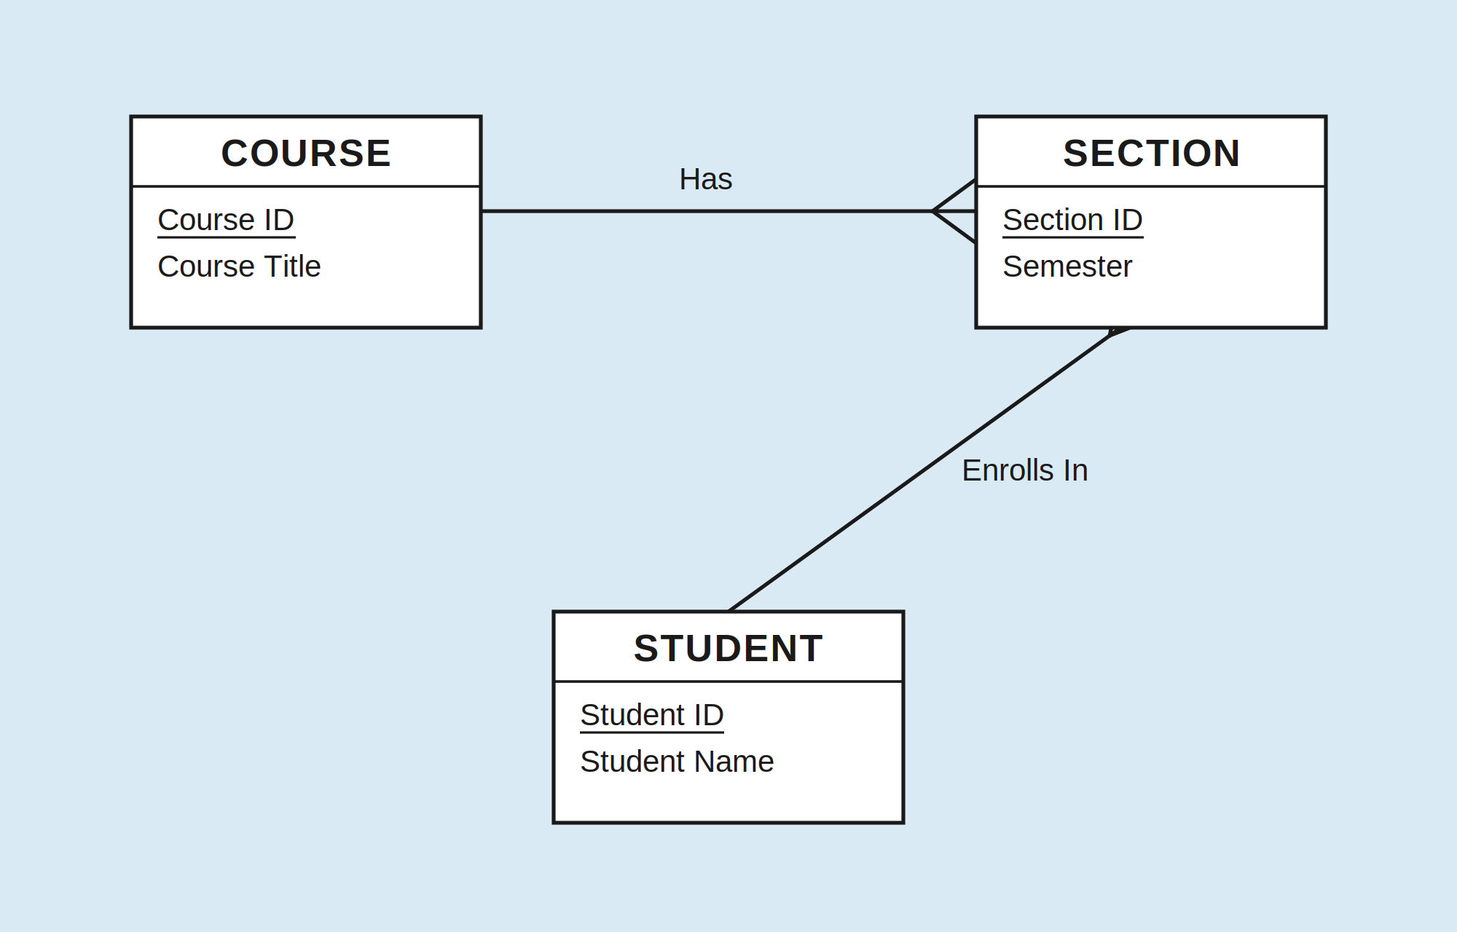
Figure 4. The target diagram. Reproduce this in Draw.io as closely as you can.
You do not need to understand this diagram. You do not need to know what the three-pronged symbols mean or why the lines connect where they do. All of that gets explained in Weeks 3 and 4. Your only job today is to look at it and rebuild it, box by box, line by line, as closely as you can. Best effort is the standard.
Everyone
- Recreate the three boxes with the same names and the same attributes, including the underlined IDs.
- Draw the two connecting lines and label them Has and Enrolls In.
- Try the little three-pronged symbols where you see them. If yours come out wobbly, that is fine.
Wrong angle on a symbol? Layout a little different? A box slightly too big? All completely fine. I grade this on completion and honest effort, not correctness.
Graduate students: one small extra
Add a fourth box you think belongs in this picture (INSTRUCTOR and ENROLLMENT are both good choices), connect it with a labeled line, and write two or three sentences telling me why you added it and what it connects to.
If you are curious (optional)
The diagram says that a course has sections, and students enroll in those sections. That is all it says. But again: understanding is not the assignment this week. Copying is.
One rule: no AI on this one
Not because I am against AI, but because the whole point of this assignment is for your hands to learn the tool. Ten minutes of dragging boxes around teaches you more than any generated diagram ever could. Per the syllabus, AI is off unless an assignment turns it on in writing, and this one does not.
Submit on Blackboard
- Export your diagram from Draw.io as an image: File, then Export As, then PNG.
- Open Microsoft Word (free through WSU Office 365) and insert the PNG into a blank document.
- Below the diagram, type the syllabus sentence from Task 1, word for word. Graduate students, add your two-to-three sentence note right below it.
- Save it as a Word document named with your last name first, then your first name: MIS600_Week1_LastName_FirstName.docx (for example, MIS600_Week1_Smith_Jordan.docx).
- Submit the Word document in the Week 1 module on Blackboard by Tuesday, August 25, at 11:59 PM.
Grading (9 Points)
Component | Points
Syllabus sentence included, word for word | 2
Diagram is an honest attempt at copying the target (graduate box and note included, where applicable) | 5
One clean, readable Word document with the correct filename | 2
This counts as In-Class Exercise 1. Like all in-class exercises, it cannot be submitted late; the automatic drop policy in the syllabus covers emergencies.
Quick Checklist
- I read the whole syllabus.
- My acknowledgment sentence is in there, word for word.
- My diagram copies the target: COURSE, SECTION, and STUDENT, their attributes, the two labeled lines, and the three-pronged symbols.
- (Graduate) I added a fourth entity plus my two-to-three sentence note.
- My submission is one Word document named MIS600_Week1_LastName_FirstName.docx, submitted before Tuesday, Aug 25 at 11:59 PM.
Questions? Email me with "MIS 600" in the subject line. See you August 26.

