Stephen Brennan
sba20180@student.cct.ie
Abstract
This report presents the findings of an investigation into whether a number of different agricultural factors can be used to predict the price of beef in both Ireland and Austria.
MSc in Data Analytics
Continuous Assessment 2

Statistics

Descriptive statistics
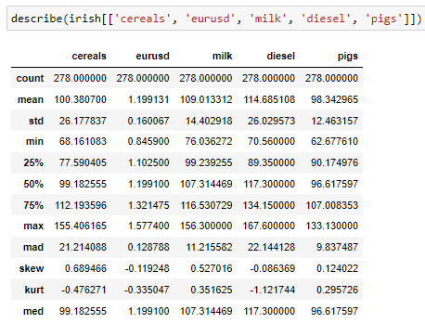
The above shows the Irish variables we will be analyzing further in the report. The first one cereals was taken from the Irish Agricultural Price Index (with a 2015 base). Cereals is the name given to a group of grain products: “wheat, rice, rye, oats, barley, corn (maize), and sorghum.” (Encyclopedia Britannica, n.d.).
The counts of all variables are 278 for the 22 year period in question so we have no missing values.
The cereals mean value was 100. 100 is the base year for 2015. This tells us that most of the time the price of grains has hovered around this value. A positive skew can be seen for cereals. This means more of the values lie on the left side of the distribution. The histogram plot of this data below confirms this.
eursusd is the exchange rate between euro and American dollars. A strong euro will make importing beef from other parts of the world less attractive because importers have to use more of their currency to buy euros to then buy beef.
The max value of eurusd is almost twice that of the min, this tells us there has been some massive exchange rate fluctuations during the twenty year period we are analyzing. This would have had an effect on import and export amounts.
The skew here is only -0.12, a normal distribution has a skew of 0 (www.itl.nist.gov, n.d.), this means that eurusd has a similar distribution of values to a normal distribution.
It has been reported that milk farmers earn up to as 7 times as much as beef farmers (Sheehan, 2015). So, it is interesting to investigate whether milk prices have an impact on beef prices and if there is a supply and demand relationship. If milk prices rise, beef farmers may switch to dairy farming and vice versa.
Diesel prices are an obvious input cost to all types of farming so they have been included in this analysis. For example, the price of diesel has generally been increasing throughout the years and such increases can result in higher prices of agricultural products.
Pigs also come from the Agricultural Price Index (with a 2015 base). Pig meat and related products can be considered a substitute good for beef (Tonsor, 2015). When the price of beef rises, price sensitive customers will switch to alternative goods such as pork and chicken. Similarly, if the price of pork rises and beef were to come down, people would switch to beef.

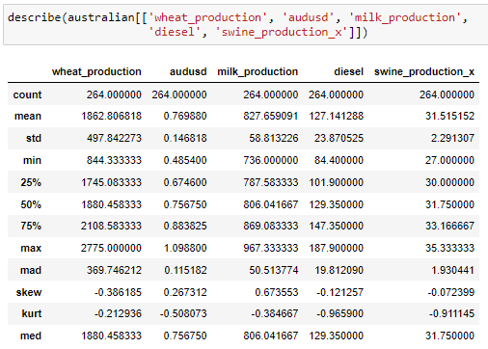

Below is the histogram plot for each of the five variables for Australia and Ireland that we are taking a closer look at.
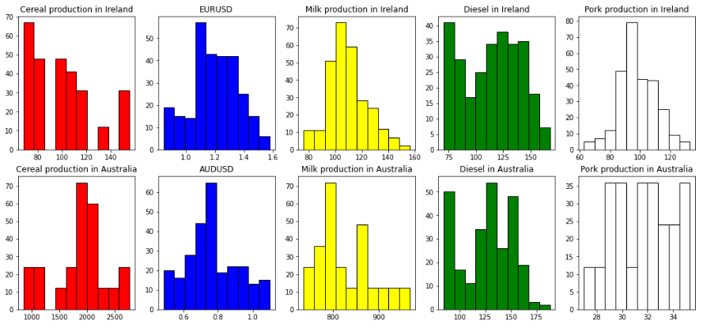

Inferential Statistics

Shapiro Wilks
The Shapiro Wilks test is used for testing the normality of each variable in the dataset.
The hypothesis of the shapiro wilks test is as follows:
H0: Variable is normally distributed
H1: Variable is not normally ditributed
If p <= 0.05, then the H0 hyp. can be rejected, the variable is not normally distributed
If p > 0.05, then the H0 hyp. cannot be rejected

As can be seen from the low figure, none of the
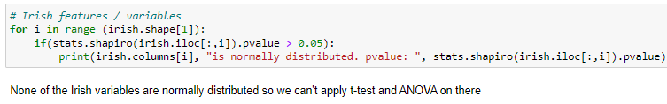

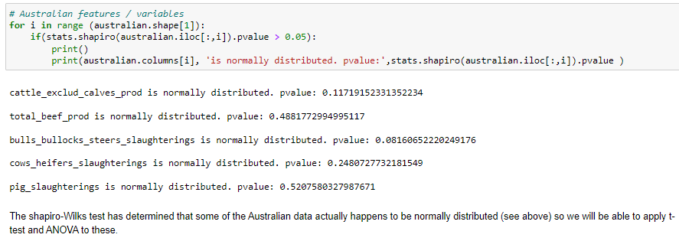

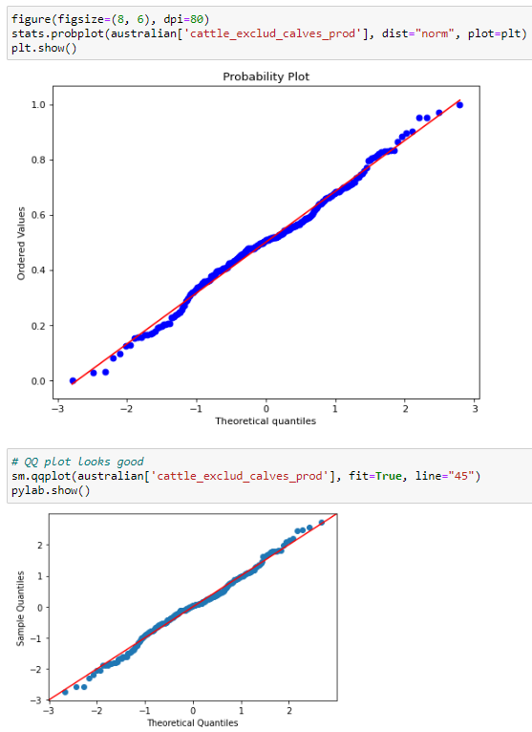

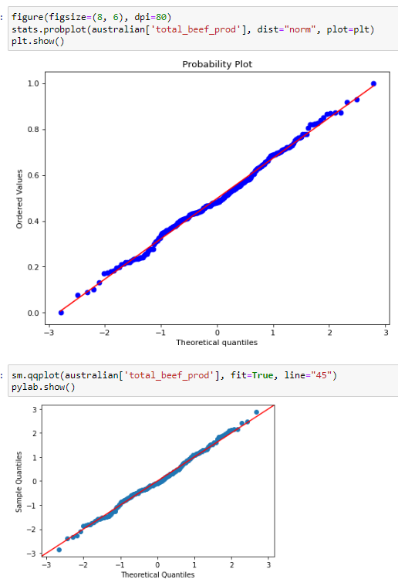
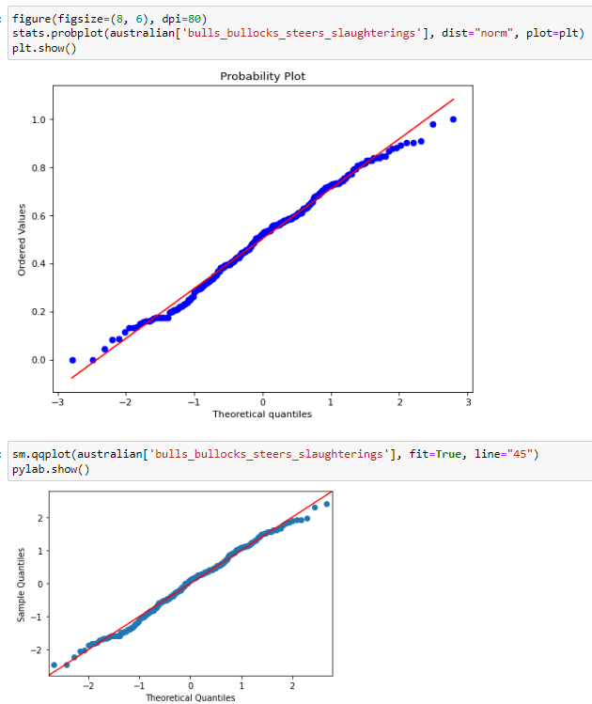

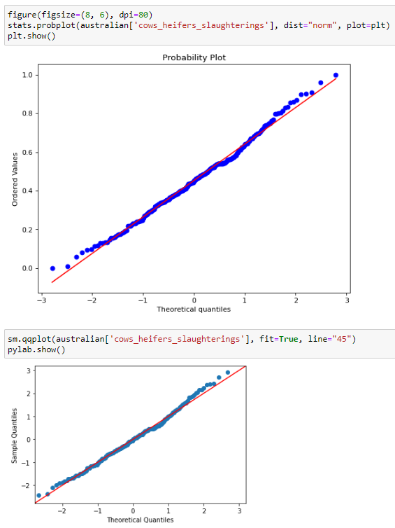
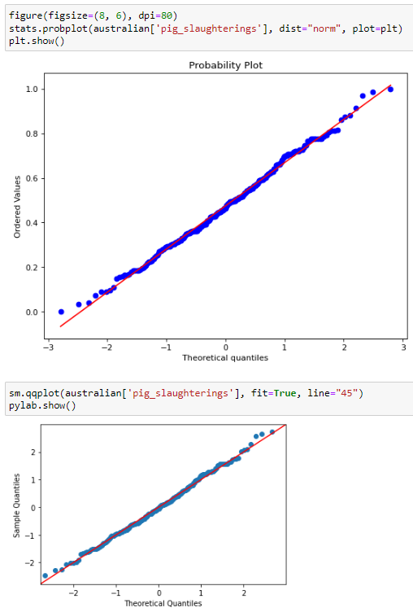

t-test
T test is used for testing the means of two independent variables, if they are the same mean or not
requires an assumption of normality. All the variables tested here have been proved to have normal distributions by shapiro-wilks test (see above).
The hypotheses are:
H0: Two variables have equal mean
H1: Two variables do not have equal mean
If the pvalue of the test is < 0.05, H0 will be rejected

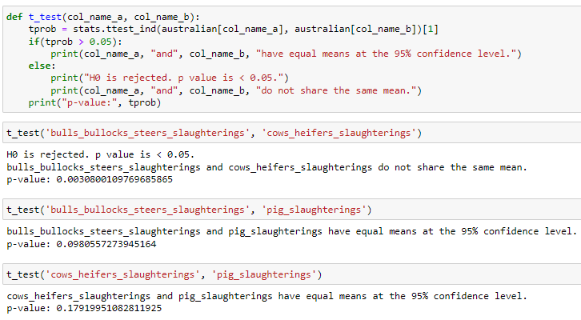

ANOVA
One way ANOVA F test is used for testing the means of two independent variables, if the are the same or not.
Requires normality.
The hypotheses are:
H0: Two variables have equal means
H1: Two variables do not have equal means
If the pvalue of the test is < 0.05, H0 will be rejected
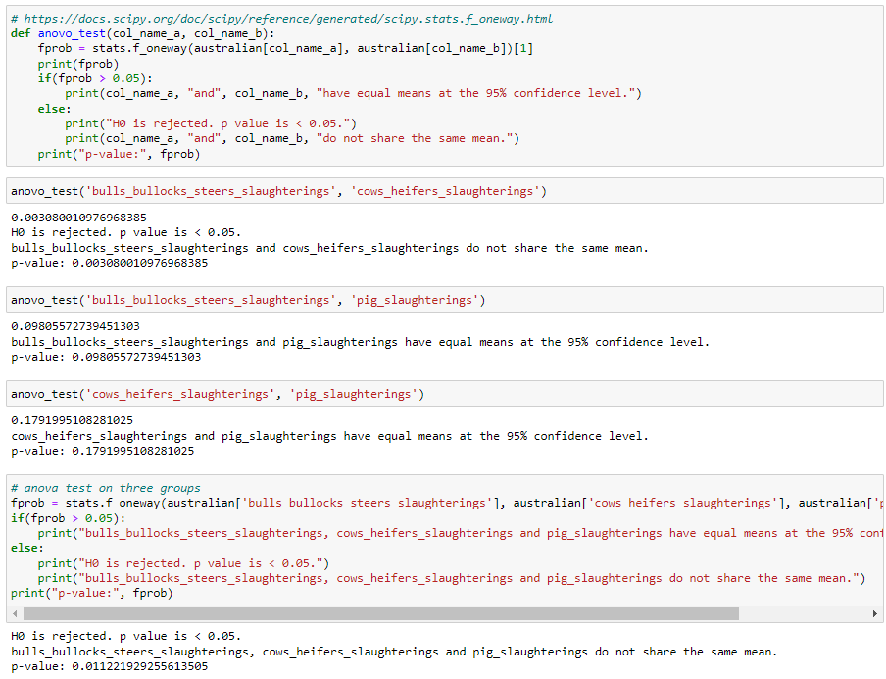

f-test
F test is used for testing the variances of two independent variables, if they are the same or not.
Requires normality
The hypotheses are:
H0: Two variables have equal variances
H1: Two variables do not have equal variances
If the pvalue of the test is < 0.05, H0 will be rejected

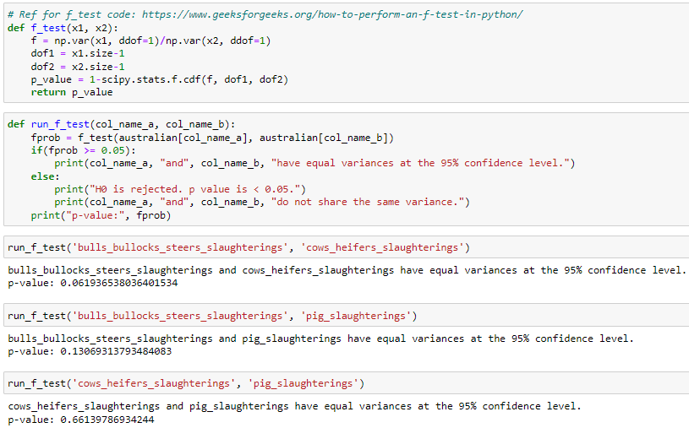

Mann Whitney U
Two independent groups, test for equal medians. Since, the sample sizes are not equal, mannwhitney is preferred and the variables are both not normally distributed.
H0: Two variables have equal medians
H1: Two variables do not have equal medians
If the pvalue of the test is < 0.05, H0 will be rejected
Mann Whitney U Test for Equal Medians
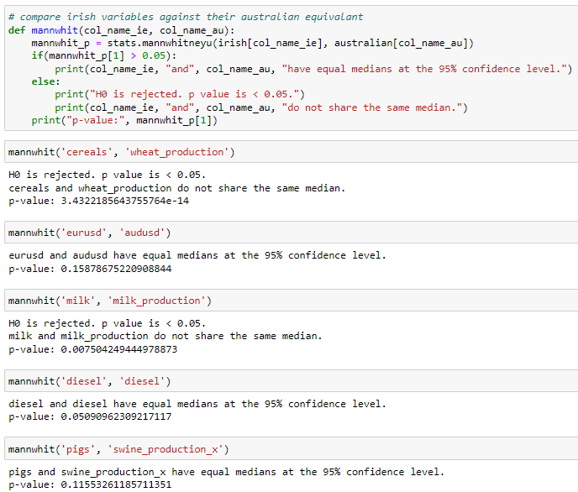

kruskall wallis
Use kruskall wallis to verify mann whitney test.
As these variables do not have normally distributed data a nonparametric test is needed.
The hypotheses are:
H0: Two variables has equal medians
H1: Two variables do not have equal medians
If the pvalue of the test is < 0.05, H0 will be rejected
Kruskall Wallis Test for Equal Medians
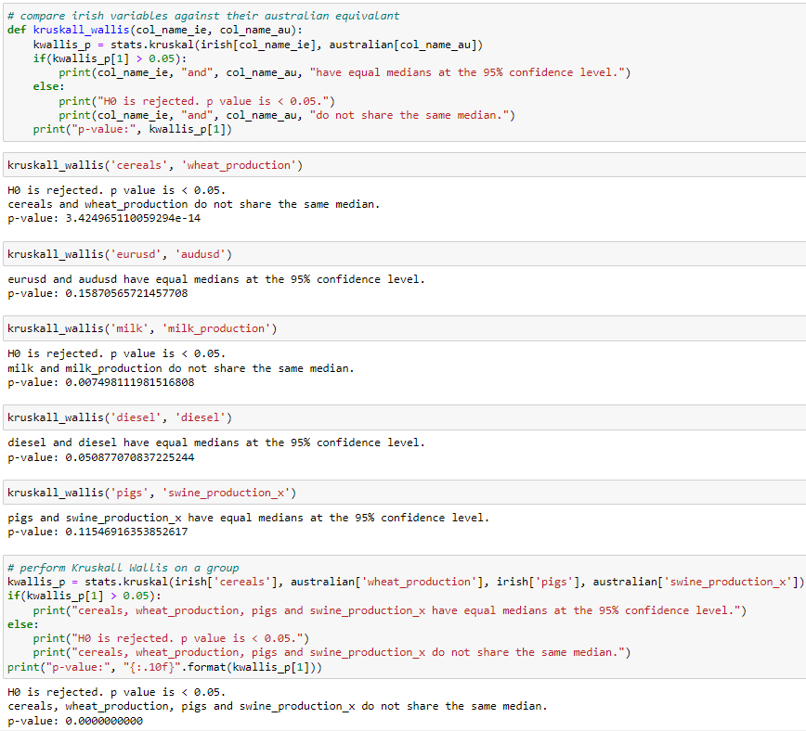

Levene
Levene's test is a nonparametric test to test the equality of variances between groups that come from non-normal distributions.
Since it does not require normality; it can be used on the same data that was used to compare the medians in mann whitney.
H0: Variances of the two groups are equal
H1: Variances of the two groups are not equal
Ref: https://www.statisticshowto.com/levene-test/
Levene Test for Equal Variances
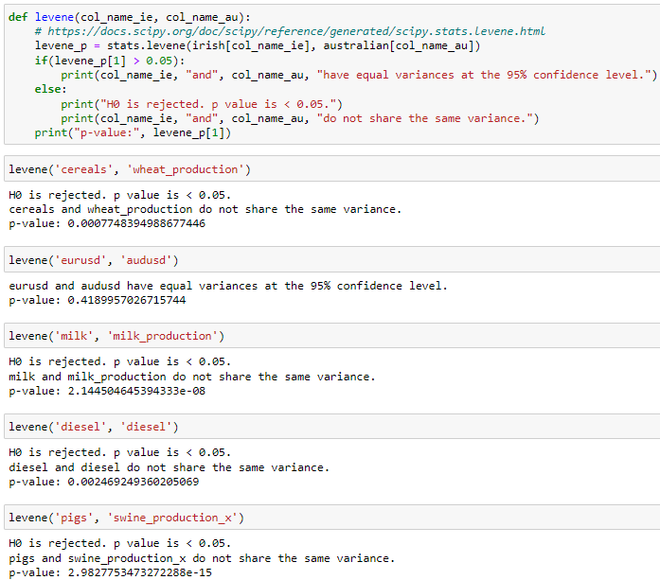

Spearman
Spearman tests the correlation between the independent and dependent variable and the significance of the independent variable.
If the correlation is significant, then it means that it has an impact on the dependent variable and that the variable is important for the dataset.
Does not assume that both datasets are normally distributed
hypotheses:
H0: The correlation is statistically significant
H1: The correlation is not statistically
significanthttps://docs.scipy.org/doc/scipy/reference/generated/scipy.stats.spearmanr.html
Spearman Test for Significance
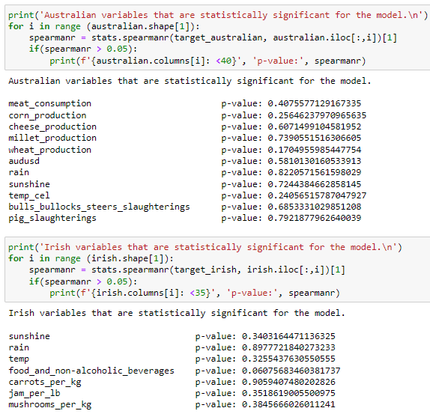

Box-Cox Transformation

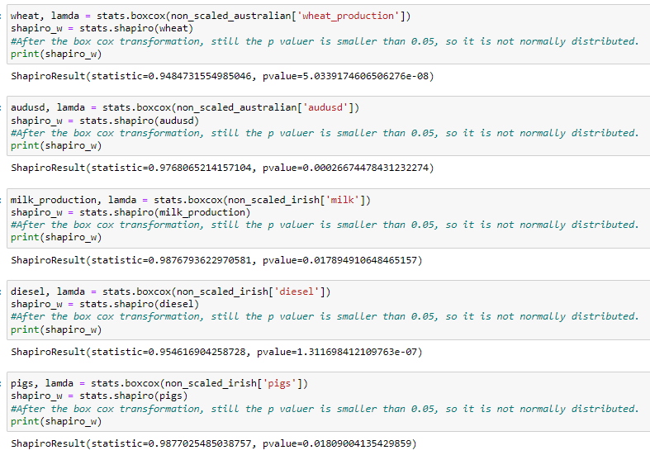

Machine Learning
- Describe the rationale and justification of the machine learning modesl
  - Predication
  - Classification
  - Clustering
  - Sentiment analysis
  - Recommendation systems
  - Time series analysis
- Use at least two ML models
  - Select hyperparameters with GridSearchCV
- Perform a sentiment analysis for the topic and compare against another country
  - Product price
  - Feed quality
- Use cross-validation
  - Use dimensionality reduction where appropriate
- Table or graphic to compare differences and similarities of modelling outcomes based on scoring metric used for analysis

Data Preparation & Visualization
- Discuss process of acquiring the raw data
  - Discuss any licensing/permission requirements
- EDA
  - Things to look for
    - Patterns
    - Inconsistencies
    - Anomalies
    - Missing data
    - Other attributes and issues
  - Detail attributes and issues found
  - Evaluation should reference evidence
  - Use visualizations to illustrate your findings
- Feature engineering
  - Cleaning
  - Engineering
  - Extraction
  - Other
- Give evidence of how your process has solved problems identified in the EDA and how your structured data will assist in the analysis stage
  - Use visualizations toillustrate work and provide evidence for your methodology
- Develop an interactive dashboard tailored to modern farmers to show case information gathered at the Machine learning analysis
  - Use tufts pricinples
  - Detail the rationale for the approach and visualization choices made during development

