Technical Analysis only on single stock strategies
9251 stocks * 15 strategies:
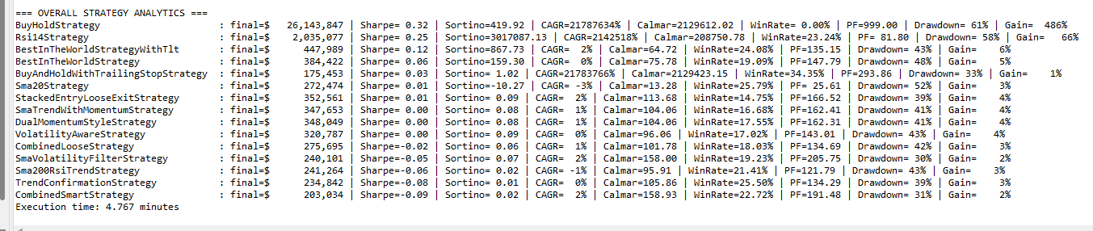
100k capital – no updates
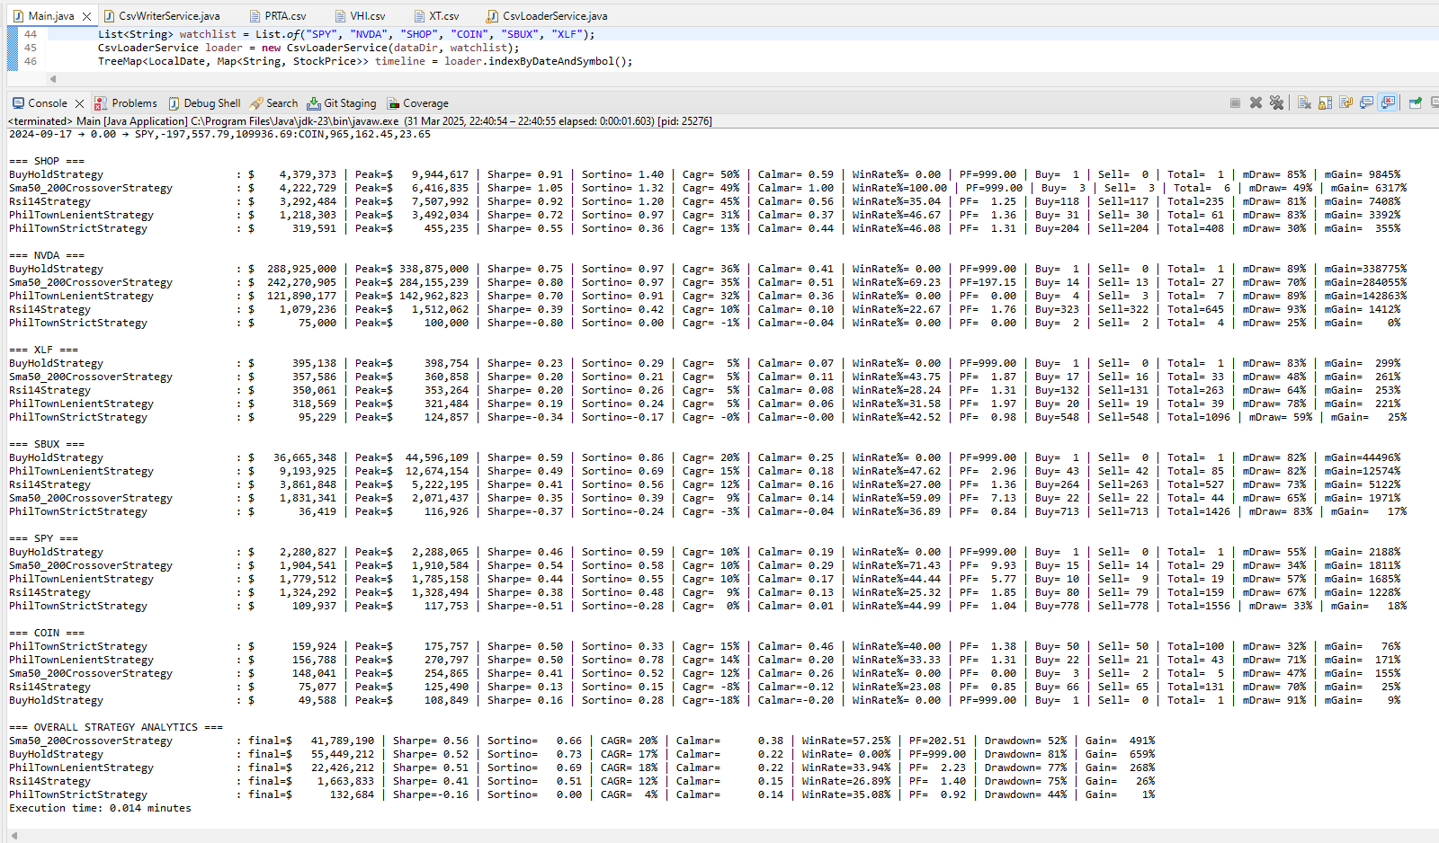

Starting 10k - $20 a day added – select stocks
List<String> watchlist = List.of("SPY", "NVDA", "SHOP", "COIN", "SBUX", "XLF");
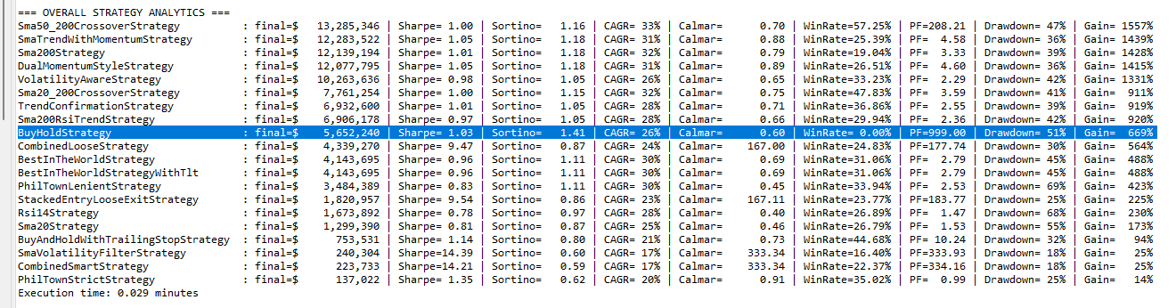

SPY – dollar cost avg. $20 – starting cash $10k
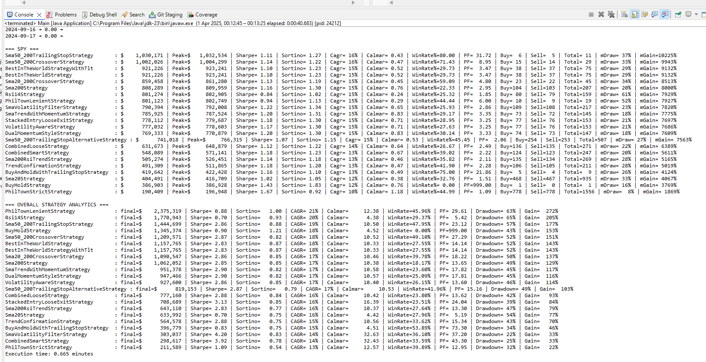
Select stocks – dollar cost avg. $20 – starting cash $10k
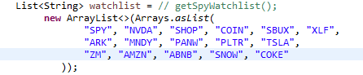

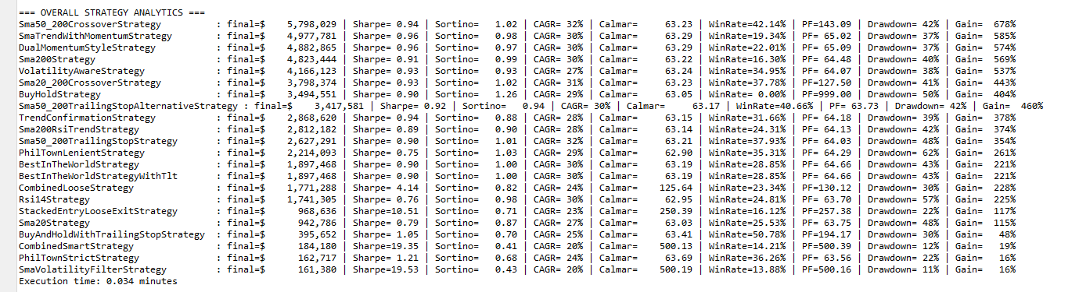

Watchlists
getFavWatchlist
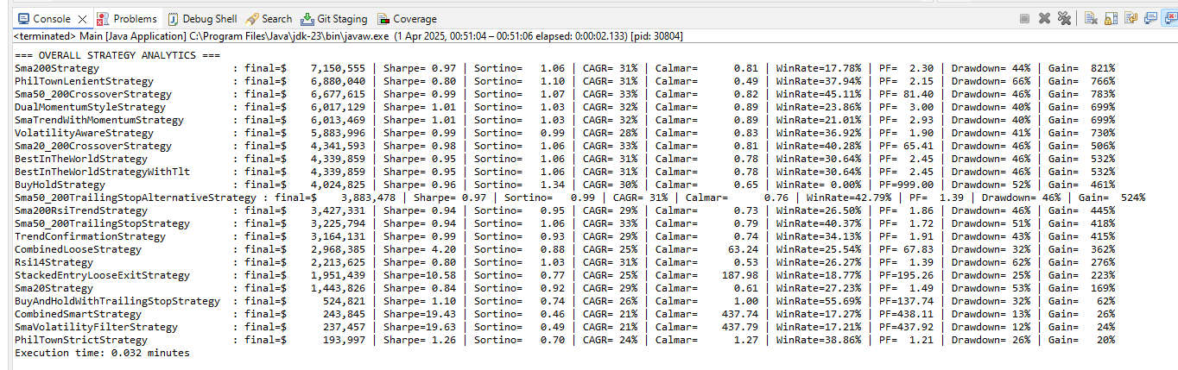

getSpyWatchlist
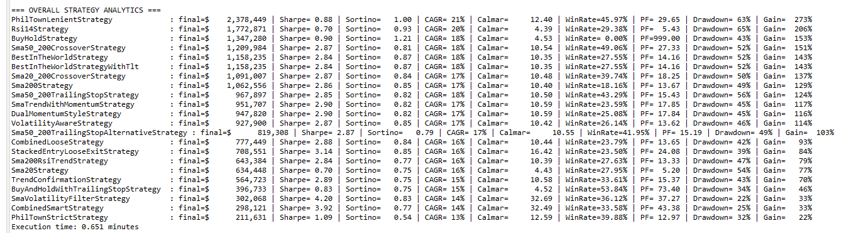
getEtfWatchlist
