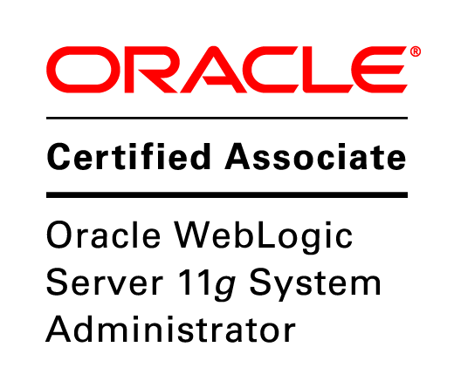 C:\Users\felecia\AppData\Local\Temp\Rar$DIa0.612\SecurityPlus_Certified_CE_Logo.tif **Felecia Washington** 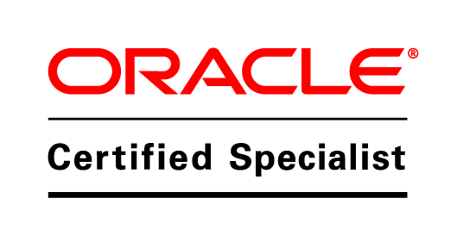

⯁ (770)-873-6298 ⯁ fwashington62@yahoo.com

**SUMMARY**

* IT professional with a demonstrated passion for Client/Server Applications including Middleware Server Administration. Well-organized and detail-oriented with excellent customer service, training, and technical support skills.

**TECHNICAL STRENGTHS**

* Troubleshooting & Diagnostics
* Project Management
* Client-Server Technology
* Systems Installation & Configuration

**CERTIFICATIONS**

* Oracle WebLogic Server 11g System Administrator
* Certified Cisco Network Administrator (CCNA)
* Security+
* Microsoft Windows 7 Enterprise Desktop Support & Configuration (MCITP, MCSA, MCTS)

**PROFESSIONAL EXPERIENCE**

## Technology Center – Norcross, GA

IT Project Manager – WebLogic Administrator  **March 2013 – Present**

* Install, configure, maintain, and support Oracle WebLogic Server 11g and 12c through the Administration Console and WLST in Linux and Windows environment
* Instructor Oracle WebLogic Lab & Development Environments using Oracle Linux, Ubuntu, and Windows 7
* Deploy various JAR, WAR, EAR, and J2EE applications on managed servers and in clustered environment using Console or auto deployment scripts
* Configure clusters, LDAP servers, HTTP Servers and Security Certificates on WebLogic Server
* Monitor log files, performance tuning through heap size, thread dumps, garbage collection and other measures
* Configure resource and application security and perform backup and recovery

## Business Solutions Consulting – GA

**Technology Enablement Project Manager**  **April 2014 – December 2014**

* Installed and maintained Microsoft Office 365 including analyze, isolate, and correct Exchange issues
* Researched, recommended, purchased, configured and maintained hardware and software – PCs, and Server
* Documented all software/hardware configurations, network security measures and support requirements
* Setup Enterprise Endpoint Protection and PC local security policies and procedures
* Managed all internal projects – Network Infrastructure, CRM and SharePoint Configuration, Marketing

## Comforce Information Technologies – Atlanta, GA

Helpdesk Specialist / Office Manager **August 2000 – February 2012**

* Performed routine maintenance related to all software and hardware.
* Performed hardware and software configuration and installation
* Provided technical support to internal and external users for client based vendor management software systems
* Trained internal and external users on company specific software
* Managed the Administration Department to standardize and centralize all accounting functions for the Southeast Region for over 250 employees

**EDUCATION & CERTIFICATIONS**

* Bachelor of Business Administration in Project Management

**MILITARY EXPERIENCE**

* United States Air Force, Inventory Management Craftsman – Honorable Discharge 1985 – 1995