LIBRARY DBMS
CMPE343 REPORT

Project Members and Contributions
- TRESOR KALOMBO KALALA 22512651 : DDL, DML,QUERIES(1-5)
- Sultan Makhmut 22305640: ERD,DML,QUERIES(6-10)
- Dzaan Zachariah Allam 22120765: Report, DML,QUERIES(11-15)

1. Introduction
This Library Database Management System (DBMS) was developed using PostgreSQL for the CMPE343 course. The system manages authors, books, genres, members, staff, borrow transactions, and fines. Assumptions include unique IDs for each entity, proper constraints for data integrity, and realistic sample data.

2. Database

ER Diagram
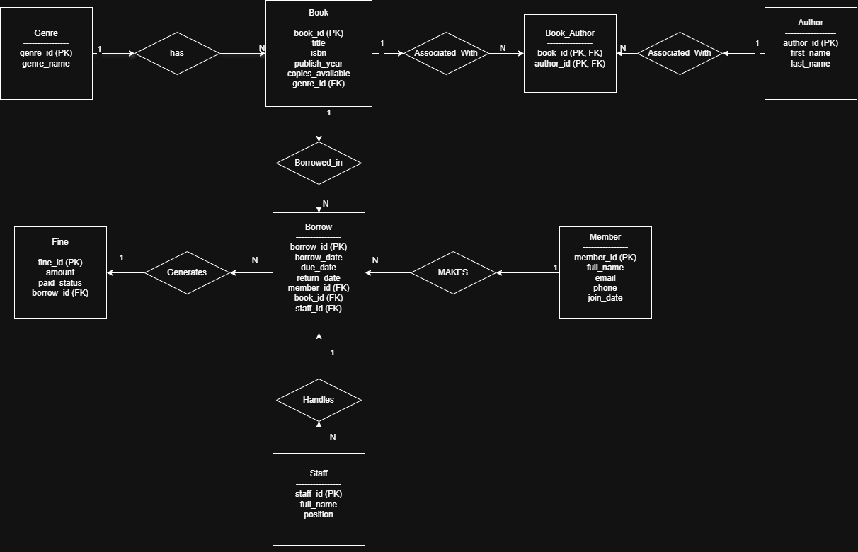

Data Definition Language (DDL)
-- TABLE 1: AUTHOR : Stores book authors
CREATE TABLE Author (
author_id INT PRIMARY KEY, -------------------Unique author ID
first_name VARCHAR(50) NOT NULL, -------------------Author first name
last_name VARCHAR(50) NOT NULL -------------------Author last name
);
-----------------------------------
-- TABLE 2: BOOK: Stores books in the library
CREATE TABLE Book (
book_id INT PRIMARY KEY, -------------------Unique book ID
title VARCHAR(100) NOT NULL, -------------------Book title
isbn VARCHAR(20) UNIQUE, -------------------ISBN number (unique)
publish_year INT, -------------------Year of publication
copies_available INT DEFAULT 1 -------------------Available copies
CHECK (copies_available >= 0) -------------------Cannot be negative
);
------------------------------
-- TABLE 3: MEMBER: Stores library members
CREATE TABLE Member (
member_id INT PRIMARY KEY, -------------------Unique member ID
full_name VARCHAR(100) NOT NULL, -------------------Member name
email VARCHAR(100) UNIQUE, -------------------Email (unique)
phone VARCHAR(20), -------------------Phone number
join_date DATE DEFAULT CURRENT_DATE -------------------Date joined
);
----------------------------
--TABLE 4: STAFF: Stores library staff
CREATE TABLE Staff (
staff_id INT PRIMARY KEY, -------------------Unique staff ID
full_name VARCHAR(100) NOT NULL, -------------------Staff name
position VARCHAR(50) -- Job position
);
---------------------------
-- TABLE 5: BOOK_AUTHOR : Connects books and authors (many-to-many)
CREATE TABLE Book_Author (
book_id INT, -------------------Book ID
author_id INT, -------------------Author ID
PRIMARY KEY (book_id, author_id), -------------------Composite primary key
FOREIGN KEY (book_id) REFERENCES Book(book_id),
FOREIGN KEY (author_id) REFERENCES Author(author_id)
);
------------------------------
--TABLE 6: BORROW: Stores borrow transactions
CREATE TABLE Borrow (
borrow_id INT PRIMARY KEY, -------------------Borrow ID
member_id INT, -------------------Member borrowing
book_id INT, -------------------Borrowed book
staff_id INT, -------------------Staff handling
borrow_date DATE NOT NULL, -------------------Borrow date
due_date DATE NOT NULL, -------------------Due date
return_date DATE, -------------------Return date
FOREIGN KEY (member_id) REFERENCES Member(member_id),
FOREIGN KEY (book_id) REFERENCES Book(book_id),
FOREIGN KEY (staff_id) REFERENCES Staff(staff_id)
);
-----------------------------------
--TABLE 7: FINE : Stores fines for late returns
CREATE TABLE Fine (
fine_id INT PRIMARY KEY, -------------------Fine ID
borrow_id INT UNIQUE, -------------------Related borrow
amount DECIMAL(6,2), -------------------Fine amount
paid_status VARCHAR(10) DEFAULT 'UNPAID',
FOREIGN KEY (borrow_id) REFERENCES Borrow(borrow_id)
);
----------------------------------------
-- TABLE 8: GENRE : Stores book genres
CREATE TABLE Genre (
genre_id INT PRIMARY KEY, -- Unique genre ID
genre_name VARCHAR(50) NOT NULL -- Genre name
);

Data Manipulation Language (DML)
-- Authors
INSERT INTO Author VALUES (1, 'Tresor', 'Kalombo');
INSERT INTO Author VALUES (2, 'Fyodor', 'Dostoevsky');
INSERT INTO Author VALUES (3, 'Friedrich', 'Nietzsche');
INSERT INTO Author VALUES (4, 'Jane', 'Austen');
INSERT INTO Author VALUES (5, 'Albert', 'Camus');

-- Books
INSERT INTO Book VALUES (1, 'The Truth', '000077770000', 2057, 7);
INSERT INTO Book VALUES (2, 'The Brothers Karamazov', '000077770001', 1880, 5);
INSERT INTO Book VALUES (3, 'Next Year', '000077770002', 2059, 4);
INSERT INTO Book VALUES (4, 'Pride and Prejudice', '000077770003', 1813, 6);
INSERT INTO Book VALUES (5, 'The Stranger', '000077770004', 1942, 0); -- no copies available
INSERT INTO Book VALUES (6, 'Thus Spoke Zarathustra', '000077770005', 1883, 1);
INSERT INTO Book VALUES (7, 'Notes from Underground', '000077770006', 1864, 0); -- no copies available

-- Connect books with authors
-- Author 1 wrote two books
INSERT INTO Book_Author VALUES (1, 1);
INSERT INTO Book_Author VALUES (3, 1);
-- Author 2 wrote two books
INSERT INTO Book_Author VALUES (2, 2);
INSERT INTO Book_Author VALUES (7, 2);
-- Other authors
INSERT INTO Book_Author VALUES (6, 3); -- Nietzsche
INSERT INTO Book_Author VALUES (4, 4); -- Austen
INSERT INTO Book_Author VALUES (5, 5); -- Camus

---Genre
-- Add genre reference to Book table
ALTER TABLE Book
ADD COLUMN genre_id INT;
-- Add foreign key constraint
ALTER TABLE Book
ADD CONSTRAINT fk_book_genre
FOREIGN KEY (genre_id) REFERENCES Genre(genre_id);
-- Insert genres
INSERT INTO Genre VALUES (1, 'Philosophy');
INSERT INTO Genre VALUES (2, 'Classic Literature');
INSERT INTO Genre VALUES (3, 'Fiction');
INSERT INTO Genre VALUES (4, 'Romance');
INSERT INTO Genre VALUES (5, 'Psychological');
-- Assign genres to books
UPDATE Book SET genre_id = 3 WHERE book_id = 1; -- The Truth (Fiction)
UPDATE Book SET genre_id = 2 WHERE book_id = 2; -- The Brothers Karamazov (Classic)
UPDATE Book SET genre_id = 3 WHERE book_id = 3; -- Next Year (Fiction)
UPDATE Book SET genre_id = 4 WHERE book_id = 4; -- Pride and Prejudice (Romance)
UPDATE Book SET genre_id = 5 WHERE book_id = 5; -- The Stranger (Psychological)
UPDATE Book SET genre_id = 1 WHERE book_id = 6; -- Thus Spoke Zarathustra (Philosophy)
UPDATE Book SET genre_id = 2 WHERE book_id = 7; -- Notes from Underground (Classic)

-- Members
INSERT INTO Member VALUES (1, 'Zachariah', '22120765@student.ciu.edu.tr', '+2347061614885', '2025-10-07');
INSERT INTO Member VALUES (2, 'Sultan', '22305640@student.ciu.edu.tr', '+77052175021', '2025-09-07');
INSERT INTO Member VALUES (3, 'Josh', 'josh@student.ciu.edu.tr', '+9000000000', '2025-08-01');
INSERT INTO Member VALUES (4, 'Joel', 'joel@student.ciu.edu.tr', '+904444444446', '2024-07-15');
-- staff members
INSERT INTO Staff VALUES (1, 'Jacob Bush', 'Assistant');
INSERT INTO Staff VALUES (2, 'Aline Koj', 'Librarian');
INSERT INTO Staff VALUES (3, 'Mark Koop', 'Supervisor');
INSERT INTO Staff VALUES (4, 'Jil Umar', 'Manager');

-- Borrow
INSERT INTO Borrow VALUES (1, 1, 1, 1, '2025-03-01', '2025-03-15', '2025-03-20');
INSERT INTO Borrow VALUES (2, 2, 2, 2, '2025-03-05', '2025-03-19', '2025-03-18');
INSERT INTO Borrow VALUES (3, 3, 3, 3, '2025-03-10', '2025-03-24', NULL);
INSERT INTO Borrow VALUES (4, 4, 4, 4, '2025-03-12', '2025-03-26', '2025-03-30');
INSERT INTO Borrow VALUES (5, 1, 6, 2, '2025-02-01', '2025-02-15', '2025-02-14');

-- Fines
INSERT INTO Fine VALUES (1, 1, 5.00, 'UNPAID');
INSERT INTO Fine VALUES (2, 4, 7.00, 'PAID');
INSERT INTO Fine VALUES (3, 3, 3.50, 'UNPAID');

3. Queries

Query 1
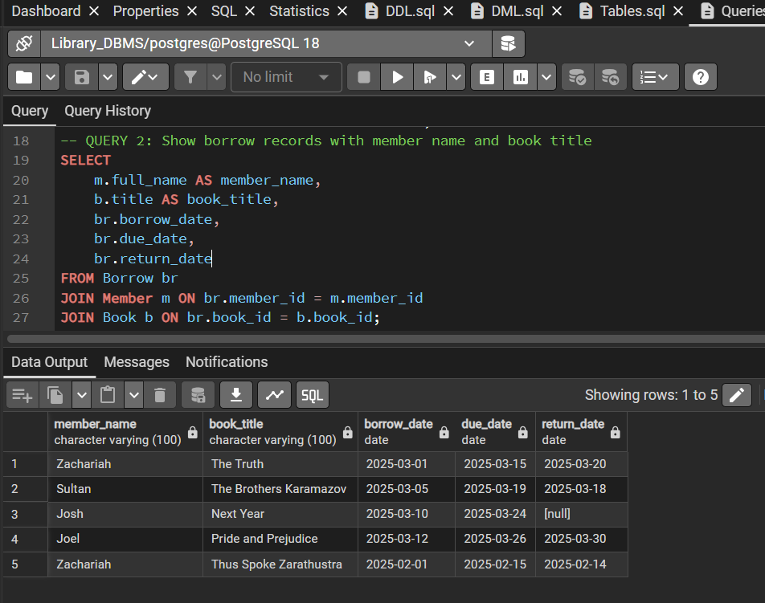

Query 2
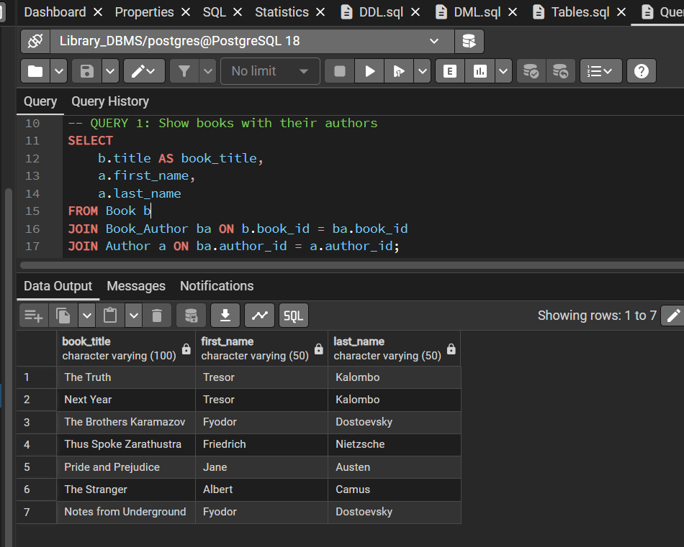

Query 3
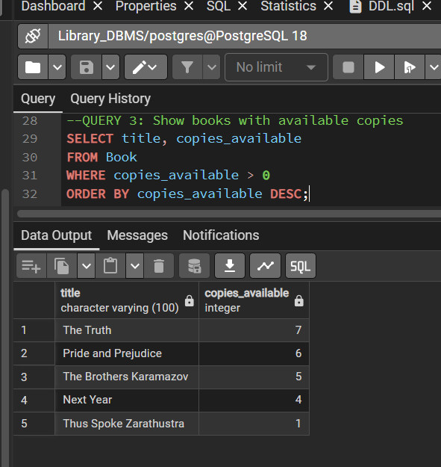

Query 4
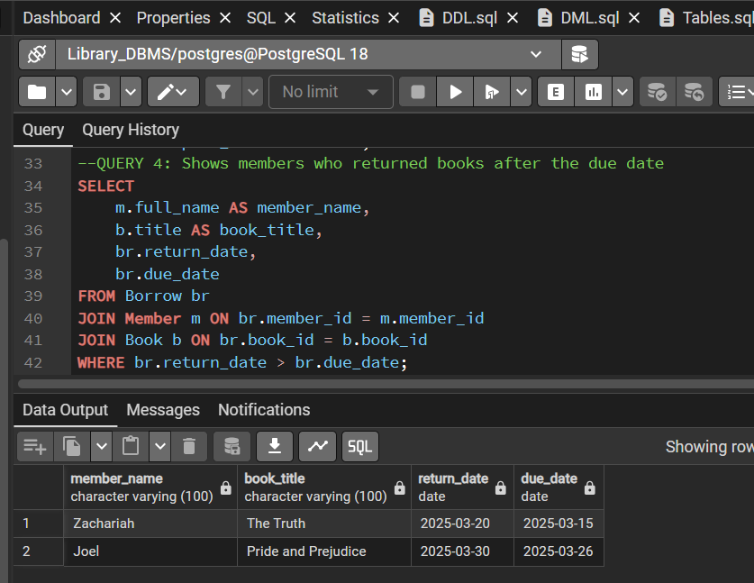

Query 5
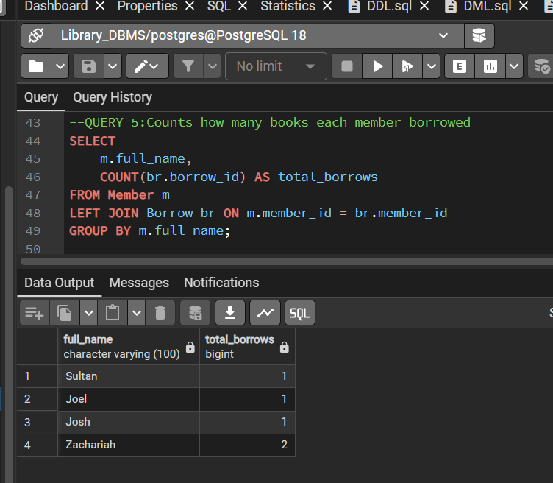

Query 6
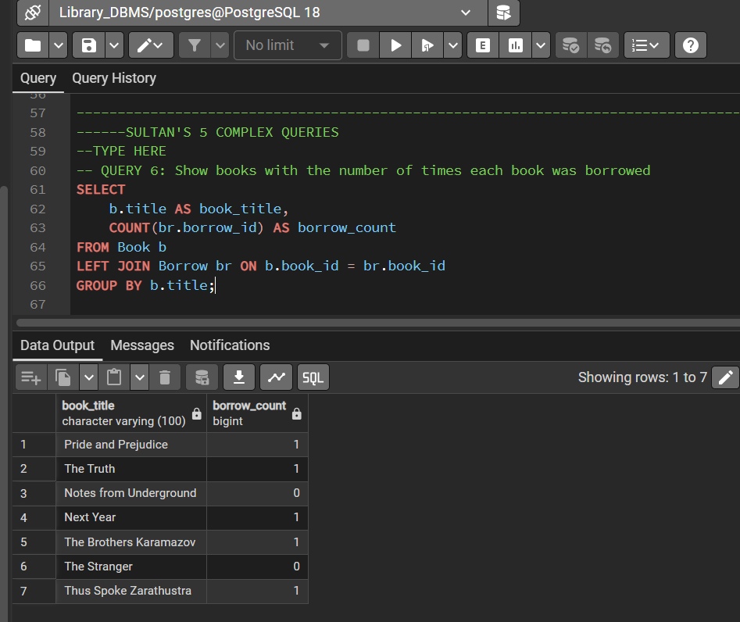

Query 7
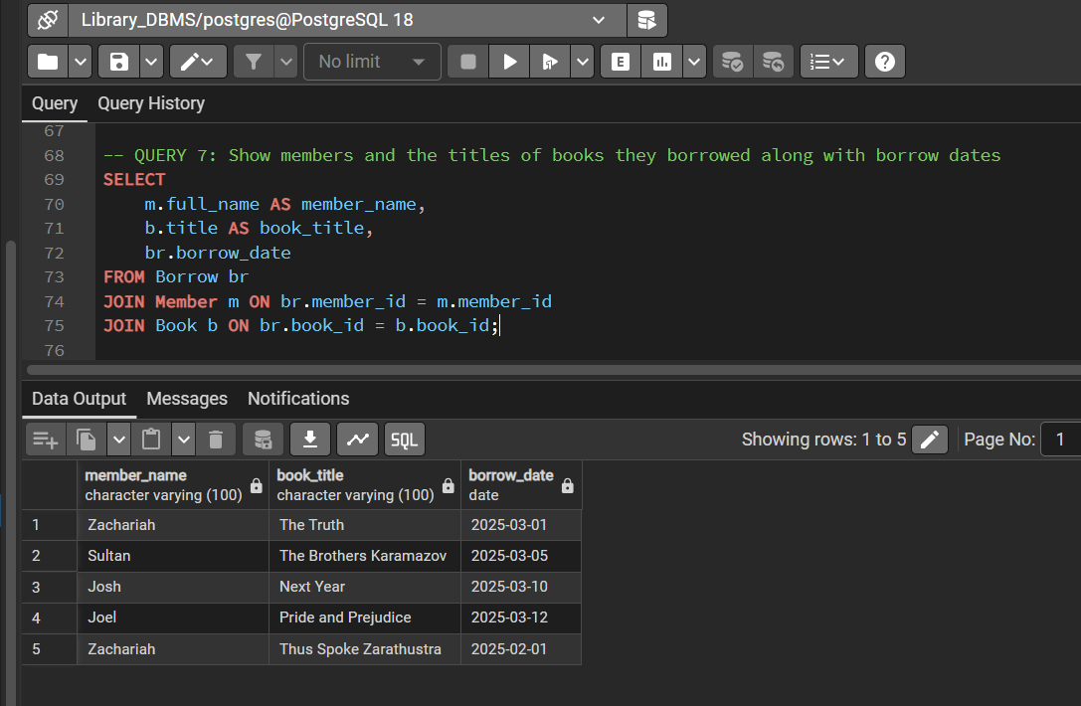

Query 8
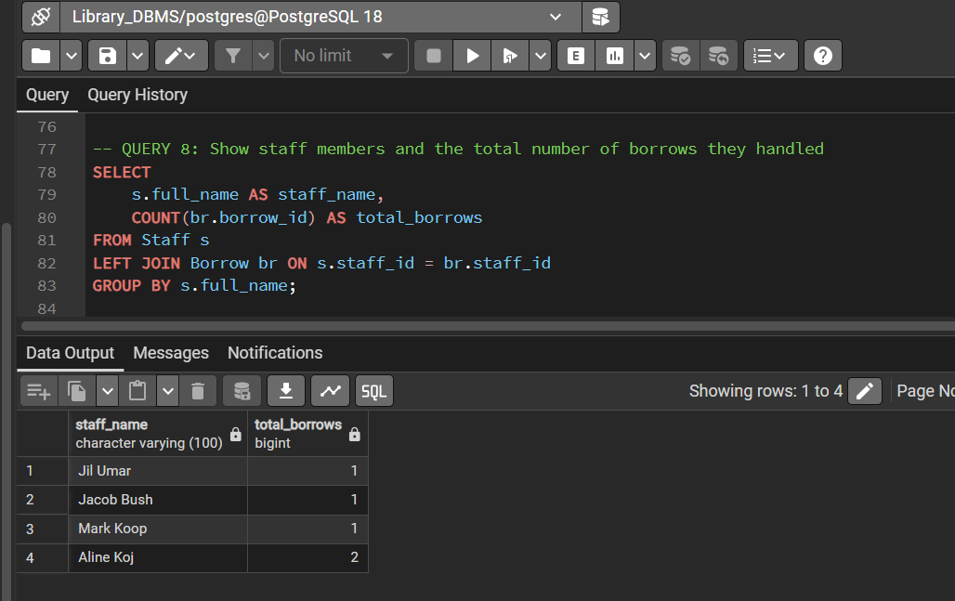

Query 9
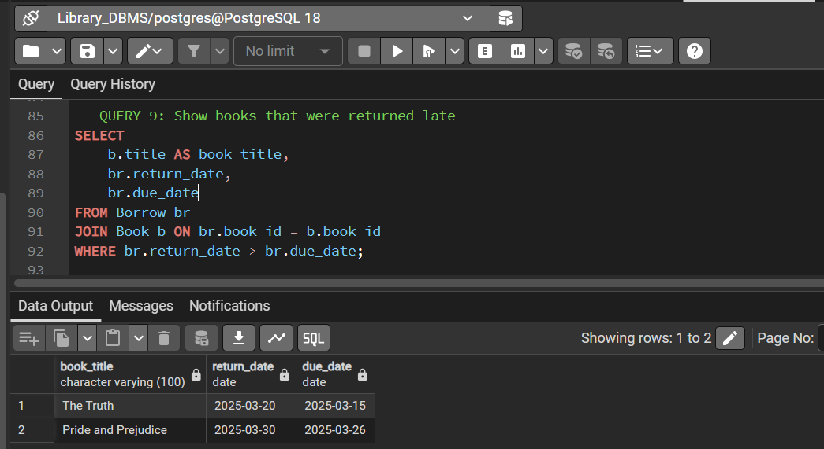

Query 10
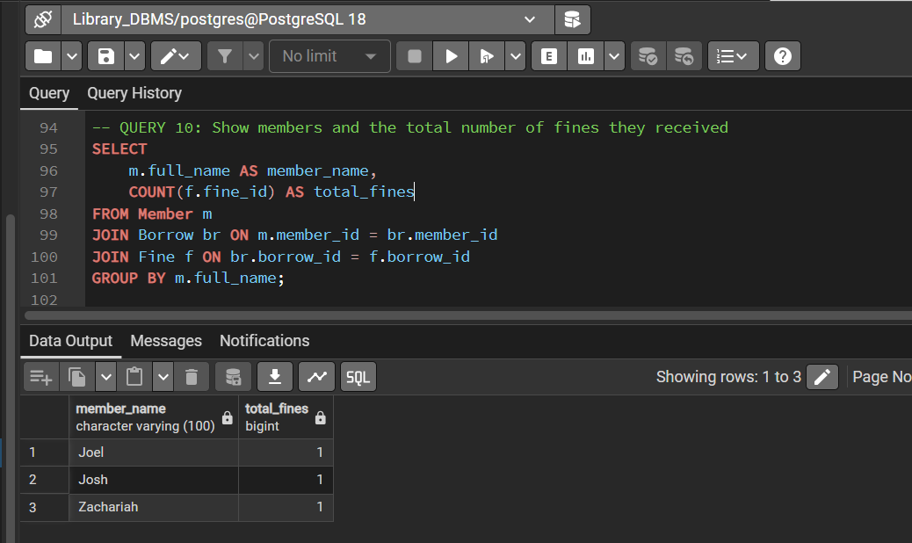

Query 11
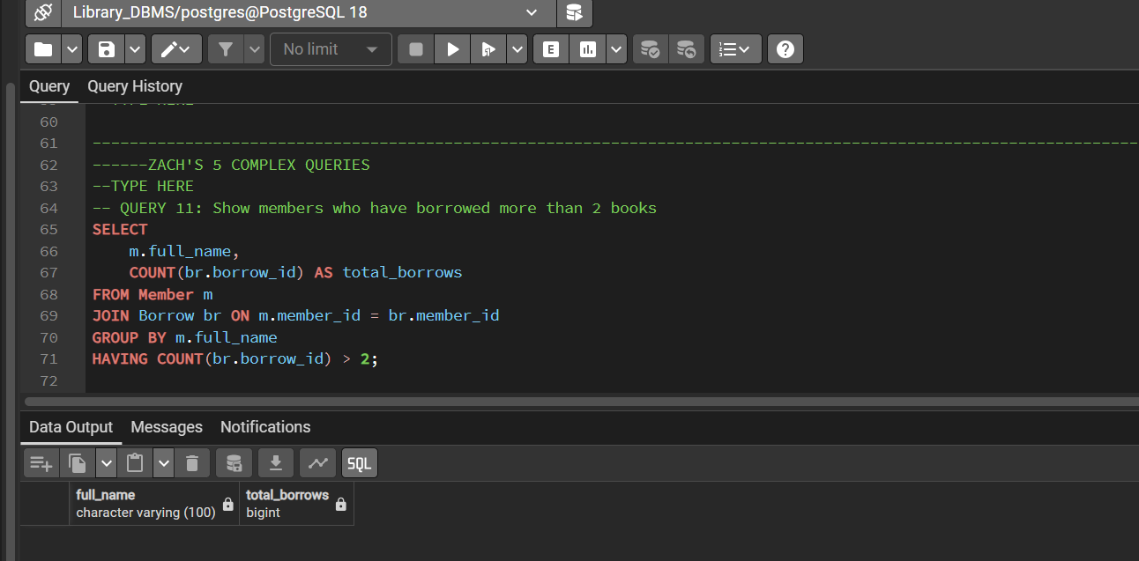

Query 12
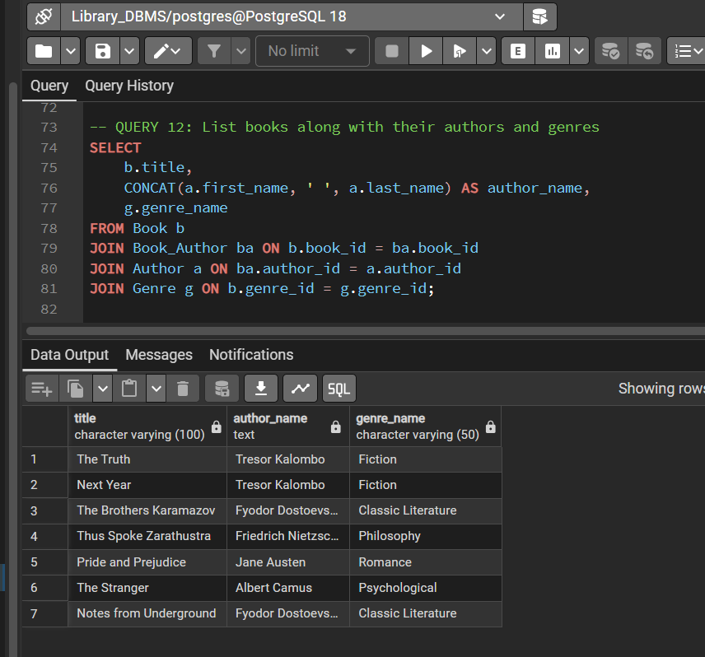

Query 13
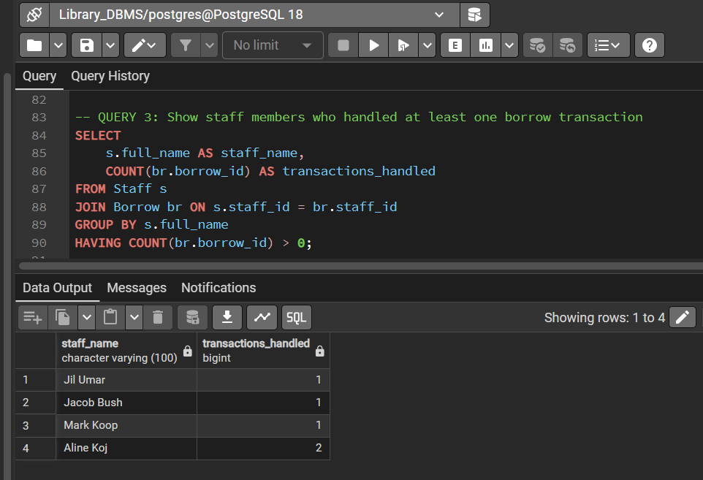

Query 14
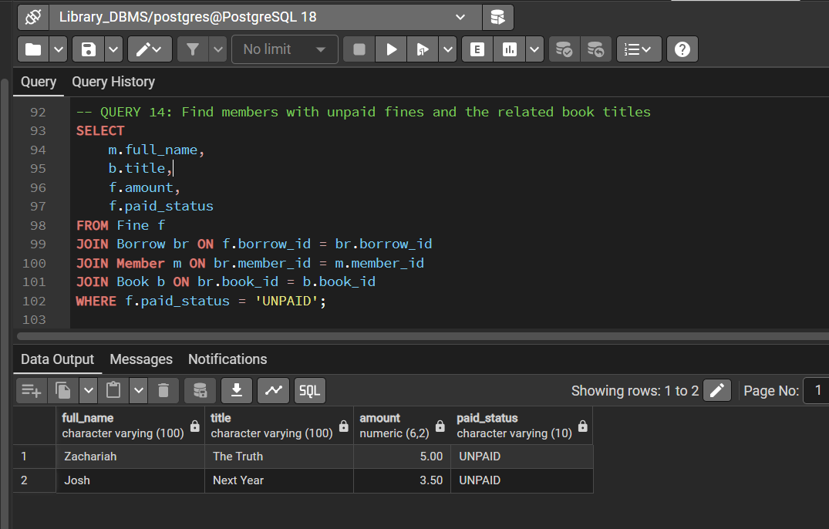

Query 15
