01/03/2019

Immagine che contiene clipart

Descrizione generata con affidabilità molto elevata

**MindSwitch**

**Hardware:**

* Raspberry Pi3B microcontroller – Approx. price € 42 ($ 35)

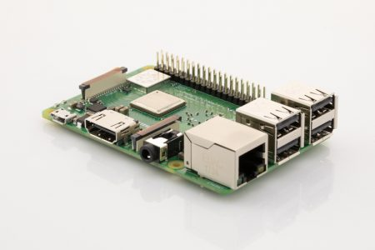

* TrueRNG3™ - Approx. price € 43 ($ 50)

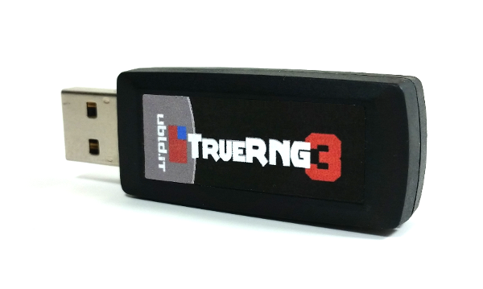

* Power bank - Approx. price € 17 ($ 19)

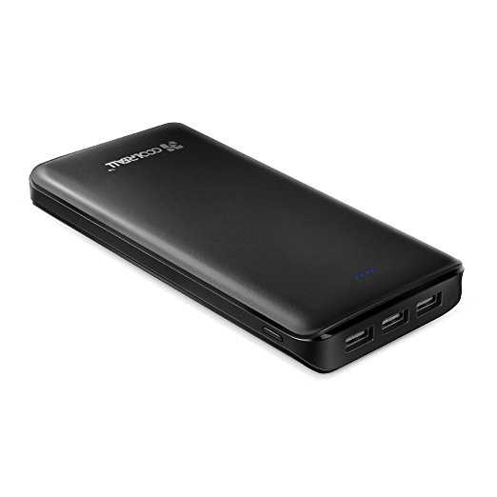

* On/Off switch – Approx. price € 3 ($ 4)
* 
* Led lights - Approx. price € 5 ($ 6)

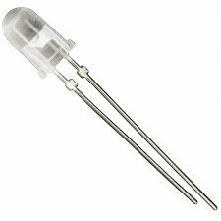

* Buzzer – Approx price € 1.5 ($ 2)

**Assembling:**

* Insert the TrueRNG3™ in a Raspberry USB for the MindSwitch use or in a port of your PC for the use of the use of the MindSwitchPC.py program after installing its drive (see <http://ubld.it/products/support/truerng-install-guide> );
* Insert the power bank (after charging it) in the Raspberry Power Micro USB port;
* Connect the long pin to the GPIO pin number 3 for the Red Led
* Optional: connect to the GPIO pin number 12 for the White Led and to the GPIO pin number 7 for the Blue Led.
* The short pin of each Led light must be connected to a ground connection of the GPIO (See the Schematic below).

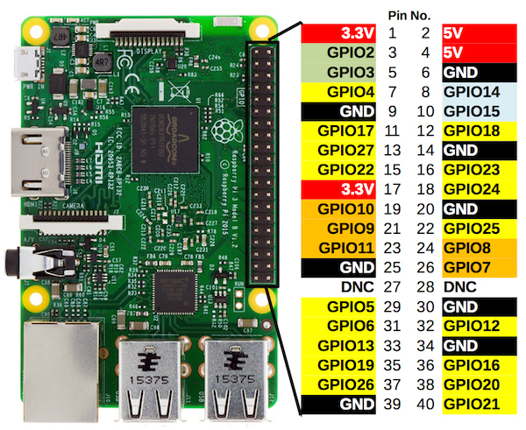

* Connect to the RUN pins of the Raspberry an On /Off Switch for the RESET (see image below).

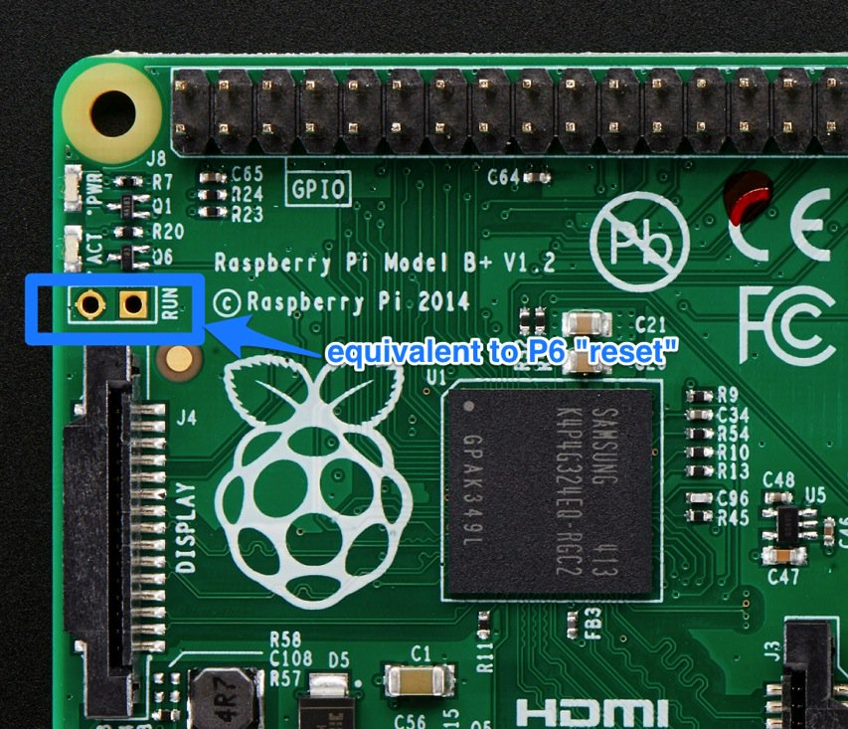

Further instructions: <https://projects.raspberrypi.org/en/projects/physical-computing/4>

**Assembled MindSwitch**

**Audio signal option:** <https://projects.raspberrypi.org/en/projects/physical-computing/10>

**Bluetooth signal option:**

<https://www.cnet.com/how-to/how-to-setup-bluetooth-on-a-raspberry-pi-3>

**Software**

Download and install Python on your Raspberry and PC: <https://www.python.org/downloads/>

Install the following modules for Python:

* Rpi-GPIO
* errno
* binascii
* numpy
* pyserial
* scipy.special
* os
* fnmatch
* time
* datetime
* configparser
* functools

Use the command pip to install them:

For example: pip install pyserial

See instruction here:

<https://packaging.python.org/guides/installing-using-pip-and-virtualenv>

From: [**https://github.com/tressoldi/MindSwitch**](https://github.com/tressoldi/MindSwitch), download

* **MindSwitchRaspberry.py**
* **CalibrationRaspberry.ini**
* **run.sh**

in a dedicated folder named MindSwitch in pi user Desktop.

To auto execute the software on every logon:

* insert in user .profile file (show hidden file and browse /home/pi/.profile), at bottom position:

. /home/pi/Desktop/MindSwitch/run.sh &

* save file and reboot

Files description and use:

**MindSwitchRaspberry.py**

This software analyses the randomness of the samples of data sent by the TrueRNG3™ (to be inserted in a Raspberry USB port) after reading the **CalibrationRaspberry.ini** file to be uploaded on the MindSwitch folder on the Raspberry desktop, where it is necessary to specify:

- The number of bits/sec from the TrueRNG3™ (it can be over 400 kbit/sec). We recommend to set this parameter to 100 to allow a faster analysis.

- The number of data samples;

- Time Interval for data analyses in seconds;

- The cutoff (.05 as default) of each of the two statistical tests (‘Frequency monobit’ and ‘Runs’ tests from the National Institute of Standards and Technology suite (Bassham et al., 2010):

- The mode of the Red Led light functioning: ON – OFF sequential or ON – OFF automatic using a Timer in seconds.

**Transferring data files from your Raspberry Pi**

* insert a USB pen drive on one of the Raspberry USB ports with a MindSwitch folder in it. The results of the data analyses will be saved automatically in this pen drive with a progressive number e.g. 1_ MindSwitchDataAnalysis

**Mind Switch Functioning:**

Press the button of the power of the battery. The MindSwitch will start to run the **MindSwitchRaspberry.py** after reading its parameters from the file **CalibrationRaspberry.ini** uploaded in the MindSwitch folder in the Raspberry Desktop

When the sample of data results as non-random, according to the predefined cutoff values of both tests, the red led light (or a different output, if programmed) is activated following the option chosen in the CalibrationRaspberry.ini

The Reset Switch can be used to restart or just to stop the MindSwitchRaspeberry software.

**MindSwitch Data Analysis:**

Open the files n_**MindSwitchDataAnalysis_(*xyz*).csv.** In the columns “Frequency test” and “Runs test” you will find the p value of these tests. In the column, “Accuracy” value 0, corresponds to the violation of randomness of both the statistical tests; value 1, corresponds to the violation of randomness of only one of the statistical tests; value 2, corresponds to the non violation of randomness of both the statistical tests;

**For testing the parameters to be used with the MindSwitch on your PC:**

Insert a TrueRNG in one of your PC USB port, select the parameters in the *Calibration.ini* file. Launch the *MindSwitchPC.py* software from the Python IDLE interface and check the results.

Before the first launch, install the following modules:

os

errno

pyserial

binascii

winsound

datetime

configparser

numpy

time

scipy.special