03/10/2018

Immagine che contiene clipart

Descrizione generata con affidabilità molto elevata

**MindSwitch**

**Hardware:**

* Raspberry Pi3B microcontroller – Approx. price € 42 ($ 35)

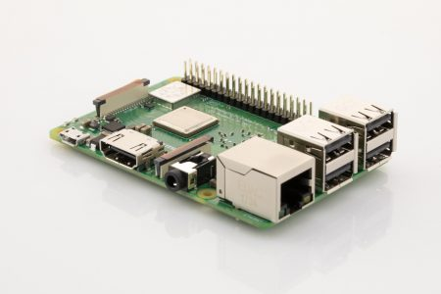

* TrueRNG3™ - Approx. price € 43 ($ 50)

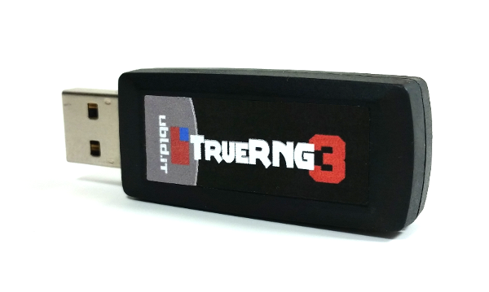

* Power bank - Approx. price € 17 ($ 19)

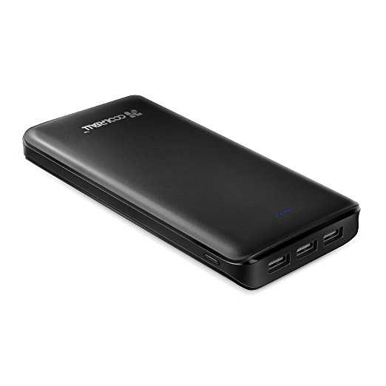

* On/Off switch – Approx. price € 3 ($ 4)
* 
* Led lights - Approx. price € 5 ($ 6)

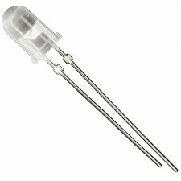

**Assembling:**

* Insert the TrueRNG3™ in a Raspberry USB for the MindSwitch use or in a port of your PC for the use of the use of the MindSwitchPC.py program after installing its drive (see <http://ubld.it/products/support/truerng-install-guide> );
* Insert the power bank (after charging it) in the Raspberry Power Micro USB port;
* Connect the long pin to the GPIO pin number 3 for the Red Led
* Optional: connect to the GPIO pin number 12 for the White Led and to the GPIO pin number 7 for the Blue Led.
* The short pin of each Led light must be connected to a ground connection of the GPIO (See the Schematic below).

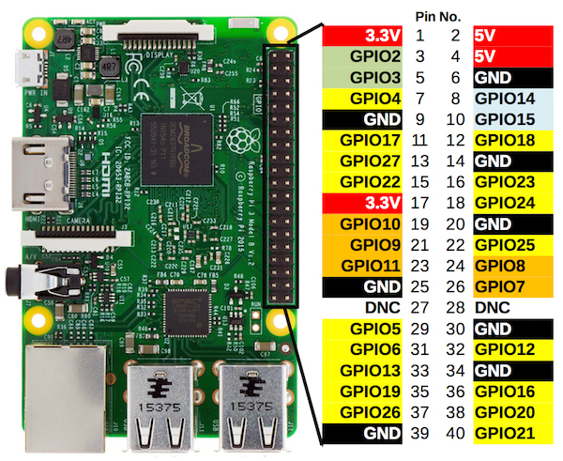

* Connect to the RUN pins of the Raspberry an On /Off Switch for the RESET (see image below).

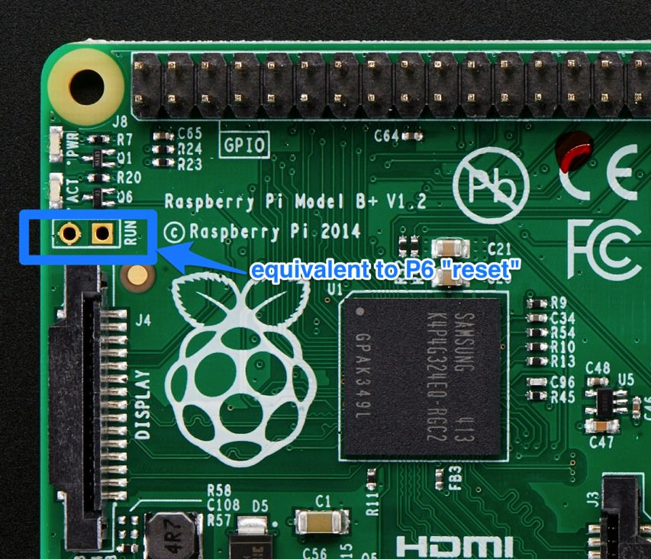

**Audio signal option:**

**Bluetooth signal option:**

Installation

Download and Install Python: <https://www.python.org/downloads/>

Install **mpmath, serial and pyserial** modules for Python with the command: pip install mpmath (see instruction here depending on your PC operating system <https://packaging.python.org/guides/installing-using-pip-and-virtualenv>

Download **MindSwitchPC.py**, **MindSwitchRaspberry.py** and **DataAnalysis.py** with the configuration files **Calibration.txt,** **MindSwitchParameters.txt** and **DataFilterInput.txt**, from: [**https://github.com/tressoldi/MindSwitch**](https://github.com/tressoldi/MindSwitch), in a dedicated folder (e.g. named MindSwitch).

Files description and use:

**MindSwitchPC.py**

This software allows to test the algorithms which analyse the randomness of the samples of data sent by the TrueRNG3™ (to be inserted in a USB port) after reading the **Calibration.txt** file (to be uploaded on a pen drive and inserted in a USB port) where it is necessary to specify:

* The number of bits/sec from the TrueRNG3™ (it can be over 400 kbit/sec)
* How long to acquire data from the TrueRNG3™ in seconds;
* The time sample-windows (expressed in second) to be analysed;
* The cutoff (.01 as default) of each of the two statistical tests (‘Frequency monobit’ and ‘Runs’ tests from the National Institute of Standards and Technology suite (Bassham et al., 2010):

Output: summary of samples resulting as random or not-random for each statistical test. The results of all samples are visible in the file **MindSwitchDataAnalisis.txt**

**MindSwitchRaspberry.py**

This software analyses the randomness of the samples of data sent by the TrueRNG3™ (to be inserted in a Raspberry USB port) after reading the **MindSwitchParameters.txt** file (to be uploaded on a pen drive and inserted in a Raspberry USB port) where it is necessary to specify:

- The number of bits/sec from the TrueRNG3™ (it can be over 400 kbit/sec)

- How long to acquire data from the TrueRNG3™ in seconds;

- The time sample-windows (expressed in second) to be analysed;

- The cutoff (.01 as default) of each of the two statistical tests (‘Frequency monobit’ and ‘Runs’ tests from the National Institute of Standards and Technology suite (Bassham et al., 2010):

- The mode of the Red Led light functioning: ON – OFF sequential or ON – OFF automatic using a Timer in seconds.

**Transferring files to and from your Raspberry Pi**

Connect the monitor of your PC with the Raspberry by using a HDMI cable. Insert a mouse in one of the Raspberry USB ports. Now you can upload the *MindSwicthRaspberry.py* file into your Raspberry Pi.

**DataAnalysis.py**

This software allows to check the data analyzed by the **MindSwitchRaspberry.py.** These data can be filtered by using the parameters added in the file **DataFilterImput.txt**

**Mind Switch Functioning:**

Press the button of the power of the battery. The MindSwitch start to run the ***MindSwitchRaspberry.py*** after reading its parameters from the file MindSwitchParameters.txt upload on a pendrive inserted in one of its USB ports.

When the sample of data results as non-random, according to the predefined cutoff values of both tests, the Red Led Light is activated following the option chosen (see ***MindSwitch parameters.txt***).

If added, the Blue Led Light is activated when the MindSwitch starts and end to read binary data from the TrueRNG3™ according to the value of the parameter “*Time Interval for data analyses in seconds*”. The White Led Light is activated when the MindSwitch completes the time of reading of the binary data emitted by the TrueRNG3™, according to the value of the parameter “*Amount of Time of data acquisition in seconds*”

The Reset Switch can be used to restart or just to stop the running test. Turn it on and then off to restart the Raspberry Pi.

**At the end of the use, press the power button of the battery to switch off the MindSwitch.**

**MindSwitch Data Analysis**

Insert the pendrive used with the MindSwtich in one of your PC USB port. Launch ***DataAnalysis.py*** from your PC. These data can be filtered by using the parameters added in the file ***DataFilterImput.txt***

**For testing the parameters to be used with the MindSwitch:**

Select the parameters in the *Calibration.txt* file. Launch the *MindSwitchPC.py* software and check the results.