20/12/2018

Immagine che contiene clipart

Descrizione generata con affidabilità molto elevata

**MindSwitch**

**Hardware:**

* Raspberry Pi3B microcontroller – Approx. price € 42 ($ 35)

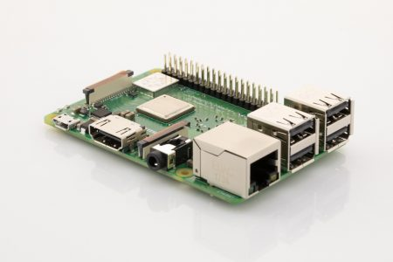

* TrueRNG3™ - Approx. price € 43 ($ 50)

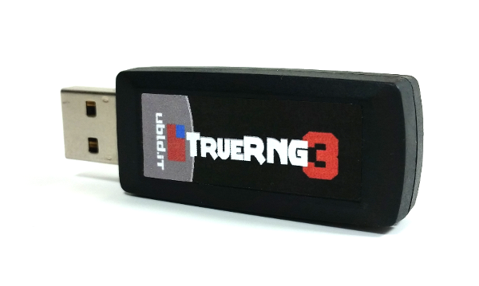

* Power bank - Approx. price € 17 ($ 19)

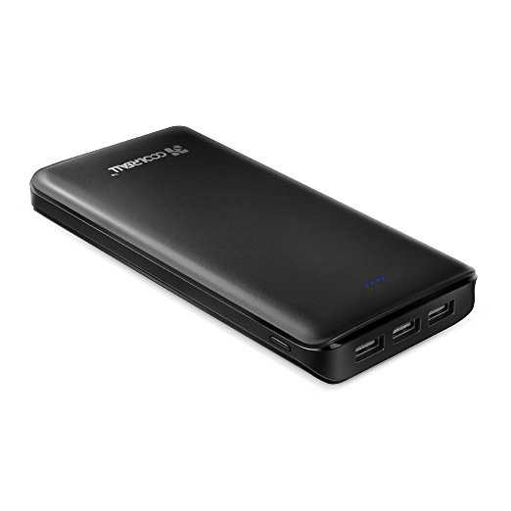

* On/Off switch – Approx. price € 3 ($ 4)
* 
* Led lights - Approx. price € 5 ($ 6)

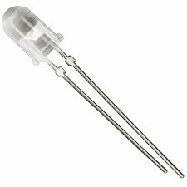

**Assembling:**

* Insert the TrueRNG3™ in a Raspberry USB for the MindSwitch use or in a port of your PC for the use of the use of the MindSwitchPC.py program after installing its drive (see <http://ubld.it/products/support/truerng-install-guide> );
* Insert the power bank (after charging it) in the Raspberry Power Micro USB port;
* Connect the long pin to the GPIO pin number 3 for the Red Led
* Optional: connect to the GPIO pin number 12 for the White Led and to the GPIO pin number 7 for the Blue Led.
* The short pin of each Led light must be connected to a ground connection of the GPIO (See the Schematic below).

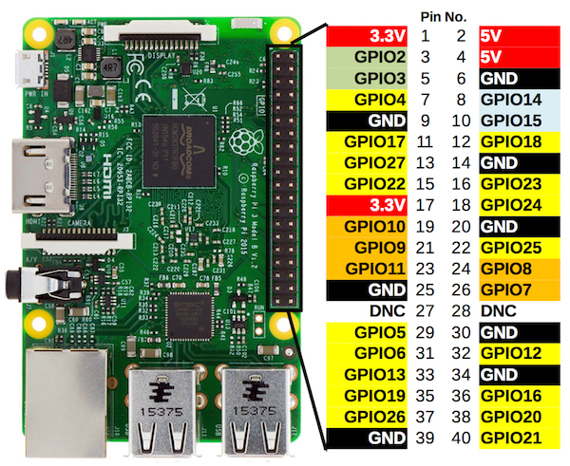

* Connect to the RUN pins of the Raspberry an On /Off Switch for the RESET (see image below).

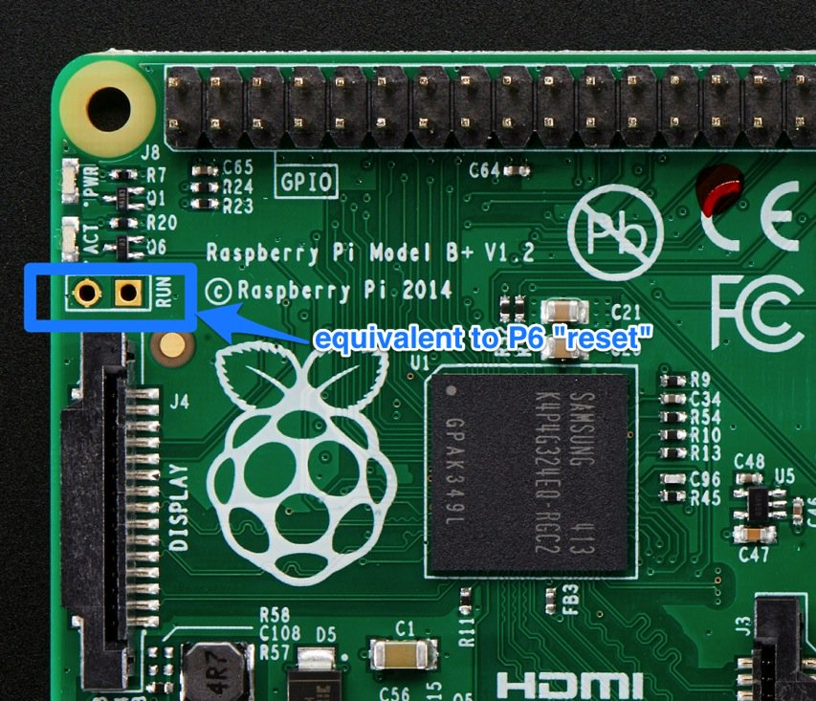

**Audio signal option:**

**Bluetooth signal option:**

Installation on Raspberry

Download and Install Python: <https://www.python.org/downloads/>

Install the following modules for Python:

* Rpi-GPIO
* numpy
* pyserial
* scipy
* setuptools

Use the command pip to install them:

For example: pip install pyserial

See instruction here :

<https://packaging.python.org/guides/installing-using-pip-and-virtualenv>

Download

* **MindSwitchRaspberry.py**
* **CalibrationRaspberry.ini**
* **run.sh**

from: [**https://github.com/tressoldi/MindSwitch**](https://github.com/tressoldi/MindSwitch), in a dedicated folder named MindSwitch in pi user Desktop.

To auto execute the script on every logon:

* insert in user .profile file (show hidden file and browse /home/pi/.profile), at bottom position:

. /home/pi/Desktop/MindSwitch/run.sh &

* save file and reboot

Using USB pen drive:

If you want you can plug an USB pen drive with a copy of the files in a Mindswitch root folder:

* the file will be copied in the Desktop MindSwitch Folder;
* after the script execution the analysis data will be written in the USB pen drive/MindSwitch folder

Files description and use:

**MindSwitchRaspberry.py**

This software analyses the randomness of the samples of data sent by the TrueRNG3™ (to be inserted in a Raspberry USB port) after reading the **MindSwitchParameters.txt** file (to be uploaded on a pen drive and inserted in a Raspberry USB port) where it is necessary to specify:

- The number of bits/sec from the TrueRNG3™ (it can be over 400 kbit/sec)

- How long to acquire data from the TrueRNG3™ in seconds;

- The time sample-windows (expressed in second) to be analysed;

- The cutoff (.01 as default) of each of the two statistical tests (‘Frequency monobit’ and ‘Runs’ tests from the National Institute of Standards and Technology suite (Bassham et al., 2010):

- The mode of the Red Led light functioning: ON – OFF sequential or ON – OFF automatic using a Timer in seconds.

**Transferring files to and from your Raspberry Pi**

Connect the monitor of your PC with the Raspberry by using a HDMI cable. Insert a mouse in one of the Raspberry USB ports. Now you can upload the **MindSwicthRaspberry.py** file into your Raspberry Pi.

**MindSwitchDataAnalysis_(*xyz*).csv**

This file allows to check the data analyzed by the **MindSwitchRaspberry.py.**

**Mind Switch Functioning:**

Press the button of the power of the battery. The MindSwitch start to run the **MindSwitchRaspberry.py** after reading its parameters from the file **CalibrationRaspberry.ini** uploaded on your pendrive inserted in one of Raspberry USB ports.

When the sample of data results as non-random, according to the predefined cutoff values of both tests, the Red Led Light is activated following the option chosen in the CalibrationRaspberry.ini

If added, the Blue Led Light is activated when the MindSwitch starts and end to read binary data from the TrueRNG3™ according to the value of the parameter “*Time Interval for data analyses in seconds*”. The White Led Light is activated when the MindSwitch completes the time of reading of the binary data emitted by the TrueRNG3™, according to the value of the parameter “*Amount of Time of data acquisition in seconds*”

The Reset Switch can be used to restart or just to stop the running test. Turn it on and then off to restart the Raspberry Pi.

**At the end of the use, press the power button of the battery to switch off the MindSwitch.**

**MindSwitch Data Analysis:**

Analyse the files **MindSwitchDataAnalysis_(*xyz*).csv.** In the column “Accuracy”, value 0, corresponds to the violation of randomness according to both the statistical tests; value 1, corresponds to the violation of randomness according to only one of the statistical tests; value 2, corresponds to the non violation of randomness according to both the statistical tests;

**For testing the parameters to be used with the MindSwitch on your PC:**

Insert a TrueRNG in one of your PC USB port, select the parameters in the *Calibration.ini* file. Launch the *MindSwitchPC.py* software and check the results.