**Damage Nr: 1**  
Date: 2023-08-10  
Windfarm: NOrdesse  
Blade: 1  
Z[mm]: 22  
Profile Depth: 22  
Edge: leading_edge  
Side: pressure_side  
Photo: 1691675157936.jpg  
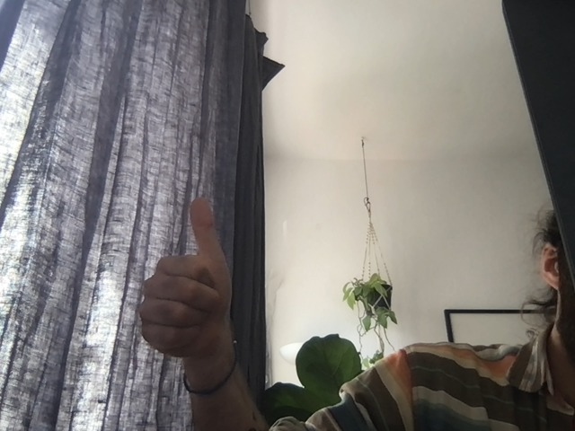

**Damage Nr: 2**  
Date: 2023-08-10  
Windfarm: Hasenheide  
Blade: 3  
Z[mm]: 2222  
Profile Depth: 45522  
Edge: trailing_edge  
Side: suction_side  
Photo: 1691675190946.jpg  
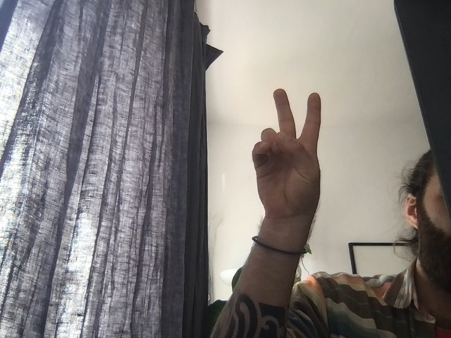

**Damage Nr: 1**  
Date: 2023-08-10  
Windfarm: NOrdesse  
Blade: 1  
Z[mm]: 22  
Profile Depth: 22  
Edge: leading_edge  
Side: pressure_side  
Photo: 1691675157936.jpg  


**Damage Nr: 2**  
Date: 2023-08-10  
Windfarm: Hasenheide  
Blade: 3  
Z[mm]: 2222  
Profile Depth: 45522  
Edge: trailing_edge  
Side: suction_side  
Photo: 1691675190946.jpg  


**Damage Nr: 1**  
Date: 2023-08-10  
Windfarm: NOrdesse  
Blade: 1  
Z[mm]: 22  
Profile Depth: 22  
Edge: leading_edge  
Side: pressure_side  
Photo: 1691675157936.jpg  


**Damage Nr: 2**  
Date: 2023-08-10  
Windfarm: Hasenheide  
Blade: 3  
Z[mm]: 2222  
Profile Depth: 45522  
Edge: trailing_edge  
Side: suction_side  
Photo: 1691675190946.jpg  


**Damage Nr: 1**  
Date: 2023-08-10  
Windfarm: NOrdesse  
Blade: 1  
Z[mm]: 22  
Profile Depth: 22  
Edge: leading_edge  
Side: pressure_side  
Photo: 1691675157936.jpg  


**Damage Nr: 2**  
Date: 2023-08-10  
Windfarm: Hasenheide  
Blade: 3  
Z[mm]: 2222  
Profile Depth: 45522  
Edge: trailing_edge  
Side: suction_side  
Photo: 1691675190946.jpg  


**Damage Nr: 1**  
Date: 2023-08-10  
Windfarm: NOrdesse  
Blade: 1  
Z[mm]: 22  
Profile Depth: 22  
Edge: leading_edge  
Side: pressure_side  
Photo: 1691675157936.jpg  


**Damage Nr: 2**  
Date: 2023-08-10  
Windfarm: Hasenheide  
Blade: 3  
Z[mm]: 2222  
Profile Depth: 45522  
Edge: trailing_edge  
Side: suction_side  
Photo: 1691675190946.jpg  


**Damage Nr: 1**  
Date: 2023-08-10  
Windfarm: NOrdesse  
Blade: 1  
Z[mm]: 22  
Profile Depth: 22  
Edge: leading_edge  
Side: pressure_side  
Photo: 1691675157936.jpg  


**Damage Nr: 2**  
Date: 2023-08-10  
Windfarm: Hasenheide  
Blade: 3  
Z[mm]: 2222  
Profile Depth: 45522  
Edge: trailing_edge  
Side: suction_side  
Photo: 1691675190946.jpg  


**Damage Nr: 1**  
Date: 2023-08-10  
Windfarm: NOrdesse  
Blade: 1  
Z[mm]: 22  
Profile Depth: 22  
Edge: leading_edge  
Side: pressure_side  
Photo: 1691675157936.jpg  


**Damage Nr: 2**  
Date: 2023-08-10  
Windfarm: Hasenheide  
Blade: 3  
Z[mm]: 2222  
Profile Depth: 45522  
Edge: trailing_edge  
Side: suction_side  
Photo: 1691675190946.jpg  


**Damage Nr: 1**  
Date: 2023-08-10  
Windfarm: NOrdesse  
Blade: 1  
Z[mm]: 22  
Profile Depth: 22  
Edge: leading_edge  
Side: pressure_side  
Photo: 1691675157936.jpg  


**Damage Nr: 2**  
Date: 2023-08-10  
Windfarm: Hasenheide  
Blade: 3  
Z[mm]: 2222  
Profile Depth: 45522  
Edge: trailing_edge  
Side: suction_side  
Photo: 1691675190946.jpg  


**Damage Nr: 1**  
Date: 2023-08-10  
Windfarm: NOrdesse  
Blade: 1  
Z[mm]: 22  
Profile Depth: 22  
Edge: leading_edge  
Side: pressure_side  
Photo: 1691675157936.jpg  


**Damage Nr: 2**  
Date: 2023-08-10  
Windfarm: Hasenheide  
Blade: 3  
Z[mm]: 2222  
Profile Depth: 45522  
Edge: trailing_edge  
Side: suction_side  
Photo: 1691675190946.jpg  
