CVB815 Winter 2015 Assignment 2 – Innovation Order Tracking System

------------------------------------------------------------------

-- SUMMARY –

In this assignment we have implemented a graphical user interface that interacts with our Database.dll library from Assignment 1. We also switched from using CSV/SOAP files for data storage and are now using a SQL Server database.

In our application, we have used the following controls:

Label

Textbox

GridDataView

Button

CheckBox

Menu Item

DateTimePicker

Status Bar

ComboBox

ContextMenu

Tab Control

We have also implemented an about dialog box, and online help. We have a master-detail view for the orders and order items. Our code is well documented, uses exception handling, regular expressions, collection classes with generics and several objects from the My namespace. We are also generating and trapping events in order to keep the tabs on the main user interface updated with the most current state of our data.

Our main application window contains a Tab Control that consists of 3 tabs, Products, Customers and Orders. Each Tab displays a list of the current items in the database, and allows for adding new items, modifying existing items and deleting items.

-- WORKING WITH PRODUCTS –-

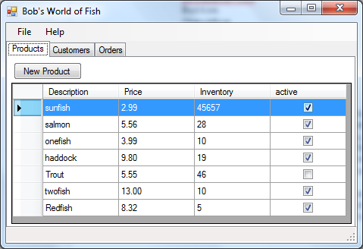

The ‘Products’ tab displays a list of all the products currently in the database, along with description, price, inventory and whether the product is active. To remove products, the user can select one or more products and right click and choose ‘Delete Selected Products’. Products can only be deleted if they do not appear on any existing orders. Attempting to delete a product that is in use on an order will result in it being set to ‘Inactive’.

To modify a product, the user should double click on a product. To add a new product, the user clicks the ‘New Product’ button. The following dialog box appears for working with products:

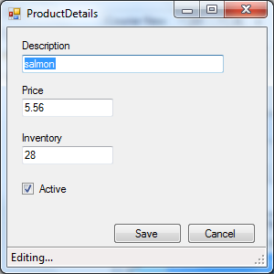

Once done working with the product, the user should click ‘Save’ to continue, or ‘Cancel’ to abort their changes. The view returns back to the ‘Products’ Tab with any product changes reflected in the display.

-- WORKING WITH CUSTOMERS –-

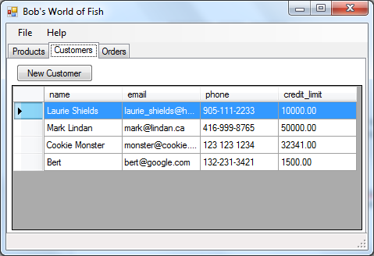

The ‘Customers’ tab displays a list of customers that are currently in the database, along with their email address, phone number and credit limit. To remove customers, the user can select one or more customers and right click and choose ‘Delete Selected Customers’. Customers can only be removed if they do not have any orders.

To modify a customer, the user should double click on a customer. To add a new customer, the user clicks the ‘New Customer’ button. The following dialog box appears for working with customers:

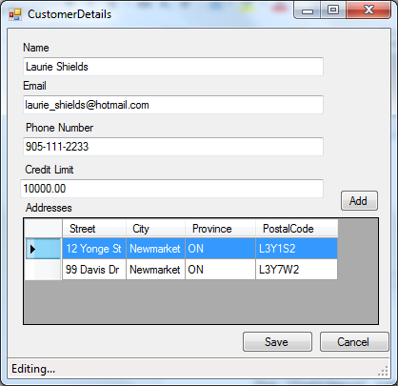

On the ‘Customer Details’ dialog, the user can modify the customer information and modify the addresses associated with that customer. To add a new address, click the ‘Add’ button, to modify an existing address, double click on the address. The following dialog will open for working with addresses:

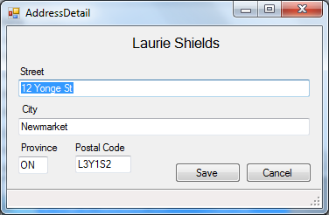

Once the user is done working with the address, they should press ‘Save’ to save their results, or cancel to abort. Once this dialog is closed, the user will be returned to the ‘Customer Details’ Dialog.

Once done working with the customer the user should click ‘Save’ to continue, or ‘Cancel’ to abort their changes. The view returns back to the ‘Customers’ Tab with any customer changes reflected in the display.

-- WORKING WITH ORDERS --

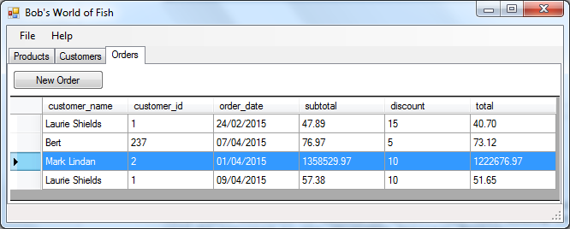

The ‘Orders’ tab displays a list of orders that are currently in the database, along with some important details. To remove orders, the user can select one or more orders and right click and choose ‘Delete Selected Orders’. Orders can only be deleted if none of the items have been shipped.

An order can be shipped by selecting the order and right clicking. Choose ‘Ship Selected Orders’. Any items that are not currently shipped and we have sufficient inventory will be shipped and the order will be updated.

To modify an order, the user should double click on an order. To add a new order, the user clicks the ‘New Order’ button. The following dialog box appears for working with orders:

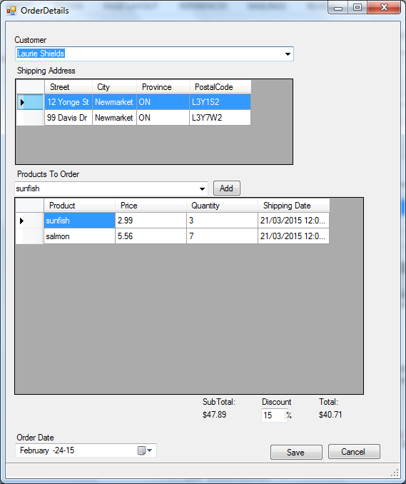

On the ‘Order Details’ Dialog, the user can select the customer, choose the shipping address, and add/remove items from the order. At the bottom we show the total of the order. After making changes to the order, the user can select ‘Save’ to save their changes, or ‘Cancel’ to abort their changes. The view will return to the ‘Orders’ Tab.

-- REQUIREMENTS --

Our application was developed with the .NET Framework version 4.5.1, and has not been tested for use with any prior versions.

-- INSTALLATION --

Extract the zip file and copy the contents of the Assignment2/bin/Release folder to a local directory. The run the Assignment2 executable file.

-- OUR EXPERIENCES –

We continued to use a GitHub repository for managing our source control and facilitate both of us working on the code simultaneously. Our repository is located at: https://github.com/trevel/vbas2

In completing our assignment we learned the following:

* How to implement WinForms
* How to use a DataGridView and attach a datasource to it
* How to interact with the Database using ADO.NET
* How to use SQL server to create and manage databases.
* How to write stored procedures in T-SQL including how to use input and output parameters with the stored procedures.
* We learned about Entity Framework, but didn’t use it in the assignment

Things we liked about doing this assignment:

* It was a challenging assignment that taught us many new things.
* Using an “actual” SQL Server enabling us to work in tandem.

Things we didn’t like about doing this assignment:

* We would have preferred to use the full features supported by the DataGridView for insert/update/delete and validation.
* The different requirements created a somewhat haphazard structure; using Linq-to-SQL and the library from Assignment 1 led to similar code structures.
* It was in VB.NET and not C#
* T-SQL is frustrating and limited compared to PL/SQL

-- KNOWN BUGS --

1. Our connection string is not easily changed. We need to find a better method to manage this string

2. Enhancements we would like to do: create order from customer or product tabs

3. We would like to convert to using the Entity Framework

-- CONTACT --

Current maintainers:

Laurie Shields (llshields@myseneca.ca)

Mark Lindan (melindan@myseneca.ca)