Lab00.m
% Trever Hines
% Earth 468
% Lab 00 (Benford's Law)

%----------------------------------------------------------------------------
% Problem A (8 points)
% Q: Write a function which calculates Benfords PMF and plot the function for
% n = 1:9
n = 1:9;
p = Benford(n);
figure(1)
plot(n,p,'-o')
xlabel('leading integer')
ylabel('probability')
title('Benfords law')
% A: see figure 1 and Benford.m

%----------------------------------------------------------------------------
% Problem B (4 points)
% Q: use sum to verify that the total probability is 1
sum(p);
% ans = 1

% A: Total probability is indeed 1

%----------------------------------------------------------------------------
% Problem C (8 points)
% Q: Write a function that takes a scalar input and returns the leading digit

LeadingDigit(1.01);
% ans = 1

LeadingDigit(60.2);
% ans = 6

LeadingDigit(-2.5);
% ans = -2 -2i

% A: See LeadingDigit.m for the function definition. The function works for
% real positive numbers

%----------------------------------------------------------------------------
% Problem D (10 points)
% import country population data and plot a histogram of the leading digits
data = csvread('CountryPopulation.csv',1,1);
% there are three extra columns added for some reason
data = data(:,1)

N = length(data);
% allocate empty array
leading_digits = zeros(N,1);
for i = 1:N
leading_digits(i) = LeadingDigit(data(i));
end
figure(2)
hist(leading_digits,1:9)
xlabel('leading digit')
ylabel('count')

% A: see figure 2

%----------------------------------------------------------------------------
% Problem E (10 points)
% count the number of leadiing digits which are 1:9
count = zeros(9,1)
for i = 1:9
count(i) = length(find(leading_digits == i))
end
figure(3)
plot(1:9,count/sum(count),'-o')
hold on
plot(1:9,Benford(1:9))

% A: see figure 1

Benford.m
function out = Benford(n)
out = log10(1 + 1./n);
end

LeadingDigit.m
function out = LeadingDigit(value)
out = floor(abs(value)/10^floor(log10(value)));
end

Figure 1

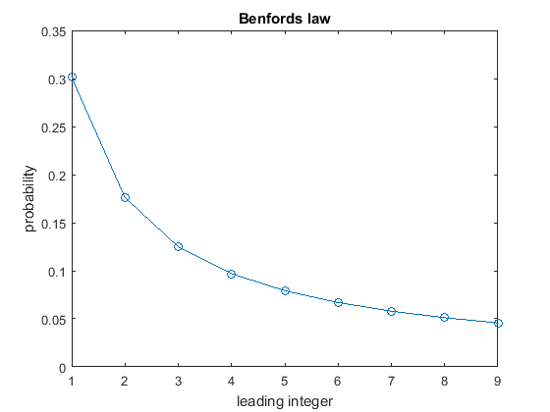

Figure 2

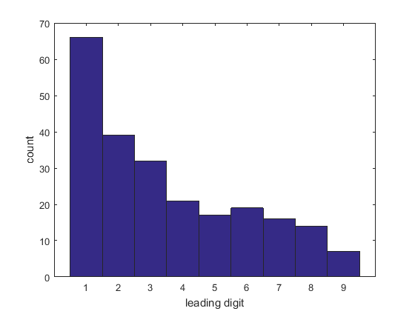

Figure 3

