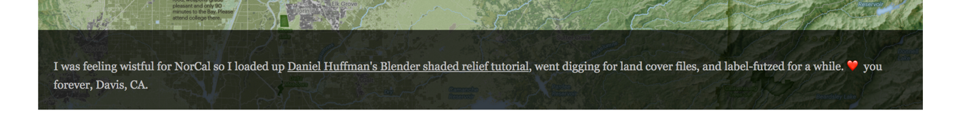

I really liked how these text bubbles popped up when the curser was over the map on Evan Applegate’s webfolio. The typeface is also a good size for what it is supposed to accomplish.

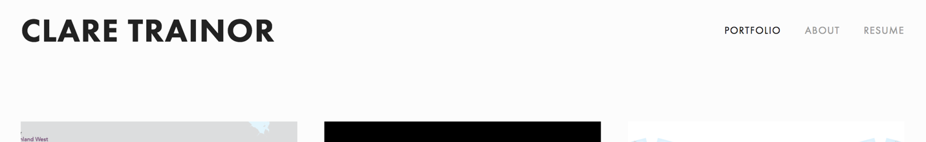

This basic bolded name as well as the simple the tabbed menu to the left was nice

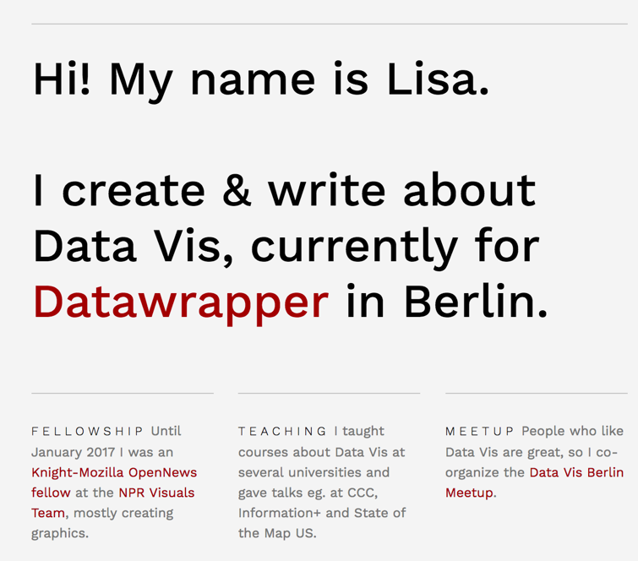

This is still simple but I think the red text is a nice addition where appropriate. Also, the physical line breaks are a good way of denoting topics/ new sections

I also like the typeface, but not the spacing in the subheadings below the lines