IRootLab Tutorials
PCA-LDA
Julio Trevisan
27/July/2011

This document is licensed under a Creative Commons Attribution-NonCommercial-ShareAlike 3.0 Unported License.

Conventions
Everytime text appears after the “>>” symbol it means it needs to be typed into the MATLAB command window (followed by ENTER). Example “>> startup”.

I. Starting

- Start MATLAB
- Change current directory to IRoot directory
- >> startup
- >> datatool

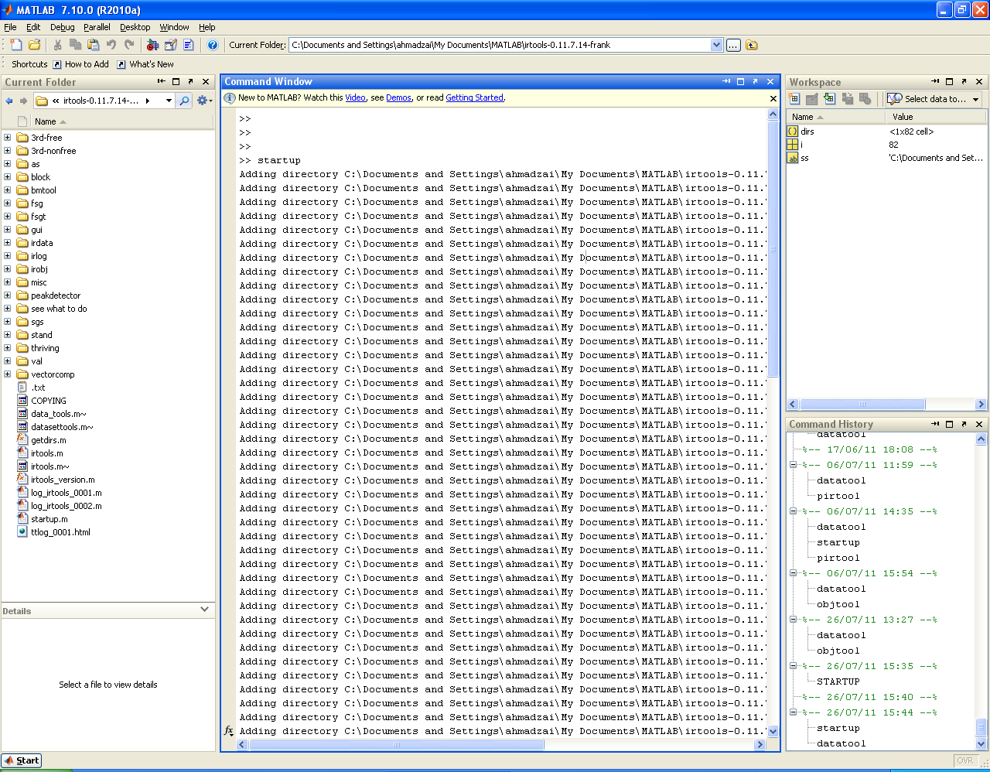

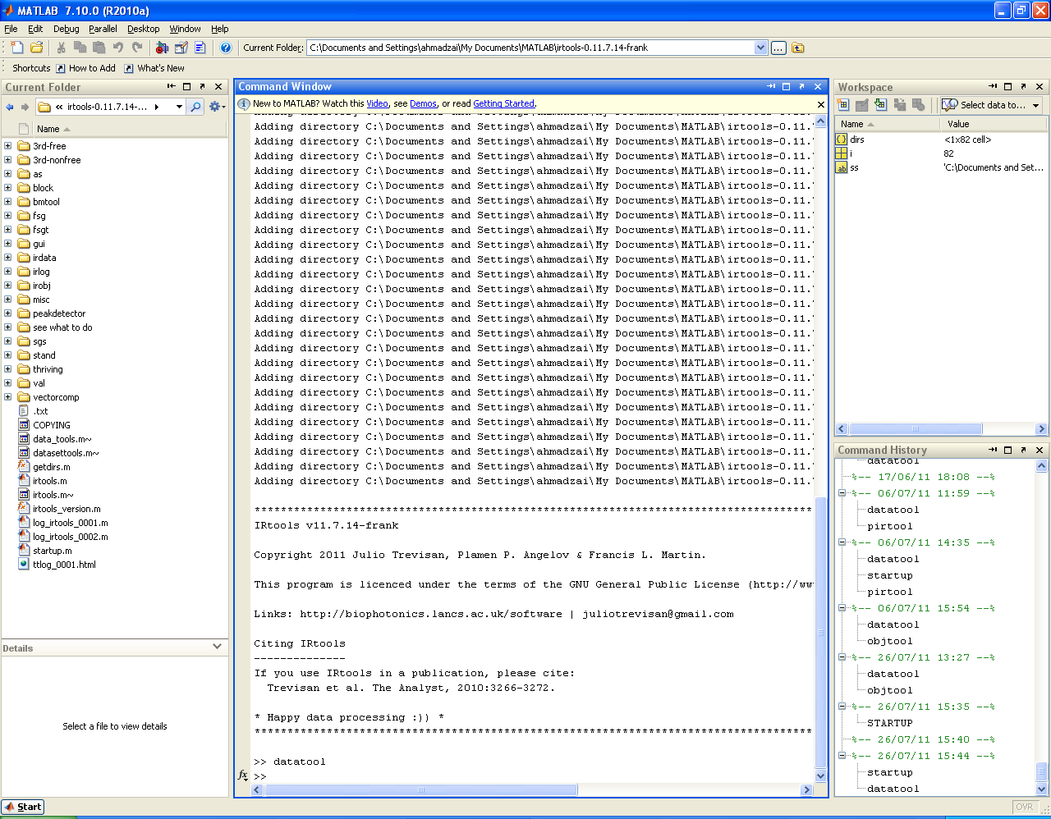

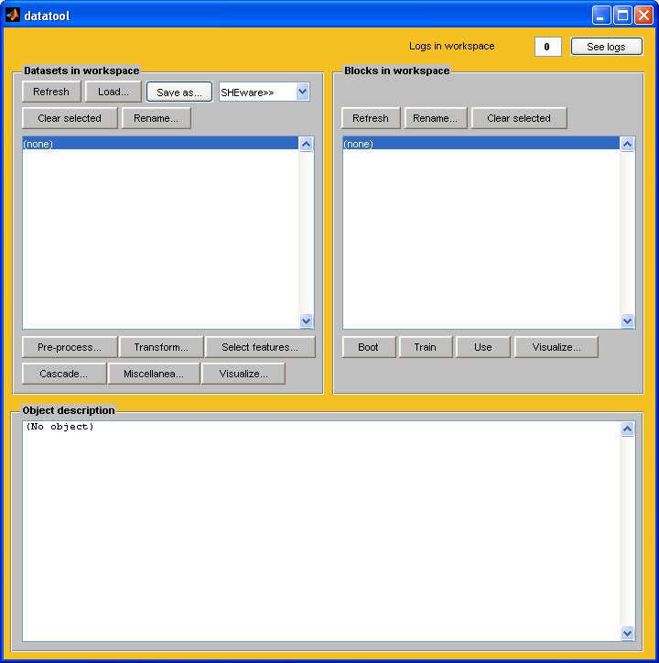

II. Loading dataset

- Click on “Load”
- Locate the data file
- In a special case, i.e.: if your data file is a basic text without the wavenumbers inside (“Basic” TXT format) AND the range of your spectra is not 1800-900, you may need to input this range manually.
- After you click OK on the “Feature range” box, a dataset named “ds01” should appear inside the list box.

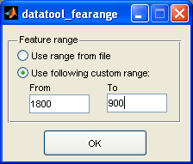

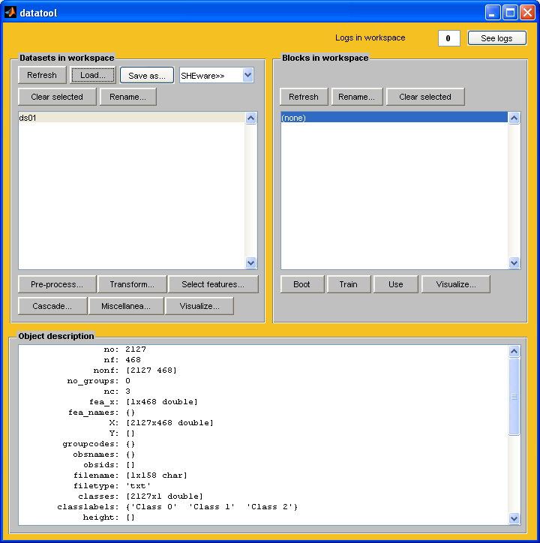

III Mean-centering the dataset

Before PCA-LDA, the dataset needs to be mean-centred, otherwise the zero (origin) won't be in the middle of the scores plots and all the cluster vectors will look pretty much the same.

- Click on “Pre-process”
- At the box that opens, find the option “Normalization”
- At the box that opens: Type of normalization : “Mean-centering”
- Click on “OK”
- A new dataset should appear in datatool named “ds01_norm01”

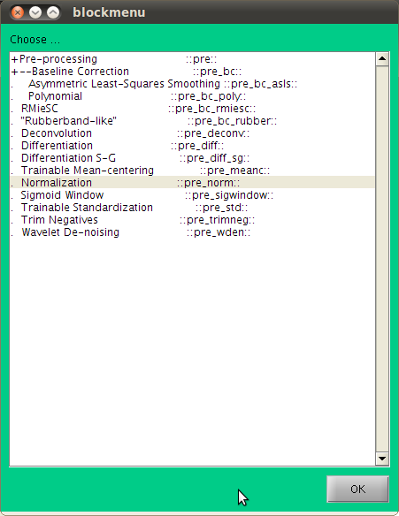

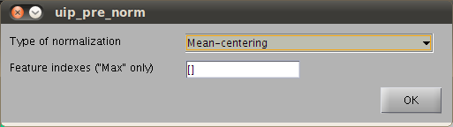
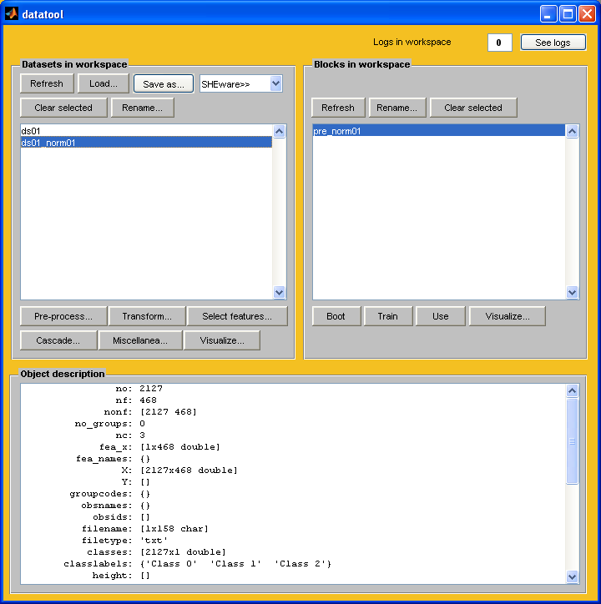

IV. Running the PCA-LDA

- In datatool, select the dataset named “ds01_norm01”
- Click on “Cascade...”, then select “PCA-LDA”. Click “OK”
- The PCA parameter box opens. Change the number of factors, if needed. If not, leave the default number 10. Click “OK”
- The LDA parameter box opens. No need for any penalty here. Just click “OK”.
- A new dataset named “ds01_norm01_pcalda01” should appear in datatool

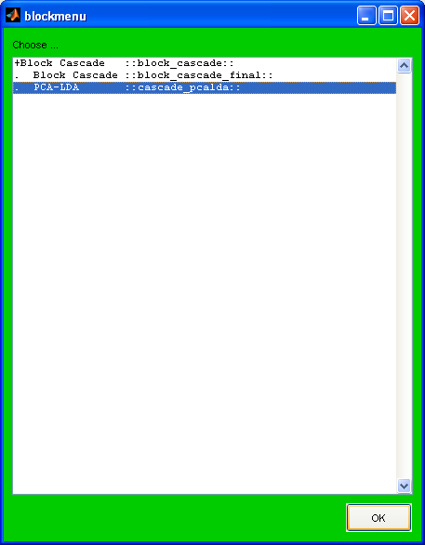

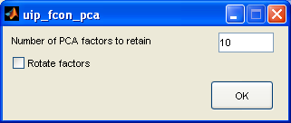

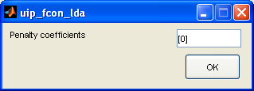

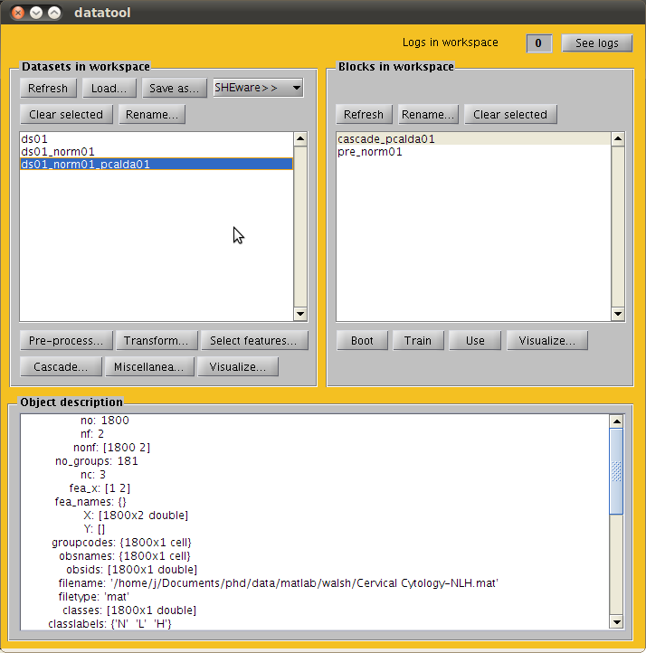

V. Visualization 1: Scores plot

- In datatool, select the dataset “ds01_norm01_pcalda01”
- Click on “Visualize”, then select “2D scatterplot”. Click “OK”. Obs: procedure is similar for 1D, 3D.
- In the box that opens, you may change the factors that you want to see (i.e., LD1, LD2, LD3 etc). You can also put a list of more than two factors. In this case, more plots will be generated (one for each combination of two factors). Examples: “[1, 2]”; “[1, 2, 3]”, “[2, 3]”, “[2, 4]”.
- You may also tell confidence ellipses to be drawn. The “0.9” below means 90%. You can specify a list, e.g., “[0.7, 0.8, 0.9]”
- Click “OK”. A figure should appear.
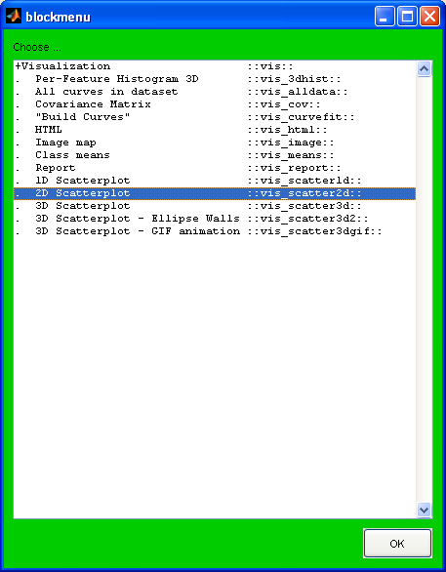

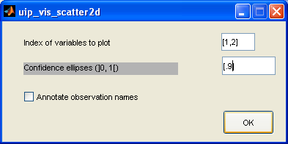

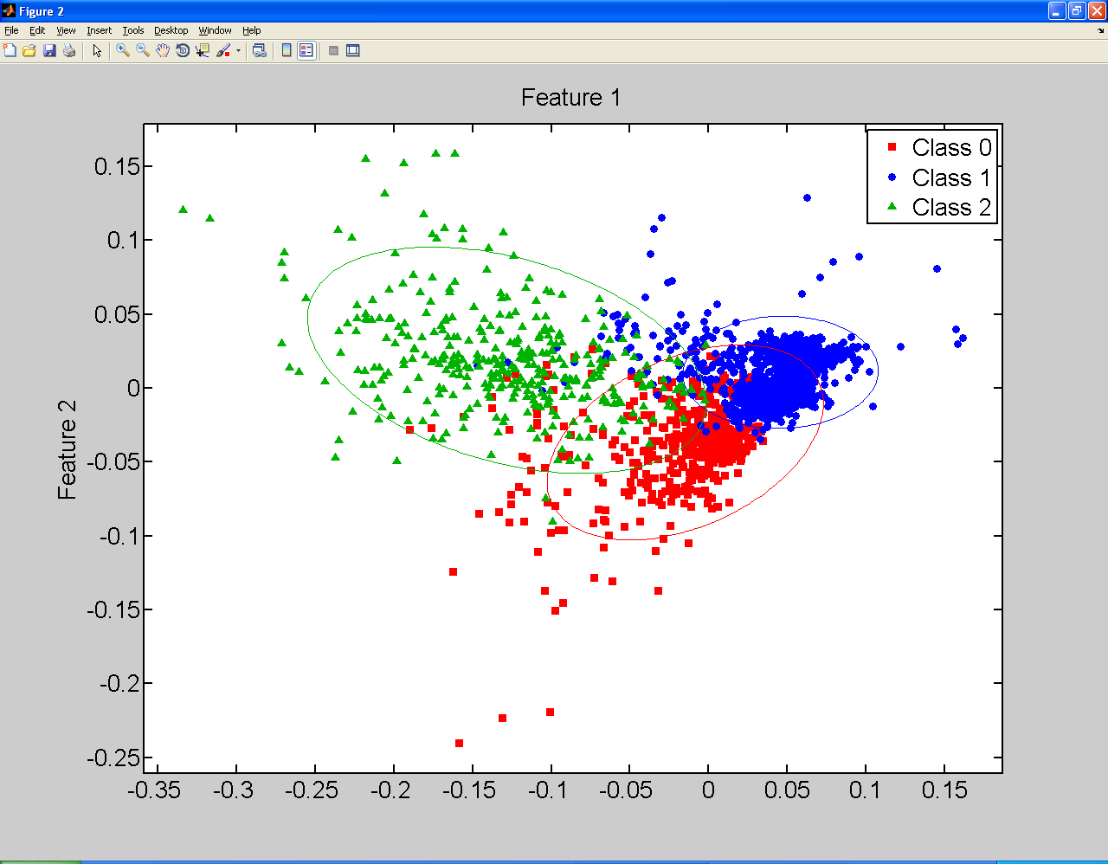

VI. Visualization 2: Cluster vectors

- In datatool, select the block “cascade_pcalda01” (right panel this time)
- Click on “Visualize” on the right panel
- Select “Cluster vectors”. Click “OK”
- In the box that opens:
Input dataset needs to be the same one that was inputted into the PCA-LDA before (i.e., “ds01_norm01”).
Index of class to be the origin may be left as zero (ignored) for the classic cluster vectors (Martin et al. JCB 2007), or the index of a class may be specified (e.g., the index of the Control class) for the alternative version (Llabjani et al. ES&T 2010). In the latter case, a class centre will be taken as the origin of the space and its corresponding cluster vector will be a flat line.
- Click “OK”. You should see a figure now.
- Enjoy your figures :)))

