

**ART INVASION PROJECT**

# System Requirement Specifications (SRS) Document for Art Invasion

### 1. Introduction

#### 1.1 Purpose

The purpose of this document is to provide a comprehensive description of the functional and non-functional requirements for the Art Invasion platform. It will guide the development team in implementing a reliable, secure, and user-friendly system for online art commerce.

#### 1.2 Scope

Art Invasion is an online platform designed to connect artists, buyers, and art enthusiasts. The system will provide features such as artist profiles, artwork listings, secure transactions, and artwork authentication. The platform will operate initially in Kenya and expand globally. The core goal is to enhance transparency and accessibility in the art market while fostering trust between buyers and sellers.

#### 1.3 Definitions, Acronyms, and Abbreviations

* **SRS:** System Requirements Specification
* **UI:** User Interface
* **DBMS:** Database Management System
* **API:** Application Programming Interface

#### 1.4 References

* Johnson, D. (2019). "The Evolution of the Online Art Market: A Case Study of Saatchi Art."
* Kim, S. (2020). "Etsy and the Democratization of Art Commerce."
* Thomas, L. (2021). "Artfinder's Journey in the Competitive Art Market."

#### 1.5 Overview

This document details the functional and non-functional requirements, interface designs, system constraints, and development assumptions for the Art Invasion platform.

### 2. Overall Description

#### 2.1 Product Perspective

Art Invasion will be a standalone system, integrated with APIs for features like artwork authentication and personalized recommendations. It will have:

* A responsive web interface for desktops and mobile devices.
* Future provisions for mobile app support using Flutter.

#### 2.2 Product Features

* **Artist Profiles:** Create and manage detailed profiles showcasing portfolios.
* **Artwork Listings:** Upload, categorize, and sell artworks.
* **Artwork Authentication:** Verify artwork originality.
* **Personalized Recommendations:** AI-driven suggestions based on user preferences.

#### 2.3 User Characteristics

The platform will serve:

* **Artists:** Tech-savvy and non-tech-savvy users needing simple tools.
* **Buyers:** Individuals who prioritize transparency and trust.
* **Art Enthusiasts:** Users casually browsing for art.
* **Interior Designers and Galleries:** Professional users requiring curated collections.

#### 2.4 Constraints

* **Initial Hosting Limitations:** Hosted on TrueHost/Safaricom.
* **Budget Constraints:** Limited funds for advanced features like AI integrations in the first phase.
* **High Dependency on Secure and Scalable Payment APIs:** Payment integration and secure transaction processing are critical.

#### 2.5 Assumptions and Dependencies

* **Internet Availability:** Required for users to access the platform.
* **Third-Party APIs:** Timely integration of APIs for payment and artwork authentication.
* **Local Art Community Support:** Collaboration with local artists for onboarding during the initial phase.

### 3. Functional Requirements

* **FR1:** Users shall be able to create accounts as artists, buyers, or administrators.
* **FR2:** Artists shall upload and manage artworks, including adding descriptions, categories, and pricing.
* **FR3:** Buyers shall search and filter artworks by category, price range, and artist location.
* **FR4:** The system shall authenticate artwork originality using image recognition APIs.
* **FR5:** Users shall receive notifications about purchases, updates, and recommendations.

### 4. Non-Functional Requirements

* **NFR1:** The system shall ensure 99.9% uptime.
* **NFR2:** The platform shall support at least 10,000 simultaneous users.
* **NFR3:** All user data shall be encrypted during transmission and storage.
* **NFR4:** The UI shall be responsive and load within 3 seconds on standard connections.
* **NFR5:** The system shall adhere to GDPR and Kenyan data protection regulations.

### 5. Interface Requirements

#### 5.1 User Interfaces

* **Artist Dashboard:** A clean and intuitive UI for artist profiles and artwork management.
* **Buyer Dashboard:** For browsing artworks, purchasing, and viewing recommendations.
* **Admin Dashboard:** For monitoring platform activity, managing user accounts, and reviewing reports.

#### 5.2 Hardware Interfaces

* The platform shall operate on standard servers (in Hosting companies).
* **Future Scalability:** Cloud hosting will be implemented if the user base exceeds initial expectations.

#### 5.3 Software Interfaces

* **MySQL Database:** For storing user profiles, artwork details, and stock inventory.
* **AI Tools:** For personalized recommendations and image recognition of artwork.

### 6. System Models

High-level diagrams such as Data Flow Diagrams (DFDs), Entity-Relationship Diagrams (ERDs), and Use Case diagrams are included here.

**Data Flow Diagram:**

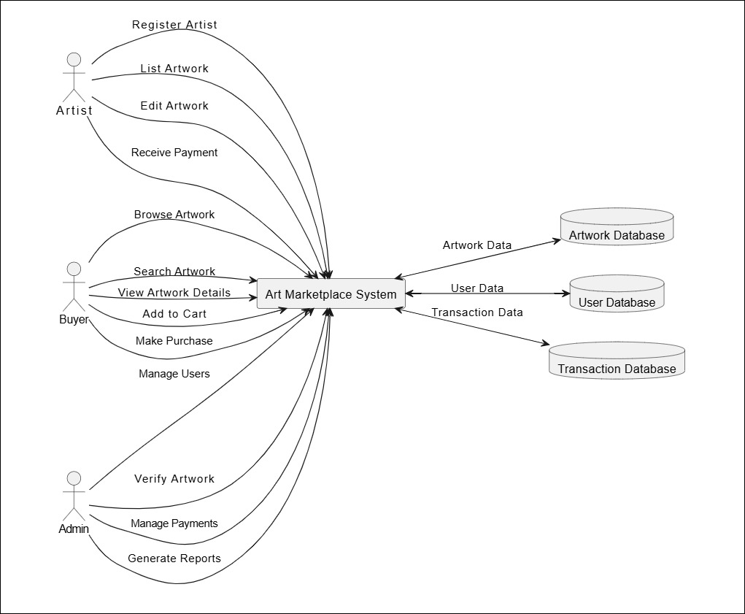

**Entity-Relationship Diagram:**

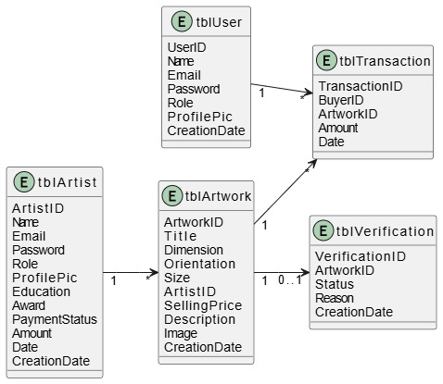

**Next Page – Use Case Diagram…**

**Use Case Diagram:**

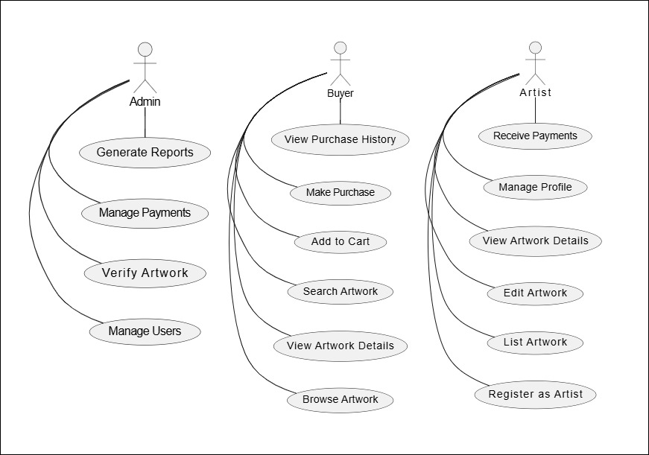

### 7. Other Requirements

* **Regulatory Compliance:** The system shall comply with local and international e-commerce and art trade regulations.
* **Documentation:** Comprehensive user manuals and final documentation are to be attached.