Use ASCII to put headers into:

1. Code
2. Vim, emacs, bash.rc, html, code comments, website
3. Figlet <https://www.askapache.com/online-tools/figlet-ascii/>
4. Ascii art collections <https://www.asciiart.eu/>
5. Art generator from picture <https://manytools.org/hacker-tools/convert-images-to-ascii-art/>

<https://pymotw.com/2/glob/>

<https://www.geeksforgeeks.org/python-program-to-recursively-scrape-all-the-urls-of-the-website/>

Object-Oriented Programming

**4 Pillars**

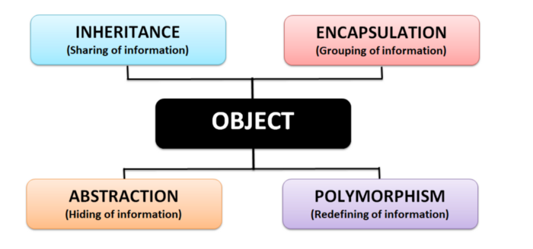

Objects

A group of related variables and methods are grouped into a unit = an object

* The object’s variables = its properties
* The object’s functions = its methods

Whenever you create something in Python, you are creating an object that is an instance of a specific class (String, function, integer, etc.)

* The class will determine how the object interacts with other objects
* The addition method is not defined for objects of int with objects of str
  + “unsupported operand type(s) for +: ‘int’ and ‘str’

Encapsulation

Grouping related variables and functions that operate on them into sections = Encapsulation

Model parameters of a functin as properties of a function » when you call the function there is not a long list of params

The fewer the parameters, the easier it is to use and maintain a function

Abstraction

Simplifying the methods and properties of an object

* Show only the essentials
* Simpler interface
* Reduce the impact of change
  + If you change the internal functinos of an object, it will not affect the program as a whole because the internal functions do not leak outside of their object
  + Deleting or redefining objects does not affet the project as a whole

Inhertiance

Objects can inherit properties and methods from other objects to eliminate redundancy

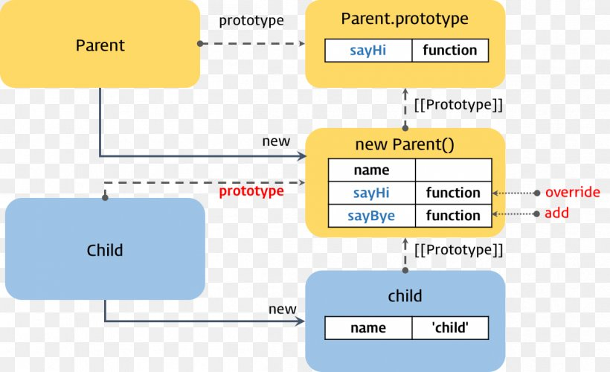

Polymorphism

Refactor ugly switch/case statemetns

A method can perform different tasks depending on what it is being applied to

Command Line Tools

apt & apt-get

Just a quick word for Linux Mint users. A few years ago, Linux Mint implemented a python wrapper called apt that actually uses apt-get but provides more friendly options. This apt which we are discussing here is not the same as the one in Linux Mint.

Before we see the difference between apt and apt-get, let’s go into the backdrop of these commands and what exactly they try to achieve.

### Why apt was introduced in the first place?

[Debian](https://www.debian.org/), mother Linux of distributions like Ubuntu, Linux Mint, elementary OS etc, has a robust packaging system and every component and application is built into a package that is installed on your system. Debian uses a set of tools called [Advanced Packaging Tool](https://wiki.debian.org/Apt) (APT) to manage this packaging system. Don’t confuse it with the command apt, it’s not the same.

There are various tools that interact with APT and allow you to install, remove and manage packages in Debian based Linux distributions. apt-get is one such command-line tool which is widely popular. Another popular tool is [Aptitude](https://wiki.debian.org/Aptitude?action=show&redirect=aptitude) with both GUI and command-line options.

If you have read my [guide on apt-get commands](https://itsfoss.com/apt-get-linux-guide/), you might have come across a number of similar [commands such as apt-cache](https://itsfoss.com/apt-cache-command/). And this is where the problem arises.

You see, these commands are way too low level and they have so many functionalities which are perhaps never used by an average Linux user. On the other hand, the most commonly used package management commands are scattered across apt-get and apt-cache.

The [apt commands](https://manpages.debian.org/jessie/apt/apt.8.en.html) have been introduced to solve this problem. apt consists some of the most widely used features from apt-get and apt-cache leaving aside obscure and seldom used features. It can also manage [apt.conf](https://linux.die.net/man/5/apt.conf) file.

With apt, you don’t have to fiddle your way from apt-get commands to apt-cache. apt is more structured and provides you with necessary options needed to manage packages.

**Bottom line: apt=most common used command options from apt-get and apt-cache.**

### Difference between apt and apt-get

So with apt, you get all the necessary tools in one place. You won’t be lost under tons of command options. The main aim of apt is to provide an efficient way of handling package in a way “pleasant for end users”.

When Debian says “pleasant for end users”, it actually means that. It has fewer but sufficient command options but in a more organized way. On top of that, it enables a few options by default that is actually helpful for the end users.

For example, you get to see the progress bar while installing or removing a program in apt.

### Difference between apt and apt-get commands

While apt does have some similar command options as apt-get, it’s not backward compatible with apt-get. That means it won’t always work if you just replace the apt-get part of an apt-get command with apt.

Let’s see which apt command replaces which apt-get and apt-cache command options.

|  |  |  |
| --- | --- | --- |
| **apt command** | **the command it replaces** | **function of the command** |
| apt install | apt-get install | Installs a package |
| apt remove | apt-get remove | Removes a package |
| apt purge | apt-get purge | Removes package with configuration |
| apt update | apt-get update | Refreshes repository index |
| apt upgrade | apt-get upgrade | Upgrades all upgradable packages |
| apt autoremove | apt-get autoremove | Removes unwanted packages |
| apt full-upgrade | apt-get dist-upgrade | Upgrades packages with auto-handling of dependencies |
| apt search | apt-cache search | Searches for the program |
| apt show | apt-cache show | Shows package details |

apt has a few commands of its own as well.

|  |  |
| --- | --- |
| **new apt command** | **function of the command** |
| apt list | Lists packages with criteria (installed, upgradable etc) |
| apt edit-sources | Edits sources list |

One point to note here is that apt is under continuous development. So you may see a few new options added to the command in the future versions.

If you are interested in learning more, I recommend reading my guide that shows [how to use apt commands](https://itsfoss.com/apt-command-guide/) with examples.

### Is apt-get deprecated?

I didn’t find any information that says that apt-get will be discontinued. And it actually shouldn’t be. It still has a lot more functionalities to offer than apt.

For low-level operations, in scripting etc, apt-get will still be used.

### Should I use apt or apt-get?

You might be thinking if you should use apt or apt-get. And as a regular Linux user, my answer is to go with apt.

apt is the command that is being recommended by the Linux distributions. It provides the necessary option to manage the packages. Most important of all, it is easier to use with its fewer but easy to remember options.

I see no reason to stick with apt-get unless you are going to do specific operations that utilize more features of apt-get.

Batch

Variables

[Set Variables](https://ss64.com/nt/set.html#expressions)

Refer to variables with %variable%

Set A/ [arithmetic here]

List of Commands to Open Microsoft Store Apps in Windows 10

<https://www.tenforums.com/tutorials/78108-app-commands-list-windows-10-a.html>

Sleep Command

timeout /t 30

The timeout would get interrupted if the user hits any key; however, the command also accepts the optional switch /nobreak, which effectively ignores anything the user may press, except an explicit CTRL-C:

timeout /t 30 /nobreak

Additionally, if you don't want the command to print its countdown on the screen, you can redirect its output to NUL:

timeout /t 30 /nobreak > NUL

Command List

<https://www.tutorialspoint.com/batch_script/batch_script_commands.htm>

Specific Tasks

Open File w/ or w/o Specified App

START application_here "c:\path to file to open\foo.dat"

Return to Previous Directory

popd

<https://ss64.com/nt/popd.html>

Echo/Print

<https://www.tutorialspoint.com/batch_script/batch_script_echo.htm>

<https://docs.microsoft.com/en-us/windows-server/administration/windows-commands/echo>

Get Most Recent File

# change directory

pushd D:\a

# for loop. Set variable

for /f "tokens=*" %%a in ('dir /b /od') do set newest=%%a

With %newest% defined

1. copy and delete:

# copy newest file by referencing the %newest% variable

copy "%newest%" D:\b

# return to login directory

Popd

1. Or open:

# echo a string that references %newest% by the file’s name

echo "Finished Downloading >> %newest%"

# open file using START and the absolute path

START C:\Users\12064\Videos\wget_downloads\"%most_recent_download_in_wgetVideo_folder%"

# set the working directory back to login directory so the directory is not

# still in the current one when the script terminates

pushd C:\Users\12064

Send Keys

<https://stackoverflow.com/questions/22836457/how-to-make-a-batch-file-to-run-a-hotkey>

<https://docs.microsoft.com/en-us/previous-versions/windows/internet-explorer/ie-developer/windows-scripting/8c6yea83(v=vs.84)?redirectedfrom=MSDN>

Issue Keys to App

1. create python script or use WshShell.Run to start app
2. call script or use WshShell.Run
3. delay
4. AppActivate the window
5. WshShell.SendKeys
6. Create Batch file
   1. wscript “scripename.vbs”

BASH

If » Then » Else » Fi Syntax

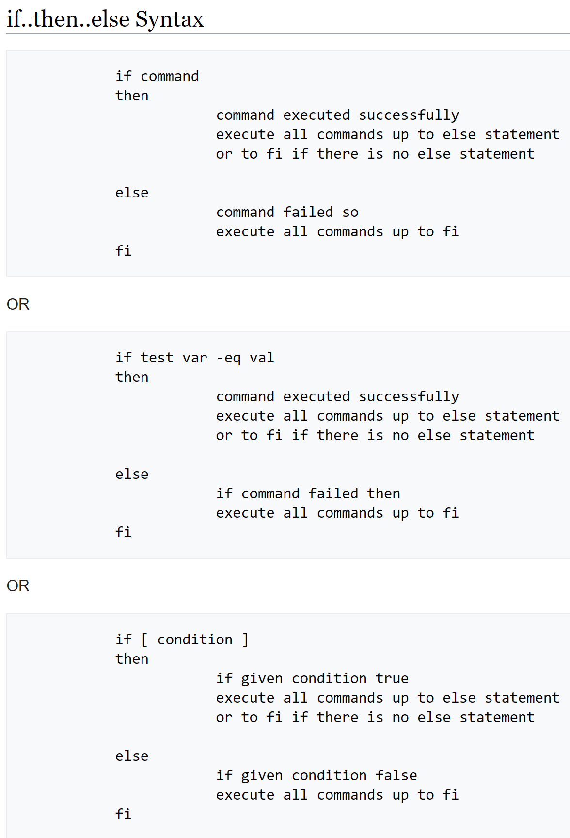

Powershell

<https://www.itprotoday.com/powershell/powershell-why-youll-never-go-back-cmdexe-batch-files>

To create a PowerShell script, you simply create a text file, with a .ps1 extension, that contains the commands you want to execute. The commands in the script can be PowerShell cmdlets, batch files, PowerShell aliases, PowerShell functions, or anything else that you could type at a PowerShell prompt as a command to execute.

Consider the batch file (Sample1.cmd) and PowerShell script (Sample1.ps1) shown in Figure 1. These two scripts are functionally identical and will produce the exact same output. Note that the batch file uses replaceable parameters (%1 and %2) to mean “the first two parameters on the script’s command line.” Rather than replaceable parameters, PowerShell uses the Param statement to define its parameters. (The line breaks after the opening parenthesis of the Param statement and before its closing parenthesis are optional; I included them to improve readability.)

Run

Navigate to the directory where the script lives

PS> cd C:\my_path\yada_yada\ (enter)

Execute the script:

PS> .\run_import_script.ps1 (enter)

Script Running Policy – Admin Access

As an Administrator, you can set the execution policy by typing this into your PowerShell window:

Set-ExecutionPolicy RemoteSigned

For more information, see Using the Set-ExecutionPolicy Cmdlet.

When you are done, you can set the policy back to its default value with:

Set-ExecutionPolicy Restricted

Or:

You can bypass this policy for a single file by adding -ExecutionPolicy Bypass when running PowerShell

powershell -ExecutionPolicy Bypass -File script.ps1

Controlling iTunes through Powershell

It's possible to partially use iTunes from Windows using Powershell - Here's how:

Config:

OS: Windows 10 - 64 bits

iTunes version: 12.7

Powershell version: 5.1

In Powershell:

# Inspired by

# - https://gist.github.com/rkumar/503162

# - http://samsoft.org.uk/iTunes/scripts.asp

# Search for iTunes COM object

Get-CimInstance Win32_COMSetting | Select-Object ProgId, Caption | Where-Object Caption -ILike "*itunes*"

# Initializing itunes

$itunes = New-Object -ComObject iTunes.Application

# list methods and properties

$itunes | Get-Member

$itunes.CurrentPlaylist | Get-Member

$itunes.LibraryPlaylist | Get-Member

$itunes.CurrentTrack | Get-Member

# commands

$itunes.Play()

$itunes.NextTrack()

$itunes.PreviousTrack()

$itunes.PlayPause()

$itunes.Resume()

$itunes.Stop()

# changing properties

$itunes.SoundVolume = 50 # sound volume to 50%

$itunes.Mute = 0 # mute

$itunes.Mute = 1 # unmute

$itunes.CurrentPlaylist.Shuffle = 0 # shuffle off

$itunes.CurrentPlaylist.Shuffle = 1 # shuffle on

$itunes.CurrentPlaylist.SongRepeat = 0 # repeat none

$itunes.CurrentPlaylist.SongRepeat = 1 # repeat one

$itunes.CurrentPlaylist.SongRepeat = 2 # repeat all

$itunes.CurrentTrack.Rating = 80 # 100 = 5 stars, 80 = 4 stars, 60 = 3 stars, 40 = 2 stars, 20 = 1 star

VBscript & VBA

If » Else

<https://corporatefinanceinstitute.com/resources/excel/study/vba-if-else/>

Specific Tasks

Activate/Focus an App

<https://www.vbsedit.com/html/2b9476ce-54a7-4a00-b761-25bf9f36e83f.asp>

Key Codes

Also, here's a [list of key-codes](http://www.nncron.ru/help/EN/add_info/keys_mnemonics.htm) that you can use.

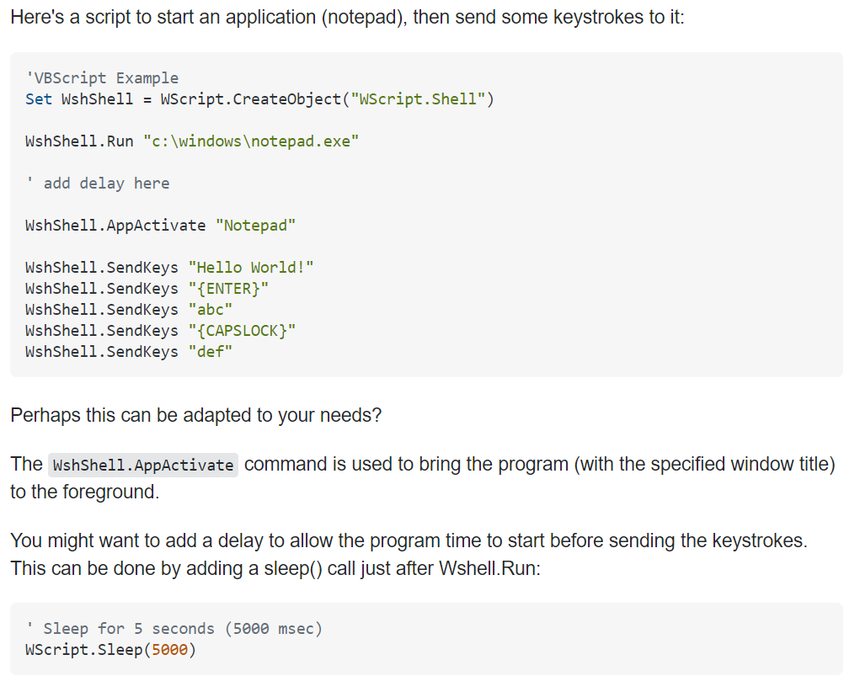

Java

Define Functions » Call in main(String []args)

public class Main{

**// If >> Elif >> No Else Statement**

public static void method1() {

int i = 5;

if (i < 5) {

System.out.println("XD!");

} else if (i == 5) {

System.out.println("bears");

}

}

**// If >> No Else Statement**

public static void method2() {

int n = 5;

if (n == 5) {

System.out.println("beats");

}

}

**// testcase**

public static void method3() {

System.out.println("battlestar galactica");

}

**// gooooo!**

public static void main(String []args){

method1();

method2();

method3();

}

}

Strings

<https://www.w3schools.com/java/java_strings.asp>

Print

<https://www.geeksforgeeks.org/system-out-println-in-java/>

Variables

[Declaring Variables](https://runestone.academy/runestone/books/published/apcsareview/VariableBasics/declareVars.html)

If statements & Logical Operators

<https://www.w3schools.com/java/java_conditions.asp>

Methods

<https://www.w3schools.com/java/java_methods.asp>

<https://docs.oracle.com/javase/8/docs/api/java/util/function/Function.html>

Class Methods: <https://www.w3schools.com/java/java_class_methods.asp>

Parameters

<https://www.w3schools.com/java/java_methods_param.asp>

Python Modules

Random Number

Import random

Random.randint(start number, finish number)

Web Browser

Commands

webbrowser.open(url, new=0, autoraise=True)[¶](https://docs.python.org/3/library/webbrowser.html#webbrowser.open)

* If new is 0, the url is opened in the same browser window if possible. If new is 1, a new browser window is opened if possible. If new is 2, a new browser page (“tab”) is opened if possible.
* If autoraise is True, the window is raised if possible (note that under many window managers this will occur regardless of the setting of this variable)
* webbrowser.**open_new**(*url*)
  + *Open url in a new window of the default browser, if possible, otherwise, open url in the only browser window.*
* webbrowser.**open_new_tab**(*url*)
  + *Open url in a new page (“tab”) of the default browser, if possible, otherwise equivalent to*[*open_new()*](https://docs.python.org/3/library/webbrowser.html#webbrowser.open_new)*.*
* webbrowser.**get**(*using=None*)
  + *Return a controller object for the browser type using. If using is None, return a controller for a default browser appropriate to the caller’s environment.*
* webbrowser.**register**(*name*, *constructor*, *instance=None*, *\**, *preferred=False*)
  + Register the browser type *name*. Once a browser type is registered, the [get()](https://docs.python.org/3/library/webbrowser.html#webbrowser.get) function can return a controller for that browser type. If *instance* is not provided, or is None, *constructor* will be called without parameters to create an instance when needed. If *instance* is provided, *constructor* will never be called, and may be None.
  + Setting *preferred* to True makes this browser a preferred result for a [get()](https://docs.python.org/3/library/webbrowser.html#webbrowser.get) call with no argument. Otherwise, this entry point is only useful if you plan to either set the BROWSER variable or call [get()](https://docs.python.org/3/library/webbrowser.html#webbrowser.get) with a nonempty argument matching the name of a handler you declare.

Browser Controller Objects

Browser controllers provide these methods which parallel three of the module-level convenience functions:

controller.**open**(url, new=0, autoraise=True)

Display url using the browser handled by this controller. If new is 1, a new browser window is opened if possible. If new is 2, a new browser page (“tab”) is opened if possible.

controller.**open_new**(url)

Open url in a new window of the browser handled by this controller, if possible, otherwise, open url in the only browser window. Alias [open_new()](https://docs.python.org/3/library/webbrowser.html#webbrowser.open_new).

controller.**open_new_tab**(url)

Open url in a new page (“tab”) of the browser handled by this controller, if possible, otherwise equivalent to [open_new()](https://docs.python.org/3/library/webbrowser.html#webbrowser.open_new).

Useful Apps

ScreenKey

[Github](https://gitlab.com/screenkey/screenkey)

Kill

pkill -f screekey

Manual

screenkey -help

Settings

screenkey --show-settings

JavaScript

Commands/Tasks

Go to URL on Event

In HTML: onclick="location.href='pageurl.html';"

In JavaScript: window.location = url;

window.open(url);

in JQuery:

In jquery to send a user to a different URL you can do it like this:

$("a#thing_to_click").on('click', function(){

window.location = "http://www.google.com/";

});

this way will work too but the above is the newer more correct way to do it these days

$("a#thing_to_click").click(function(e){

e.preventDefault();

window.location = "http://www.google.com/";

});

Variables

Const:

Block Scope

Declaring a variable with const is similar to let when it comes to **Block Scope**.

The x declared in the block, in this example, is not the same as the x declared outside the block:

Logical Operations

Check if array includes

Check if an array includes "Mango":

var fruits = ["Banana", "Orange", "Apple", "Mango"];  
var n = fruits.includes("Mango");

Array functions

## **JavaScript**

[JS Array](https://www.w3schools.com/jsref/jsref_obj_array.asp)

[concat()](https://www.w3schools.com/jsref/jsref_concat_array.asp)[constructor](https://www.w3schools.com/jsref/jsref_constructor_array.asp)[copyWithin()](https://www.w3schools.com/jsref/jsref_copywithin.asp)[entries()](https://www.w3schools.com/jsref/jsref_entries.asp)[every()](https://www.w3schools.com/jsref/jsref_every.asp)[fill()](https://www.w3schools.com/jsref/jsref_fill.asp)[filter()](https://www.w3schools.com/jsref/jsref_filter.asp)[find()](https://www.w3schools.com/jsref/jsref_find.asp)[findIndex()](https://www.w3schools.com/jsref/jsref_findindex.asp)[forEach()](https://www.w3schools.com/jsref/jsref_foreach.asp)[from()](https://www.w3schools.com/jsref/jsref_from.asp)[includes()](https://www.w3schools.com/jsref/jsref_includes_array.asp)[indexOf()](https://www.w3schools.com/jsref/jsref_indexof_array.asp)[isArray()](https://www.w3schools.com/jsref/jsref_isarray.asp)[join()](https://www.w3schools.com/jsref/jsref_join.asp)[keys()](https://www.w3schools.com/jsref/jsref_keys.asp)[length](https://www.w3schools.com/jsref/jsref_length_array.asp)[lastIndexOf()](https://www.w3schools.com/jsref/jsref_lastindexof_array.asp)[map()](https://www.w3schools.com/jsref/jsref_map.asp)[pop()](https://www.w3schools.com/jsref/jsref_pop.asp)[prototype](https://www.w3schools.com/jsref/jsref_prototype_array.asp)[push()](https://www.w3schools.com/jsref/jsref_push.asp)[reduce()](https://www.w3schools.com/jsref/jsref_reduce.asp)[reduceRight()](https://www.w3schools.com/jsref/jsref_reduceright.asp)[reverse()](https://www.w3schools.com/jsref/jsref_reverse.asp)[shift()](https://www.w3schools.com/jsref/jsref_shift.asp)[slice()](https://www.w3schools.com/jsref/jsref_slice_array.asp)

[some()](https://www.w3schools.com/jsref/jsref_some.asp)[sort()](https://www.w3schools.com/jsref/jsref_sort.asp)[splice()](https://www.w3schools.com/jsref/jsref_splice.asp)[toString()](https://www.w3schools.com/jsref/jsref_tostring_array.asp)[unshift()](https://www.w3schools.com/jsref/jsref_unshift.asp)[valueOf()](https://www.w3schools.com/jsref/jsref_valueof_array.asp)

JSQuery Sripts/Modules

JTerminal

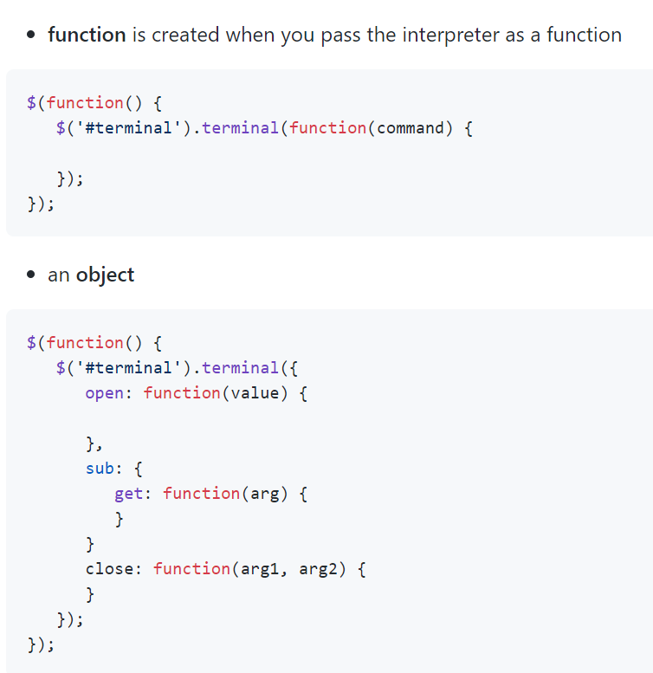Of course, you can use local files instead by downloading them directly, by installing with npm or bower or even by cloning the git repository.

When you select your jQuery object, you need to invoke terminal plugin:

$(function() {

$('#terminal').terminal();

});

If you want terminal to look like from OSX, Ubuntu or Winows 10 you can take a look at shell.js library, I've used its css with some tweaks to work with jQuery Terminal. See codepen demo

<https://github.com/davidecaruso/shell.js>

<https://codepen.io/jcubic/pen/WZvYGj>

HTML // CSS

**CSS**

**Get CSS style sheet (from inspecting on chrome, looking at template, clicking the href in other websites or templates or projects, etc.) » paste into Beautifier/Autoformatter tool (e.g.,** [**https://www.cleancss.com/css-beautify/**](https://www.cleancss.com/css-beautify/)**) » create your own style sheet and save into website director » change href in header to your local version**

[Resources](https://www.cssportal.com/css-resources.php)

[Tools](https://www.cssportal.com/css-tools.php)

[Geneators](https://www.cssportal.com/css-generators.php)

Guide to Display Attribute: <https://developer.mozilla.org/en-US/docs/Web/CSS/display>

### CSS display: contents

[- WD](https://drafts.csswg.org/css-display/)

display: contents causes an element's children to appear as if they were direct children of the element's parent, ignoring the element itself. This can be useful when a wrapper element should be ignored when using CSS grid or similar layout techniques.

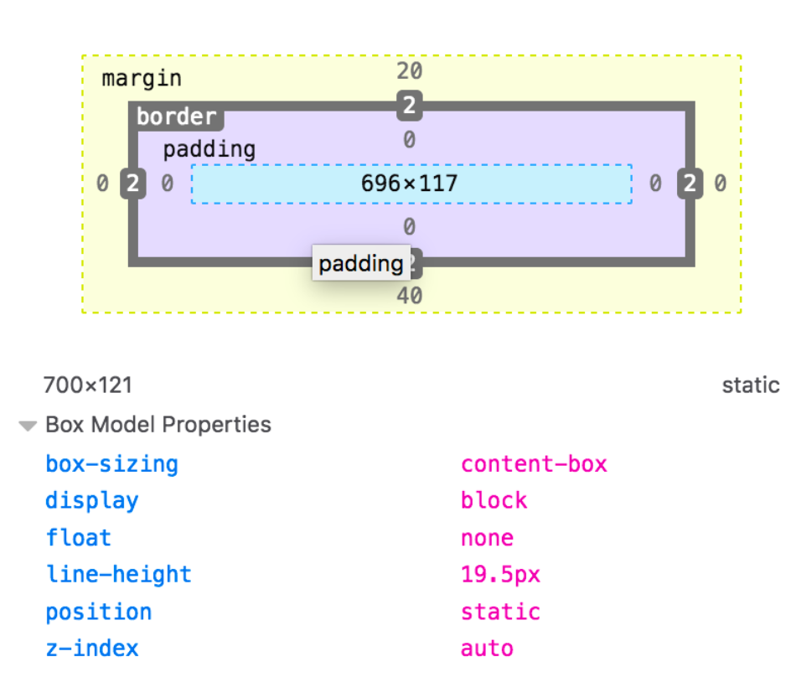

**HTML**

[Resrouces](https://www.cssportal.com/html-resources.php)

Sit in Middle of Screen

.formpop {

  display: none;

  z-index: 100; /* Sit on top when clicked*/

  background-image: url("../pictures/yes_sir.ico");

  background-color: #aaa;

  width: 50%;

  height: 50%;

  overflow: auto; /* Enable scroll if needed */

  -webkit-box-shadow: 10px black;

  box-shadow: 10px black;

  font-family: monospace;

  float: left;

  position: absolute;

  top: 50%;

  left: 50%;

  transform: translate(-50%, -50%);

  -webkit-box-shadow: calc(var(--char-width) * 2px) calc(var(--char-height) * 1px) black;

  box-shadow: calc(var(--char-width) * 2px) calc(var(--char-height) * 1px) black;

Background Images/Videos

Multiple images layered: <https://www.w3schools.com/css/css3_backgrounds.asp>

Video BG Using tm wrapper and icon

.tm-video-wrapper { position: relative; }

#tm-video-control-button {

    cursor: pointer;

    position: fixed;

    bottom: 30px;

    right: 30px;

    z-index: 1000;

    background-color: rgba(0,0,0,0.5);

    color: white;

    padding: 10px;

}

#tm-video {

    position: fixed;

    right: 0;

    bottom: 0;

    z-index: -1000;

}

<!—Font Awesome link for icon “fas fa-pause”-->

    <link rel="stylesheet" href="https://cdnjs.cloudflare.com/ajax/libs/font-awesome/4.7.0/css/font-awesome.min.css">

  <!-- Background video -->

  <div class="tm-video-wrapper">

      <i id="tm-video-control-button" class="fas fa-pause"></i>

      <video autoplay muted loop id="tm-video">

          <source src="video/tunnelzoom.mp4" type="video/mp4">

      </video>

  </div>

Templates

Good Sources

[tooplplate](https://www.tooplate.com/free-templates)

CSS Tricks

CSS Styles inline vs in <styles>

**Define inline when it should only apply to that specific container**

  <div class="row" style="margin-top: 30px;">

This allowed me to put a margin on the second row of videos in the 4x4 grid while maintaining the integrity of the double flex box grid system

**Define with class when it should be be applied as a rule**

Borders

Box sizing vs. Content Box: <https://developer.mozilla.org/en-US/docs/Web/CSS/box-sizing>

Backgrounds

**15 Awesome Animated Background Effects:**

https://1stwebdesigner.com/15-css-background-effects/

Flex Boxes

Good Guide with infographics explaining orientation keywords: <https://css-tricks.com/snippets/css/a-guide-to-flexbox/>

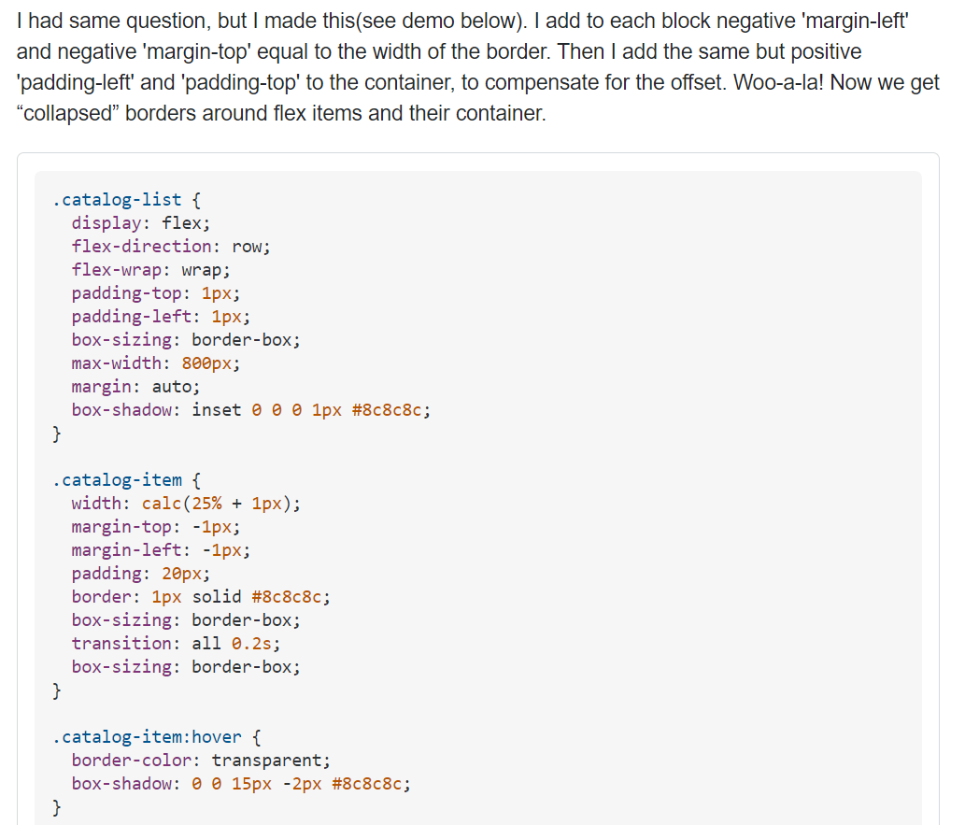

**Border on Flex Box Elements:**

body {

  background-color: transparent;

}

.row_items {

  border-color: pink;

  border-width: 4px;

  margin-top: -4px;

  margin-left: -4px;

  padding: 20px;

  box-sizing: border-box;

  transition: all 0.2s;

  width: calc(50% + 1px);

  background-color: black;

}

.row {

  display: flex;

  flex-direction: row;

  justify-content: space-around;

  padding-top: 4px;

  padding-left: 4px;

  box-sizing: border-box;

  margin: auto;

  box-shadow: inset 0 0 0 1px #8c8c8c;

  background: transparent;

  overflow: hidden;

}

.grid {

  display: flex;

  flex-direction: column;

  justify-content: space-around;

}

Features

Picture Grid that Opens In-Page Popup Sections

From: <https://www.w3schools.com/w3css/tryit.asp?filename=tryw3css_templates_parallax&stacked=h>

<link rel="stylesheet" href="https://www.w3schools.com/w3css/4/w3.css">

<link rel="stylesheet" href="https://fonts.googleapis.com/css?family=Lato">

<link rel="stylesheet" href="https://cdnjs.cloudflare.com/ajax/libs/font-awesome/4.7.0/css/font-awesome.min.css">

before style section^

<!-- Responsive Grid. Four columns on tablets, laptops and desktops. Will stack on mobile devices/small screens (100% width) -->

<div class="w3-row-padding w3-center">

<div class="w3-col m3">

<img src="/w3images/p1.jpg" style="width:100%" onclick="onClick(this)" class="w3-hover-opacity" alt="The mist over the mountains">

</div>

<div class="w3-col m3">

<img src="/w3images/p2.jpg" style="width:100%" onclick="onClick(this)" class="w3-hover-opacity" alt="Coffee beans">

</div>

<div class="w3-col m3">

<img src="/w3images/p3.jpg" style="width:100%" onclick="onClick(this)" class="w3-hover-opacity" alt="Bear closeup">

</div>

<div class="w3-col m3">

<img src="/w3images/p4.jpg" style="width:100%" onclick="onClick(this)" class="w3-hover-opacity" alt="Quiet ocean">

</div>

</div>

<div class="w3-row-padding w3-center w3-section">

<div class="w3-col m3">

<img src="/w3images/p5.jpg" style="width:100%" onclick="onClick(this)" class="w3-hover-opacity" alt="The mist">

</div>

<div class="w3-col m3">

<img src="/w3images/p6.jpg" style="width:100%" onclick="onClick(this)" class="w3-hover-opacity" alt="My beloved typewriter">

</div>

<div class="w3-col m3">

<img src="/w3images/p7.jpg" style="width:100%" onclick="onClick(this)" class="w3-hover-opacity" alt="Empty ghost train">

</div>

<div class="w3-col m3">

<img src="/w3images/p8.jpg" style="width:100%" onclick="onClick(this)" class="w3-hover-opacity" alt="Sailing">

</div>

<button class="w3-button w3-padding-large w3-light-grey" style="margin-top:64px">LOAD MORE</button>

</div>

</div>

<!-- Modal for full size images on click-->

<div id="modal01" class="w3-modal w3-black" onclick="this.style.display='none'">

<span class="w3-button w3-large w3-black w3-display-topright" title="Close Modal Image"><i class="fa fa-remove"></i></span>

<div class="w3-modal-content w3-animate-zoom w3-center w3-transparent w3-padding-64">

</div>

</div>

<script>

// Modal Image Gallery

function onClick(element) {

document.getElementById("img01").src = element.src;

document.getElementById("modal01").style.display = "block";

var captionText = document.getElementById("caption");

captionText.innerHTML = element.alt;

}

</script>

Pop-Out Modal Button

Styles

.modal {

display: none; /* Hidden by default */

position: fixed; /* Stay in place */

z-index: 1; /* Sit on top */

padding-top: 100px; /* Location of the box */

left: 0;

top: 0;

width: 100%; /* Full width */

height: 100%; /* Full height */

overflow: auto; /* Enable scroll if needed */

background-color: rgb(0,0,0); /* Fallback color */

background-color: rgba(0,0,0,0.4); /* Black w/ opacity */

Modals – General

<!-- Add this tag to make an element close the modal on click :

  onclick="this.style.display='none'" ;

  onclick="[Another element by Id].style.display='none'"    -->

<div id="playlistmodal" class="w3-modal w3-black">

  <span class="w3-button w3-large w3-black w3-display-topright" title="Close Modal Image"><i class="fa fa-remove"></i></span>

  <div class="w3-modal-content w3-animate-zoom w3-center w3-transparent w3-padding-64">

    <p> PLACEHOLDER </p>

  </div>

</div>

Dropdown Form that Pops Style

*Make it pop when a function is called*

.formpop {

  display: none;

  position:sticky;

  z-index: 1; /* Sit on top when clicked*/

  padding-top: 100px;

  background: transparent;

  background-image: url("../pictures/yes_sir.ico");

  background-repeat: no-repeat;

  background-position: center;

  left: 0;

  top: 0;

  width: 100%;

  height: 100%;

  overflow: auto; /* Enable scroll if needed */

  background-color: rgb(0,0,0);

  background-color: rgba(0,0,0,0.4);

  content: none;

Script Functions

**Script**

**Expand on below code to do various things**

**// Display Modal by Clicking Something that is Visible on Load**

<!— IN HTML 🡪

<div class="formpop" id="info_modal" onclick="cnClick()">

<!— IN SCRIPT 🡪

function onClick(element) {

  document.getElementById("playlistmodal").style.display = "block";

}

*Reverse this function in order to make modal disappear when it is clicked*

// Get the modal

var modal = document.getElementById("myModal");

// Get the button that opens the modal

var btn = document.getElementById("myBtn");

// Get the <span> element that closes the modal

var span = document.getElementsByClassName("close")[0];

// When the user clicks the button, open the modal

btn.onclick = function() {

modal.style.display = "block";

}

// When the user clicks on <span> (x), close the modal

span.onclick = function() {

modal.style.display = "none";

}

// When the user clicks anywhere outside of the modal, close it

window.onclick = function(event) {

if (event.target == modal) {

modal.style.display = "none";

}

}

**Add Animation**

.popout {

  display: none;

  position: fixed;

  z-index: 1; /* Sit on top when clicked*/

  padding-top: 100px;

  background: transparent;

  background-image: url("../pictures/yes_sir.ico");

  background-repeat: no-repeat;

  background-position: center;

  left: 0;

  top: 0;

  width: 100%;

  height: 100%;

  overflow: auto; /* Enable scroll if needed */

  background-color: rgb(0,0,0);

  background-color: rgba(0,0,0,0.4);

  }

/* Popout Content */

.popout_content {

  position: absolute;

  color:lavenderblush;

  left: 35%;

  right: 40%;

  text-align: center;

  top: 63%;

  bottom: 20%;

  margin: auto;

  box-shadow: 0 4px 8px 0 rgba(0,0,0,0.2),0 6px 20px 0 rgba(0,0,0,0.19);

  -webkit-animation-name: animatetop;

  -webkit-animation-duration: 0.4s;

  animation-name: animatetop;

  animation-duration: 0.4s

}

/* Add Animation */

@-webkit-keyframes animatetop {

  from {top:-300px; opacity:0}

  to {top:0; opacity:1}

}

@keyframes animatetop {

  from {top:-300px; opacity:0}

  to {top:0; opacity:1}

}

Images

Transparency

You need to save it using an image format that supports the type of transparency that you want. The JPEG format doesn't support transparency at all.

There are two types of transparency, transparency index and alpha channel. The GIF and PNG-8 formats support transparency index, i.e. one of the 256 colors are chosen to represent transparency. That means that each pixel in the image can only be either 100% transparent or 100% solid.

The PNG-24 format support alpha channel. That is transparency value for each pixel, so that it can be anything from 100% transparent to 100% solid (in 256 levels).

If your image has mostly fully transparent or fully solid pixels, you can use transparency index, but if it has a lot of partly transparent pixels, you have to use alpha channel.

Note that older versions of IE has problems displaying the transparency in PNG-24 images correctly.

Icons

<https://fontawesome.com/v4.7.0/icons/>

Multiple Classes and Class Nesting

<https://css-tricks.com/multiple-class-id-selectors/>

Forms

Templates

Template 1 – Bymyself Downloaders Form

<!DOCTYPE html>

<title> FORM TEMPLATE </title>

<style>

/* Search Form */

.tm-search-form .form-control {

  font-size: 0.8rem;

  padding: 0.75rem 0.75rem 0.75rem 45px;

}

/* Padding */

.tm-section-pad { padding: 30px 50px; }

.tm-section-pad-2 { padding: 30px 40px; }

/* Row */

.tm-search-form-row { width: 98%; max-width: 900px; }

.tm-form-element { position: relative; }

.tm-form-element:last-child { margin-right: 0; }

/* Form Icons */

.tm-form-element-icon {

  color: #ee5057;

  position: absolute;

  top: 10px;

  left: 15px;

}

.tm-form-element-icon-small {

  top: 16px;

  left: 18px;

}

/* Form Control */

.form-control {

  border-radius: 0;

  padding: 0.6rem 0.75rem;

}

.form-control:focus {

  border-color: #ee5057;

  box-shadow: 0 0 0 0.2rem rgba(238,80,87,.25);

}

select.tm-select.form-control:not([size]):not([multiple]) { height: 100%; }

.tm-search-form .form-control {

  font-size: 0.8rem;

  padding: 0.75rem 0.75rem 0.75rem 45px;

}

/* Go Button */

.btn-primary {

  background-color: #ee5057;

  border-color: #ee5057;

  border-radius: 0;

  cursor: pointer;

  font-size: 0.7rem;

  font-weight: 600;

  padding: 13px 30px;

  text-transform: uppercase;

}

.btn-primary:hover,

.btn-primary:focus,

.btn-primary:active {

  background-color: #d53239;

  border-color: #d53239;

}

.tm-btn-search { width: 100%; }

/* Unused Button Variant */

.tm-btn-white-bordered {

  display: inline-block;

  padding: 10px 25px;

  border: 2px solid white;

  background: transparent;

  text-transform: uppercase;

}

.tm-btn-white-bordered:hover,

.tm-btn-white-bordered:focus {

  color: #ee5057;

  background: white;

}

/* Media Screens */

/* Media Screens */

/* Media Screens */

/* Media Screens */

/* Media Screens */

@media screen and (max-width: 767px) and (min-width: 524px) {

  .tm-search-form .tm-form-element-100 {

    width: 100%;

    max-width: none;

  }

  .tm-search-form .tm-form-element-50 { width: 50%; }

}

@media screen and (max-width: 524px) {

  .tm-section-pad-2 { padding: 20px 25px; }

  .tm-search-form .tm-form-element {

    width: 100%;

    max-width: 100%;

  }

  .tm-fx-col-xs { flex-direction: column; }

  .tm-section-pad { padding: 25px 15px; }

  #tm-section-1 { height: 600px; }

}

</style>

<head>

Load Scripts

<!-- load JS files -->

<script src="js/jquery-1.11.3.min.js"></script>             <!-- jQuery (https://jquery.com/download/) -->

<script src="js/datepicker.min.js"></script>                <!-- https://github.com/qodesmith/datepicker -->

</head>

<body>

The Form

<form action="index.html" method="get" class="tm-search-form tm-section-pad-2">

  <div class="form-row tm-search-form-row">

      <div class="form-group tm-form-element tm-form-element-100">

          <i class="fa fa-map-marker fa-2x tm-form-element-icon"></i>

          <input name="URL" type="text" class="form-control" id="input_URL" placeholder="Playlist link (URL should contain the word playlist)">

      </div>

      <div class="form-group tm-form-element tm-form-element-50">

          <i class="fa fa-calendar fa-2x tm-form-element-icon"></i>

          <input name="check-in" type="text" class="form-control" id="inputCheckIn" placeholder="Check In">

      </div>

      <div class="form-group tm-form-element tm-form-element-50">

          <i class="fa fa-calendar fa-2x tm-form-element-icon"></i>

          <input name="check-out" type="text" class="form-control" id="inputCheckOut" placeholder="Check Out">

      </div>

  </div>

  <div class="form-row tm-search-form-row">

      <div class="form-group tm-form-element tm-form-element-2">

          <select name="adult" class="form-control tm-select" id="adult">

              <option value="">Adult</option>

              <option value="1">1</option>

              <option value="2">2</option>

              <option value="3">3</option>

              <option value="4">4</option>

              <option value="5">5</option>

              <option value="6">6</option>

              <option value="7">7</option>

              <option value="8">8</option>

              <option value="9">9</option>

              <option value="10">10</option>

          </select>

          <i class="fa fa-2x fa-user tm-form-element-icon"></i>

      </div>

      <div class="form-group tm-form-element tm-form-element-2">

          <select name="children" class="form-control tm-select" id="children">

              <option value="">Children</option>

              <option value="0">0</option>

              <option value="1">1</option>

              <option value="2">2</option>

              <option value="3">3</option>

              <option value="4">4</option>

              <option value="5">5</option>

              <option value="6">6</option>

              <option value="7">7</option>

              <option value="8">8</option>

              <option value="9">9</option>

              <option value="10">10</option>

          </select>

          <i class="fa fa-user tm-form-element-icon tm-form-element-icon-small"></i>

      </div>

      <div class="form-group tm-form-element tm-form-element-2">

          <select name="room" class="form-control tm-select" id="room">

              <option value="">Room</option>

              <option value="1">1</option>

              <option value="2">2</option>

              <option value="3">3</option>

              <option value="4">4</option>

              <option value="5">5</option>

              <option value="6">6</option>

              <option value="7">7</option>

              <option value="8">8</option>

              <option value="9">9</option>

              <option value="10">10</option>

          </select>

          <i class="fa fa-2x fa-bed tm-form-element-icon"></i>

      </div>

      <div class="form-group tm-form-element tm-form-element-2">

          <button type="submit" class="btn btn-primary tm-btn-search">Go</button>

      </div>

      </div>

      <div class="form-row clearfix pl-2 pr-2 tm-fx-col-xs">

          <p class="tm-margin-b-0">Leave a section blank if you don't want to apply that filter.</p>

          <a href="#" class="ie-10-ml-auto ml-auto mt-1 tm-font-semibold tm-color-primary">Need Help?</a>

      </div>

</form>

</body>

<script>

  // Date Picker

    const pickerCheckIn = datepicker('#inputCheckIn');

    const pickerCheckOut = datepicker('#inputCheckOut');

CSS Tooltips:

**https://www.w3schools.com/css/css_tooltip.asp**

**Font Awesome Icons**

[**https://fontawesome.com/icons/video?style=solid**](https://fontawesome.com/icons/video?style=solid)

Bundling Across Files

[Browserify](http://browserify.org/)

[**https://www.npmjs.com/package/tinyify**](https://www.npmjs.com/package/tinyify) **--** a browserify plugin that runs various optimizations, so you don't have to install them all manually.

Microsoft.AspNet.Optimization package in ASP.NET

// App_Start\BundleConfig.cs  
public static void RegisterBundles(BundleCollection bundles)  
{  
 bundles.Add(new ScriptBundle("~/Scripts/scripts.js").Include(  
 "~/Scripts/lib/jquery-3.1.1.js",  
 "~/Scripts/lib/timepicker/jquery.timepicker.js",  
 "~/Scripts/lib/jquery.datetimepicker.js",  
 "~/Scripts/textExtensions.js",  
 "~/Scripts/numberExtensions.js",  
 "~/Scripts/app.js"));  
}<!-- And then you just render the bundle in _Layout.cshtml -->  
 @Scripts.Render(“~/Scripts/scripts.js”)  
</body>

You can do the same in ASP.NET 5 using an <environment> tag from Microsoft.AspNet.Mvc.TagHelpers.

<!-- _Layout.cshtml -->  
<environment names="Development">  
 <script src="~/Scripts/lib/jquery-3.1.1.js"></script>  
 <script src="~/Scripts/lib/timepicker/jquery.timepicker.js"></script>  
 <script src="~/Scripts/lib/jquery.datetimepicker.js"></script>  
 <script src="~/Scripts/textExtensions.js"></script>  
 <script src="~/Scripts/numberExtensions.js"></script>  
 <script src="~/Scripts/app.js"></script>  
</environment>  
<environment names="Staging,Production">  
 <script src="~/Scripts/scripts.js" asp-append-version="true"></script>  
</environment>

Webpack

**Beginniner Guide:** [**https://www.sitepoint.com/webpack-beginner-guide/**](https://www.sitepoint.com/webpack-beginner-guide/)

[**https://medium.com/better-programming/modern-approach-of-javascript-bundling-with-webpack-3b7b3e5f4e7**](https://medium.com/better-programming/modern-approach-of-javascript-bundling-with-webpack-3b7b3e5f4e7)

# vs. . Classes in CSS

signifies a **class** name while the hash ( # ) signifies an element with a specific id attribute. The **class** will apply to any element decorated with that particular **class**, while the # style will only apply to the element with that particular id.

HAML

**HAML to Html: https://haml2erb.org/**

SASS & SCSS

**SASS >> CSS Compiler:** [**http://beautifytools.com/sass-compiler.php**](http://beautifytools.com/sass-compiler.php)

**SCSS >> CSS Compiler:** [**https://www.cssportal.com/scss-to-css/**](https://www.cssportal.com/scss-to-css/)

**How to Use:** [**https://flaviocopes.com/vue-using-scss/**](https://flaviocopes.com/vue-using-scss/)

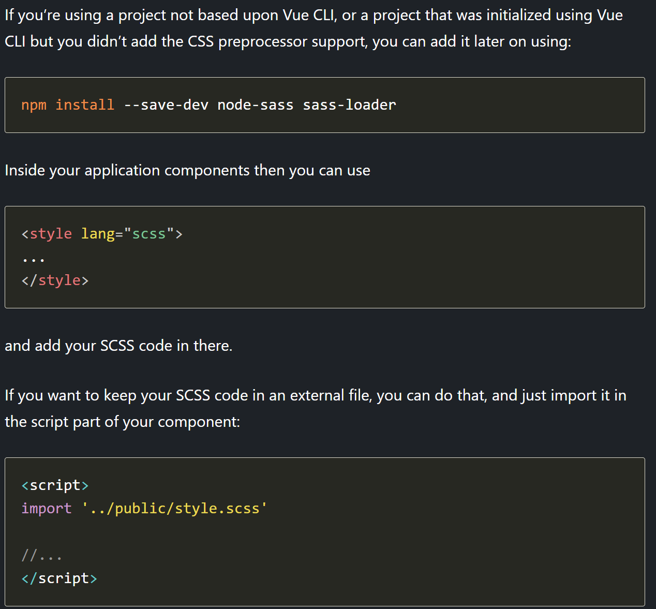

**https://sass-lang.com/guide**

**Preprocessing**

CSS on its own can be fun, but stylesheets are getting larger, more complex, and harder to maintain. This is where a preprocessor can help. Sass lets you use features that don't exist in CSS yet like variables, nesting, mixins, inheritance and other nifty goodies that make writing CSS fun again.

Once you start tinkering with Sass, it will take your preprocessed Sass file and save it as a normal CSS file that you can use in your website.

The most direct way to make this happen is in your terminal. Once Sass is installed, you can compile your Sass to CSS using the sass command. You'll need to tell Sass which file to build from, and where to output CSS to. For example, running sass input.scss output.css from your terminal would take a single Sass file, input.scss, and compile that file to output.css.

You can also watch individual files or directories with the --watch flag. The watch flag tells Sass to watch your source files for changes, and re-compile CSS each time you save your Sass. If you wanted to watch (instead of manually build) your input.scss file, you'd just add the watch flag to your command, like so:

sass --watch input.scss output.css

You can watch and output to directories by using folder paths as your input and output, and separating them with a colon. In this example:

sass --watch app/sass:public/stylesheets

Sass would watch all files in the app/sass folder for changes, and compile CSS to the public/stylesheets folder.

**Variables**

Think of variables as a way to store information that you want to reuse throughout your stylesheet. You can store things like colors, font stacks, or any CSS value you think you'll want to reuse. Sass uses the $ symbol to make something a variable. Here's an example:

* [SCSS](https://sass-lang.com/guide#example-1-scss)
* [Sass](https://sass-lang.com/guide#example-1-sass)
* [CSS](https://sass-lang.com/guide#example-1-css)

### SCSS SYNTAX

$font-stack: Helvetica**,** sans-serif;

$primary-color: #333;

body {

**font**: 100% $font-stack;

**color**: $primary-color;

}

### CSS OUTPUT

body {

**font**: 100% Helvetica, sans-serif;

**color**: #333;

}

When the Sass is processed, it takes the variables we define for the $font-stack and $primary-color and outputs normal CSS with our variable values placed in the CSS. This can be extremely powerful when working with brand colors and keeping them consistent throughout the site.

GUI Design

**Solarized Cheat Sheet**:

https://www.zovirl.com/2011/07/22/solarized_cheat_sheet/