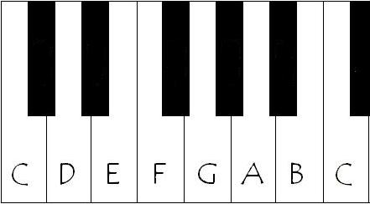

You have to understand that while in the diagram above the keys are labelled A B C D E F and G, these are not really the names of the keys.

Take the note C for example. The corresponding key can be called C but it can have other note names as well. That key can be called B sharp or even D double flat. In theory this key can have an infinite number of names. The key that corresponds to D can also be called C double sharp, E double flat or F triple flat.

When a key has more than one note names the different names are called enharmonic equivalents. For instance, F flat and E are enharmonic equivalents. G and F double sharp are enharmonic equivalents.

To put the naming of piano notes and keys into perspective we need to understand what are sharps and flats. A sharp simply means to move up one semitone or half step on your piano keyboard. A flat means to move one semitone or half step lower on your piano keyboard. So since E is one semitone lower than F, it can also be referred to as F flat. Since C is one semitone higher than B it can also be called B sharp. The name a note gets usually has to do with the choice of the composer. He may call a note a certain name to make it easier and more natural for the performer to read the music of a particular composition.

Here's another diagram with piano notes and keys.

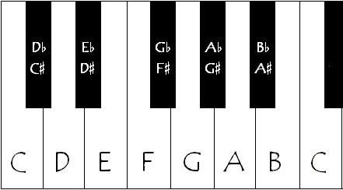

The black notes are also named here. Each black note has been given two names. These are the more common names, but as said earlier they can have a limitless number of names. The name given to a key would depend on the key of the song. For example, if in the key of E, a note would be called G sharp, but if in the key of E flat, it would be called A flat.

So we can clearly see that there's a difference between piano notes and keys. Each key on the piano keyboard can represent several notes. Strictly speaking, the keys do not have names. Keys are not really called A B C D E F or G. They just play these notes. They can play other notes as well.

**Labelling Piano Keyboard: An Introduction**

**Recommended Products**

I created this “**How to label notes on the piano keyboard**” article based on a reader’s question.

Karen writes:

My 10 year old daughter has a 54 key keyboard and is teaching herself to play it. She is already mastering the songs from Mary Poppins along with some current chart music using her own ear.

My problem is that she wants me to be able to label the keys for her with the letters and numbers, but I know nothing about this and from what I have found on the internet it just confuses me further. I have spent a long time reading stuff on the notes and octaves but got no further.

This guide will hopefully make it easy to create a system that not only works *now*but can be used as a stepping stone to *reading and writing standard musical notation*.

**Basic Keyboard Layout**

Before embarking on **labelling the notes of the keyboard**, it’s important to understand **how the keyboard is laid out** — its **structure**.

If you look at any keyboard you will see that it is made up of a repeating series of 12 keys. How many times that series repeats depends on how many keys the keyboard has overall.

Here’s one section of a keyboard, starting with the white key immediately to the left of the pair of black keys, and finishing with the white key immediately to the right of the group of three black keys.

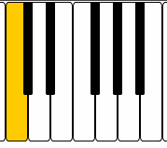

This set of 12 keys – seven white notes and five black notes – repeats across the whole keyboard. The pattern may well be cut off at the left and right ends of the keyboard, but this is the pattern of keys you’ll see repeated on any keyboard instrument.

**Basic Piano Keyboard Labelling Techniques**

The highlighted key in the diagram above is often called C (as in the third letter of the alphabet). It’s also known as “do” (from the do-re-mi scale that you’ve no doubt heard of from The Sound of Music).

The next white note to the right is labelled D (or “re”) followed by E (“mi”), F (“fa”), G (“sol”), A (“la”) and B (“ti”), before returning to C (“do”).

Only seven letters or sounds are used to describe the white notes on a keyboard, and they form a run of notes known as a **scale**.

The black notes are labelled in relation to the white notes they sit in between.

Each black key immediately to the right of a white note is said to be “**sharp**” and each black key immediately to the left of a white note is said to be “**flat**“.

You can probably see that, when using letters of the alphabet to name the notes, each black note can have *two names*.

To the immediate right of C is C sharp (C#), though it is also known as D flat (Db) because it’s also to the immediate left of D.

The complete run of notes in the diagram above — both black and white notes — is:

**C – C#/Db – D – D#/Eb – E – F – F#/Gb – G – G#/Ab – A – A#/Bb – B**

Twelve distinct notes.

If using the “do-re-mi” scale then each black note only has one name. The complete run of notes is:

do – di – re – ri – mi – fa – fi – sol – si – la – li – ti

But if this set of twelve notes repeats across the keyboard, how can you tell one “C” from another “C”, or an “A” from another “A”, or an “F#” from another “F#”?

This is where I’m going to recommend working only with the alphabetic names of notes. I personally find it easier, and shorter, to write down notes this way.

Firstly, it’s important to find out where “**Middle C**” is. On a full-sized piano, that’s generally the “C” closest to the middle of the instrument, but on a smaller keyboard with less notes this might not be the case.

To help you find it, play all the “C” notes on your keyboard until you find the one that sounds the closest to the following note:

[Middle C](http://pianoandsynth.com/wp-content/uploads/2009/05/middlec.mid) [MIDI file. Most modern PCs should play this automatically when you click on it]

It’s worth starting to learn what that particular C – Middle C – sounds like so that you can find it easily on any other keyboard or piano you might want to play.

[*Continued below...*](http://pianoandsynth.com/how-to-label-and-write-notes-on-the-piano-keyboard-a-basic-guide/#readmore)

We’re now going to introduce some numbers so that it’s possible to identify all the different notes on the keyboard.

“Middle C” will be known as “C4″. Why C4? Well, on a large piano it’s likely to be the fourth “C” counting up from the left hand side of the keyboard.

This is a fairly standard naming convention. It doesn’t matter if you don’t have that many notes on your keyboard.

This means that the first C to the left of “Middle C” will be “C3″, and the one to the left of that is “C2″, and the one to the left of that is “C1″. And so on (you’ll probably have run out of notes by now).

And, unsurprisingly, the first C to the right of “Middle C” will be “C5″, followed by “C6″, then “C7″.

Finally, all the other notes slot into place just as before, but with the correct number after them. Always ensure you have a complete run from A through to G using the same number before starting with a new number.

What about the black notes? Well, for now you can either call them “sharp” or “flat”, or if you really want to you can label them as both.

Here’s a **fully labelled piano keyboard diagram** that you can use to help you**label your keyboard**. Click on it to see the full sized version.

[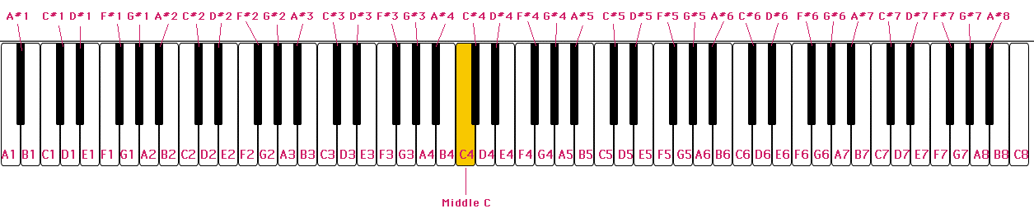](http://pianoandsynth.com/wp-content/uploads/2009/05/music-keyboard.gif)

Practically, it’s probably worth using lightly coloured sticky labels that you can write the name of each note on and then stick either directly on each key, or above it on the casing of the instrument.

**Writing Down Music Notes**

Now that you’ve labelled the keyboard, how do you go about writing down the notes that you’ve played so that you can go back in the future and play them again?

It could be as simple as writing down the letter and number combination for every note that you play, but this doesn’t take into account the *length* of each note, or if there are any gaps/pauses in the music (often known as “rests”).

If you play mainly “by ear” and are writing the notes down mainly to jog your memory, this might not matter.

The first two lines of “Twinkle Twinkle Little Star” might simply look like this:

C4 C4 G4 G4 A5 A5 G4 F4 F4 E4 E4 D4 D4 C4

And if you know the tune well, you’ll automatically play each note with the correct length.

If you are interested in recording the length of each note, you could put the names of each note into a grid. To do this, you’ll need to count each “beat” in the music. The beat is a steady rhythm.

For “Twinkle Twinkle Little Star” it’s easiest to count in groups of four. Here’s how the first two lines would look.

|  |  |  |  |  |  |  |  |  |  |  |  |  |  |  |  |
| --- | --- | --- | --- | --- | --- | --- | --- | --- | --- | --- | --- | --- | --- | --- | --- |
| 1 | 2 | 3 | 4 | 1 | 2 | 3 | 4 | 1 | 2 | 3 | 4 | 1 | 2 | 3 | 4 |
| C4 | C4 | G4 | G4 | A5 | A5 | G4 | — | F4 | F4 | E4 | E4 | D4 | D4 | C4 | — |

You’ll see that I’ve used a dash where a note needs to be held on for more than one beat.

If there are any sections of music where nothing should be played, you could simply write an “X” or a “/” to indicate that nothing should be played (not even a held on note).

You might find in more complicated music that sometimes there’s more than one note in a beat. Then you’ll have to squeeze more notes into each space on the grid.

For example, here’s the first two lines of “Castle on a Cloud” from Les Miserables:

|  |  |  |  |  |  |  |  |  |  |  |  |  |  |  |  |
| --- | --- | --- | --- | --- | --- | --- | --- | --- | --- | --- | --- | --- | --- | --- | --- |
| 1 | 2 | 3 | 4 | 1 | 2 | 3 | 4 | 1 | 2 | 3 | 4 | 1 | 2 | 3 | 4 |
| A4 | B4 C4 | B4 | A4 | A4 | G#3 | A4 | — | A4 | B4 C4 | B4 | A4 | G3 | F3 | E3 | — |

Do you get the idea?

That’s just one method for writing down music in a fairly simple way.

It would start to get more complicated if you wanted to write down music where more than one note is played at the same time.

You could create a taller grid and write down groups of notes, but you’d have to remember which fingers on each hand you’d used to play them.

If you want to [read other people’s music](http://pianoandsynth.com/how-to-read-music-basic-primer-piano-keyboard" \o "Link to tutorial on how to read standard printed music notation), you’ll probably find that it’s been written using standard modern musical symbols. It’s also very useful for writing down more complicated music.

That’s a bit much to handle in this article, but **check out our [how to read printed music primer](http://pianoandsynth.com/how-to-read-music-basic-primer-piano-keyboard" \o "Link to tutorial on how to read standard printed music notation) for a thorough introduction of the basics**.

I hope this guide helped you. If you have any questions do feel free to leave a comment below and I’ll help you out as much as I can.