Beginners Piano - The Basics

Introduction

To master the piano will take many years of practice but to get started and work up to anintermediate level can be a lot easier and quicker than many people imagine. Here aresome basic lessons to get you started followed by a complete chord sheet with the 24basic major and minor chords. Mastering these will enable you to play most popular songsby ear or by reading chord sheets.

The Notes

The ﬁrst thing to learn is where to ﬁnd the notes on the keyboard. A full sized pianokeyboard will have up to 88 black and white keys. This will vary according to your piano..some electronic keyboards have signiﬁcantly less. The keyboard is divided up into groupsof 12 notes which are repeated so you only have to learn these 12. Looking at thekeyboard you will see that the black notes are in groups of 2 and 3. To start you need tolocate C which is found just to the left of the pair of black notes. All of the other white notesare named sequentially from C to G and then back to A again. See the diagram below.

Beginners Piano -http://BeginnersPiano.net

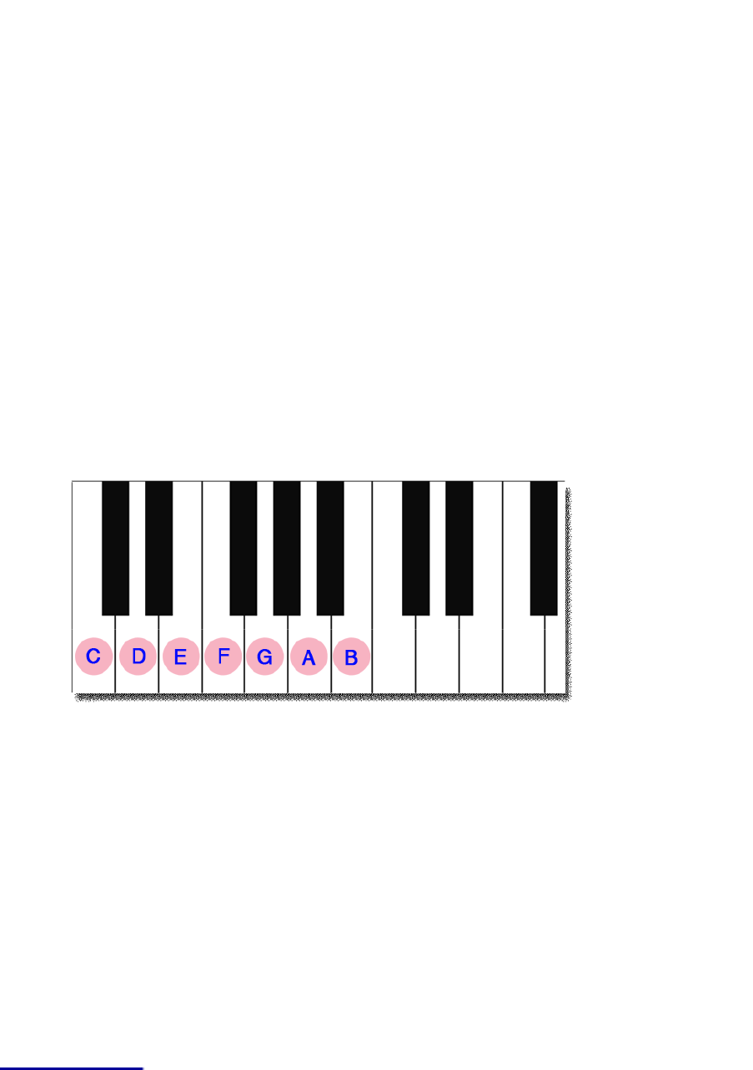



The black notes are the sharps and ﬂats, a sharp being a half a tone higher than its notename and a ﬂat being half a tone lower. Note that the black notes can be called by theirsharp name or their ﬂat name..

The Chords

The basic chords to learn are the simple major and minor chords. These are all listedbelow. They all consist of 3 notes which are played together. The notes are listed in theirmost basic form with the root note at the bottom followed by the third note of the scale andthen the ﬁfth. The notes can be played in any order really but in most cases it is best tomake sure that the root note is sounding in at the bottom ie played with the let hand.I have made a shot video to accompany this guide which explains in a little more detailhow to play the chords.http://www.youtube.com/watch?v=MKBT1MkrnY0This is just a taster lesson to get you started. If you wish to pursue piano or keyboardplaying more then you should consider one of the home study courses available onlineform immediate download. We have reviews and videos on the best ones available at ourwebsitehttp://beginnerspiano.net

Beginners Piano -http://BeginnersPiano.net

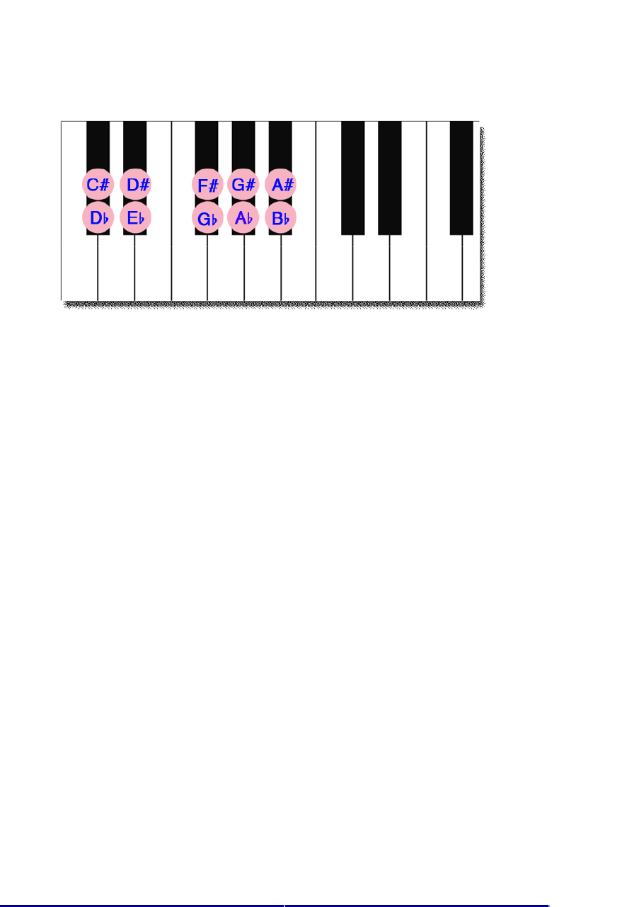



The Major Chords

Beginners Piano -http://BeginnersPiano.net

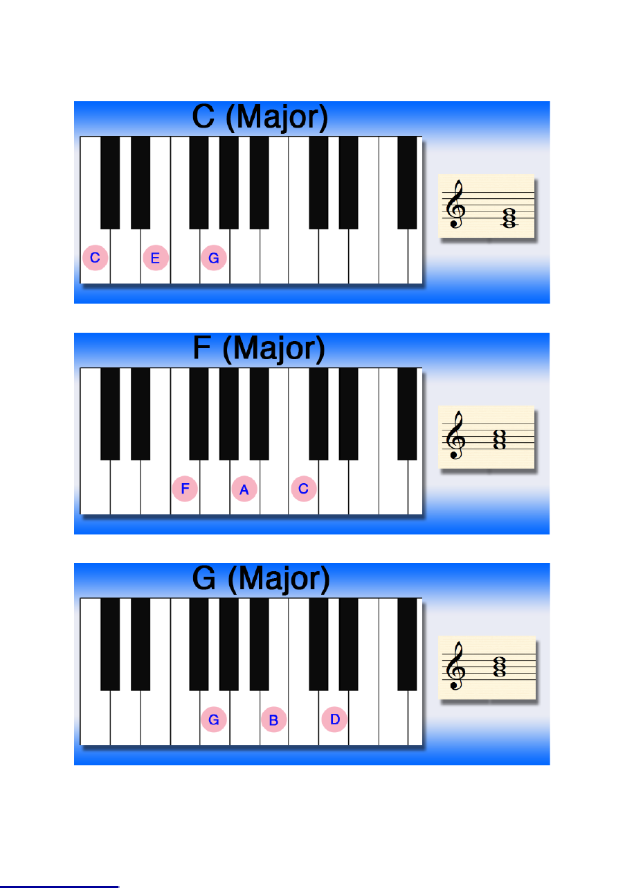



Beginners Piano -http://BeginnersPiano.net

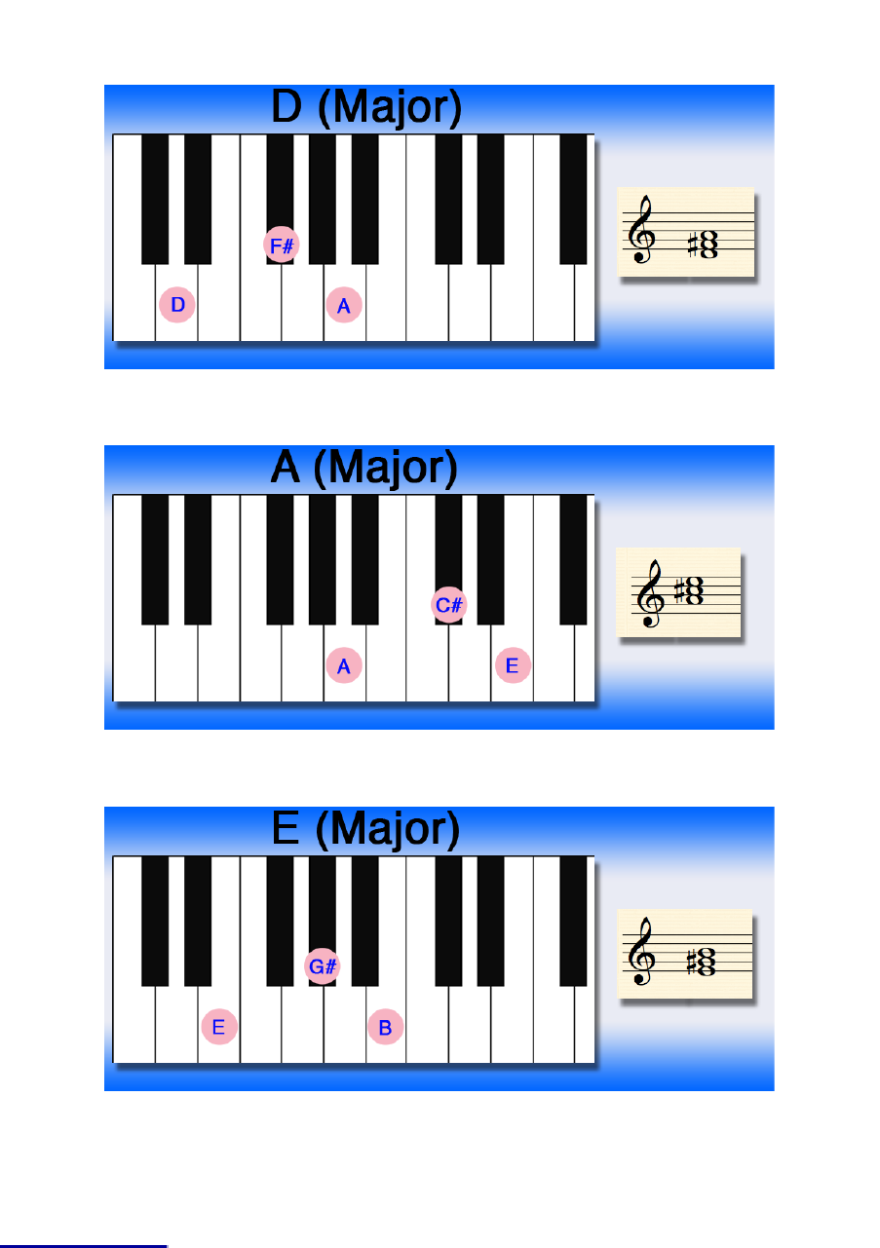



Beginners Piano -http://BeginnersPiano.net

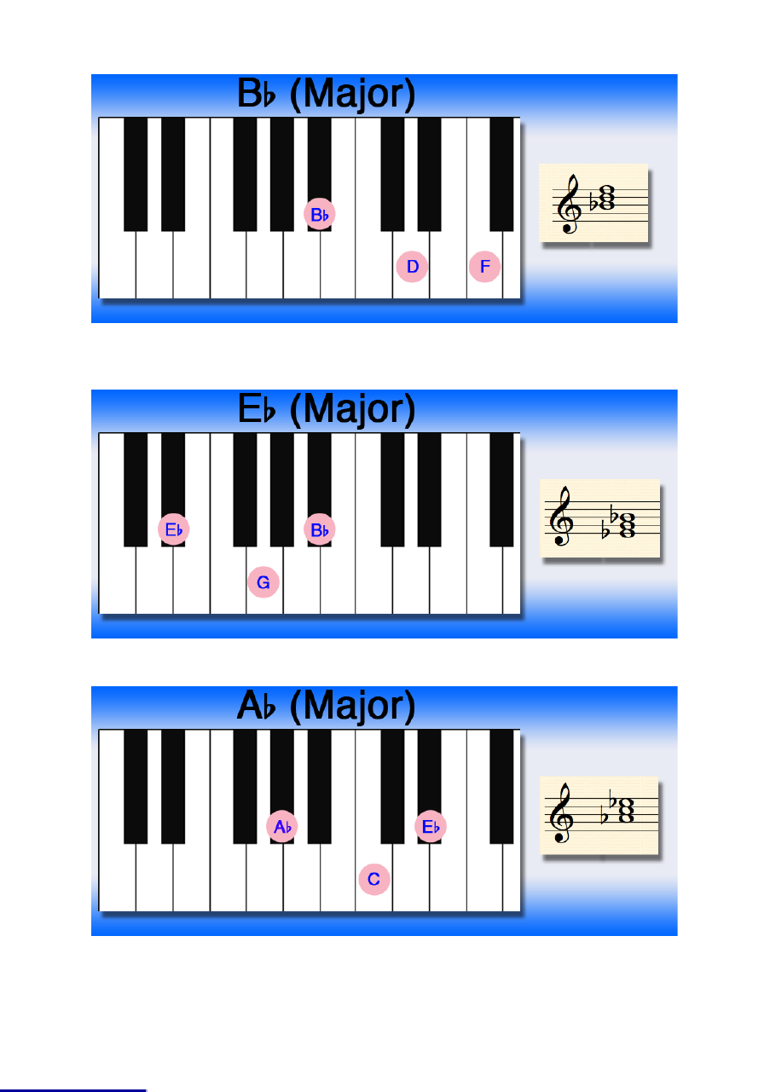



Beginners Piano -http://BeginnersPiano.net

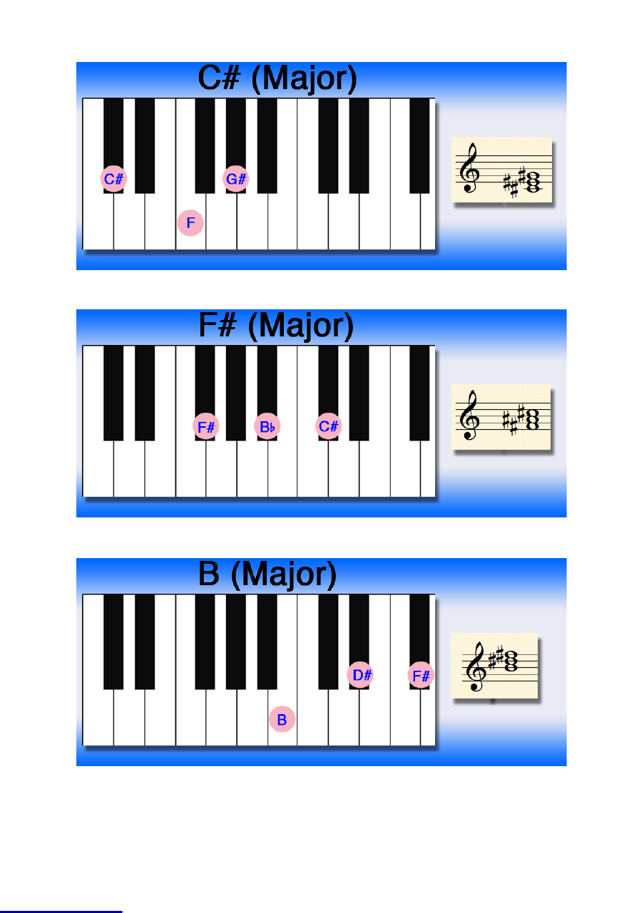



The Minor Chords

Beginners Piano -http://BeginnersPiano.net

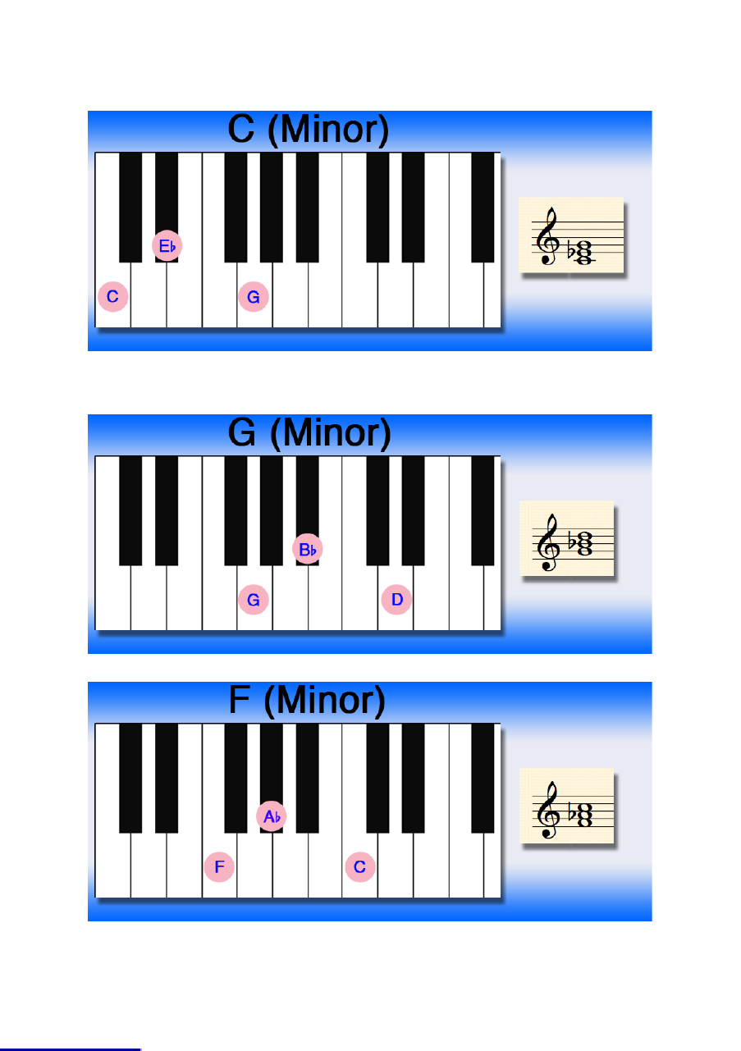



**Beginners Piano -http://BeginnersPiano.net**

Beginners Piano - The Basics

**Introduction**

To master the piano will take many years of practice but to get started and work up to an intermediate level can be a lot easier and quicker than many people imagine. Here are some basic lessons to get you started followed by a complete chord sheet with the 24basic major and minor chords. Mastering these will enable you to play most popular songs by ear or by reading chord sheets.

**The Notes**

The ﬁrst thing to learn is where to ﬁnd the notes on the keyboard. A full sized piano keyboard will have up to 88 black and white keys. This will vary according to your piano..some electronic keyboards have signiﬁcantly less. The keyboard is divided up into groups of 12 notes which are repeated so you only have to learn these 12. Looking at the keyboard you will see that the black notes are in groups of 2 and 3. To start you need to locate C which is found just to the left of the pair of black notes. All of the other white notes are named sequentially from C to G and then back to A again. See the diagram below.



The black notes are the sharps and ﬂats, a sharp being a half a tone higher than its notename and a ﬂat being half a tone lower. Note that the black notes can be called by theirsharp name or their ﬂat name..

**The Chords**

The basic chords to learn are the simple major and minor chords. These are all listedbelow. They all consist of 3 notes which are played together. The notes are listed in theirmost basic form with the root note at the bottom followed by the third note of the scale andthen the ﬁfth. The notes can be played in any order really but in most cases it is best tomake sure that the root note is sounding in at the bottom ie played with the let hand.

I have made a shot video to accompany this guide which explains in a little more detailhow to play the chords.http://www.youtube.com/watch?v=MKBT1MkrnY0

This is just a taster lesson to get you started. If you wish to pursue piano or keyboardplaying more then you should consider one of the home study courses available onlineform immediate download. We have reviews and videos on the best ones available at













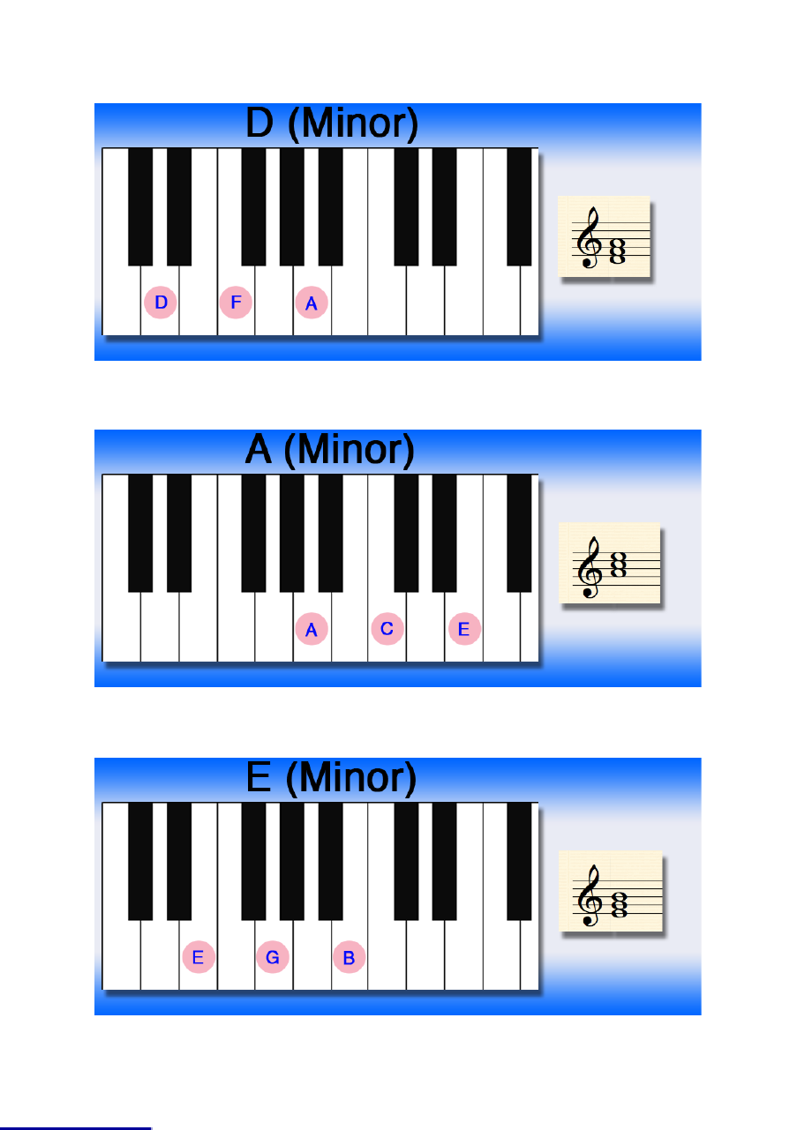



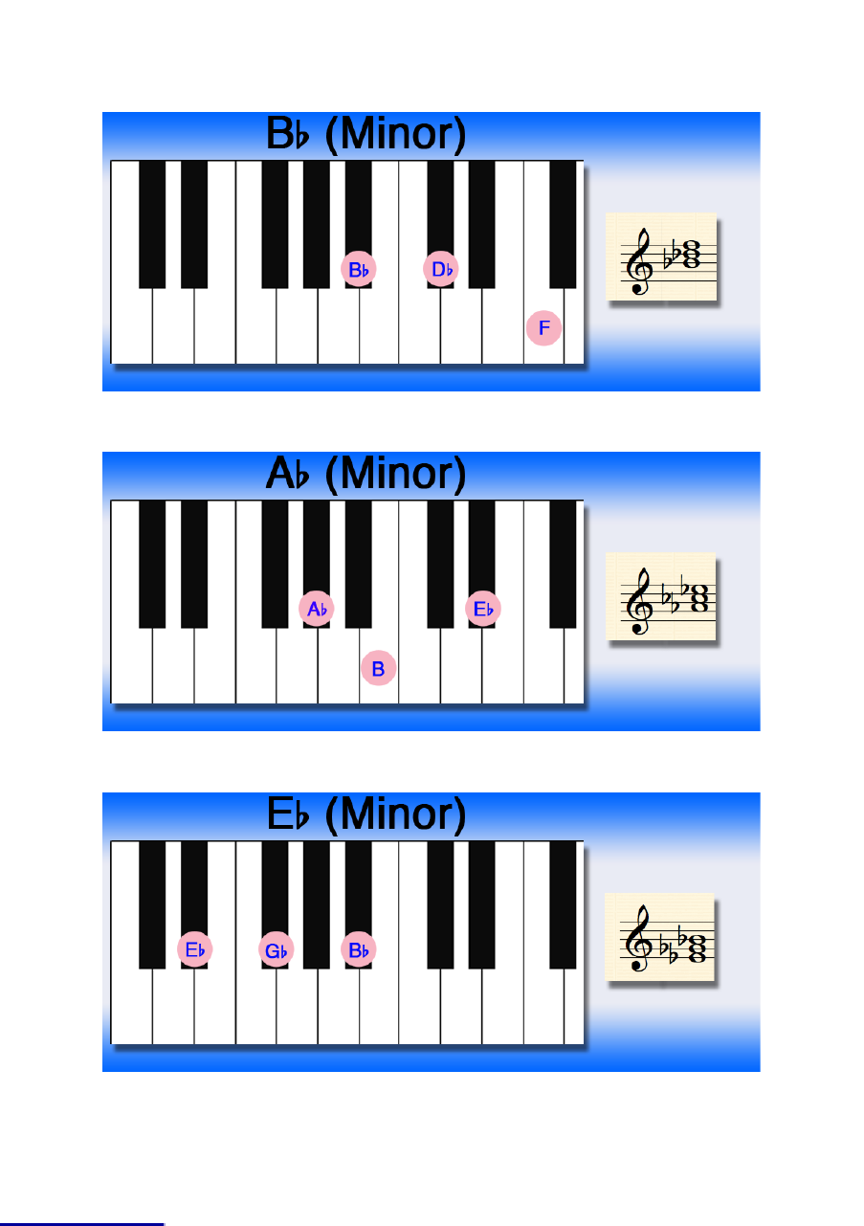



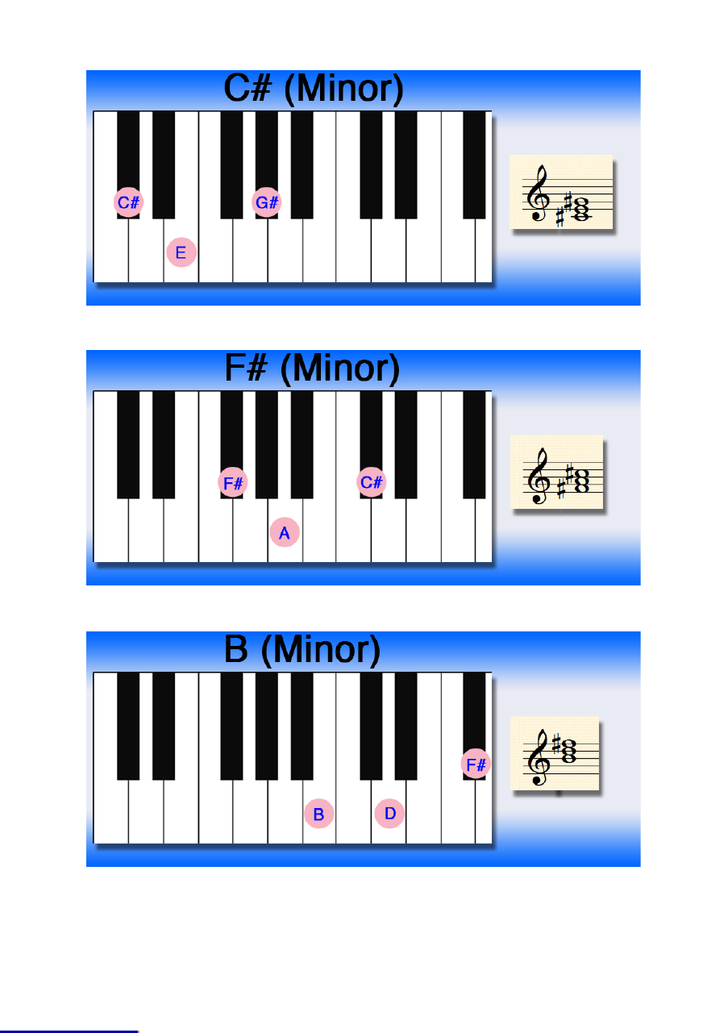

The Best Way To Learn Piano Fast

The ﬁrst thing to ﬁgure out when learning the piano is what sort of training will bebest for you. You basically have two options, the traditional piano teacher who of-fers one on one lesson or a home study course.For ages the only real way to learn piano has been to take one on one lessons witha qualiﬁed piano teacher. Today however you can choose from a selection of inter-active multimedia home study courses too.The biggest advantage of the home study courses is that you can go through themas fast or as slow as want. You have no lesson times set so you can move onwhenever you are ready or your own schedule permits. The home study coursesare also a lot cheaper. You can easily get a course for the price of one or two les-sons with a traditional piano teacher.There are many home study methods and courses available today for immediatedownload on the internet. These will have a series of ebooks as instruction manu-als. They can be viewed on your computer or even printed out if you need them.You will also get a selection of video and audio ﬁles with the exercises explained bya real person so you can see exactly how you should be playing them. Most of theonline courses go from beginner level up to quite advanced levels of playing andare suited for intermediate players as well as the non experienced.Which ever course you decide on you will be taught in a variety of different styleswhich will probably include blues, pop, jazz, rock, improvisation and classical. Youshould by the end be reading music with no problem and also be able to play by earor by using chord charts.A big disadvantage to learning at home without a teacher is that you have no onethere to correct your bad habits. The solution to this could be as simple as taking apiano lesson with a teacher once ever few weeks just to keep an eye on your tech-nique and to curb any bad habits before they go too far

<http://www.teach-me-piano.com/piano-notes-chart.html>