# Basic Musical Notation

Especially in the days before audio recording and playback, music was often written out as a means of preserving and communicating it. To do this, a system of notation was developed that gives musicians the information they need to play music as the composer intended it.

Here is a list of topics discussed on this page:

* **[The Staff](https://method-behind-the-music.com/theory/notation/" \l "staff)**
* **[Clefs](https://method-behind-the-music.com/theory/notation/" \l "clefs)**
* **[The Grand Staff](https://method-behind-the-music.com/theory/notation/" \l "grand)**
* **[Measures](https://method-behind-the-music.com/theory/notation/" \l "measures)**
* **[Notes](https://method-behind-the-music.com/theory/notation/" \l "notes)**
* **[Notes Written on the Staff](https://method-behind-the-music.com/theory/notation/" \l "noteonstaff)**
* **[Ledger Lines](https://method-behind-the-music.com/theory/notation/" \l "ledger)**
* **[Note Durations](https://method-behind-the-music.com/theory/notation/" \l "durations)**
* **[Dotted Notes](https://method-behind-the-music.com/theory/notation/" \l "dots)**
* **[Rests](https://method-behind-the-music.com/theory/notation/" \l "rests)**
* **[Accidentals](https://method-behind-the-music.com/theory/notation/" \l "accidentals)**
* **[Ties and Slurs](https://method-behind-the-music.com/theory/notation/" \l "tiesnslurs)**
* **[Articulation](https://method-behind-the-music.com/theory/notation/" \l "articulation)**
* **[Dynamics](https://method-behind-the-music.com/theory/notation/" \l "dynamics)**
* **[Repeats](https://method-behind-the-music.com/theory/notation/" \l "repeats)**
* **[Time Signatures](https://method-behind-the-music.com/theory/notation/" \l "timesigs)**

## The Staff

The staff is the basis of written music. It is what the notes are presented on. It consists of 5 lines with four spaces between them. A simple, unadorned staff is shown below.

IMG_256

## Clefs

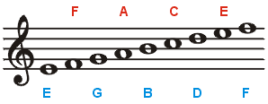

This is the treble staff. The treble clef (the large fancy symbol to the far left) shows the musician that the staff is treble. Since it curls around the G line, it is also called a G clef. The treble staff begins with the first line as E. Each successive space and line is the next letter in the musical alphabet. The staff ends with the last line as an F. Many mnemonic devices exist to help a person remember which line and space is which. One of the most common phrases to remember the names of the lines is: **E**very **G**ood **B**oy **D**oes **F**ine. (Also popular is **E**lvis' **G**uitar **B**roke **D**own **F**riday). To remember the spaces, just remember that they spell **FACE** starting from the bottom.

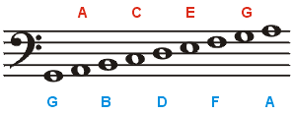

This is the bass (pronounced 'base' ) staff. The bass clef, also known as the F clef because it locates the line known as F, is on the far left. The bass clef uses the same musical alphabet as treble, but the letters start in different places. Instead of an E, the bottom line is a G, and the letters proceed logically from there. Again, simple mnemonics can be used to remember the names of the notes. The lines on the bass cleft, from bottom to top are: G, B, D, F, A (**G**ood **B**oys **D**on't **F**ight **A**nyone), and the spaces are A,C,E,G (**A**ll **C**ows **E**at **G**rass).

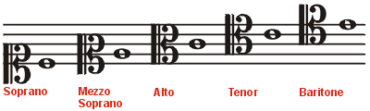

This is a C clef. The C clef can move on the staff, and the center of the symbol is always over middle C. Depending on where it is, it is given different names. The note beside each clef is middle C. These clefs are used very infrequently.

## The Grand Staff

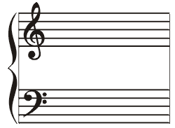

When the bass and treble clef are combined and connected by a brace (left) and lines, they become the grand staff. This greatly increases the range of pitches that can be noted, and is often used in piano music, due to the piano's wide range.

## Measures

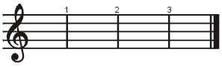

The vertical lines on the staff mark the measures. Measures are used to divide and organize music. The [time signature](https://method-behind-the-music.com/theory/notation/" \l "timesigs) determines how many beats can be in a measure. The thick double bars mark the beginning and ends of a piece of music. Measures are sometimes marked with numbers to make navigating a piece easier. The first measure would be measure one, the second measure two and so on.

## Notes

Different pitches are named by letters. The musical alphabet is, in ascending order by pitch, A, B, C, D, E, F and G. After G, the cycle repeats going back to A. Each line and space on the staff represents a different pitch. The lower on the staff, the lower the pitch of the note. Notes are represented by little ovals on the staff. Depending on the clef (discussed below), the position of each note on the staff corresponds to a letter name.

## Notes Written on the Staff

IMG_262

Notes are centered on the lines or in the spaces between the lines. Stems on notes above the middle line trail down from the left of the note. Stems on notes below the middle line stick up on the right of the note. Stems on notes on the line usually go down except when adjacent notes have flags that go up. Note stems are usually one octave (eight successive lines and spaces) long. When two melodies occupy the same staff, the stems for the notes in one melody are written up and the stems for notes in the other are written down.

## Ledger Lines

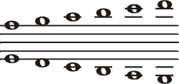

Ledger lines extend above and below the staff, allowing for higher or lower notes to be shown than would otherwise fit on the staff. These lines follow the same musical alphabet pattern as the staff does. Think of them as just extra lines and spaces on the end of the staff.

The stems of notes on ledger lines extend either up or down towards the middle line.

## Note Durations

All notes have length. However, the number of beats they get depends on the [time signature](https://method-behind-the-music.com/theory/notation/" \l "timesigs), so only relative note durations will be discussed here.

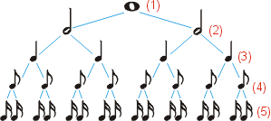

This graphic shows a heirarchy of note values.

At the top is a whole note (1). A half note is half the duration of a whole note, so a whole note is as long as two half notes (2). Likewise, a half note is as long as two quarter notes (3). A quarter note is as long as two eighth notes (4), and an eighth note is as long as two sixteenth notes (5).

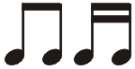

Sixteenth notes (right) and eighth notes (left) may also look like this. Single sixteenth and eighth notes have flags, many sixteenth and eighth notes combine flags into connecting bars.

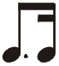

Sixteenth notes and eighth notes may also combine together. the combination looks like this picture to the left.

## Dotted Notes

IMG_267

A dot beside a note increases its duration by half its original value. For example, half notes, in 4/4 time, are worth 2 beats. When a dot is placed next to the half note, the duration is increased by one (one being half of the original duration of two) and the resulting duration is three beats. The curved line in the picture above is a **tie**. Ties connect notes that are the same pitch together to create a sustained note.

## Rests

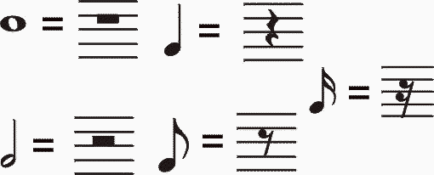

Rests are simply places where the musician does not play. Rests have equivalent values to corresponding notes of duration. Thus, there is a whole rest, half rest, quarter rest, etc., just like normal notes. Rests are always located in the same vertical position.

## Accidentals

Accidentals modify the pitch of a note by increasing or decreasing it by one half step. Accidentals stay in effect for all notes of the same pitch for the rest of the measure. When these same symbols appear at the very beginning of the music they are specifying a [key signature](https://method-behind-the-music.com/theory/scalesandkeys/).

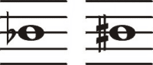

Flats (left side of the picture) lower the pitch of the note by one half step.

Sharps (right side of picture) raise the pitch of the note by one half step.

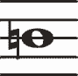

Naturals cancel out any previous sharps or flats. The pitch returns to normal.

## Ties and Slurs

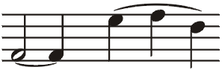

Ties and slurs connect two or more notes together. Ties connect notes of the same pitch, forming essentialy one longer note. Slurs smoothly connect notes of different pitch. This means to play the notes without breaks. The first set of notes above exhibit a tie. The second show a slur.

## Articulation

**IMG_272**

Staccato - Means to play the note very short and detatched.

IMG_273

Accent - Means to hit the note harder and louder.

IMG_274

Marcato - Almost a combination of staccato and accent, provides a sharp sound.

IMG_275

Tenuto - Hold the note for its full value.

IMG_276

Sforzando - A sudden, strong accent.

IMG_277

Fermata - Hold the note longer, approximately half again as long (1.5x), or until conducted to stop.

## Dynamics

IMG_278

This symbol is pianissimo, it means play very softly.

IMG_279

This symbol is piano, it means play softly.

IMG_280

This symbol is mezzo piano, it means play moderately soft.

IMG_281

This symbol is mezzo forte, it means play moderately loud.

IMG_282

This symbol is forte, it means play loudly.

IMG_283

This symbol is fortissimo, it means play very loudly.

IMG_284

Also abbreviated Cresc. or written in as crescendo. This sign is the crescendo sign, it means gradually become louder.

IMG_285

Also abbreviated as Decresc. or written as decrescendo, dim., or diminuendo. This sign is decrescendo, it means gradually become softer.

## Repeats

IMG_286

These are the begin and end repeat signs. When you reach the second, go back to the first and repeat the music. These are often accompanied by first, second and even third endings.

IMG_287

This is a directional marking. It means 'Del Signo'. When you see this in music, you must go to the sign (below). This marking may also be accompanied by 'al coda' or 'al fine'. These mean 'Go to the sign, from there go to the coda' and 'Go to the sign, from there go to the end' respectively. Essentially these are big repeat signs.

IMG_288

This is the sign. From here you play to the coda or the end or wherever the Dal Segno directs you.

IMG_289

This is the coda sign. It marks when to go to the special ending, or coda. Usually you won't go to the coda until after a D.S. al coda.

## Time Signatures

The time signatures (also called meter signatures) tell the musician how many beats per measure there are, and what kind of note gets the beat.

IMG_290

The top number determines how many beats there are per measure. The bottom number tells what kind of note gets the beat. In this example, 4/4 time, there are 4 beats per measure, and the quarter note (bottom 4) gets the beat. In 3/4 time, the quarter note would still get the beat, but there would only be 3 beats in a measure. In 6/8 time, the eigth note gets the beat, and there are 6 beats to a measure.

The **pulse** (or meter) is the driving beat in music that we march, feel, dance, clap and conduct to. First find the beat that seems the strongest, then try tapping along to it. Eventually you should be able to tap along with the music, and you will have found the pulse. Listen to the bass line and the rhythm section, as often they play with the pulse.

# **A Complete List of Music Symbols With Their Meaning**

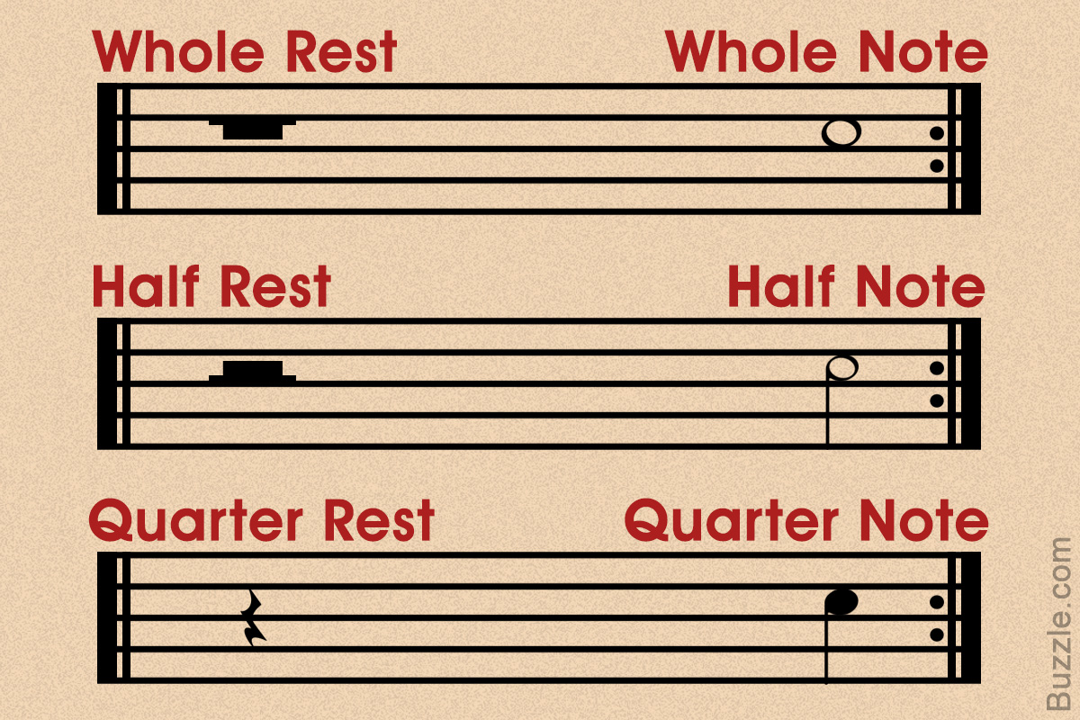

From articulation to rhythm, musical notes are written in symbols or easily distinguishable marks. Each of these musical notes has a pitch, duration, and intensity. Having knowledge about these marks is beneficial when it comes to reading and composing melodies. This Melodyful article will give you the meaning of music symbols employed in Western music.

 Melodyful Staff

 Last Updated: Mar 19, 2018

The mnemonics "Every Good Boy Does Fine" and "All Cows Eat Grass," helps kids memorize the notes on the lines of the treble clef and the spaces of the bass clef, respectively.

Sheet music, or music notation as it is known, employs a series of symbols and marks that pertain to certain notes, pitch, and tone. Music notations are visually represented symbols, which often include both modern and ancient musical symbols.

Modern music notation which is commonly used by musicians of different genres throughout the world is said to have their origins in European classical music. This popular system uses a five-line staff to place the musical notes. Sheet music is used as a record or a guide to perform or compose a piece of music.

To be able to read this sheet music, one has to study the musical notations, for which, one has to be acquainted with the symbols used to represent the notes. Given below is a list of the musical symbols employed to write sheet music.

**The Staff**

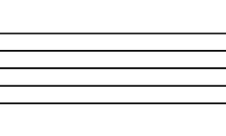

The staff  or stave forms the very basis of sheet music. Notes are written on a staff of five lines consisting of four spaces between them. The staff is counted from the lowest line upwards. The lines and the spaces correspond to pitches of a eight-note musical scale depending on the defining clef.

**Ledger or Leger lines**

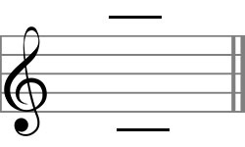

Ledger or leger lines extend the staff to pitches that fall below it. It is a short line added above or below the staff. Ledger lines are generally placed behind note heads and are spaced at the same distance as the lines of the staff. Range of notes that go beyond the two staffs are put on extra short lines or between the spaces formed between them.

**Bars and Measures**

Vertical lines called bars are used to connect the upper and lower staffs of the grand staff. The vertical bars are used to divide the staff into measures.

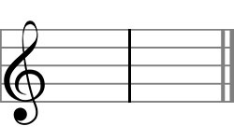

A single bar line is used to separate a measure. Each bar or measure refers to a segment of time that is defined by a given number of beats and note value. To make it easier to understand, the term bar  refers only to the vertical line, while the term measure  refers to the beats that are contained between two bars.

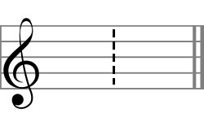

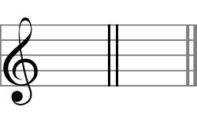

A double barline  is used to separate two sections of music. A double bar line is also used to signify changes in key signature, time signature or major change in style and tempo. A dotted bar is used to sub-divide long measures of a complex meter into shorter segments.

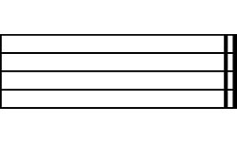

A bold double bar or the end line is used to indicate the end of a movement in a piece of music. It is used to signify the end of an entire composition.

**Brackets**

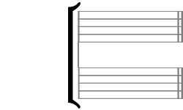

A bracket is generally used to indicate the connection between the staff of two or more separate instruments. To say the least, it is used to connect two or more lines of music that are to be played simultaneously by multiple instruments.

**Accolade**

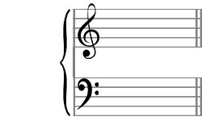

The brace on the other hand connects two or more lines of music played simultaneously by a single instrument. Also called an accolade, the brace connects multiple parts for a single instrument (the right and left-hand stave of a piano―for instance is connected using a brace).

**Clef**

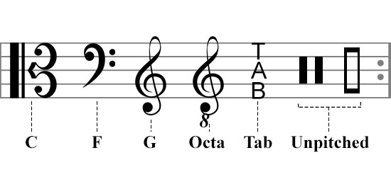

The stave, essentially, is mere lines; however, the presence of the clef marking the beginning of the stave is what assigns a certain pitch to the notes. The clef, in other words, helps to accurately relate to the pitch of the musical note placed on or between specific lines on the stave. In short, a clef is used to fix the position of certain high and low notes on the stave.

**G Clef or the Treble Clef**

Originally resembling the capital letter 'G', the treble clef fixes the second line as the note G on the stave. The treble clef denotes the high notes on the stave, and is commonly used for most modern vocal music.

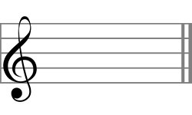

**F Clef or the Bass Clef**

The bass clef fixes the fourth line as the note 'F' on the bass stave. The two dots placed above and below the fourth line from the bottom of the staff is the pitch F. Specifically used in choral music, the bass clef represents the bass and baritone voices.

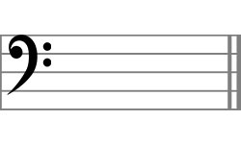

**C Clef or Alto and Tenor Clef**

The alto and tenor clef fixes the third line on the stave as the middle C. In modern notation, it is used for the viola, and is often used when composing music using the bassoon, cello, trombone, and double bass. It is a movable clef, and when it points to the fourth line, it is called a tenor clef.

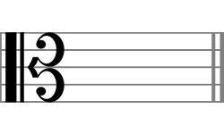

**Octave Clef**

The octave clef is nothing but a modified version of either the treble or the bass clef. The number 8 or 15 is affixed either to the top or bottom of the clef to raise or lower the intended pitch by one or two octaves, respectively. Generally, you will find a treble clef with an eight below in notes written for the guitar and the octave mandolin.

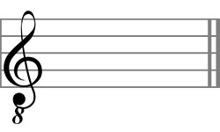

**Tablature**

Used specifically for stringed instruments, the tablature or Tab is often written instead of a clef. Like the neutral clef, the Tab clef is not a true clef, but a mere symbol used instead of a clef. Tablature generally involves writing notes on six lines when writing notes for a regular six-string guitar.

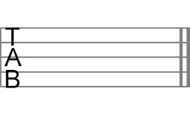

**Neutral Clef**

The neutral clef is used while composing musical notes for non-pitched percussion instruments like drums and cymbals. It is simply used as a convention to indicate that the lines and spaces on the stave are assigned to a percussion instrument with no precise pitch. Generally, it is not a compulsion for the neutral clef to be placed on a regular five-stave, it can be placed on a single stave or line.

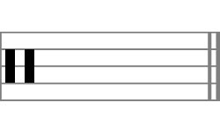

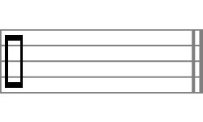

**Notes and Restsc**

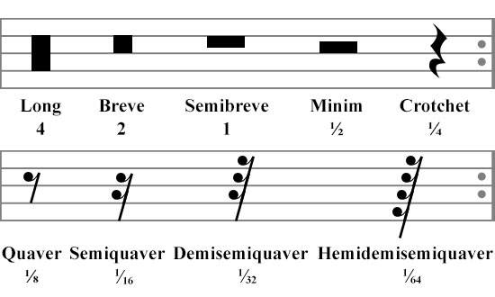

Notes represent the length of time of a particular pitch. Each note stands for a particular number of beats. In written music, the length of a note is shown by its shape. When there is no note sounding, a rest  is written, and the duration is shown by its shape. To make things easier, we have classified notes on the basis of their relation with the whole note or a semi breve.

**Whole Note or Semibreve**

A hollow oval note head represents a whole note or a semibreve. The length of a full note is equivalent to four beats in a 4/4 time. A whole note receives 4 counts, which means, you have to hold the note for its full value.  
  
A whole rest corresponds to a whole note, which means, the rest period is equivalent to the duration of the musical note. A whole rest is denoted by a filled-in rectangle hanging under the second line from the top of the staff.

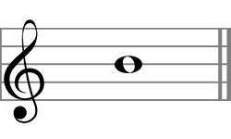

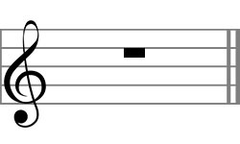

**Notes lesser than a whole note**

**Half Note or Minim**

A half note or minim is played for half the duration of a semibreve. In other words, a minim receives 2 counts, allowing the musician to hold the note for 2 counts instead of 4. The minim, like the semibreve, is a hollowed oval with a stem or tail attached. The stem or the tail of the minim can either be drawn upwards or downwards depending on the placement of the note on the stave. When a note falls below the middle line of the stave the stem is drawn upwards from the right side of the note, while the stems drops down from the left side when the note falls above the middle line of the stave.  
  
A half rest corresponds to a half note or a minim. A half note is represented by a filled-in rectangle sitting above the third or the middle line of the staff.

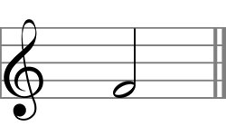

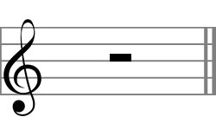

**Quarter Note or Crotchet**

A quarter note is half of a minim, and one-fourth of a full note. It is represented by a filled-in oval. Like the minim, a quarter note has a tail or a stem attached to the note head, which points upwards or downwards depending on how the note falls in a musical piece of work. The note head orientation for the minim and crotchet largely depends on the position of the stem.  
  
The crotchet rest corresponds to a quarter note. Like the quarter note, the crotchet rest receives one count or beat in a bar of 4/4, in a musical piece of work. It is represented like a filled-in squiggle.

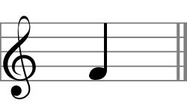

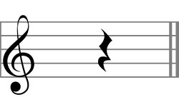

**Quaver or Eight Note**

A quaver note is played for one eighth the duration of a whole note or semibreve. It is represented with a filled-in oval with a stem accompanied with a flag. The flag is always positioned on the right side of the stem. However, a note placed above the middle line of the staff will have the flag pointing upwards and downwards if the note falls below the middle line ensuring the curve of the flag is towards the right. Multiple eight notes falling next to each other are connected with a beam instead of the regular flag.  
  
The quaver rest corresponds to the eight note, and is represented with a filled-in curlicue flag just like their note heads. The eight-note has a single curly flag that rests on the left side of a slanting stem.

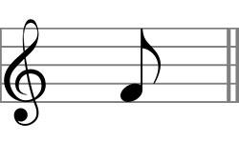

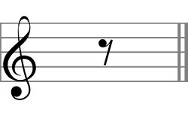

**Semiquaver or Sixteenth Note**

A sixteenth note, also known as a semiquaver is half of a quaver. It is played for one sixteenth the duration of a whole note. It is represented by a filled-in oval note head with a straight stem―like a quaver―with two flags. Multiple semiquaver notes falling one after the other are beamed with two horizontal lines.  
  
Like the quaver rest, the semi quaver rest is denoted with curly flags resting on a slanted stem. The number of curly flags is in proportion to the number of flags adorning the note head.

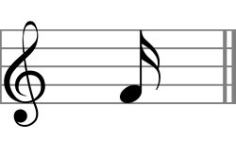

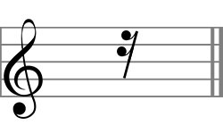

**Thirty-second Note**

A thirty-second note or a demisemiquaver is played for half the duration of a semiquaver. It is represented by a filled-in quarter note with three flags on the right side of the stem. Multiple demisemiquaver notes falling one after the other are beamed together with three equidistant horizontal bars.  
  
The demisemiquaver rest consists of a slanting line with three curlicue flags attached to the top of the stem.

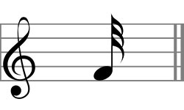

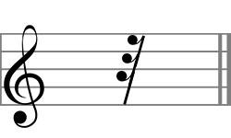

**Sixty-fourth Note**

A sixty-fourth note, also called a hemidemisemiquaver note, lasts for just about 1/64 of the duration of a semibreve. In other words, it is half of a demisemiquaver note and one eighth that of a quaver note. It is represented by a filled-in note head with four flags attached to a straight stem. Multiple notes are beamed together with four horizontal bars. It is important to note that music notes and rests as short as these are occasionally found.  
  
The hemidemisemiquaver rest has four curlicue flags attached to a slanting stem.

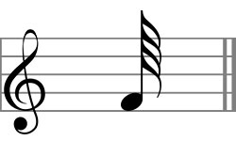

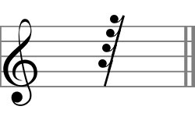

**Hundred twenty-eighth Note**

A semihemidemisemiquaver, or a hundred twenty-eighth note, is relatively unknown and lasts for 1/128 of the duration of a semibreve. Used to represent brief, rapid sections in extremely slow movements in a piece of music. Five flags adorn the stem of the basic quarter note, and multiple notes are beamed with five horizontal bars.  
  
Five curlicue flags attached to the slanting stem represents the semidemihemisemiquaver or quasihemidemisemiquaver rest.

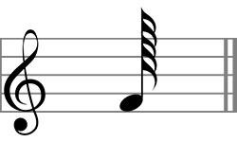

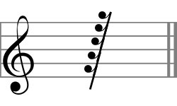

**Two Hundred fifty-sixth Note**

Played for 1/256 of the duration of a single whole note, the demisemihemidemisemiquaver or the two hundred fifty-sixth note is used very rarely in musical notations. It is represented in music notes with a filled-in note head with six flags attached to the main stem. It is also known as the semigarrapatea note, and it is used to denote rapid sections of music.  
  
The 256th rest is denoted by six curlicue flags adorning a slanting stem.

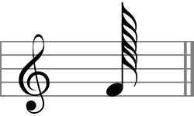

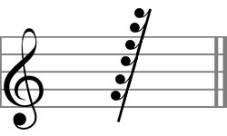

**Notes greater than a whole note**

**Double Whole Note**

Also known as a breve or a double note, it is twice as long as a semibreve. It is the longest note value that is still in use in modern music notation. Like the whole note, it is represented by a hollow oval with double stems on either sides.  
  
A double whole rest is represented by a filled-in rectangle that spans the vertical space between the second and third line from the top of the musical staff. Like the notes, the breve rest denotes a silence that is twice that of a semibreve rest.

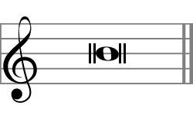

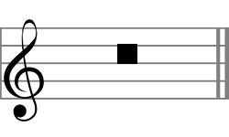

**Quadruple Whole Note**

Also known as a longa or a sextuple whole note, is four to six times as long as a double whole note. The modern form of the longa can alternatively be written as a semibreve with two stems on either side―one stem is longer than the other―like the longa note with the stem facing upwards.  
  
A longa rest associated with the note is represented by a vertical filled-in rectangle.

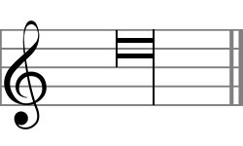

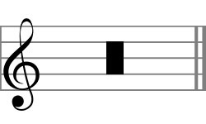

**Maxima or Octuple Whole Note**

Used specifically in early music, the maxima or the octuple longa is considered to be a rare musical note that is twice as long as the longa, or eight to twelve times as long as a semibreve. Incidentally, the duplex longa or maxima occurs only in instances of early music. It resembles a quadruple whole note, except that the horizontal bars are slightly longer than the longa notes.  
  
The maxima rest is symbolized by two longa rests, or the more modern alternative for it is a filled-in longa rests.

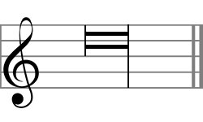

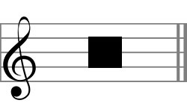

**Beamed Notes**

Beams or horizontal bars are used to connect multiple quaver notes together. The beams join the tails or stems of two or more quaver notes together to form a beat. The number of beams joining quaver notes corresponds to the number of flags adorning the single quaver note of shorter value. For example, two or more quaver notes will have a single bar or beam joining them, while a sixty-fourth quaver note with three flags will have three beams attaching the tails together.

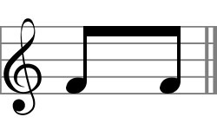

**Dotted Notes**

A dot is placed to the right of a note head to lengthen the duration of the beat of the particular note. For example, a single dot placed next to a minim or a quarter note increases the beat of the note to that of a minim plus a quaver note―equaling 3 beats instead of half. Additional dots are used to lengthen the previous dot instead of the note. So, if a half note has two dots, it is equivalent to a half note plus a quarter note, which is added to a quaver note. In short, half the value is added to the note head using a dot.

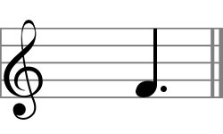

**Multi-measure Rest**

Also called a gathered rest or a multi-bar rest, it is a horizontal line placed on the middle stave with serifs on either side. It is used to simplify musical notation, and to indicate the number of measures in a resting part. It is used to denote rest of more than one bar in the same meter. The number printed above the stave corresponds to the length or duration of the rest of the particular note.

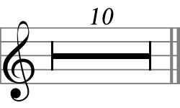

**Breaks**

**Breath Mark**

A breath mark or a luftpause is represented by a filled-in single inverted comma placed above the musical staff. For a singer or a performer playing a wind instrument, it translates as an instruction to pause for breath. For those playing non-wind instruments, it is an instruction to take a slight pause. For example, in the case of a bowed instrument, the breath mark is indication for the player to lift the bow and play the next note with either a downward or upward bow. The breath mark works just like a comma does in a sentence.

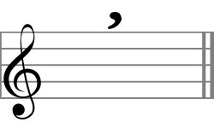

**Caesura**

Like a breath mark, the caesura indicates a brief pause or break in the piece of music. It is placed between notes or measures before or above the lines of a stave. It is represented with two slanting parallel lines often referred to as railroad tracks or tram lines. The break or interruption in music can be of any length, and the time often depends on the discretion of the conductor.

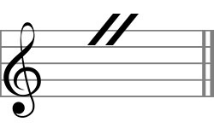

**Accidentals**

Accidentals are notes that are used in musical notations to symbolize notes that fall between two main notes. The accidentals either raise or lower the note it precedes by a semitone. In other words, the notes placed before the corresponding note heads help raise or lower the pitch by half a tone.

**Flat**

Also known as a soft B or a bemolle, the flat note lowers a natural note by half a step. In music notation, a flat note lowers the pitch of a note by a semitone and is denoted by a stylized lowercase 'b'. For example, a flat note placed before a natural B note makes it a B flat represented by B♭. The order of the flats in key signature notation are B♭, E♭, A♭, D♭, G♭, C♭, and F♭. An easier way to remember this is with the mnemonic: Before Eating A Doughnut Get Coffee First; or Battle Ends And Down Goes Charles' Father.

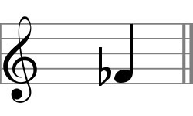

**Double Flat**

Double flats are, in reality, two flats that reduce the natural note by a whole step or by two semitones. It is represented by two flat notes placed next to each other. It can also be written as integrated stylized letter 'b' written in the lower case.

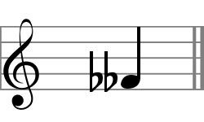

**Sharp**

Contrary to a flat note, a sharp note placed before a natural note raises the keynote by half a tone. A sharp note is represented with a hash sign (♯) placed before the natural note. In short, a sharp note raises the frequency of a natural note by a small musical interval. The order of sharps in a key signature notation are F♯, C♯, G ♯, D♯, A♯, E♯, and B♯, which can be remembered by the mnemonic Father Charles Goes Down And Ends Battle.

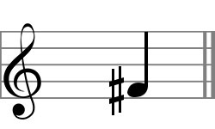

**Double Sharp**

Like flat notes, sharps also have a double sharp that raise the tone of a natural note by an entire semitone. It is represented by a horizontally placed cross. When placed before a semitone, the double sharp increases the value of the note by a whole step. For example, an F with double sharp would be equivalent to a G natural.

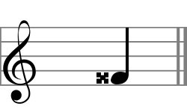

**Natural**

A natural sign (**♮**) is used in musical notation to cancel a preceding sharp, double sharp, flat, or double flat note employed to lower or raise the keynote in a musical piece. It is used to signify a natural note which is neither sharp nor flat. In the very sense, the natural sign is used to cancel out the previous notes and represents an unaltered pitch of a given note.

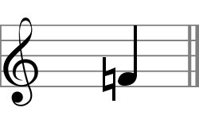

**Key Signatures**

In written music, key signatures stand for a set of sharp of flat symbols placed on the stave. Key signatures are written adjacent to a clef placed at the beginning of a line of musical notation. The key signature is used to define the diatonic scale in a piece of music without the need of accidentals being employed for individual notes.

**Flat Key Signatures**

A flat key signature lowers the pitch of a corresponding line of a defining major or minor key by a semitone. The number of flats in the key signature varies depending on the natural note being taken. For example, the number of flats on a C major key is 0, while that on the C minor key is 7.

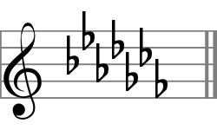

**Sharp Key Signatures**

A sharp key signature is used to raise the pitch of an entire line of a defining major or minor key by an entire semitone. Like the flat key signature, the number of sharps on the stave indicate the keynote being played in a piece of music. The number of sharps varies from 0 to 7 sharps from the C major to the C sharp (C♯) major key, respectively.

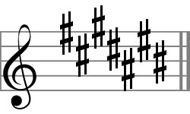

**Quarter Tones**

A quarter tone music divides an octave into twenty-four equal intervals, that is better understood as twenty-four equal steps or tones. Quarter tone notation employs a new set of accidental signs or marks that add a microtonal value alongside a conventional sharp, flat, or natural note.

**Demiflat**

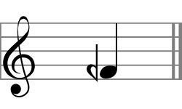

The demiflat note is known to lower the pitch of a note by an entire quarter of a tone. It resembles a reversed flat note and is placed before the notehead, like the accidentals in a piece of music notation.

**Demisharp**

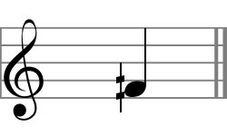

The opposite of a demiflat, the demisharp is used to raise the pitch of a note by a quarter tone. It is represented by a vertical line striking through two horizontal beams.

**Sesquiflat**

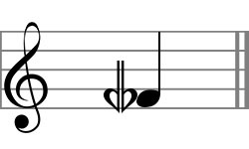

The sesquiflat, also known as a flat-and-a-half, lowers the pitch of a note by three quarters. It is written with a flat accidental and a demiflat sign placed next to each other. Musically understood, a note is lowered by a quarter note short of a lower natural note.

**Sesquisharp**

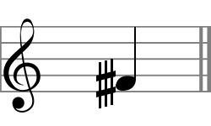

On the contrary, a sesquisharp is known to raise the pitch of a natural note by three quarters of a tone. It is represented either by two horizontal bars with three vertical lines or two vertical lines and three diagonal bars placed before the note head on a stave.

**Time Signatures**

Normal music has a regular pulse or throb which is termed as beats. These beats are grouped into regular groups to form the time or meter of the music. Time signatures are used to establish the number of beats in each uniformed section or measures.

**Simple Time**

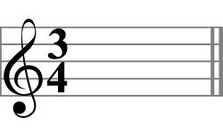

Basic or simple time signatures employ two numerals stacked on each other, which are placed immediately after the clef or the key signature. It is used to indicate the beats in each bar. The lower numeral indicates the note value representing one beat, while the upper numeral indicates the number of such beats in each bar. 2/4, 3/4, and 4/4 are some of the most common simple time signatures used in written music. The beat in a simple tune is divided into two sub divisions making it easier to understand.

**Compound Time**

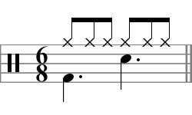

Even though compound time is written as two numerals stacked on each other, the number of pulse within each beat is split into three equal parts instead of two equal parts. Simply put, the top number is written in multiples of 3―6, 9, or 12―which signify the triple pulse of the beat, while the lover number is most commonly an eighth-note. It is commonly written as 6/8 (Duple Meter), 9/8 (Triple Meter), and 12/8 (Quadruple Meter), signifying the division of the beat in groups of three.

**Common Time**

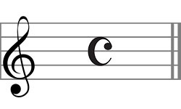

A stylized upper case 'C' is sometimes used to denote the 4/4 time instead of the numbers used in simple time signature. It represents common time or what is considered as imperfect time. It is symbolic of the broken circle used in music notation to represent a two by four time employed in the fourteenth century rhythmic notation.

**Cut Time**

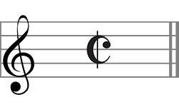

Cut common time or alla breve is denoted with a stylized letter 'C' with a line through it. It refers to a musical meter that is equivalent to 2/2, or a half note pulse. It is used to signify a fairly quick tempo and is a prominent part of military marches. It can also be read as diminished imperfect time, which is the half of a 4/4 time.

**Metronome Mark**

The metronome mark is a unit typically used to measure the tempo of a piece of music. As shown in the image, the metronome mark is indicative of the number of crotchet or quarter notes to be played per minute. In a compound time signature, the beat is made up of three note durations, which is when a dotted quarter note is used to indicate the beats per minute.

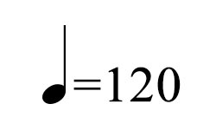

**Note Relationships**

In a musical composition, notes are often grouped together to show the position of the beats in a bar. For a piece of work to be called music, the notes need to be synchronized and must fall smoothly in place. This harmony is brought about by the introduction of different note relationships or marks used to determine the relationship of one note with the other.

**Tie**

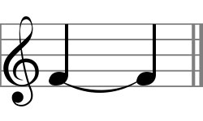

A tie is denoted by a curved line that connects two or more note heads falling on the same pitch. Any number of notes falling on the same pitch can be tied together with a curved line. Simply understood, the presence of the tie mark indicates the duration of the notes on the particular line or space on a stave is to be added together.

**Slur**

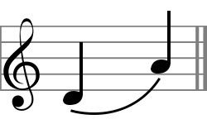

Not to be confused with a tie, a slur is a curved line that joins note heads of different pitches. A slur can extend over two or several notes at a time, stretching as far as several bars of music. This is done to indicate that the following notes have to be played smoothly and in one breath. It is employed to lay stress on a particular stretch of musical work.

**Glissando**

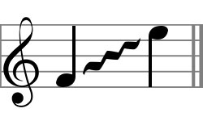

The glissando or portamento, as it is known, is used to indicate a continuous and unbroken glide from one note to another. Simply understood, the sign stands for a smooth glide from one pitch to another. When the glide is taken continuously, it is termed as a portamento.

**Tuplet**

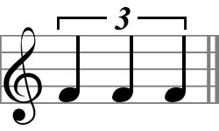

A tuplet is also known as an irrational rhythm that groups or divides the beat into different number of subdivisions. The most common tuplet is that of the triplet, wherein the notes are grouped with a bracket with the number written in between.

**Chord**

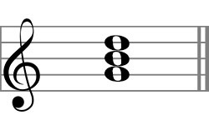

A harmonic set of three or more notes sounded simultaneously or in quick succession is known as a chord. The triad is the most frequently encountered chord which consists of three distinct notes played simultaneously.

**Arpeggiated Chord**

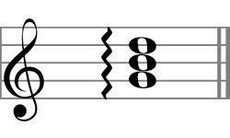

An arpeggiated chord, or an arpeggio, is a group of notes played one after the other in a sequence. It is also called a broken chord, owing to the fact that the notes are played in quick succession. This allows clear distinction of the notes being played.

**Accents**

Accents or articulations are used to specify how an individual note is to be performed within a musical passage. The articulation affects the transition or continuity on a single note or between multiple notes and sounds.

**Staccato**

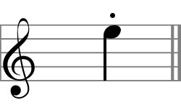

A staccato is denoted by a single dot placed above or below a note head. It is used to signify a note of shortened duration. The note on which the staccato is placed is played for half the actual note value. So a quarter note with a staccato will be played for half its value, with silence forming the rest half of the value.

**Staccatissimo**

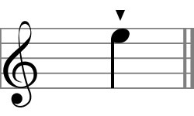

A staccatissimo, also known as a spiccato, is a tiny pike placed over or under a note. It signifies a longer silence as compared to the staccato, implying that the note is played for a quarter of its actual duration. Used in string instruments, it implies a bowing technique where the bow bounces lightly on the string.

**Marcato**

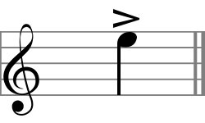

The marcato, also called the regular accent, is an open horizontal wedge placed above or below the staff. It indicates playing a note or a long chord to be played louder and more forcefully than that of the surrounding music. It lays emphasis on the beginning of the note which has to be tapered off rather quickly.

**Strong Marcato**

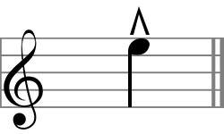

Also known as a martellato or marcatissimo, the strong marcato is denoted with vertical open wedge placed above or below the staff. It signifies a greater dynamic accent or very strong accentuation played on the note. It is characterized by a rhythmic thrust of the note followed by a decay of the sound.

**Tenuto**

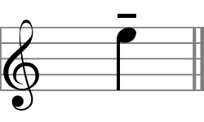

Marked by a horizontal line placed above or below the note head, the tenuto signifies that the note be held to its full length or longer. It could also indicate that the particular note be given more emphasis than the surrounding notes in a musical piece.

**Pizzicato**

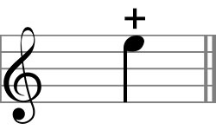

Also known as the left-hand pizzicato or the stopped note, the pizzicato is denoted by a plus sign. For a stringed instrument, like a guitar, it implies that the pitch of a stopped note is determined by pressing the strings at one of the frets.

**Snap Pizzicato**

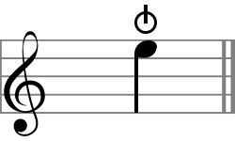

When employed on a stringed instrument, the snap pizzicato is played by vertically stretching the string away from the instrument causing it to snap against the frame. The technique is also called slapping and is popular in jazz music.

**Harmonic**

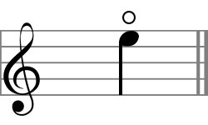

A circle is used to denote an open note or a natural harmonic, also known as a flageolet, that is to be played on the note. For a percussion instrument, it signifies releasing the hi-hat allowing it to ring or the vibrations to be heard.

**Up Bow**

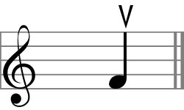

Employed when playing a stringed instrument, the accent mark indicates that the note be played with an upward stroke.

**Down Bow**

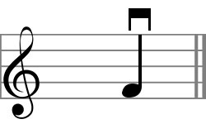

Quite the opposite of an up bow, the down bow instructs the player to play the instrument with a down stroke.

**Fermata**

Also known as a pause, or a grand pause, the fermata is used to add length to a note or rest. Although the duration of the pause depends on the music conductor, it is most often considered to be twice as long as a regular pause. It can also be placed at the end or the middle of a piece of movement.

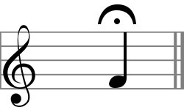

**Ornaments**

Ornaments are embellishments or musical flourishes used to decorate a line in a musical piece. They are often used to modify the pitch pattern of individual notes in a single line of music.

**Trill**

A trill or a shake, is a rapid alternation between an indicated note and the one immediately above it. In short, it is used to alternate between a note above the actual written note, sometimes requiring the player to end a note below the written note.

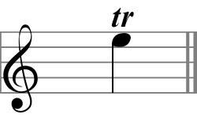

**Mordent**

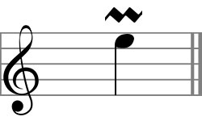

Placed above the note, the mordent instructs the player to play the principal note followed by the immediate next note, ending it with the principal note.

**Inverted Mordent**

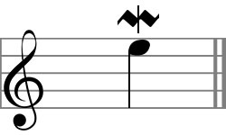

The opposite of the mordent, this ornament instructs playing the principal note followed by the immediate lower note and returning to the principal note.

**Turn**

Marked by a mirrored letter 'S', lying on its side, the turn, or gruppetto as it is known, indicates a sequence of adjacent notes in the particular scale to be played. When placed directly above the note head, it implies that the auxiliary note be played before the principal note followed by the lower auxiliary note. Which means, you play a higher notes followed by the main note and play the immediate lower note and return to the principal note. When placed to the right of the note, you play the principal note before playing the turn sequence. In short, when the note is placed to the right you end up playing a quintuplet.

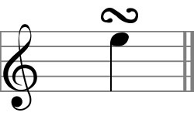

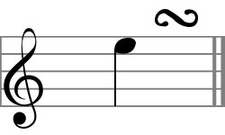

**Inverted Turn**

An inverted turn resembles a turn with a vertical line running through it. It can also be written as a vertically mirrored letter 'S'. The sequence this sign indicates is the reverse of the turn ornament. It means, the player starts with the lower auxiliary note followed by the principal note and the higher auxiliary note, finally ending on the principal note.

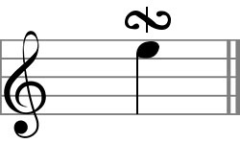

**Appoggiatura**

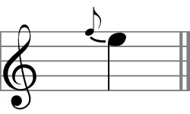

Also known as a grace note, the appoggiatura resembles a smaller quaver note and is written just above the principal note head. It receives half the value of the note it precedes. When placed before a dotted note, it receives two-thirds of its value. It is also known as the long appoggiatura.

**Acciaccatura**

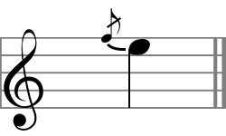

Like the appoggiatura, the acciaccatura resembles a smaller quaver note written with a stroke through its tail. It is played on the beat as quickly as is convenient and is about a demisemiquaver in length. The delay on the principal note with a acciaccatura is scarcely perceptible unlike that with the long appoggiatura.

**Repetition and Codas**

**Tremolo**

Also known as the tremolando, it is symbolized by strokes through the stem of a note. Simply put, it indicates that a note be rapidly repeated to create a tremble or a shuddering effect depending on the instrument being used.

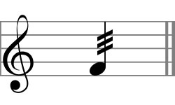

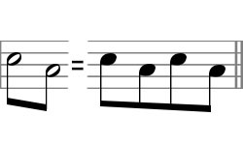

**Repeat**

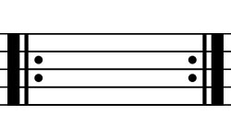

In a piece of music, the repeat sign indicates that the particular section be repeated. A single repeat sign placed at the end of the piece indicates the entire stretch be repeated from start to finish, while a corresponding mirrored sign indicates the beginning of the repetition.

**Simile**

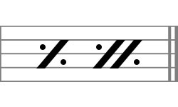

Unlike the repetition sign in which an entire section is repeated, the simile denotes that a group of beats are to be repeated. When a single slash with two dots is shown, it means only the previous beat is to be repeated, while two slashes with a vertical bar suggests the previous two measures are to be repeated.

**Da capo**

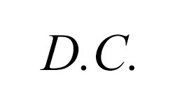

Literally meaning from the beginning, the abbreviated D.C. is taken as a directive to repeat the previous part of the music.

**Dal segno**

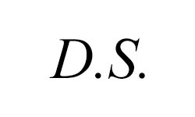

Abbreviated as D.S., the sign is taken as a directive to repeat a particular piece or passage of music starting from the nearest segno.

**Segno**

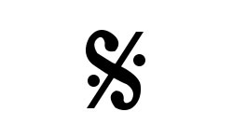

Used with a dal segno, it indicates the beginning of the repetition of a passage. It resembles the letter 'S' placed at an angle and has a slash running through it.

**Coda**

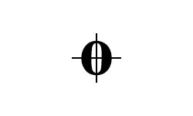

A circle with a cross is used to indicate the coda. This is used to instruct a forward jump in the music, and it is used after a D.C. or D.S. to indicate an end.

**Crescendo**

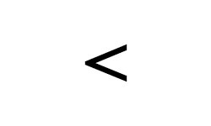

A crescendo sign placed below a musical stave instructs the player to gradually increase the volume while performing the passage.

**Diminuendo**

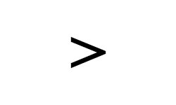

The opposite of the crescendo, the diminuendo is used to instruct the player to gradually decrease the volume of the particular passage.

**Dynamic Piano**

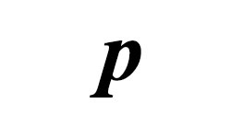

The letter *p* written in small case is used to denote piano. It means soft.

**Dynamic Forte**

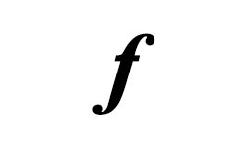

Used as a contrast to dynamic piano, the letter *f* written in smaller case denotes loud.

**Mezzo Piano**

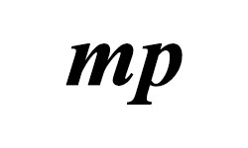

The letters mp  written in small case are used to denote mezzo piano. They instruct the player to reduce the relative intensity of the musical line to a level that is softer than that of a dynamic piano.

**Mezzo Forte**

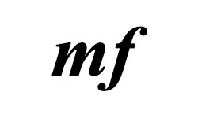

Considered to be half as loud as the forte, the mezzo forte written as mf  is used to increase the intensity of the musical line. It is assumed to be the prevailing dynamic level.

**Dynamic Pianissimo**

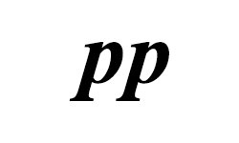

It is considered to be the softest indication in a piece of music. Simply put, it indicates very soft.

**Dynamic Fortissimo**

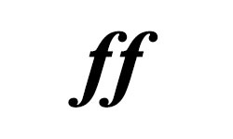

Quite the opposite of pp, fortississimo indicates that the piece of music be played very loud.

**Dynamic Pianissimo**

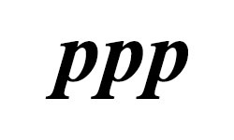

Triple p s indicates that the relative intensity or volume of a musical line be extremely soft.

**Dynamic Fortississimo**

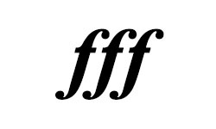

Triple f s indicate that the intensity of a line of music be played extremely loud.

**Sforzando**

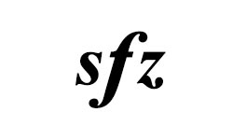

It indicates an abrupt and fierce accent on a single note or chord. Its literally translation is to be forced out.

**Forte Piano**

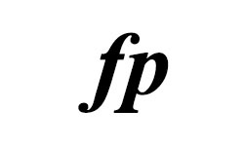

Forte piano indicates that a section of music has to initially be played loud