**Staff**

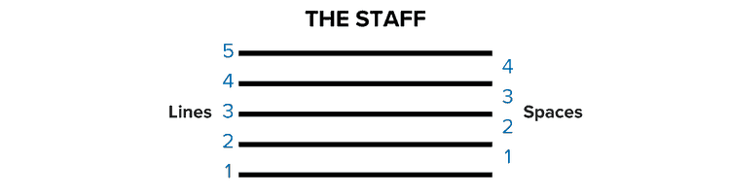

The staff is the fundamental latticework of music notation, on which symbols are placed. The five staff lines and four intervening spaces correspond to pitches of the diatonic scale; which pitch is meant by a given line or space is defined by the clef. In British usage, the word "stave" is often used.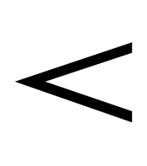

**Crescendo**

A gradual increase in volume. Can be extended under many notes to indicate that the volume steadily increases during the passage.

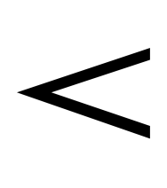

**Diminuendo**

Also decrescendo A gradual decrease in volume. Can be extended in the same manner as crescendo.

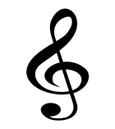

**Clef** graphical symbol placed on the left of the stave which establishes the relationship between particular note names and their position on the staff lines and spaces

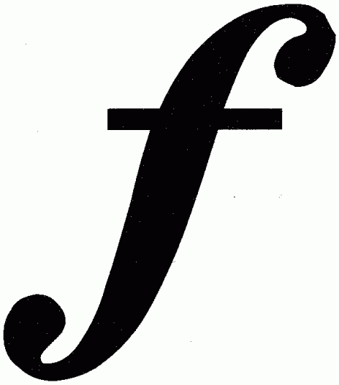

**f**

or forte, meaning "loud"

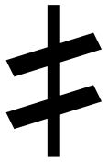

A **half sharp** raises a note by a [quarter tone](https://en.wikipedia.org/wiki/Quarter_tone) = 50 [cents](https://en.wikipedia.org/wiki/Cent_(music)) and may be marked with various symbols