Chords In The Key Of C Major

The C major scale consists of the notes C D E F G A B C

I – C major, C major seventh (Cmaj, Cmaj7)

ii – D minor, D minor seventh (Dm, Dm7)

iii – E minor, E minor seventh (Em, Em7)

IV – F major, F major seventh (F, Fmaj 7)

V – G major, G dominant seventh (G, G7)

vi – A minor, A minor seventh (Am, Am7)

vii° – B diminished, B minor seventh flat five (B°, Bm7b5)

Common chord progressions in the key of C major are as follows:

I – IV – V (C – F- G)

I – vi – IV – V (C – Am – F – G)

ii – V – I (Dm7 – G7 – Cmaj7)

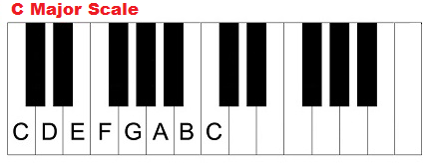

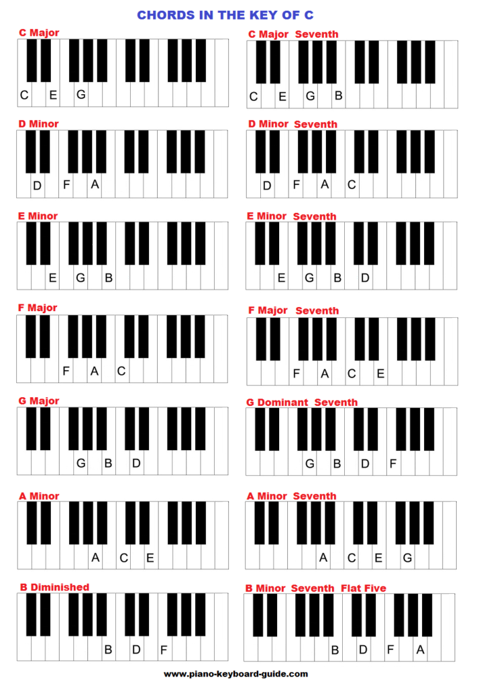

The Chords In The Key Of C Sharp

C# D# E# F# G# A# B# C#.

I – C sharp major (and C sharp major seventh)

ii – D sharp minor (and D sharp minor seventh)

iii – E sharp minor (and E sharp minor seventh)

IV – F sharp major (and F sharp major seventh)

V – G sharp major (and G sharp dominant seventh)

vi – A sharp minor (and A sharp minor seventh)

vii° – B sharp diminished (and B sharp minor seventh flat five)

Common chord progressions

I – IV – V (C# – F# – G#)

I – vi – IV – V (C# – A#m – F# – G#)

ii – V – I (D#m7 – G#7 – C#maj7)

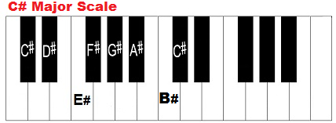

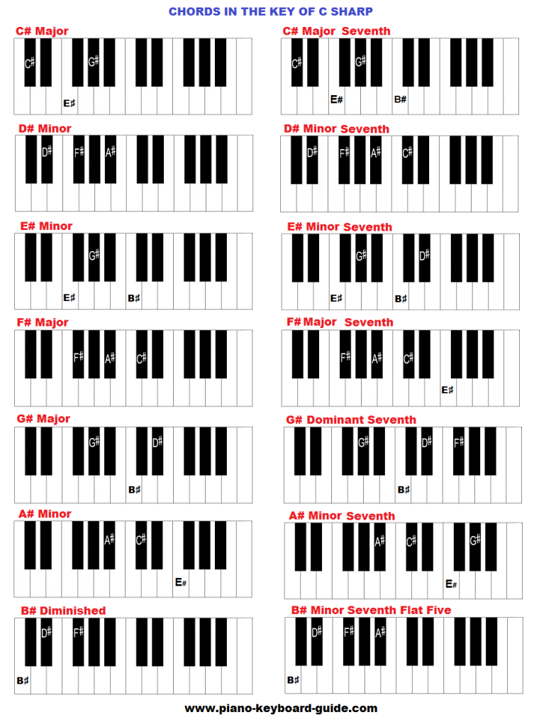

Chords In The Key Of D Flat Major

Db Eb F Gb Ab Bb C Db

I – Db major, Db major seventh (bDmaj, Dbmaj7)

ii – Eb minor, Eb minor seventh (Ebm, Ebm7)

iii – F minor, F minor seventh (Fm, Fm7)

IV – Gb major, Gb major seventh (Gb, Gbmaj 7)

V – Ab major, Ab dominant seventh (Ab, Ab7)

vi – Bb minor, Bb minor seventh (Bbm, Bbm7)

vii° – C diminished, C minor seventh flat five (C°, Cm7b5)

Common chord progressions in the key of Db major are:

I – IV – V (Db – Gb – Ab)

I – vi – IV – V (Db – Bbm – Gb – Ab)

ii – V – I (Ebm7 – Ab7 – Dbmaj7)

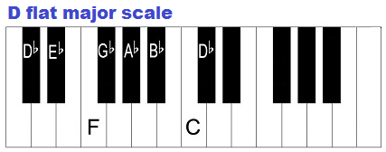

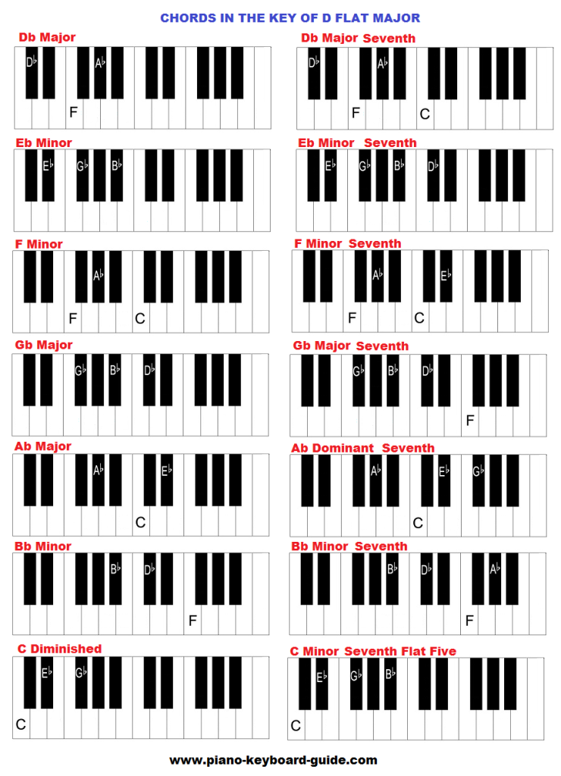

Chords In The Key Of D Major

D E F# G A B C#

I – D major, D major seventh (Dmaj, Dmaj7)

ii – E minor, E minor seventh (Em, Em7)

iii – F# minor, F# minor seventh (F#m, F#m7)

IV – G major, G major seventh (G, Gmaj 7)

V – A major, A dominant seventh (A, A7)

vi – B minor, B minor seventh (Bm, Bm7)

vii° – C# diminished, C# minor seventh flat five (C#°, C#m7b5)

Common chord progressions in the key of D major are as follows:

I – IV – V (D – G- A)

I – vi – IV – V (D – Bm – G – A)

ii – V – I (Em7 – A7 – Dmaj7)

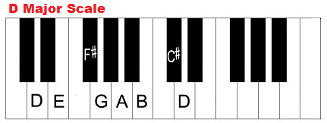

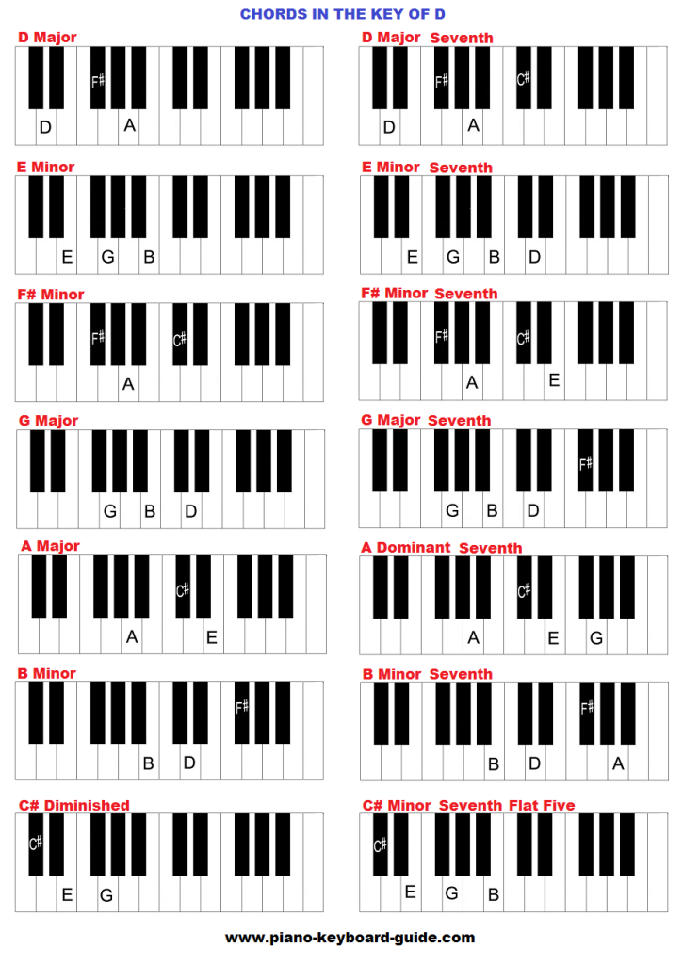

Chords In The Key Of E Flat Major

Eb F G Ab Bb C D

I – Eb major, Eb major seventh (Ebmaj, Ebmaj7)

ii – F minor, F minor seventh (Fm, Fm7)

iii – G minor, G minor seventh (Gm, Gm7)

IV – Ab major, Ab major seventh (Ab, Abmaj 7)

V – Bb major, Bb dominant seventh (Bb, Bb7)

vi – C minor, C minor seventh (Cm, Cm7)

vii° – D diminished, D minor seventh flat five (D°, Dm7b5)

Common chord progressions in the key of E flat major are as follows:

I – IV – V (Eb – Ab – Bb)

I – vi – IV – V (Eb – Cm – Ab – Bb)

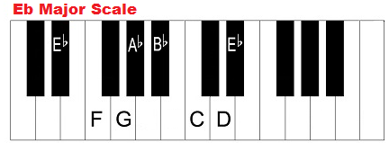ii – V – I (Fm7 – Bb7 – Ebmaj7)

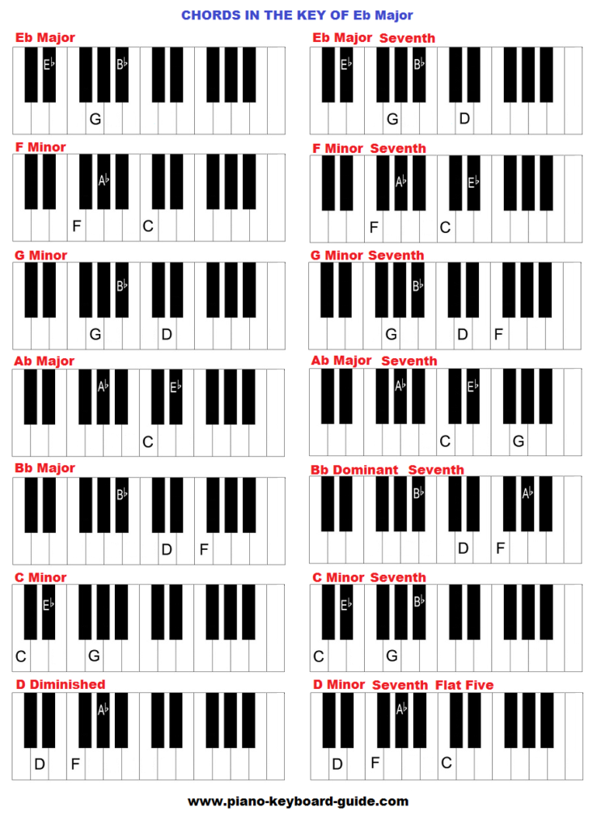

Chords In The Key Of E Flat Major

Eb F G Ab Bb C D

I – Eb major, Eb major seventh (Ebmaj, Ebmaj7)

ii – F minor, F minor seventh (Fm, Fm7)

iii – G minor, G minor seventh (Gm, Gm7)

IV – Ab major, Ab major seventh (Ab, Abmaj 7)

V – Bb major, Bb dominant seventh (Bb, Bb7)

vi – C minor, C minor seventh (Cm, Cm7)

vii° – D diminished, D minor seventh flat five (D°, Dm7b5)

Common chord progressions in the key of E flat major are as follows:

I – IV – V (Eb – Ab – Bb)

I – vi – IV – V (Eb – Cm – Ab – Bb)

 ii – V – I (Fm7 – Bb7 – Ebmaj7)



The Chords In The Key Of E Major

E F# G# A B C# D#

I – E major, E major seventh (Emaj, Emaj7)

ii – F sharp minor, F# minor seventh (F#m, F#m7)

iii – G sharp minor, G# minor seventh (G#m, G#m7)

IV – A major, A major seventh (A, Amaj 7)

V – B major, B dominant seventh (B, B7)

vi – C sharp minor, C# minor seventh (C#m, C#m7)

vii° – D# diminished, D# minor seventh flat five (D#°, D#m7b5)

Common chord progressions in the key of E major are as follows:

I – IV – V (E – A – B)

I – vi – IV – V (E – C#m – A – B)

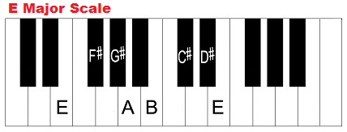 ii – V – I (F#m7 – B7 – Emaj7)

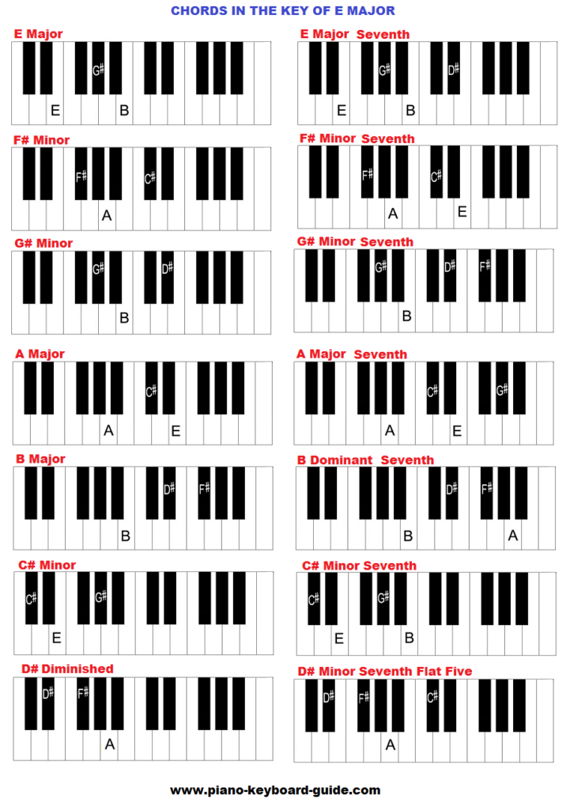

The Chords In The Key Of F Major

F G A Bb C D E

I – F major, F major seventh (Fmaj, Fmaj7)

ii – G minor, G minor seventh (Gm, Gm7)

iii – A minor, A minor seventh (Am, Am7)

IV – Bb major, Bb major seventh (Bb, Bbmaj 7)

V – C major, C dominant seventh (C, C7)

vi – D minor, D minor seventh (Dm, Dm7)

vii° – E diminished, E minor seventh flat five (E°, Em7b5)

common chord progressions

I – IV – V (F – Bb- C)

I – vi – IV – V (F – Dm – Bb – C)

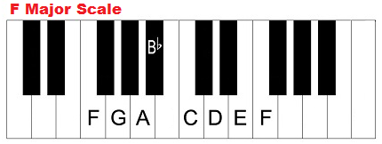 ii – V – I (Gm7 – C7 – Fmaj7)

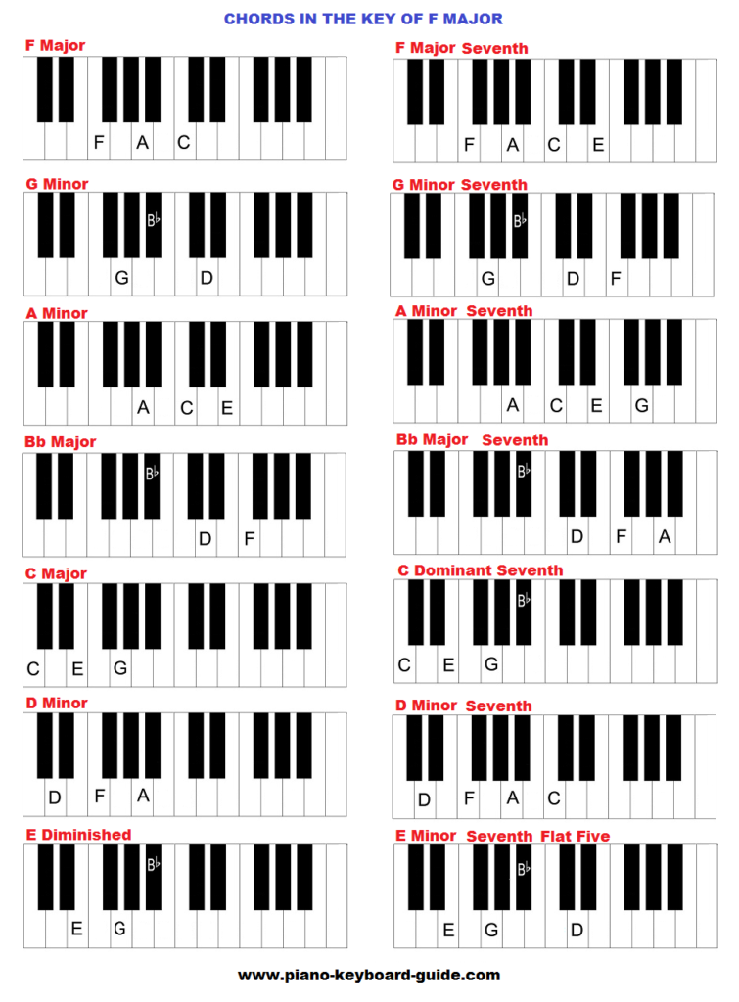

Chords In The Key Of F Sharp (G Flat) Major

F# G# A# B C# D# E#

I – F sharp major, F# major seventh (F#maj, F#maj7)

ii – G sharp minor, G# minor seventh (G#m, G#m7)

iii – A sharp minor, A# minor seventh (A#m, A#m7)

IV – B major, B major seventh (B, Bmaj 7)

V – C sharp major, C# dominant seventh (C#, C#7)

vi – D sharp minor, D# minor seventh (D#m, D#m7)

vii° – E sharp diminished, E# minor seventh flat five (E#°, E#m7b5)

common chord progressions (in F sharp major)

I – IV – V (F# – B- C#)

I – vi – IV – V (F# – D#m – B – C#)

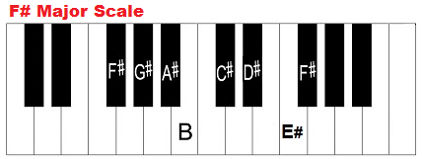 ii – V – I (G#m7 – C#7 – F#maj7)

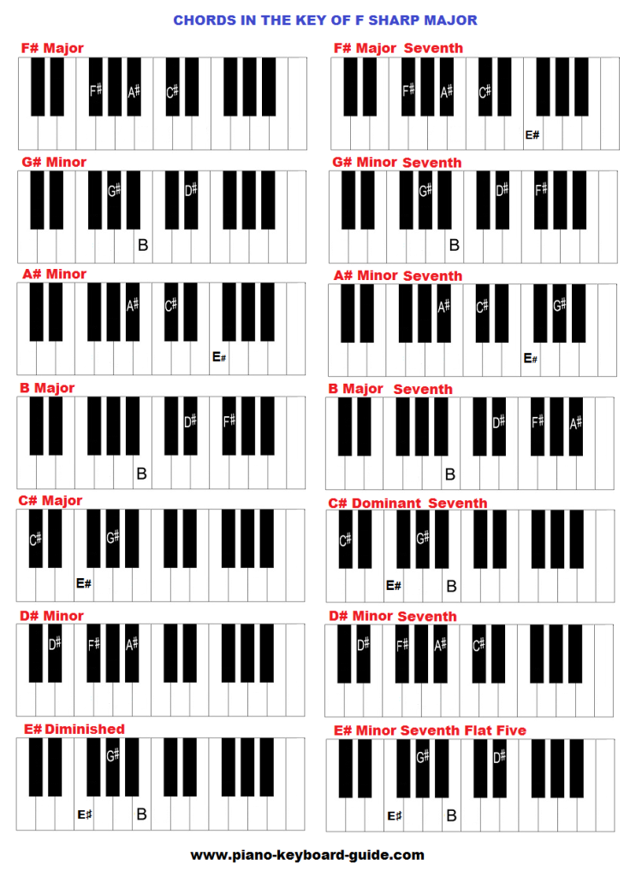

Chords In The Key Of G Flat Major

Gb Ab Bb Cb Db Eb F

I – G flat major, Gb major seventh (Gbmaj, Gbmaj7)

ii – A flat minor, Ab minor seventh (Abm, Abm7)

iii – B flat minor, Bb minor seventh (Bbm, Bbm7)

IV – C flat major, Cb major seventh (Cb, Cbmaj 7)

V – D flat major, Db dominant seventh (Db, Db7)

vi – E flat minor, Eb minor seventh (Ebm, Ebm7)

vii° – F diminished, F minor seventh flat five (F°, Fm7b5)

Common chord Progressions in the Key of G Flat

I – IV – V (Gb – Cb- Db)

I – vi – IV – V (Gb – Ebm – Cb – Db)

ii – V – I (Abm7 – Db7 – Gbmaj7)

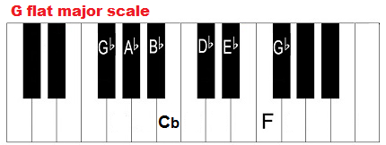

|  |  |  |  |
| --- | --- | --- | --- |
| **G flat** | Gb-Bb-Db | **G major seventh** | Gb-B-Db-F |
| **Ab minor** | Ab-Cb-Eb | **Ab minor seventh** | Ab-Cb-Eb-Gb |
| **Bb minor** | Bb-Db-F | **Bb minor seventh** | Bb-Db-F-Ab |
| **Cb major** | Cb-Eb-Gb | **Cb major seventh** | Cb-Eb-Gb-Bb |
| **Db major** | Db-F-Ab | **Db major seventh** | Db-F-Ab-Cb |
| **Eb minor** | Eb-Gb-Bb | **Eb minor seventh** | Eb-Gb-Bb-Db |
| **F Diminished** | F-Ab-Cb | **F minor seventh flat five** | F-Ab-Cb-Eb |

The Chords In The Key Of G

G A B C D E F#

I – G major, G major seventh (Gmaj, Gmaj7)

ii – A minor, A minor seventh (Am, Am7)

iii – B minor, B minor seventh (Bm, Bm7)

IV – C major, C major seventh (C, Cmaj 7)

V – D major, D dominant seventh (D, D7)

vi – E minor, E minor seventh (Em, Em7)

vii° – F# diminished, F# minor seventh flat five (F#°, F#m7b5)

Chord Progressions in the Key of G

I – IV – V (G – C- D)

I – vi – IV – V (G – Em – C – D)

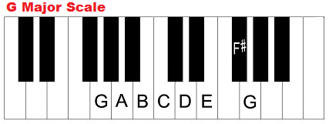 ii – V – I (Am7 – D7 – Gmaj7)

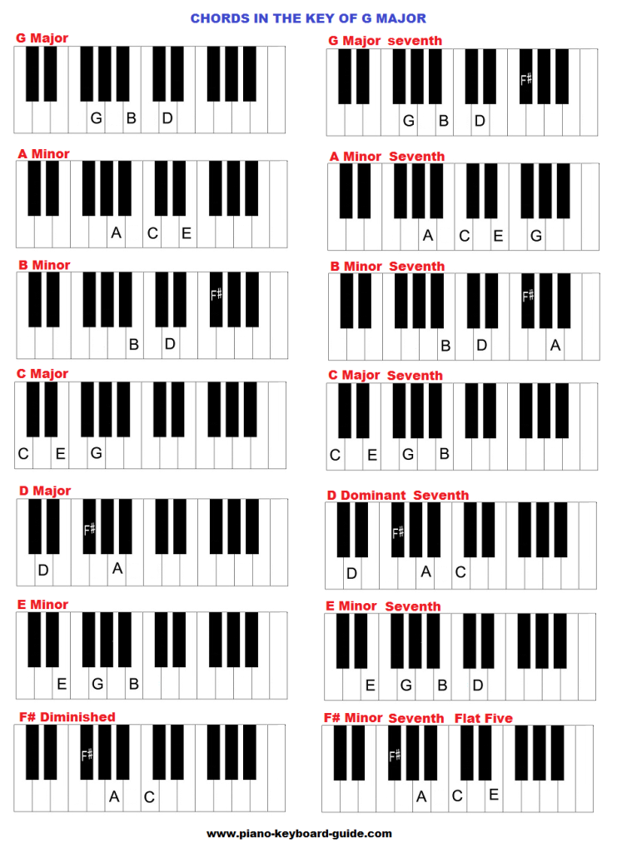

The Key Of A Flat (And G Sharp)

Ab Bb C Db Eb F G

I – Ab major, Ab major seventh (Abmaj, Abmaj7)

ii – Bb minor, Bb minor seventh (Bbm, Bbm7)

iii – C minor, C minor seventh (Cm, Cm7)

IV – Db major, Db major seventh (Db, Dbmaj 7)

V – Eb major, Eb dominant seventh (Eb, Eb7)

vi – F minor, F minor seventh (Fm, Fm7)

vii° – G diminished, G minor seventh flat five (G°, Gm7b5)