**Step 1: Learn the Basic Symbols of Notation**

Music is made up of a variety of symbols, the most basic of which are the staff, the clefs and the notes. All music contains these fundamental components, and in order to learn how to read music, you must first familiarize yourself with these basics.

**The Staff**

The staff consists of five lines and four spaces. Each of those lines and each of those spaces represents a different letter, which in turn represents a note. Those lines and spaces represent notes named A-G, and the note sequence moves alphabetically up the staff.

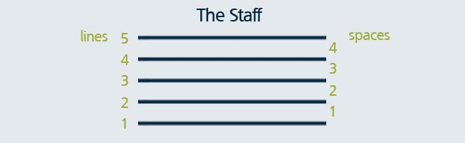

**Treble Clef**

There are two main clefs with which to familiarize yourself; the first is a treble clef. The treble clef has the ornamental letter G on the far left side. The G’s inner swoop encircles the “G” line on the staff. The treble clef notates the higher registers of music, so if your instrument has a higher pitch, such as a flute, violin or saxophone, your sheet music is written in the treble clef.  Higher notes on a keyboard also are notated on the treble clef.

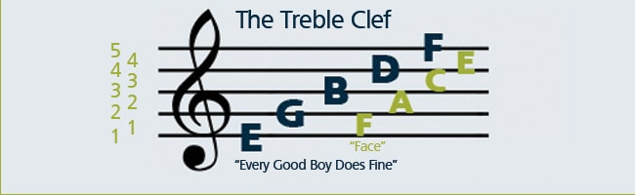

We use common mnemonics to remember the note names for the lines and spaces of the treble clef. For lines, we remember EGBDF by the word cue “Every Good Boy Does Fine.” Similarly for the spaces, FACE is just like the word “face.”

**Bass Clef**

The line between the two bass clef dots is the “F” line on the bass clef staff, and it’s also referred to as the F clef. The bass clef notates the lower registers of music, so if your instrument has a lower pitch, such as a bassoon, tuba or cello, your sheet music is written in the bass clef. Lower notes on your keyboard also are notated in the bass clef.

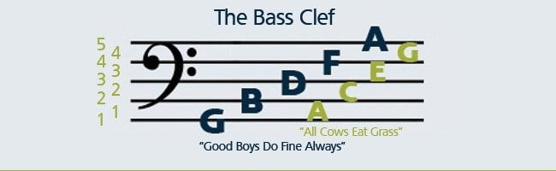

A common mnemonic to remember note names for the lines of the bass clef is: GBDFA “Good Boys Do Fine Always.” And for the spaces: ACEG, “All Cows Eat Grass.”

**Notes**

Notes placed on the staff tell us which note letter to play on our instrument and how long to play it. There are three parts of each note, the **note head**, the **stem** and the **flag**.

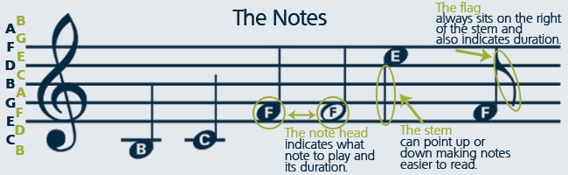

Every note has a **note head**, either filled (black) or open (white). Where the note head sits on the staff (either on a line or a space) determines which note you will play. Sometimes, note heads will sit above or below the five lines and four spaces of a staff. In that case, a line is drawn through the note, above the note or below the note head, to indicate the note letter to play, as in the B and C notes above.

The note **stem** is a thin line that extends either up or down from the note head. The line extends from the right if pointing upward or from the left if pointing downward. The direction of the line doesn’t affect how you play the note, but serves as a way to make the notes easier to read while allowing them to fit neatly on the staff. As a rule, any notes at or above the B line on the staff have downward pointing stems, those notes below the B line have upward pointing stems.

The note **flag** is a curvy mark to the right of the note stem. Its purpose is to tell you how long to hold a note. We’ll see below how a single flag shortens the note’s duration, while multiple flags can make it shorter still.

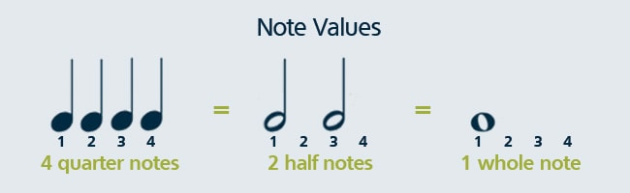

Now that you know the parts to each note, we’ll take a closer look at those filled and open note heads discussed above. Whether a note head is filled or open shows us the note’s **value**, or how long that note should be held. Start with a closed note head with a stem. That’s our **quarter note**, and it gets one beat. An open note head with a stem is a **half note**, and it gets two beats. An open note that looks like an “o” without a stem is a **whole note**, and it gets held for four beats.

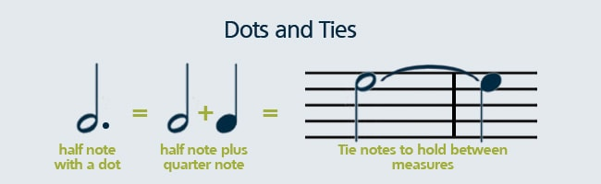

There are other ways to extend the length of a note. A **dot** after the note head, for example, adds another half of that note’s duration to it. So, a half note with a dot would equal a half note and a quarter note; a quarter note with a dot equals a quarter plus an eighth note. A **tie** may also be used to extend a note. Two notes tied together should be held as long as the value of both of those notes together, and ties are commonly used to signify held notes that cross measures or bars.

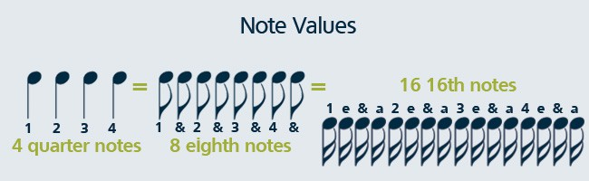

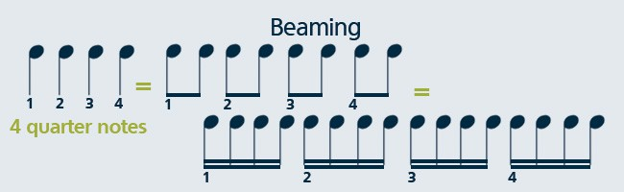

The opposite may also happen, we can shorten the amount of time a note should be held, relative to the quarter note. Faster notes are signified with either **flags**, like the ones discussed above, or with **beams** between the notes. Each flag halves the value of a note, so a single flag signifies 1/2 of a quarter note, a double flag halves that to 1/4 of a quarter note, et cetera. Beams do the same, while allowing us to read the music more clearly and keep the notation less cluttered. As you can see, there’s no difference in how you count the eighth and 16th notes above. [Follow along with the sheet music for “Alouette”](http://www.musicnotes.com/sheetmusic/mtdFPE.asp?ppn=MN0128990&utm_source=Musicnotes%20Blog&utm_medium=referral&utm_campaign=How%20to%20Read%20Sheet%20Music:%20Step-by-Step%20Instructions) to see how beams organize notes!

But what happens when there isn’t a note taking up each beat? It’s easy, we take a rest! A **rest**, just like a note, shows us how long it should be held based on its shape. [See how whole and quarter rests are used](http://www.musicnotes.com/sheetmusic/mtdFPE.asp?ppn=MN0127894&utm_source=Musicnotes%20Blog&utm_medium=referral&utm_campaign=How%20to%20Read%20Sheet%20Music:%20Step-by-Step%20Instructions) in the song “Here We Go Looby-Loo.”

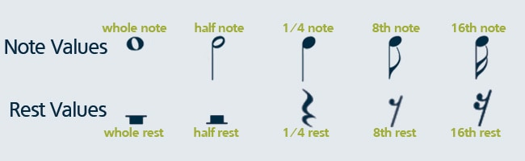

**Step 2: Pick Up the Beat**

In order to play music, you need to know its **meter**, the beat you use when dancing, clapping or tapping your foot along with a song. When reading music, the meter is presented similar to a fraction, with a top number and a bottom number, we call this the song’s **time signature**. The top number tells you how many beats to a **measure**, the space of staff in between each vertical line (called a **bar**). The bottom number tells you the note value for a single beat, the pulse your foot taps along with while listening.  
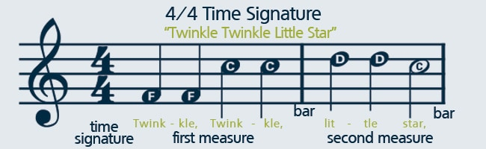

In the example above, the time signature is 4/4, meaning there are 4 beats per bar and that every quarter note gets one beat. [Click here to listen to sheet music written in 4/4 time](http://www.musicnotes.com/sheetmusic/mtdFPE.asp?ppn=MN0127923&utm_source=Musicnotes%20Blog&utm_medium=referral&utm_campaign=How%20to%20Read%20Sheet%20Music:%20Step-by-Step%20Instructions), and try counting along 1,2,3,4 – 1,2,3,4 with the beat numbers above.  
In the example below, the time signature is 3/4, meaning there are 3 beats per bar and that every quarter note gets one beat. [Click here to listen to sheet music written in 3/4 time](http://www.musicnotes.com/sheetmusic/mtdFPE.asp?ppn=MN0127908&utm_source=Musicnotes%20Blog&utm_medium=referral&utm_campaign=How%20to%20Read%20Sheet%20Music:%20Step-by-Step%20Instructions), try counting the beats, 1,2,3 – 1,2,3.

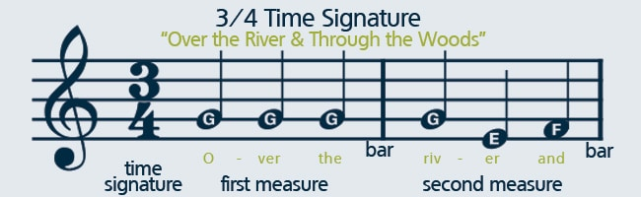

Let’s look again at the above examples, notice that even though the 4/4 time signature in “Twinkle, Twinkle Little Star” calls for 4 beats per bar, there aren’t 4 notes in second bar? That’s because you have two quarter notes and one half note, which added together equal 4 beats.

In addition to your note values and time signature, the last piece to feeling the rhythm is knowing your **tempo**, or beats per minute. Tempo tells you how fast or slow a piece is intended to be played, and often is shown at the top of a piece of sheet music. A tempo of, say 60 BPM (beats per minute) would mean you’d play 60 of the signified notes every minute or a single note every second. Likewise, a tempo of 120 would double the speed at 2 notes every second.  You may also see Italian words like “Largo,” “Allegro” or “Presto” at the top of your sheet music, which signify common tempos. Musicians use a tool, called a metronome, to help them keep tempo while practicing a new piece. [Click here to see an online metronome tool](http://www.metronomeonline.com/), and click on the circles next to the BPM values to see how a tempo can speed up and slow down.

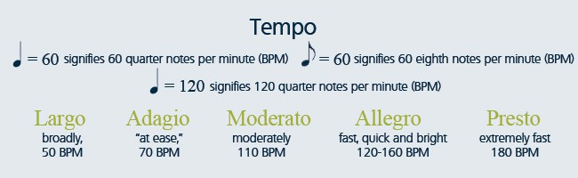

**Step 3: Play a Melody**

Congratulations, you’re almost on your way to reading music! First, let’s look at **scales**. A scale is made of eight consecutive notes, for example, the C major scale is composed of C, D, E, F, G, A, B, C. The interval between the first note of your C major scale and the last is an example of an **octave**. The C major scale is very important to practice, since once you have the C scale down, the other major scales will start to fall into place. Each of the notes of a C major scale corresponds with a white key on your keyboard. Here’s how a C major scale looks on a staff and how that corresponds to the keys on your keyboard:

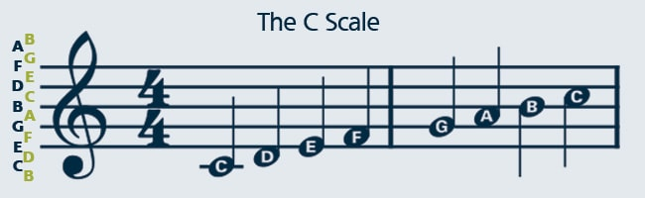

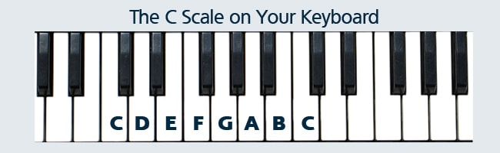

You’ll notice that as the notes ascend the staff, and move to the right on your keyboard, the pitch of the notes gets higher. But, what about the black keys? Musically, **whole tones**, or whole steps between the note letters, would limit the sounds we’re able to produce on our instruments. Let’s consider the C major scale you just learned to play. The distance between the C and the D keys in your C scale is a whole step, however the distance between the E and the F keys in your C scale is a half step. Do you see the difference? The E and the F keys don’t have a black key in between them, thus they’re just a half step away from one another. Every major scale you’ll play on a keyboard has the same pattern, whole-whole-half-whole-whole-whole-half. There are many other types of scales, each with unique sounds, like minor scales, modal scales and more that you’ll come across later on, but for now let’s focus just on major scales and the major scale pattern. Look at the C major scale again on the keyboard below.

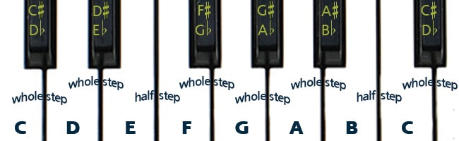

**Semitones**, or half-steps on the keyboard, allow us to write an infinite variety of sounds into music. A **sharp**, denoted by the ♯ symbol, means that note is a semitone (or half step) *higher* than the note head to its right on sheet music. Conversely, a **flat**, denoted by a ♭ symbol, means the note is a semitone *lower* than the note head to its right. You’ll notice on the keyboard picture and notated staff below, showing each half step between the C and the E notes, that whether you use the sharp or the flat of a note depends on whether you’re moving *up* or *down* the keyboard.

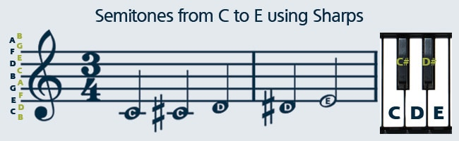

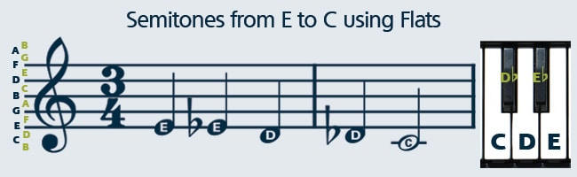

There’s one more symbol to learn regarding semitones, and that’s the **natural,** denoted by a ♮. If a note is sharp or flat, that sharp or flat extends throughout the measure, unless there’s a natural symbol. A natural  cancels a sharp or flat within a measure or a song. Here’s what playing C to E would look like with natural symbols.

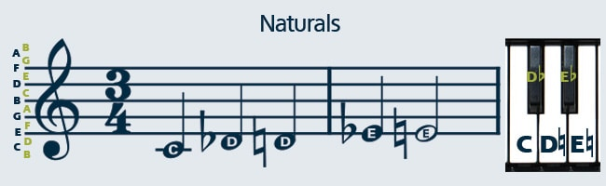

Finally, in order to read music, you’ll need to understand **key signatures**. You actually already know one key signature, the key of C! The C major scale you learned above was in the key of C. Scales are named after their **tonic**, the preeminent note within the scale, and the tonic determines what key you play in. You can start a major scale on any note, so long as you follow the whole-whole-half-whole-whole-whole-half pattern. Now, following that pattern in keys other than the key of C will require you to use sharps and flats. Since that’s the case, we place the sharps or flats for your song’s key signature right before the meter, after the clef, on your sheet music. That tells you to maintain those sharps or flats throughout the music, unless of course there’s a natural symbol to override it. You will begin to recognize the key signatures of pieces based on what sharps or flats are shown. Here’s a quick glimpse at some key signatures using sharps and flats:

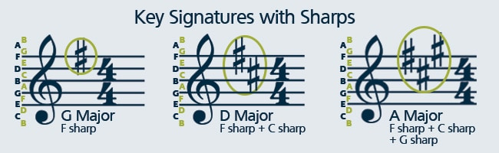

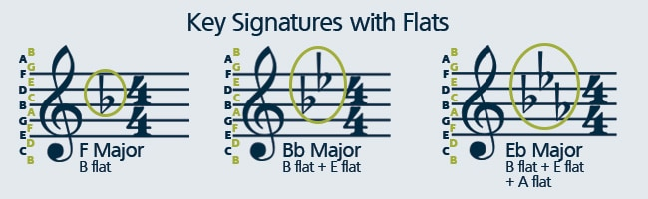

**Step 4: Print Out Your FREE Tools!**

We hope you’re excited to start reading music! In order to help you along on your musical journey, we’ve created a few FREE tools to start practicing with.

First, we’re offering you a FREE Beginner Notes download! [Click here for the sheet music to “Mary Had a Little Lamb,](http://www.musicnotes.com/sheetmusic/mtd.asp?ppn=MN0127902&utm_source=Musicnotes%20Blog&utm_medium=referral&utm_campaign=How%20to%20Read%20Sheet%20Music:%20Step-by-Step%20Instructions)” just add the free song to your cart and proceed through checkout to claim your copy, and be sure to take a look at our [huge Beginner Notes sheet music assortment](http://www.musicnotes.com/piano/beginner_notes.asp?utm_source=Musicnotes%20Blog&utm_medium=referral&utm_campaign=How%20to%20Read%20Sheet%20Music:%20Step-by-Step%20Instructions), all of which you’ll be able to play using the steps above. Play current hits like “[Happy](http://www.musicnotes.com/sheetmusic/mtdFPE.asp?ppn=MN0129253&utm_source=Musicnotes%20Blog&utm_medium=referral&utm_campaign=How%20to%20Read%20Sheet%20Music:%20Step-by-Step%20Instructions)” by Pharrell Williams, “[Let It Go](http://www.musicnotes.com/sheetmusic/mtdFPE.asp?ppn=MN0128074&utm_source=Musicnotes%20Blog&utm_medium=referral&utm_campaign=How%20to%20Read%20Sheet%20Music:%20Step-by-Step%20Instructions)” from ‘Frozen’ and “[Say Something](http://www.musicnotes.com/sheetmusic/mtdFPE.asp?ppn=MN0128075&utm_source=Musicnotes%20Blog&utm_medium=referral&utm_campaign=How%20to%20Read%20Sheet%20Music:%20Step-by-Step%20Instructions)” by A Great Big World, just to name a few. We’re adding NEW Beginner Notes daily, so be sure to check back often and learn to play all your favorite songs!

We’ve also created a handy guide for lettering the keys on your keyboard or piano. [Download your Keyboard Note Guide here](http://www.musicnotes.com/blog/wp-content/uploads/Keyboard_Note_Print_Out.pdf), to print, fold and place on your keyboard. Once you become familiar with the keys, you can easily remove it and continue to strengthen your note-reading skills.

For those who don’t have access to a keyboard, you can download a free keyboard app for your iPad [here](https://itunes.apple.com/us/app/virtuoso-piano-free-2-hd/id304075989?mt=8), or a free Android keyboard app [here](https://play.google.com/store/apps/details?id=com.alexandru.piano.free). Don’t forget to [download your Musicnotes Decks: Music Flash Cards app](https://itunes.apple.com/us/app/musicnotes-decks-music-flash/id547373642?) for iPhone and iPad as well. For just $2.99 you’ll receive three decks of flash cards, including music symbols, two full octaves of treble clef notes and two octaves of bass clef notes.

Good luck, and most importantly, have fun!

### Part 1

### The Basics

[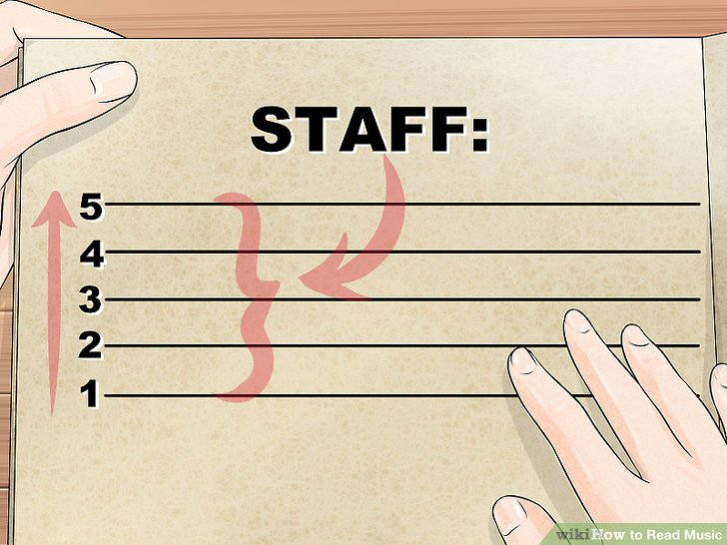](https://www.wikihow.com/Read-Music#/Image:Read-Music-Step-1.jpg)

**1**

**Get a handle on the staff.** Before you are ready to start learning music, you must get a sense for the basic information that virtually everyone who reads music needs to know. The horizontal lines on a piece of music make up *the staff*. This is the most basic of all musical symbols and the foundation for everything that is to follow.

* + The staff is an arrangement of five parallel lines, and the spaces between them. Both lines and spaces are numbered for reference purposes, and are always counted from lowest (bottom of the staff) to highest (top of the staff).

[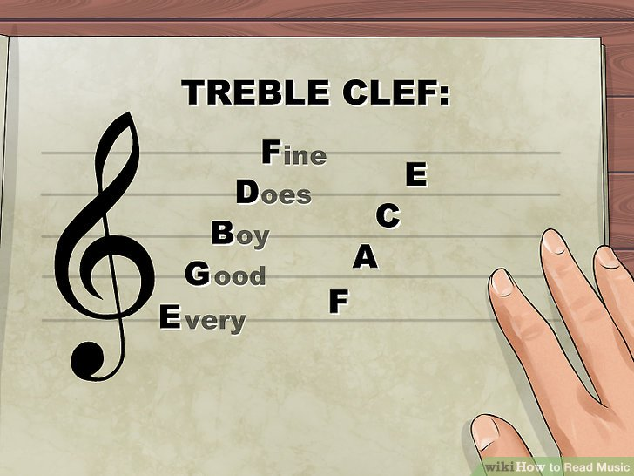](https://www.wikihow.com/Read-Music#/Image:Read-Music-Step-2.jpg)**2**

**Start with the Treble Clef.** One of the first things you'll encounter when reading music is the *clef*. This sign, which looks like a big, fancy cursive symbol at the left end of the staff, is the legend that tells you approximately what range your instrument will play in. All instruments and voices in the higher ranges use the treble clef, and for this intro to reading music, we'll focus primarily on this clef for our examples.

* + The Treble Clef, or G Clef, is derived from an ornamental Latin letter G. One good way to remember this is that the line at the center of the clef's "swirl" wraps around the line that represents the note G. When notes are added to the staff in the treble clef, they will have the following values:
  + The five lines, from the bottom up, represent the following notes: E G B D F.
  + The four spaces, from the bottom up, represent these notes: F A C E.
  + This may seem like a lot to remember, but you can use mnemonics—or word cues—that may help you remember them. For the lines, "Every Good Boy Does Fine" is one popular mnemonic, and the spaces spell out the word "FACE." Practicing with an online note recognition tool is another great way to reinforce these associations.

[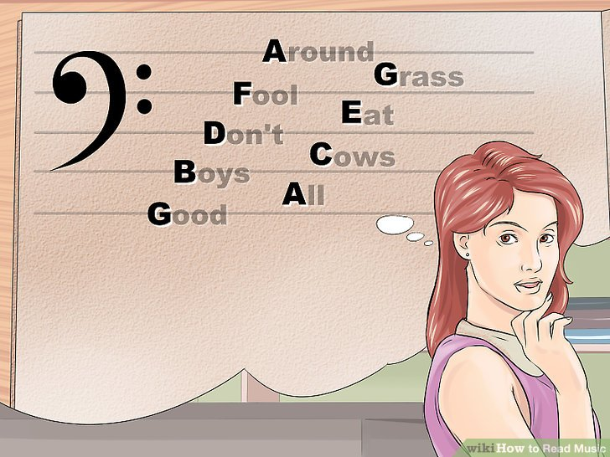](https://www.wikihow.com/Read-Music#/Image:Read-Music-Step-3.jpg)

**3** **Understand the Bass Clef.** The bass clef, also known as the F clef, is used for instruments in the lower registers, including the left hand of the piano, bass guitar, trombone, and so on.

* + The name "F clef" derives from its origins as the Gothic letter F. The two dots on the clef lie above and below the "F" line on the staff. The staff of the bass clef represents different notes than that of the treble clef.
  + The five lines, bottom to top, represent these notes: G B D F A (Good Boys Don't Fool Around).
  + The four spaces, bottom to top, represent these notes: A C E G (All Cows Eat Grass).

[[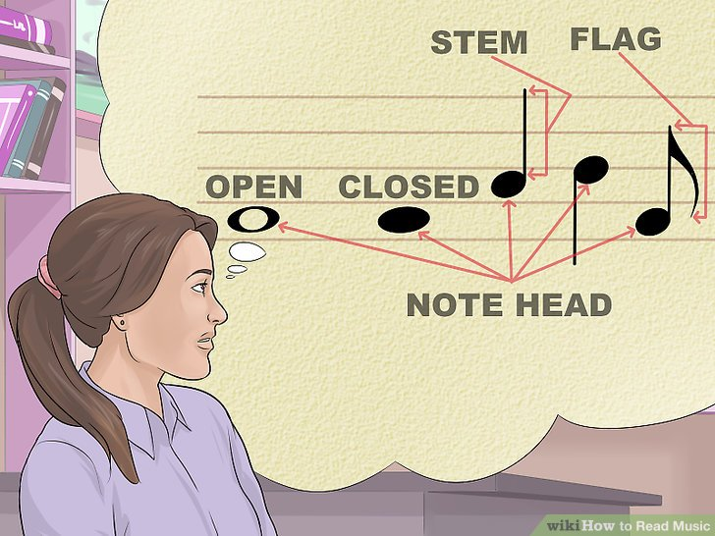](https://www.wikihow.com/Read-Music#/Image:Read-Music-Step-4.jpg)](https://www.wikihow.com/Read-Music" \l "/Image:Read-Music-Step-4.jpg)

**4** **Learn the parts of a note.** Individual note symbols are a combination of up to three basic elements: the note head, the stem, and flags.

* + **The note head**. This is an oval shape that is either open (white) or closed (black). At its most basic, it tells the performer what note to play on their instrument.
  + **The stem**. This is the thin vertical line that is attached to the note head. When the stem is pointing up, it joins on the right side of the note head. When the stem is pointing down, it joins the note head on the left. The direction of the stem has no effect on the note, but it makes notation easier to read and less cluttered.
  + The general rule on stem direction is that at or above the center line of the staff, the stem points down, and when the note is below the middle of the staff, the stem points up.
  + **The flag**. This is the curved stroke that is attached to the end of the stem. No matter if the stem is joined to the right or left of the note head, the flag is *always* drawn to the right of the stem, and never to the left!
  + Taken together, the note, stem, and flag or flags show the musician the time value for any given note, as measured in beats or fractions of beats. When you listen to music, and you're tapping your foot in time to the music, you're recognizing that beat.

**Score  
8 / 8**

Part 1 Quiz

What clef will you pay attention to if you are singing in the higher range?

Top of Form

The bass clef.

Definitely not! If you are sining or playing an instrument in a high range, you won't focus on the bass clef. The bass clef looks like a backwards "C" while the treble clef looks more like a "G." Click on another answer to find the right one...

The treble clef.

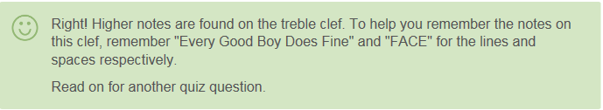

Right! Higher notes are found on the treble clef. To help you remember the notes on this clef, remember "Every Good Boy Does Fine" and "FACE" for the lines and spaces respectively. Read on for another quiz question.

The "F" clef.

Not quite! The "F" clef is another name for the bass clef, which has lower notes. To remember the notes of the bass clef, remember "Good Boys Don't Fool Around" and "All Cows Eat Grass." Pick another answer!

All of the above.

Nope! If you are singing in a high range, you'll only need to pay attention to one of the previous clefs. Keep in mind, though, that if you're playing the piano with both hands, you'll need to watch more than one clef! Try again...

Bottom of Form

### Part 2

### Meter and Time

[[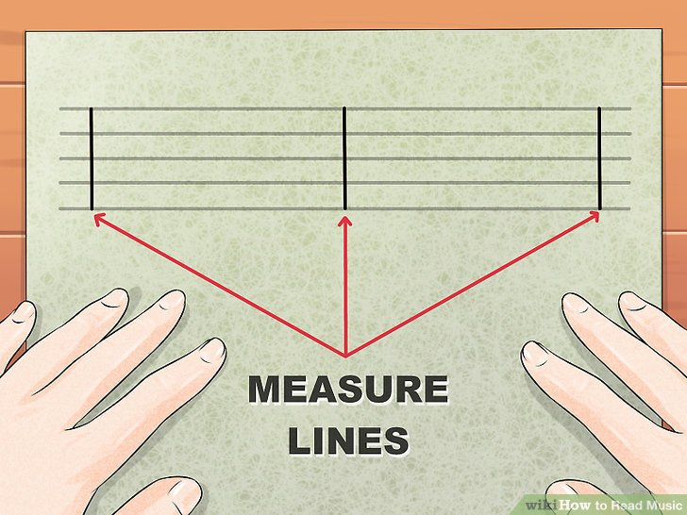](https://www.wikihow.com/Read-Music#/Image:Read-Music-Step-5.jpg)](https://www.wikihow.com/Read-Music" \l "/Image:Read-Music-Step-5.jpg)

**1** **Learn about measure lines.** On a piece of sheet music, you will see thin vertical lines crossing the staff at fairly regular intervals. These lines represent *measures* — the space before the first line is the first measure, the space between the first and second lines is the second measure, and so on. Measure lines don't affect how the music sounds, but they help the performer keep their place in the music.

* + As we'll see below, another handy thing about measures is that *each one gets the same number of beats.* For example, if you find yourself tapping "1-2-3-4" along to a piece of music on the radio, you've probably subconsciously found the measure lines already.

[[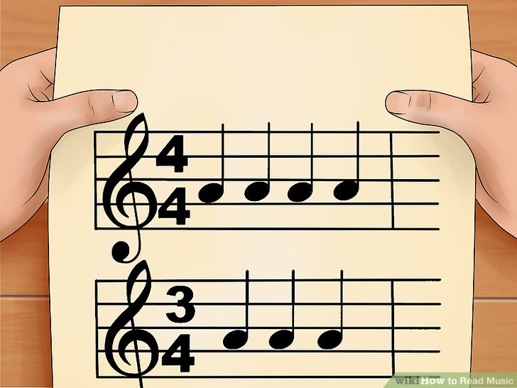](https://www.wikihow.com/Read-Music#/Image:2667-6-1.jpg)](https://www.wikihow.com/Read-Music" \l "/Image:2667-6-1.jpg)

**2** **Learn about timing, or meter.** Meter can be generally thought of as the "pulse" or the beat of music. You feel it instinctively when you listen to dance or pop music — the "boom, tiss, boom, tiss" of a stereotypical dance track is a simple example of meter.

* + On a piece of sheet music, the beat is expressed by something that looks like a fraction written next to the first clef symbol. Like any fraction, there is a numerator, and a denominator. The numerator, written in the top two spaces of the staff, tells you how many beats there are in one measure. The denominator tells you the note value that receives one beat (the "pulse" that you tap your toe to).
  + Perhaps the easiest meter to understand is 4/4 time, or "common" time. In 4/4 time, there are four beats in each measure and each quarter note is equal to one beat. This is the time signature you'll hear in most popular music. You can count along to common time music by counting "ONE two three four ONE two three four..." to the beat.
  + By changing the numerator, we change the number of beats in a measure. Another very common time signature is 3/4. For example, most waltzes will have a steady "ONE two three ONE two three" beat, making them in 3/4 time.
  + Some meters will be shown with a letter C instead of two numbers. 4/4 time is often shown as a big C, which stands for Common time. Likewise, 2/2 meter is often shown as a big C with a vertical line through it. The C with the line through it stands for Cut time.

**Score  
8 / 8**

Part 2 Quiz

How many beats does a piece of music written in 3/4 time have in each measure?

Top of Form

3

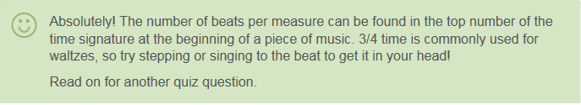

Absolutely! The number of beats per measure can be found in the top number of the time signature at the beginning of a piece of music. 3/4 time is commonly used for waltzes, so try stepping or singing to the beat to get it in your head! Read on for another quiz question.

4

Not quite! The bottom number in the time signature tells you the type of note that receives the beat. In 3/4 time, the quarter note will receive one beat. Choose another answer!

7

Nope! Don't add the numbers of the time signature together! When you first start learning how to read music, stick with common 4/4 time to get the hang of reading music and understanding meter. Guess again!

It depends on the types of notes

Definitely not! The types of notes in each measure have to add up to the correct number of beats as shown in the time signature, not the other way around! The time signature can be found at the beginning of each piece of music, and the top number will tell you how many beats are in each measure of music. Click on another answer to find the right one...

Bottom of Form

### Part 3

### Rhythm

[[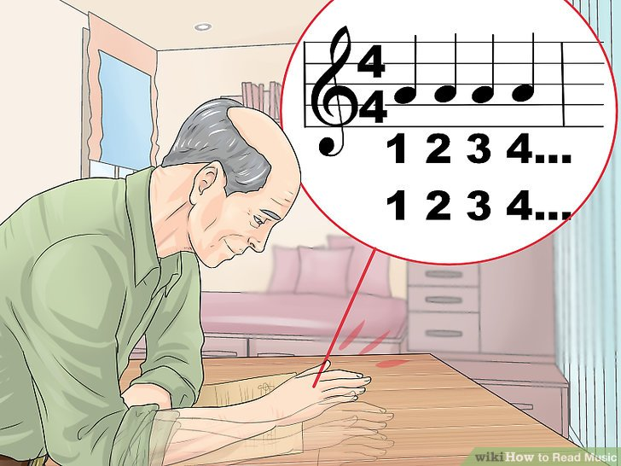](https://www.wikihow.com/Read-Music#/Image:Read-Music-Step-7.jpg)](https://www.wikihow.com/Read-Music" \l "/Image:Read-Music-Step-7.jpg)

**1** **Get in the groove.** Since it incorporates meter and time, "rhythm" is a crucial part of how the music feels. However, whereas meter simply tells you how many beats, rhythm is how those beats are used.

* + Try this: tap your finger on your desk, and count 1-2-3-4 1-2-3-4, steadily. Not very interesting, is it? Now try this: on beats 1 and 3, tap louder, and on beats 2 and 4, tap softer. That's got a different feel to it! Now try the reverse: tapping loud on 2 and 4, and soft on beats 1 and 3.
  + Check out Regina Spektor's [Don't Leave Me](http://www.youtube.com/watch?v=BWXWivwhi14). You can clearly hear the rhythm: the quieter bass note happens on beat 1 and beat 3, and a loud clap and snare drum happens on beats 2 and 4. You'll start to get a sense of how music is organized. That's what we call rhythm!

[[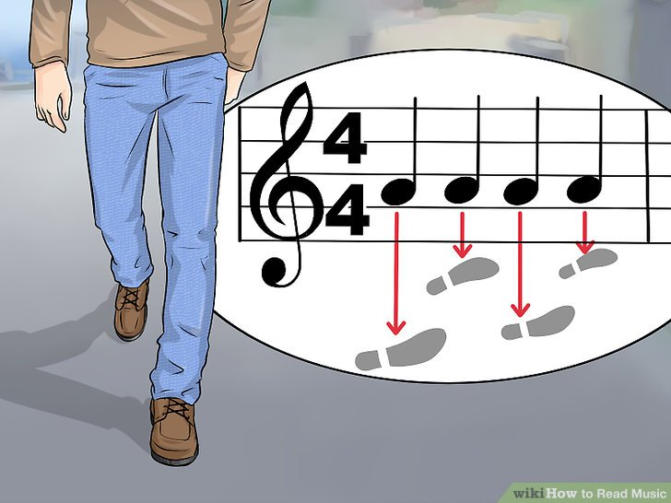](https://www.wikihow.com/Read-Music#/Image:Read-Music-Step-8.jpg)](https://www.wikihow.com/Read-Music" \l "/Image:Read-Music-Step-8.jpg)

**2** **Imagine yourself walking.** Each footstep will equal one beat. Those are represented musically by quarter notes, because in much of Western music (meaning music of the western world, not just the music of Hank Williams!), there are four of these beats for every measure. Musically, the rhythm of your walking will look like this:

* + Each step is one quarter note. On a sheet of music, quarter notes are the solid black dots attached to stems without any flags. You can count that off as you walk: "1, 2, 3, 4-1, 2, 3, 4"
  + If you were to slow your pace down to half that speed, so that you only took a step every two beats on the 1 and on the 3, that would be notated with half notes (for half a measure). On a sheet of music, half notes look like quarter notes, only they aren't solid black — they are outlined in black with white centers.
  + If you slowed your pace down even further, so that you only took a step every four beats, on the 1, you would write that as a whole note—or one note per measure. On a sheet of music, whole notes look like "Os" or donuts — similar to half notes without stems.

[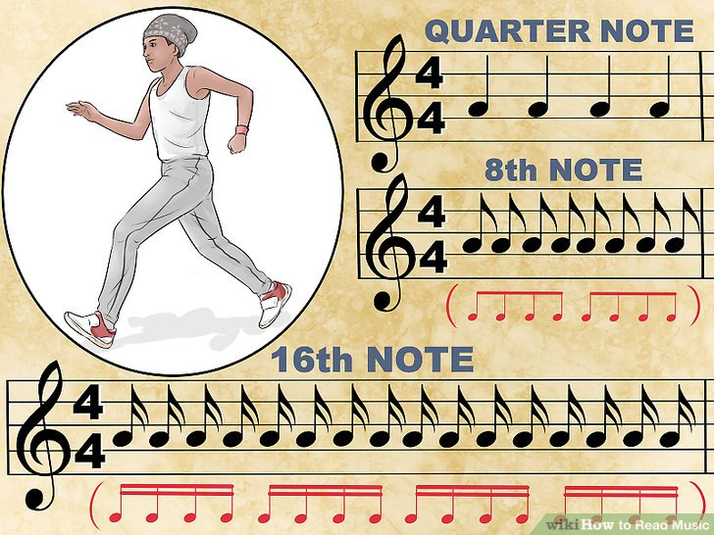](https://www.wikihow.com/Read-Music#/Image:Read-Music-Step-9.jpg)

**3** **Pick up the pace!** Enough of this slowing down. As you noticed, as we slowed the notes down, we started taking away bits of the note. First we took away the solid note, then we took away the stem. Now let's look at speeding things up. To do that, we're going to add things to the note.

* + Go back to our walking tempo, and picture that in your mind (tapping your foot to the beat can help). Now imagine that your bus has just pulled up to the stop, and you're about a block away. What do you do? You run! And as you run, you try to *flag* the bus driver.
  + To make notes faster in music, we add a flag. Each flag cuts the time value of the note in half. For example, an eighth note (which gets one flag) is 1/2 the value of a quarter note; and a 16th note (which gets two flags) is 1/2 the value of an eighth note. In terms of walking, we go from a walk (quarter note) to a run (8th note)—twice as fast as a walk, to a sprint (16th note)—twice as fast as a run. Thinking in terms of each quarter note being a step as you walk, tap along with the example above.

[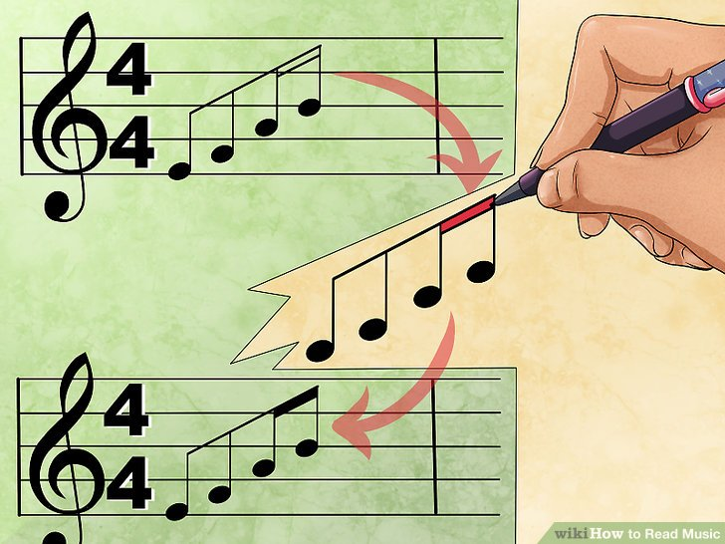](https://www.wikihow.com/Read-Music#/Image:Read-Music-Step-10.jpg)

[[](https://www.wikihow.com/Read-Music#/Image:Read-Music-Step-10.jpg)](<img alt=\"Image titled Read Music Step 10\" src=\"https://www.wikihow.com/images/thumb/f/fd/Read-Music-Step-10.jpg/aid2667-v4-728px-Read-Music-Step-10.jpg\" width=\"728\" height=\"546\" class=\"whcdn content-fill\">)

**4** **Beam me up!** As you can see with that above example, things can start to get a little confusing when there are a bunch of notes on the page like that. Your eyes start to cross, and you lose track of where you were. To group notes into smaller packages that make sense visually, we use *beaming*.

* + Beaming merely replaces individual note flags with thick lines drawn between note stems. These are grouped logically, and while more complex music requires more complex beaming rules, for our purposes, we'll generally beam in groups of quarter notes. Compare the example below with the example above. Try tapping out the rhythm again, and see how much clearer beaming makes the notation.

[[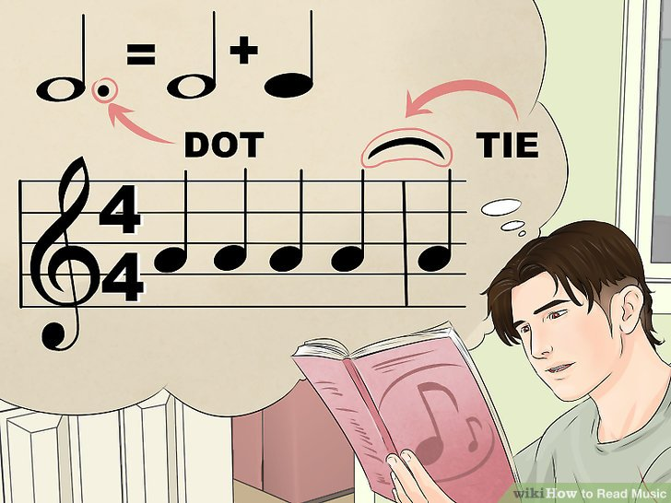](https://www.wikihow.com/Read-Music#/Image:Read-Music-Step-11.jpg)](https://www.wikihow.com/Read-Music" \l "/Image:Read-Music-Step-11.jpg)

**5** **Learn the value of ties and dots.** Where a flag will cut the value of a note in half, the dot has a similar—but opposite—function. With limited exceptions that do not come into play here, the dot is always placed to the right of the note head. When you see a dotted note, that note is increased by one half the length of its original value.

* + For example, a dot placed after a half note will be equal to the half note plus a quarter note. A dot placed after a quarter note will be equal to a quarter note plus an eighth note.
  + Ties are similar to dots—they extend the value of the original note. A tie is simply two notes linked together with a curved line between the note heads. Unlike dots, which are abstract and based wholly on the value of the original note, ties are explicit: the note is increased in length by exactly as long as the second note value.
  + One reason you would use a tie versus a dot is, for example, when a note's duration would not fit musically into the space of a measure. In that case, you simply add the leftover duration into the next measure as a note, and tie the two together.
  + Note that the tie is drawn from note head to note head in the opposite direction as the stem.

[[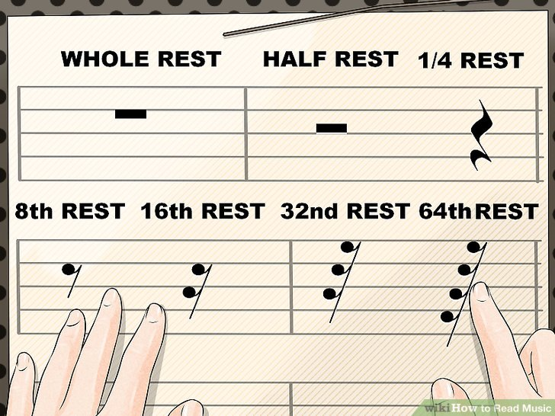](https://www.wikihow.com/Read-Music#/Image:Read-Music-Step-12.jpg)](https://www.wikihow.com/Read-Music" \l "/Image:Read-Music-Step-12.jpg)

**6** **Take a rest.** Some say music is just a series of notes, and they're half correct. Music is series of notes and the spaces between them. Those spaces are called *rests*, and even in silence, they can really add motion and life to music. Let's take a look at how they're notated.

* + Like notes, they have specific symbols for specific durations. A whole note rest is a rectangle descending from the 4th line, and a half note rest is a rectangle resting on the 3rd line and pointing upwards. The quarter note rest is a squiggly line, and the rest of the rests are an angled bar that looks like a number "7" with the same number of flags as their equivalent note value. These flags *always* sweep to the left.

**Score  
8 / 8**

Part 3 Quiz

What do you do if you come to a rest symbol in the music?

Top of Form

Double the length of the most recent note.

Definitely not! If you are supposed to double the length of the note, there will be other notations in the music. For example, if you are supposed to add the length of half of the note's original value, you'll see a dot next to the note. Try again...

Ignore the next note.

Nope! A rest is just like a regular note in that it isn't giving you information for the future! If you see a line connecting a couple of notes, though, this means that you should connect the two and not breathe or stop playing/singing between the two. Click on another answer to find the right one...

Stop playing for a certain amount of time.

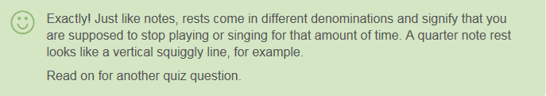

Exactly! Just like notes, rests come in different denominations and signify that you are supposed to stop playing or singing for that amount of time. A quarter note rest looks like a vertical squiggly line, for example. Read on for another quiz question.

Play the next notes softer.

Not quite! Any directions in the music about how loud or soft to play will be written in words. A rest is giving you a different direction! Choose another answer!

Bottom of Form

### Part 4

### Melody

[[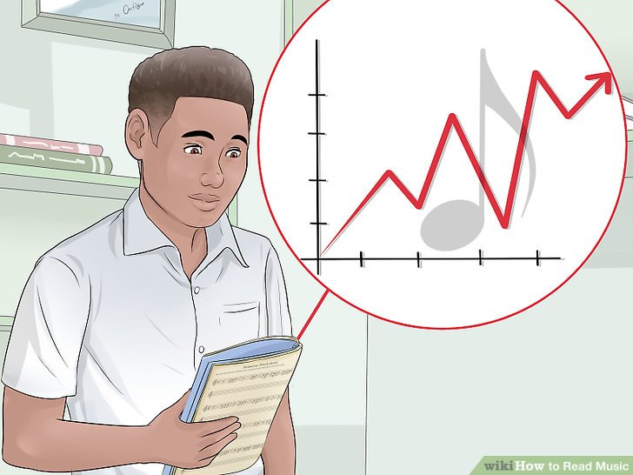](https://www.wikihow.com/Read-Music#/Image:Read-Music-Step-13.jpg)](https://www.wikihow.com/Read-Music" \l "/Image:Read-Music-Step-13.jpg)

**1** **We now have the basics down:** the staff, the parts of a note, and the basics of notating durations of notes and rests. Make sure you understand the above, and then let's dive into the fun stuff: reading music!

[[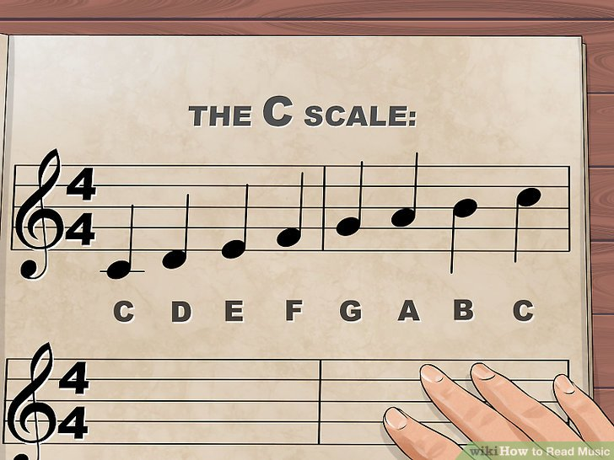](https://www.wikihow.com/Read-Music#/Image:Read-Music-Step-14.jpg)](https://www.wikihow.com/Read-Music" \l "/Image:Read-Music-Step-14.jpg)

**2** **Learn the C scale.** The C Major scale is the first scale we use when teaching how to read music because it's the one that uses just the white keys. Once you have that locked into your brain cells, the rest will follow naturally.

* + First, we'll show you what it looks like, then we'll show you how to make sense of it, and begin to read music! Here's what it looks like on the staff. See the "C scale" above.
  + If you'll take a look at the first note, the low C, you'll see that it actually goes below the staff lines. When that happens, we simply add a staff line for that note only—thus, the little line through the note head. The lower the note, the more staff lines we add. But we don't need to worry about that now.
  + The C scale is made up of eight notes. These are the equivalent of the white keys on the piano.
  + You may or may not have a piano handy, but at this point, it's important for you to begin to get an idea of not just what music looks like, but of what it *sounds* like, too.

[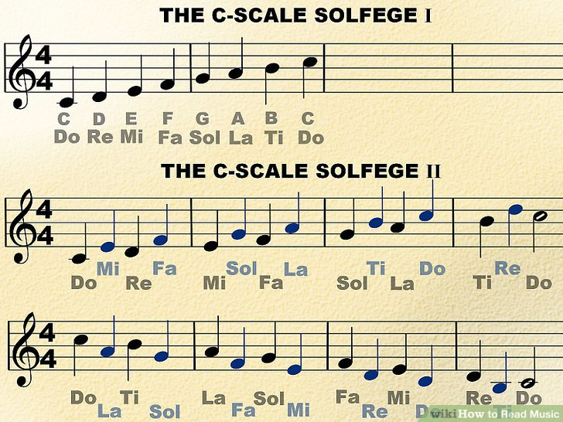](https://www.wikihow.com/Read-Music#/Image:Read-Music-Step-15.jpg)

**3** **Learn a little** [**sight singing**](https://www.wikihow.com/Sight-Sing)**—or "solfège.**" That may sound intimidating, but chances are, you already know it: it's the fancy way of saying "do, re, mi."

* + By learning to sing the notes that you see, you'll begin to develop the skill of sight reading—a skill that can take a lifetime to perfect, but will be useful right from the beginning. Let's take a look at that C scale again, with the solfege scale added. See the "C Scale Solfege 11" above.
  + Chances are, you know the Rogers and Hammerstein song "Do-Re-Mi" from *The Sound of Music.* If you can sing the "do re mi" scale, do that now while you look at the notes. If you need a refresher course, you can hear the song on [YouTube](http://www.youtube.com/watch?v=1RW3nDRmu6k).
  + Here's a slightly more advanced version, walking up and down the C scale using the solfège notes. See the "C Scale Solfege 1" above.
  + Practice singing Solfege—part II a few times, until it becomes familiar. The first couple times, read very slowly so that you can look at each note as you sing it. The next couple times, substitute the "do re me" for C, D, E. The goal is to sing the actual notes.
  + Remember our note values from before: the high C at the end of the first line, and the low C at the end of the second line are half notes, while the rest of the notes are quarter notes. If you imagine yourself walking, again, there is a note for each step. The half notes take two steps.

[[](https://www.wikihow.com/Read-Music#/Image:Read-Music-Step-16.jpg)](https://www.wikihow.com/Read-Music" \l "/Image:Read-Music-Step-16.jpg)

**4**

**Congratulations, you're now reading music!**

**Score  
8 / 8**

Part 4 Quiz

Why do most beginners start by learning the C scale?

Top of Form

It is the shortest scale.

Definitely not! All scales have eight notes, so don't try to find the shortest or longest scale to learn! Learning multiple scales will help you learn how different notes sound-- this will certainly help when you start reading music quickly! There’s a better option out there!

It includes all of the white keys on a keyboard.

Not exactly! While the C scale is made up of white keys, it will not touch every single white key on the keyboard! Keep in mind that a scale only has eight notes in it! Pick another answer!

It only includes white keys on a keyboard.

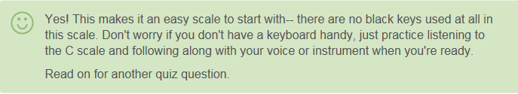

Yes! This makes it an easy scale to start with-- there are no black keys used at all in this scale. Don't worry if you don't have a keyboard handy, just practice listening to the C scale and following along with your voice or instrument when you're ready. Read on for another quiz question.

It is the only scale with words.

Nope! You can use solfege-- do, re, me-- with any scale. Practice singing solfege with the C scale first, and then move up and down so you're singing the words with other scales, too. Choose another answer!

Bottom of Form

### Part 5

### Sharps, Flats, Naturals, and Keys

[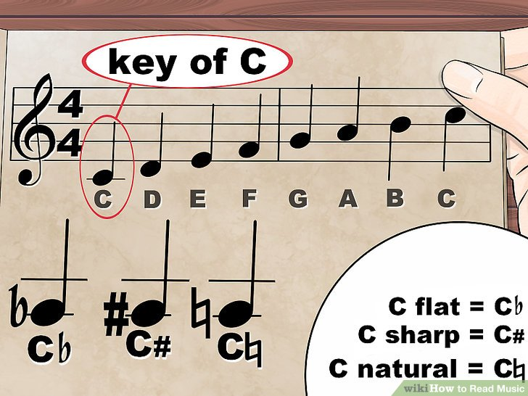](https://www.wikihow.com/Read-Music#/Image:Read-Music-Step-17.jpg)**1**

**Take the next step.** So far we've covered the very basics of rhythm and melody, and you should possess the basic skills necessary that you now understand what all those dots and squiggles represent. While this might get you through basic Flutophone class, there are still a few more things you'll want to know. Chief among these are key signatures.

* + You may have seen sharps and flats in music: a sharp looks like a hashtag (♯) and a flat looks like a lowercase B (♭). They are placed to the left of a note head and indicate that the note to follow is played a half-step higher (for a sharp), or a half-step lower (for a flat). The C scale, as we learned, comprises the white keys on the piano. When you're beginning to read music, it's easiest to think of the sharps and flats as the black keys. C major has no sharps or flats.

[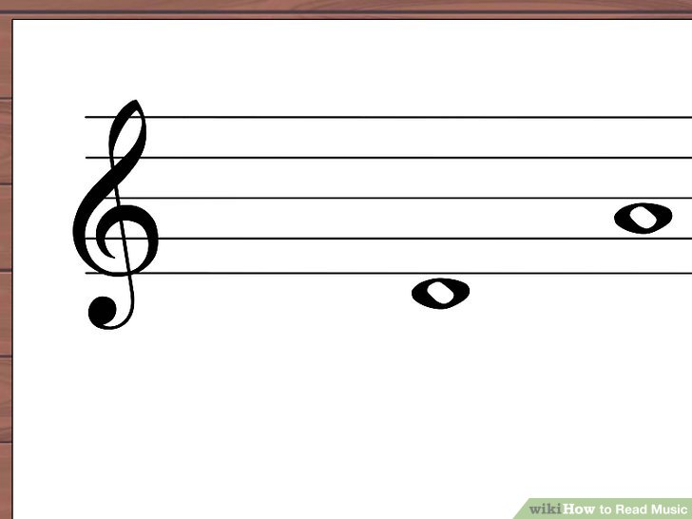](https://www.wikihow.com/Read-Music#/Image:Read-Music-for-the-Violin-Step-3-Version-2.jpg)

**2**

**Whole tones and semitones.** In western music, notes are either a whole tone or a semitone apart. If you look at the C note on the piano keyboard, you’ll see there’s a black key between it and the next note up, the D. The musical distance between the C and the D is called a whole tone. The distance between the C and the black key is called a semitone. Now, you may be wondering what that black key is called. The answer is, “it depends.”

* + A good rule of thumb is if you are going up the scale, that note is the sharp version of the beginning note. When moving down the scale, that note would be the flat version of the beginning note. Thus, if you are moving from C to D with the black key, it would be written using a sharp (♯).
  + In this case, the black note is written as C#. When moving down the scale, from D to C and using the black note as a passing tone between them, the black key would be written using a flat (♭).
  + Conventions like that makes music a little easier to read. If you were to write those three notes going up and used a D♭ instead of a C#, the notation would be written using a natural sign (♮).
  + Notice that there's a new sign—the natural. Whenever you see a natural sign (♮) that means that the note cancels any sharps or flats previously written. In this example, the second and third notes are both D's: the first a D♭, and so the second D, since it goes up a semitone from the first D, has to have the note "corrected" to show the right note. The more sharps and flats scattered around a sheet of music, the more a musician must take in before the score can be played.
  + Often, composers that previously used accidentals in previous measures may put "unnecessary" natural signs to provide clarity for the player. For example, if a previous measure in a D major piece used an A#, the next measure that uses an A may be notated with an A-natural instead.

[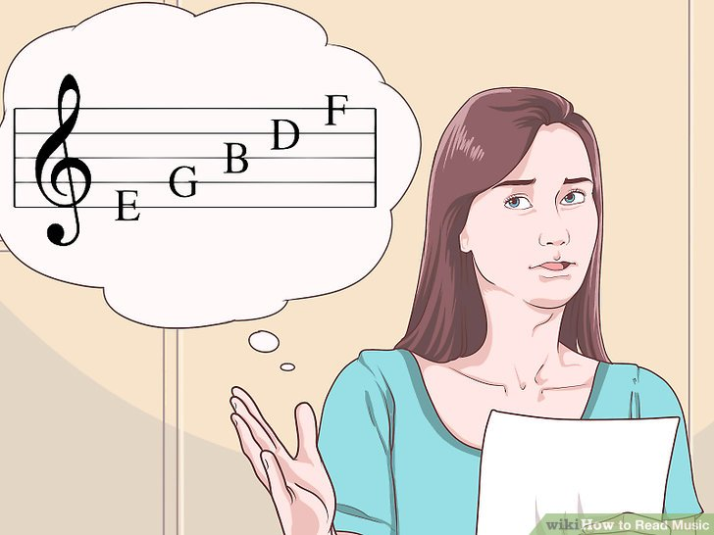](https://www.wikihow.com/Read-Music#/Image:Sight-Read-Music-Step-3-Version-2.jpg)

**3** **Understanding key signatures.** So far, we've been looking at the C major scale: eight notes, all the white keys, starting on C. However, you can start a scale on *any* note. If you just play all the white keys, though, you will not be playing a major scale, but something called a "modal scale," which is beyond the scope of this article.

* + The starting note, or *tonic*, is also the name of the key. You may have heard somebody say "It's in the key of C" or something similar. This example means that the basic scale starts on C, and includes the notes C D E F G A B C. The notes in a major scale have a very specific relationship to each other. Take a look at the keyboard above.
  + Note that between most notes, there is a whole step. But there is only a half step (semitone) between E and F, and between B and C. Every major scale has this same relationship: whole-whole-half-whole-whole-whole-half. If you start your scale on G, for example, it could be written like this:
  + Notice the F# near the top. In order to maintain the proper relationship, the F has to be raised a semitone so that it's a half step from the G, not a whole step. That's easy enough to read by itself, but what if you started a major scale in C#? (See above.)
  + Now it starts to get complicated! In order to cut down the confusion and make music easier to read, key signatures were created. Each major scale has a particular set of sharps or flats, and those are shown at the very beginning of the music. Looking again at the key of G, we notice that has one sharp—F#. Instead of putting that sharp next to the F on the staff, we move it all the way to the left, and it is just assumed from that point on that every F you see is played as an F#. (See above picture.)
  + This sounds, and is played, exactly the same as the G major scale above, with no key signature. See the Key Signatures section below for a full list of all key signatures.

**Score  
8 / 8**

Part 5 Quiz

What is the difference between a sharp and a flat?

Top of Form

A sharp is a black key while a flat is a white key.

Nope! All flats and sharps will be black keys on a keyboard. When you are sightreading a piece of music, look out for flat and sharp symbols next to notes in addition to checking the key signature. Click on another answer to find the right one...

A sharp is higher while a flat is lower.

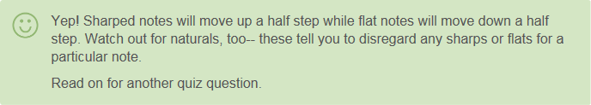

Yep! Sharped notes will move up a half step while flat notes will move down a half step. Watch out for naturals, too-- these tell you to disregard any sharps or flats for a particular note. Read on for another quiz question.

A sharp is signified in the key of the piece while a flat is signified by a symbol next to a note.

Not exactly! Both sharps and flats can be in the key signature as well as signified by symbols next to notes. The sharp symbol looks like a little hashtag while the flat symbol looks like a "b." Try another answer...

Only "G" notes can be sharp while only "B" notes can be flat.

Definitely not! Any note can be sharp or flat. Pay attention to the key signature of the piece to know what notes will be flat or sharp. Pick another answer!

Bottom of Form

### Part 6

### Dynamics and Expression

[[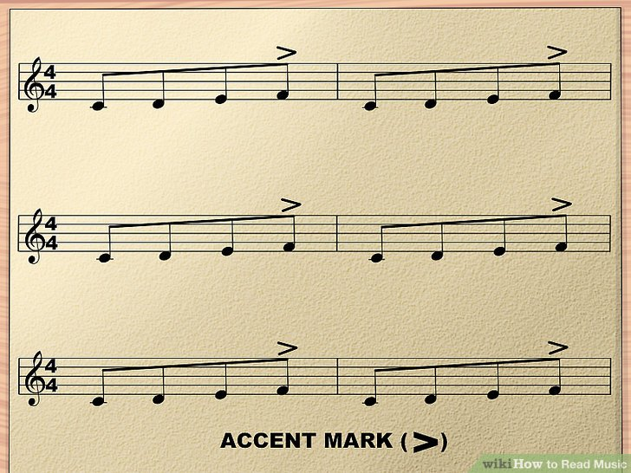](https://www.wikihow.com/Read-Music#/Image:Read-Music-Step-20.jpg)](https://www.wikihow.com/Read-Music" \l "/Image:Read-Music-Step-20.jpg)

**1** **Get loud—or get soft!** When you listen to music, you have probably noticed that it's not all at the same volume, all the time. Some parts get really loud, and some parts get really soft. These variations are known as "dynamics."

* + If the rhythm and meter are the heart of the music, and notes and keys are the brains, then dynamics are surely the voice of the music. Consider the first version above.
  + On your table, tap out: 1 and 2 and 3 and 4 and 5 and 6 and 7 and 8, etc. (the *and* is how musicians "say" eighth notes). Make sure every beat is tapped at the same loudness, so that it so it sounds sort of like a helicopter. Now take a look at the second version.
  + Notice the accent mark (>) above every 4th C note. Tap that out, only this time, accent every beat that you see the accent mark. Now, instead of a helicopter, it should sound more like a train. With just a subtle shift in accent, we completely change the character of the music!

[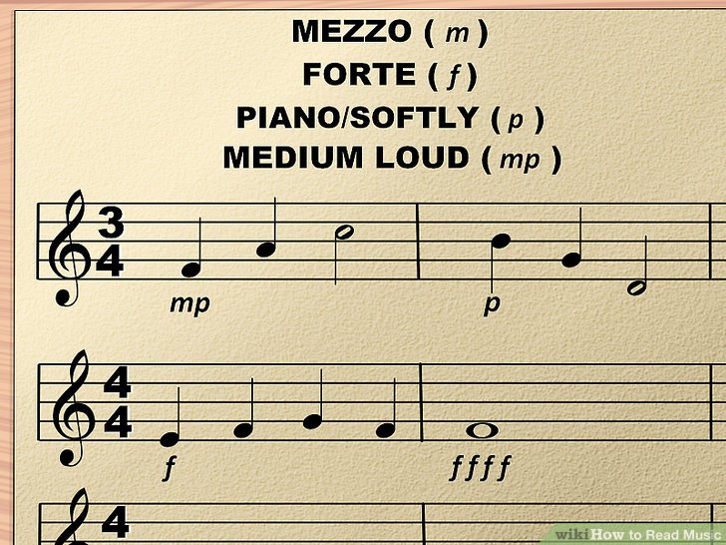](https://www.wikihow.com/Read-Music#/Image:Read-Music-Step-21-Version-2.jpg)

**2**

**Play it piano, or fortissimo, or somewhere in between.** Just like you don't always talk at the same level—you modulate your voice louder or softer, depending on the situation—music modulates in level too. The way the composer tells the musician what is intended is by using dynamic markings.

* + There are dozens of dynamic markings you may see on a piece of music, but some of the most common ones you'll find will be the letters *f*, *m*, and *p*.
  + ***p*** means "piano," or "softly."
  + ***f*** means "forte," or "loud."
  + ***m*** means "mezzo," or "medium." This modifies the dynamic after it, as in ***mf*** or ***mp***, which means "medium loud," or "medium soft."
  + The more ***p***s or ***f***s you have, the softer or louder the music is to be played. Try singing the example above (using solfège—the first note in this example is the tonic, or "do"), and use the dynamic markings to notice the difference.

[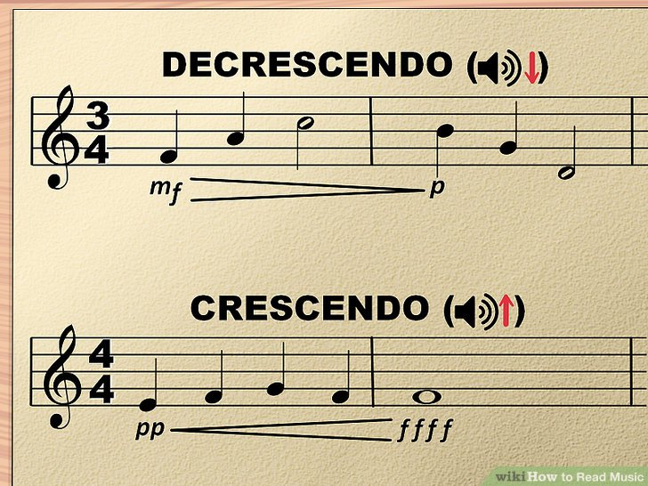](https://www.wikihow.com/Read-Music#/Image:Read-Music-Step-22-Version-2.jpg)

**3** **Get louder and louder and louder, or quieter and quieter and quieter.** Another very common dynamic notation is the *crescendo*, and it's corollary, the *decrescendo*. They are a visual representations of a gradual change in volume which look like stretched-out "<" and ">" symbols.

* + A crescendo gradually gets louder, and a decrescendo gradually decreases the volume. You'll notice that, with these two symbols, the "open" end of the symbol represents the louder dynamic and the closed end represents the quieter dynamic. For example, if the music directs you to gradually go from forte to piano, you'll see an ***f'****, then a stretched out "****>****", then a '****p'****.*

**Score  
8 / 8**

Part 6 Quiz

What are dynamics in a piece of music?

Top of Form

How loud or soft you're supposed to play.

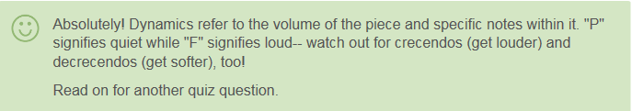

Absolutely! Dynamics refer to the volume of the piece and specific notes within it. "P" signifies quiet while "F" signifies loud-- watch out for crecendos (get louder) and decrecendos (get softer), too! Read on for another quiz question.

The average length of notes.

Nope! You won't see the average length of notes written anywhere on the piece-- there are other, more important pieces of information! As a beginner, it might be helpful to keep a cheat sheet of dynamic markings nearby so you know how to play each note! Choose another answer!

The style of music.

Not exactly! The style of a piece might affect the dynamics, but dynamics doesn't mean style! You may have to reserach the piece or listen to some recorded renditions of it to discover the style. Try another answer...

The overall mood of the piece.

Not quite! While the dynamics will contribute to the mood, dynamic markings themselves won't tell you the mood of the music! Look through the piece and identify the dynamics markings as you get more comfortable with the notes themselves. Guess again!

Bottom of Form

### Part 7

### Advancing

[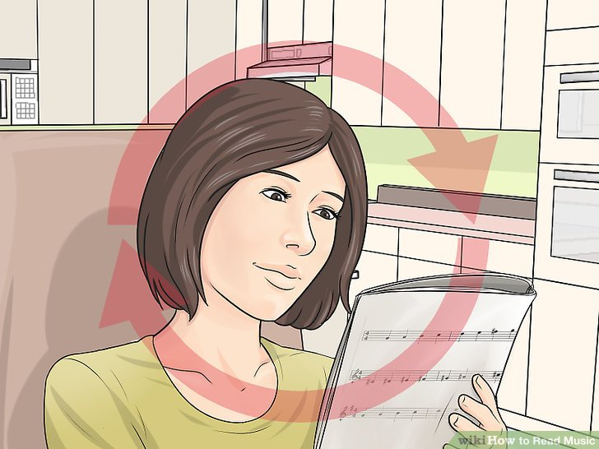](https://www.wikihow.com/Read-Music#/Image:Read-Music-Step-23.jpg)

**1** **Keep learning!** Learning to read music is like learning the alphabet. The basics take a little bit to learn, but are fairly easy, overall. However, there are so many nuances, concepts, and skills that you can learn that it can keep you learning for a lifetime. Some composers even go so far as to write music on staff lines that form spirals or patterns, or the even use no staff lines at all! This article should give you a good foundation to keep growing!

**Score  
8 / 8**

Part 7 Quiz

True or False: Once you've learned the basics, you will be able to read any piece of music easily.

Top of Form

True

Nope! Even if you can read basic or easy music, there is always more to learn! Try challenging yourself with more difficult pieces or new composers! Pick another answer!

False

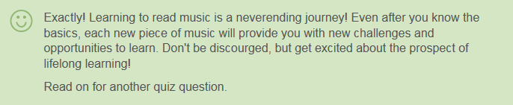

Exactly! Learning to read music is a neverending journey! Even after you know the basics, each new piece of music will provide you with new challenges and opportunities to learn. Don't be discourged, but get excited about the prospect of lifelong learning! Read on for another quiz question.

Bottom of Form

### Part 8

### Table of Key Signatures

[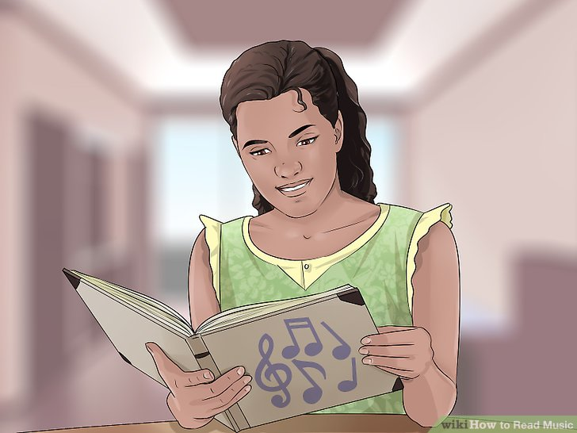](https://www.wikihow.com/Read-Music#/Image:Sing-Classically-Step-6.jpg)

**1** **Learn these key signatures.** There is at least one for every note in the scale—and the savvy student will see that in some cases, there are two keys for the same note. For example, the key of G# sounds exactly the same as the key of A♭! When playing the piano—and for the purposes of this article, the difference is academic. However, there are some composers—especially those that write for strings—who will suggest that the A♭ is played a little "flatter" than the G#. Here are the key signatures for the major scales:

* + Keys not using sharps or flats: C
  + Keys using sharps: G, D, A, E, B, F♯, C♯
  + Keys using flats: F, B♭, E♭, A♭, D♭, G♭, C♭
  + As you can see above, as you move through the sharp key signatures, you add sharps one at a time until every note is played sharp in the key of C♯. As you move through the flat key signatures, you add flats until every note is played flat in the key of C♭.
  + It may be of some comfort to know that composers usually write in key signatures that are comfortable for the player to read. D major is a very common key for string instruments to play because the open strings are closely related to the tonic, D. There are few works out there that have strings play in E♭ minor, or brass playing E major - it's as much a pain for them to write as it is for you to read.

**Score  
8 / 8**

Part 8 Quiz

What is the difference between the key of G# and the key of A flat if you are playing the piano?

Top of Form

A flat is "flatter."

Not quite! This might be the case if you are playing a string instrument, but not for the piano! On the piano, a flat is a flat-- there is no "flatter" way to play a note! Guess again!

G# is "sharper."

Nope! While you may be able to play a note "sharper" on a stringed instrument, this isn't possible on a piano or keyboard! Once you're familiar with the basic key signatures, you'll automatically know what each one means! Try again...

There is no difference.

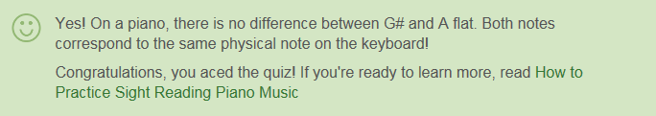

Yes! On a piano, there is no difference between G# and A flat. Both notes correspond to the same physical note on the keyboard! Congratulations, you aced the quiz! If you're ready to learn more, read [How to Practice Sight Reading Piano Music](https://www.wikihow.com/Practice-Sight-Reading-Piano-Music)

A flat is more common.

Not exactly! Generally, composers choose key signatures that align with instruments' natural abiilities, so it is equally likely that you'll encounter a piano piece in A flat or G#. Make sure you look at the key signature before you start playing a piece-- and mark any sharps or flats! Try again...

Bottom of Form