|  |  |  |
| --- | --- | --- |
| Input | Process | Output |
| Word pairs | -check for proper format  -parse each word  -check for word ladder solution  -prepare word ladder solution for output  -clear previous solution to prepare for next word pair if any | -display error message for improper input format or improper word  -display word ladder solution or no solution |
| Dictionary | -process file based off assignment 4 guidelines  -store dictionary into hashset stored as member variable in WordLadderSolver | None |

Assignment 4 IPO Diagram

Assignment 4 UML

Java Class

Assign4Driver

main(String[])

Java Class

NoSuchLadderException

Java Class

WordLadderSolver

**private** List<String> solutionList

**private** HashSet<String> dict

**private** HashSet<String> visited

computeLadder(String, String): List<String>

makeLadder(String, String, **int**): boolean

getDifferenceIndex(String, String): int

compareLetters(String, String): int

clear()

Java Interface

Assignment4Interface

computeLadder(String, String): List<String>

validateResult(String, String, List<String>): boolean

clear()

The algorithm needed for the driver logic (main method)

The main method first checks for the appropriate number of command line arguments. If this fails, the program exits after outputting an error message. Then it initializes a WordLadderSolver object with the appropriate dictionary input. Then it begins to read the word pair inputs. The main method checks for proper syntactical formatting when parsing the word pairs. The WordLadderSolver then takes the pair to find its word ladder if one exists. The main takes these results and outputs the ladder if there is one or an error message as appropriate. This process is repeated until there are no more lines in input file.

Use Case Diagram

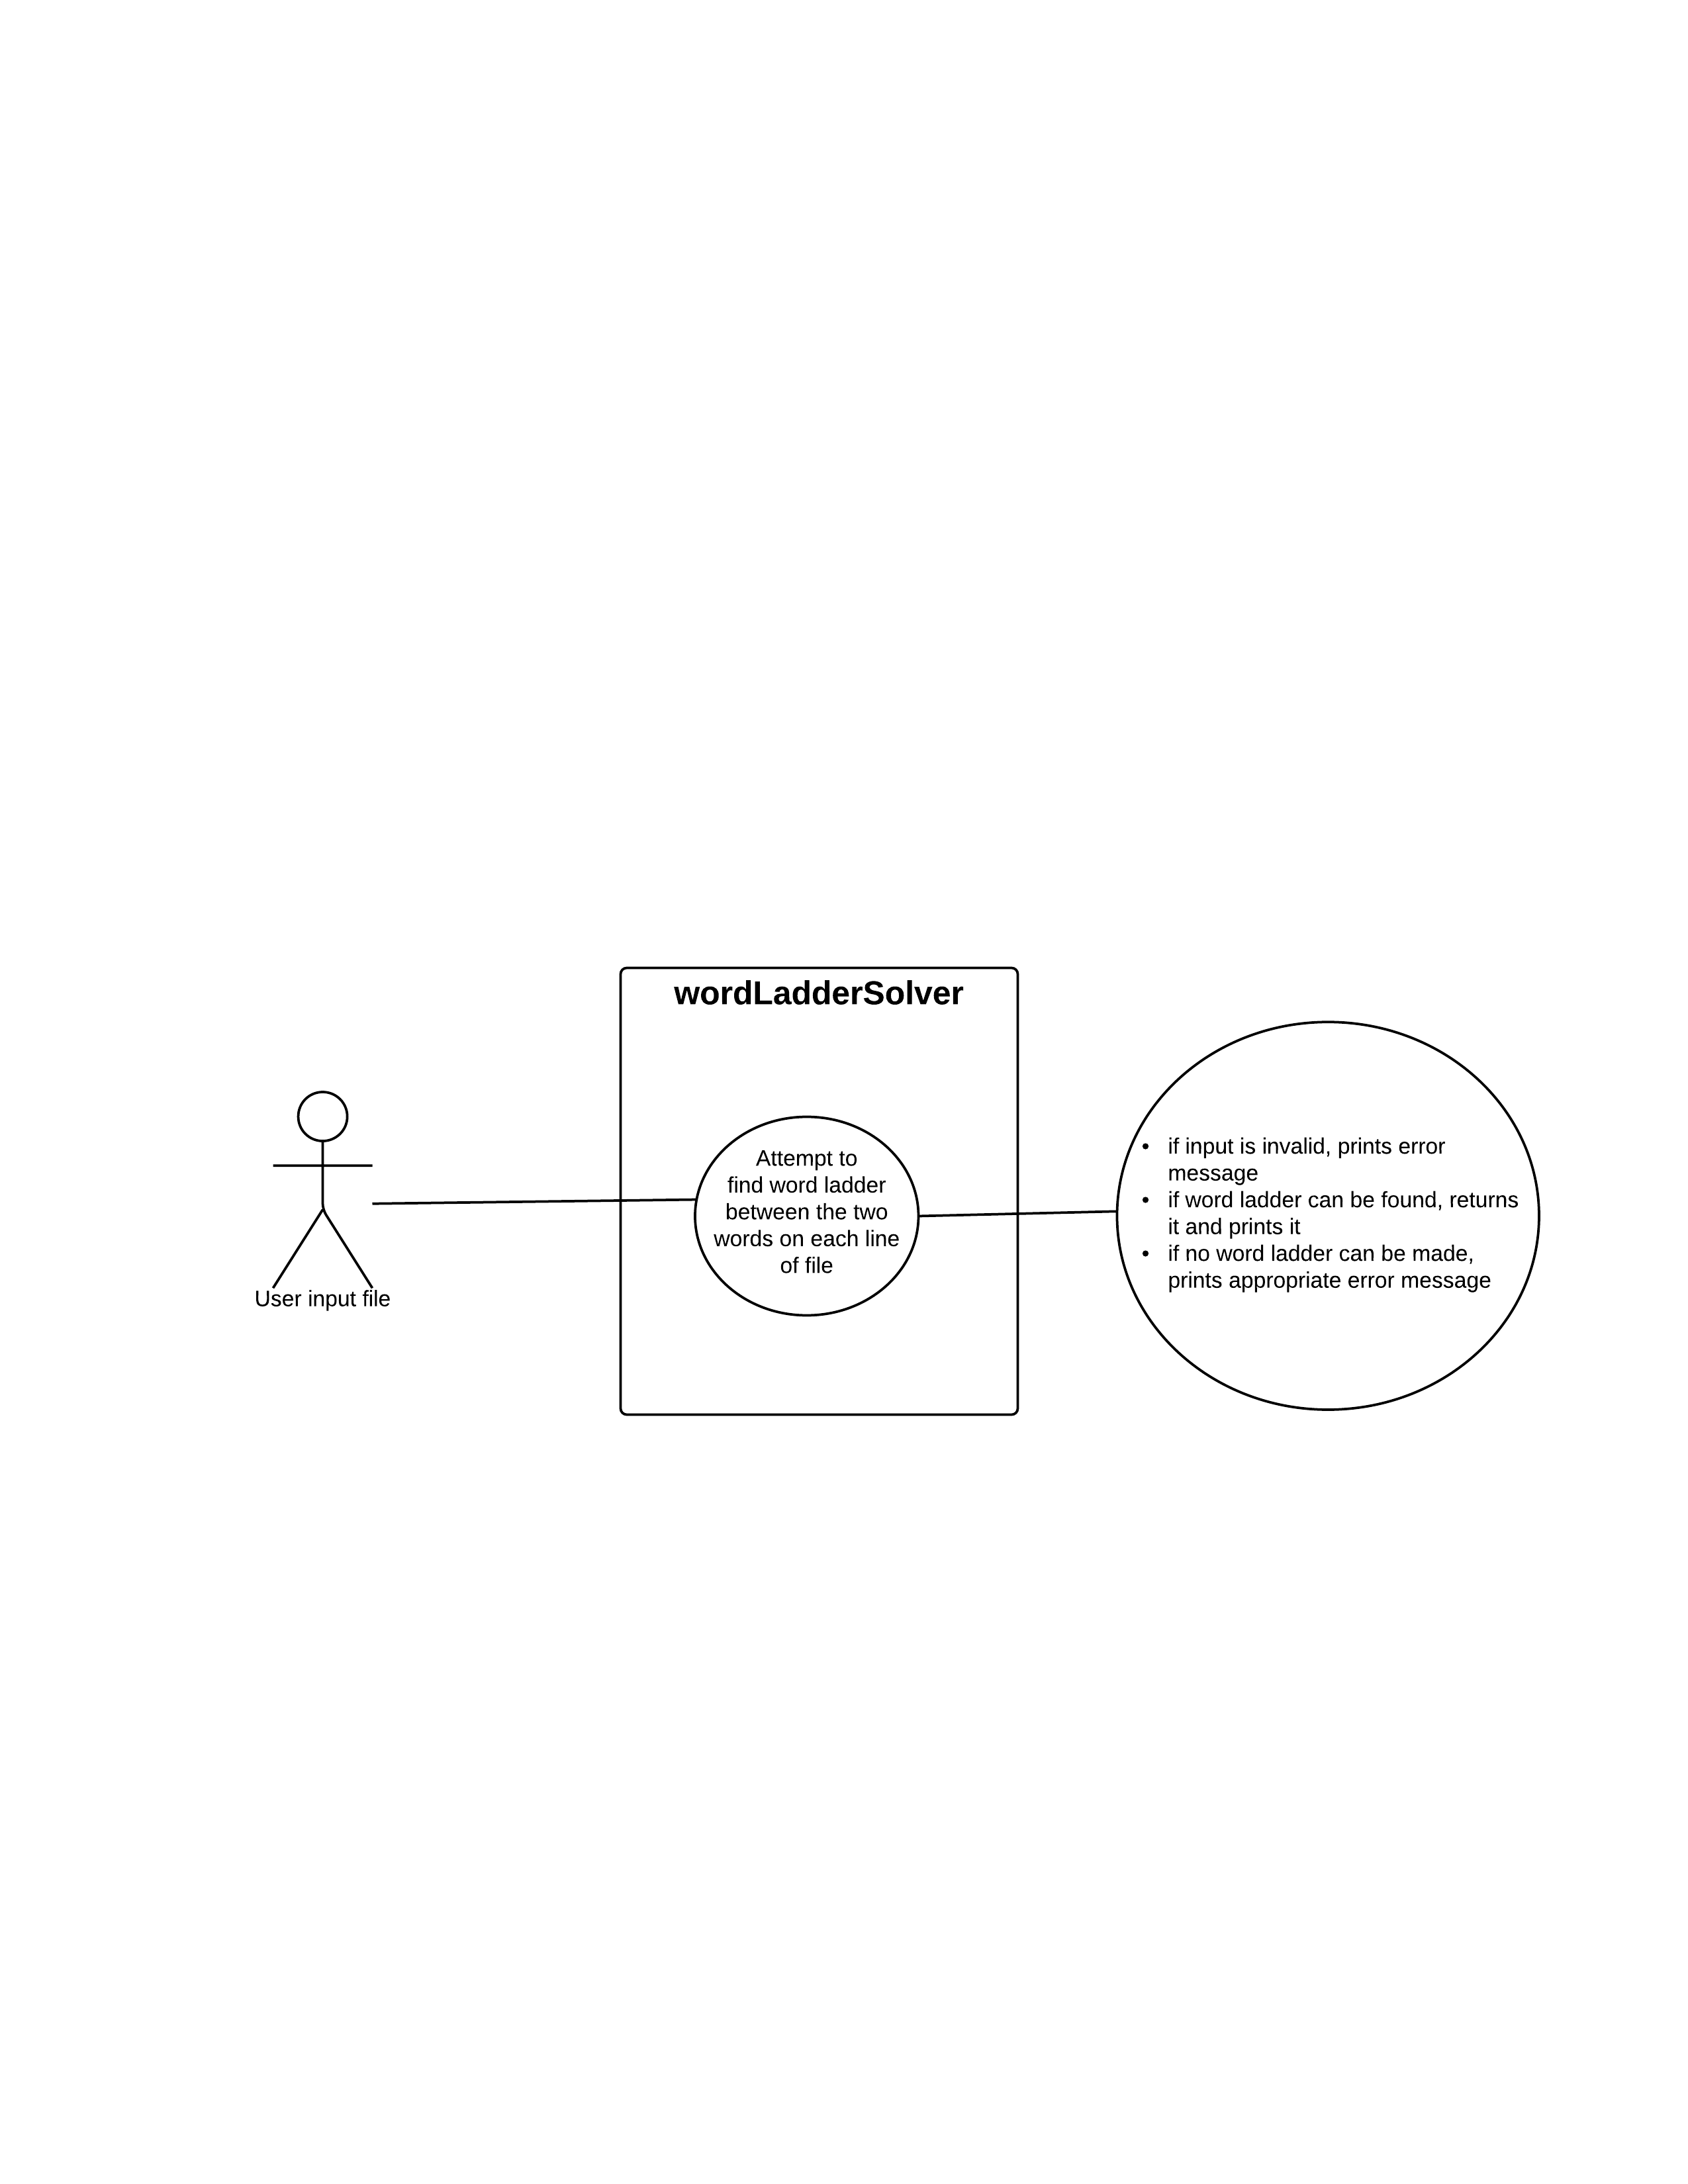

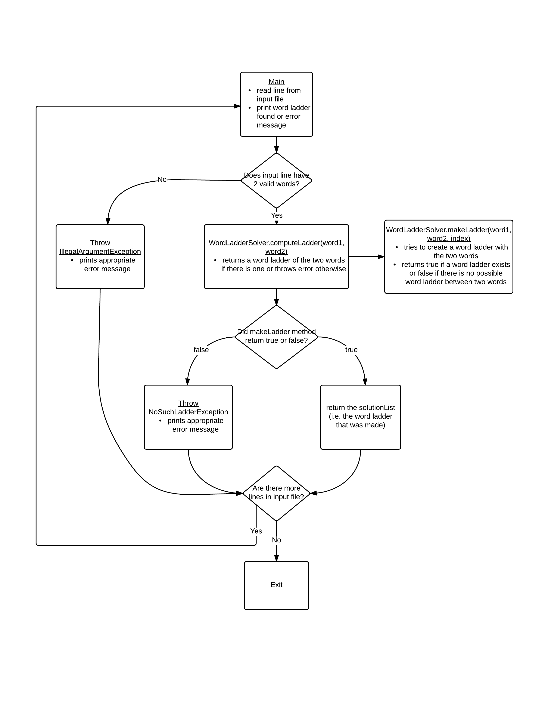Block Diagram

Design Rationale

Our program is a word ladder solver, and there aren’t really any real world objects that this models, other than a computational solver. We solved the problem using a depth-first search and recursion, but an alternative is to use a breadth-first search in which there is no recursion. One advantage is that if recursion is hard to understand for you, then breadth-first is more straightforward and easier to debug. However, recursion usually simplifies the amount of code needed to solve the problem. From a user perspective, the speed of the two searches may differ, so one might be faster than the other for the user, and efficiency is always an advantage. The program could be optimized to have a method that finds the shortest word ladder out of all possible word ladders between two words, but this would likely require longer computing times. Our design makes sure that the scope of methods is appropriate, encapsulates the word ladder solver class and allows for flexibility in the dictionary used to find word ladders as well as the user input file used.