6 Dimensional Visual Hallucination Questionnaire (6D-VHQ) (validated version)
Trevor Hewitt and Colleagues
This is the validated version of the questionnaire from the following preprint (in prep): https://doi.org/10.31234/osf.io/qv5hz_v1

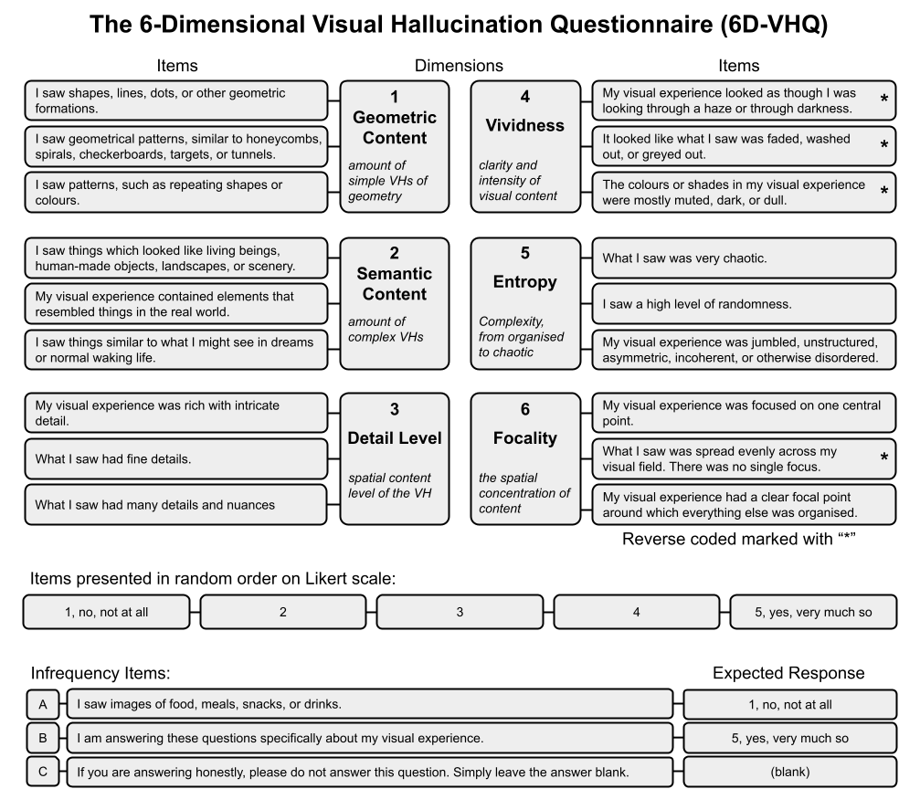

Figure 1. Structure of the 6-Dimensional Visual Hallucination Questionnaire (6D-VHQ).
The questionnaire comprises six dimensions—geometric content, semantic content, detail level, vividness, entropy, and focality—each assessed with three items. For each dimension, example items and brief descriptors are shown. Three infrequency items at the bottom of the figure are used as attention checks and exclusion criteria. All questions are presented to participants in a randomised order and rated on a 5-point Likert scale (1 = no, not at all; 5 = yes, very much so).

Each dimension is designed to capture a broad range of content in order to accommodate the wide range of possible visual experiences. For example, the full range of geometric patterns that can occur in simple visual hallucinations has not been comprehensively documented (Bressloff et al., 2002; Grove et al., 2025), so the geometric dimension was designed to elicit positive responses from participants who saw any geometric content at all, not just commonly reported VH forms, such as spirals and tunnels.

The items are presented in a randomised order. All items are posed as statements answered on a Likert scale (1-5) anchored from “1: no, not at all” to “5: yes, very much so”. The questionnaire is designed to be answered about a single visual experience, usually a single hallucination or a single point in time, not an entire psychedelic trip or psychotic episode that may contain many hallucinations. Dimensional scores are calculated by averaging the values of all items within a dimension after reverse-coding the relevant items. The survey has three infrequency items that sit outside the dimensional structure and are used to exclude inattentive responses.

Dimensions and Items:

Geometric content (simple or elementary hallucinations)
Construct: Did the participant have simple geometric hallucinations of any kind? This dimension should be sensitive to the presence of geometric hallucinations regardless of what kind of geometry the user saw and whether or not that geometry fits within the current theories of geometric hallucinatory content, which are likely quite limited.
- I saw shapes, lines, dots, or other geometric formations.
- I saw geometrical patterns, similar to honeycombs, spirals, checkerboards, targets, or tunnels.
- I saw patterns, such as repeating shapes or colours.

Semantic content (complex hallucinations)
Construct: Did the participant have complex hallucinations of any kind, consisting of semantic content likely originating in higher order areas of the brain? This dimension should be sensitive to any semantic content whatsoever.
- I saw things which looked like living beings, human-made objects, landscapes, or scenery.
- My visual experience contained elements that resembled things in the real world.
- I saw things similar to what I might see in dreams or normal waking life.

Detail level
Construct: How detailed was the hallucinatory experience spatially?

removed: My visual experience was blurry, vague, blank or otherwise undetailed. (reverse coded)
- My visual experience was rich with intricate detail.
- What I saw had fine details.
- I saw many little details and nuances.

Vividness
Construct: how vivid and bright was the hallucinatory experience, from barely perceptible, to as or more clear than normal everyday life.

- My visual experience looked as though I was looking through a haze or through darkness.
- It looked like what I saw was faded, washed out, or greyed out.
- The colours or shades in my visual experience were mostly muted, dark, or dull.

Entropy
where did the experience fall on a scale from perfectly organised (low) to completely chaotic (high)
- What I saw was very chaotic.
- I saw a high level of randomness.
- My visual experience was jumbled, unstructured, asymmetric, incoherent, or otherwise disordered.

Focality
Was the visual experience focused in on one central point (high) or was detail evenly spread (low) or spread differently, such as concentrated towards the edges (also low).
- My visual experience was focused on one central point.
- What I saw was spread evenly across my visual field. There was no single focus.
- My visual experience had a clear focal point around which everything else was organised.

Infrequency
These should have obvious and consistent answers so that participants who do not answer them correctly, who are likely not paying attention, may be excluded.
- I saw images of food, meals, snacks, or drinks. (expected no)
- I am answering these questions specifically about my visual experience. (expected yes)
- If you are answering honestly, please do not answer this question. Simply leave the answer blank. (expected blank)

