**CREATIVE BRIEF**

Trevor McKee

11.13.2019

**Alexander the Great**

1. **PROJECT OVERVIEW**: The goal of this website is to give a glimpse of Alexander’s life as a character and personality. I don’t want all the attention to be given to his campaigns and achievements – instead I want to present Alexander the Great simply as Alexander.
2. **RESOURCES**: Copy is available at <https://en.wikipedia.org/wiki/Alexander_the_Great>. The two most important sections are “Early life” and “Character.” There are many photographs of sculpture and artistic renderings. I would like the images to be digitally manipulated into a similar visual language – either monotone or duotone.
3. **AUDIENCE**: This is a strictly informational site and won’t be promoted commercially in any way. Demographic information could be all across the board, but the audience won’t likely include children, or people of higher than retirement age.
4. **MESSAGE**: Alexander the Great was an incredible leader, strategist, and fighter. But before any of that, he was a man with personality and relationships. How did these aspects of his life influence his victories? Who was Alexander the Great?
5. **TONE**: I want the tone of the website to be **exploratory** and **curious** into the identity of Alexander the Great. Feel free to use content that is more speculative than purely informational. I would also like a few modern assets that address how various demographics view Alexander the Great. If you’re one of the tech savvy ones, I’d love to work with you to construct variably responsive data visualization (given we can find some data to use).
6. **VISUAL STYLE**: I want the visual style to reflect the theme of identity – perhaps overlapping elements that, depending on how the user interacts with the site, alters the way Alexander is presented. VERY limited color use – maybe two contrasting colors in temperature and brightness (i.e. blue and yellow, orange and green, red and blue).



Example image of Timothee Chalamet showing expressive use of color and tone

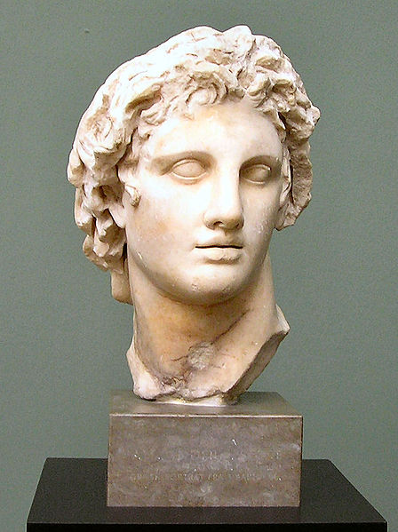

Image of Alexander the Great sculpture



Example website that showcases a person