**Shale** is a fine-grained, [clastic](https://en.wikipedia.org/wiki/Clastic) [sedimentary rock](https://en.wikipedia.org/wiki/Sedimentary_rock), composed of [mud](https://en.wikipedia.org/wiki/Mud) that is a mix of flakes of [clay minerals](https://en.wikipedia.org/wiki/Clay_mineral) and tiny fragments ([silt](https://en.wikipedia.org/wiki/Silt)-sized particles) of other minerals, especially [quartz](https://en.wikipedia.org/wiki/Quartz) and [calcite](https://en.wikipedia.org/wiki/Calcite).[[1]](https://en.wikipedia.org/wiki/Shale#cite_note-Blatt-1) Shale is characterized by breaks along thin laminae or parallel layering or bedding less than one centimeter in thickness, called [fissility](https://en.wikipedia.org/wiki/Fissility_(geology)" \o "Fissility (geology)).[[1]](https://en.wikipedia.org/wiki/Shale#cite_note-Blatt-1) It is the most common sedimentary rock.[[2]](https://en.wikipedia.org/wiki/Shale#cite_note-RocksMaterials-2)

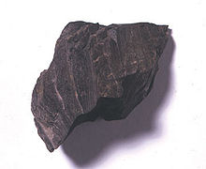

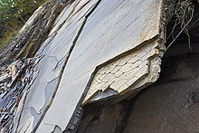

/img/ShaleUSGOV.jpg

/img/Shale_in_Potokgraben.jpg