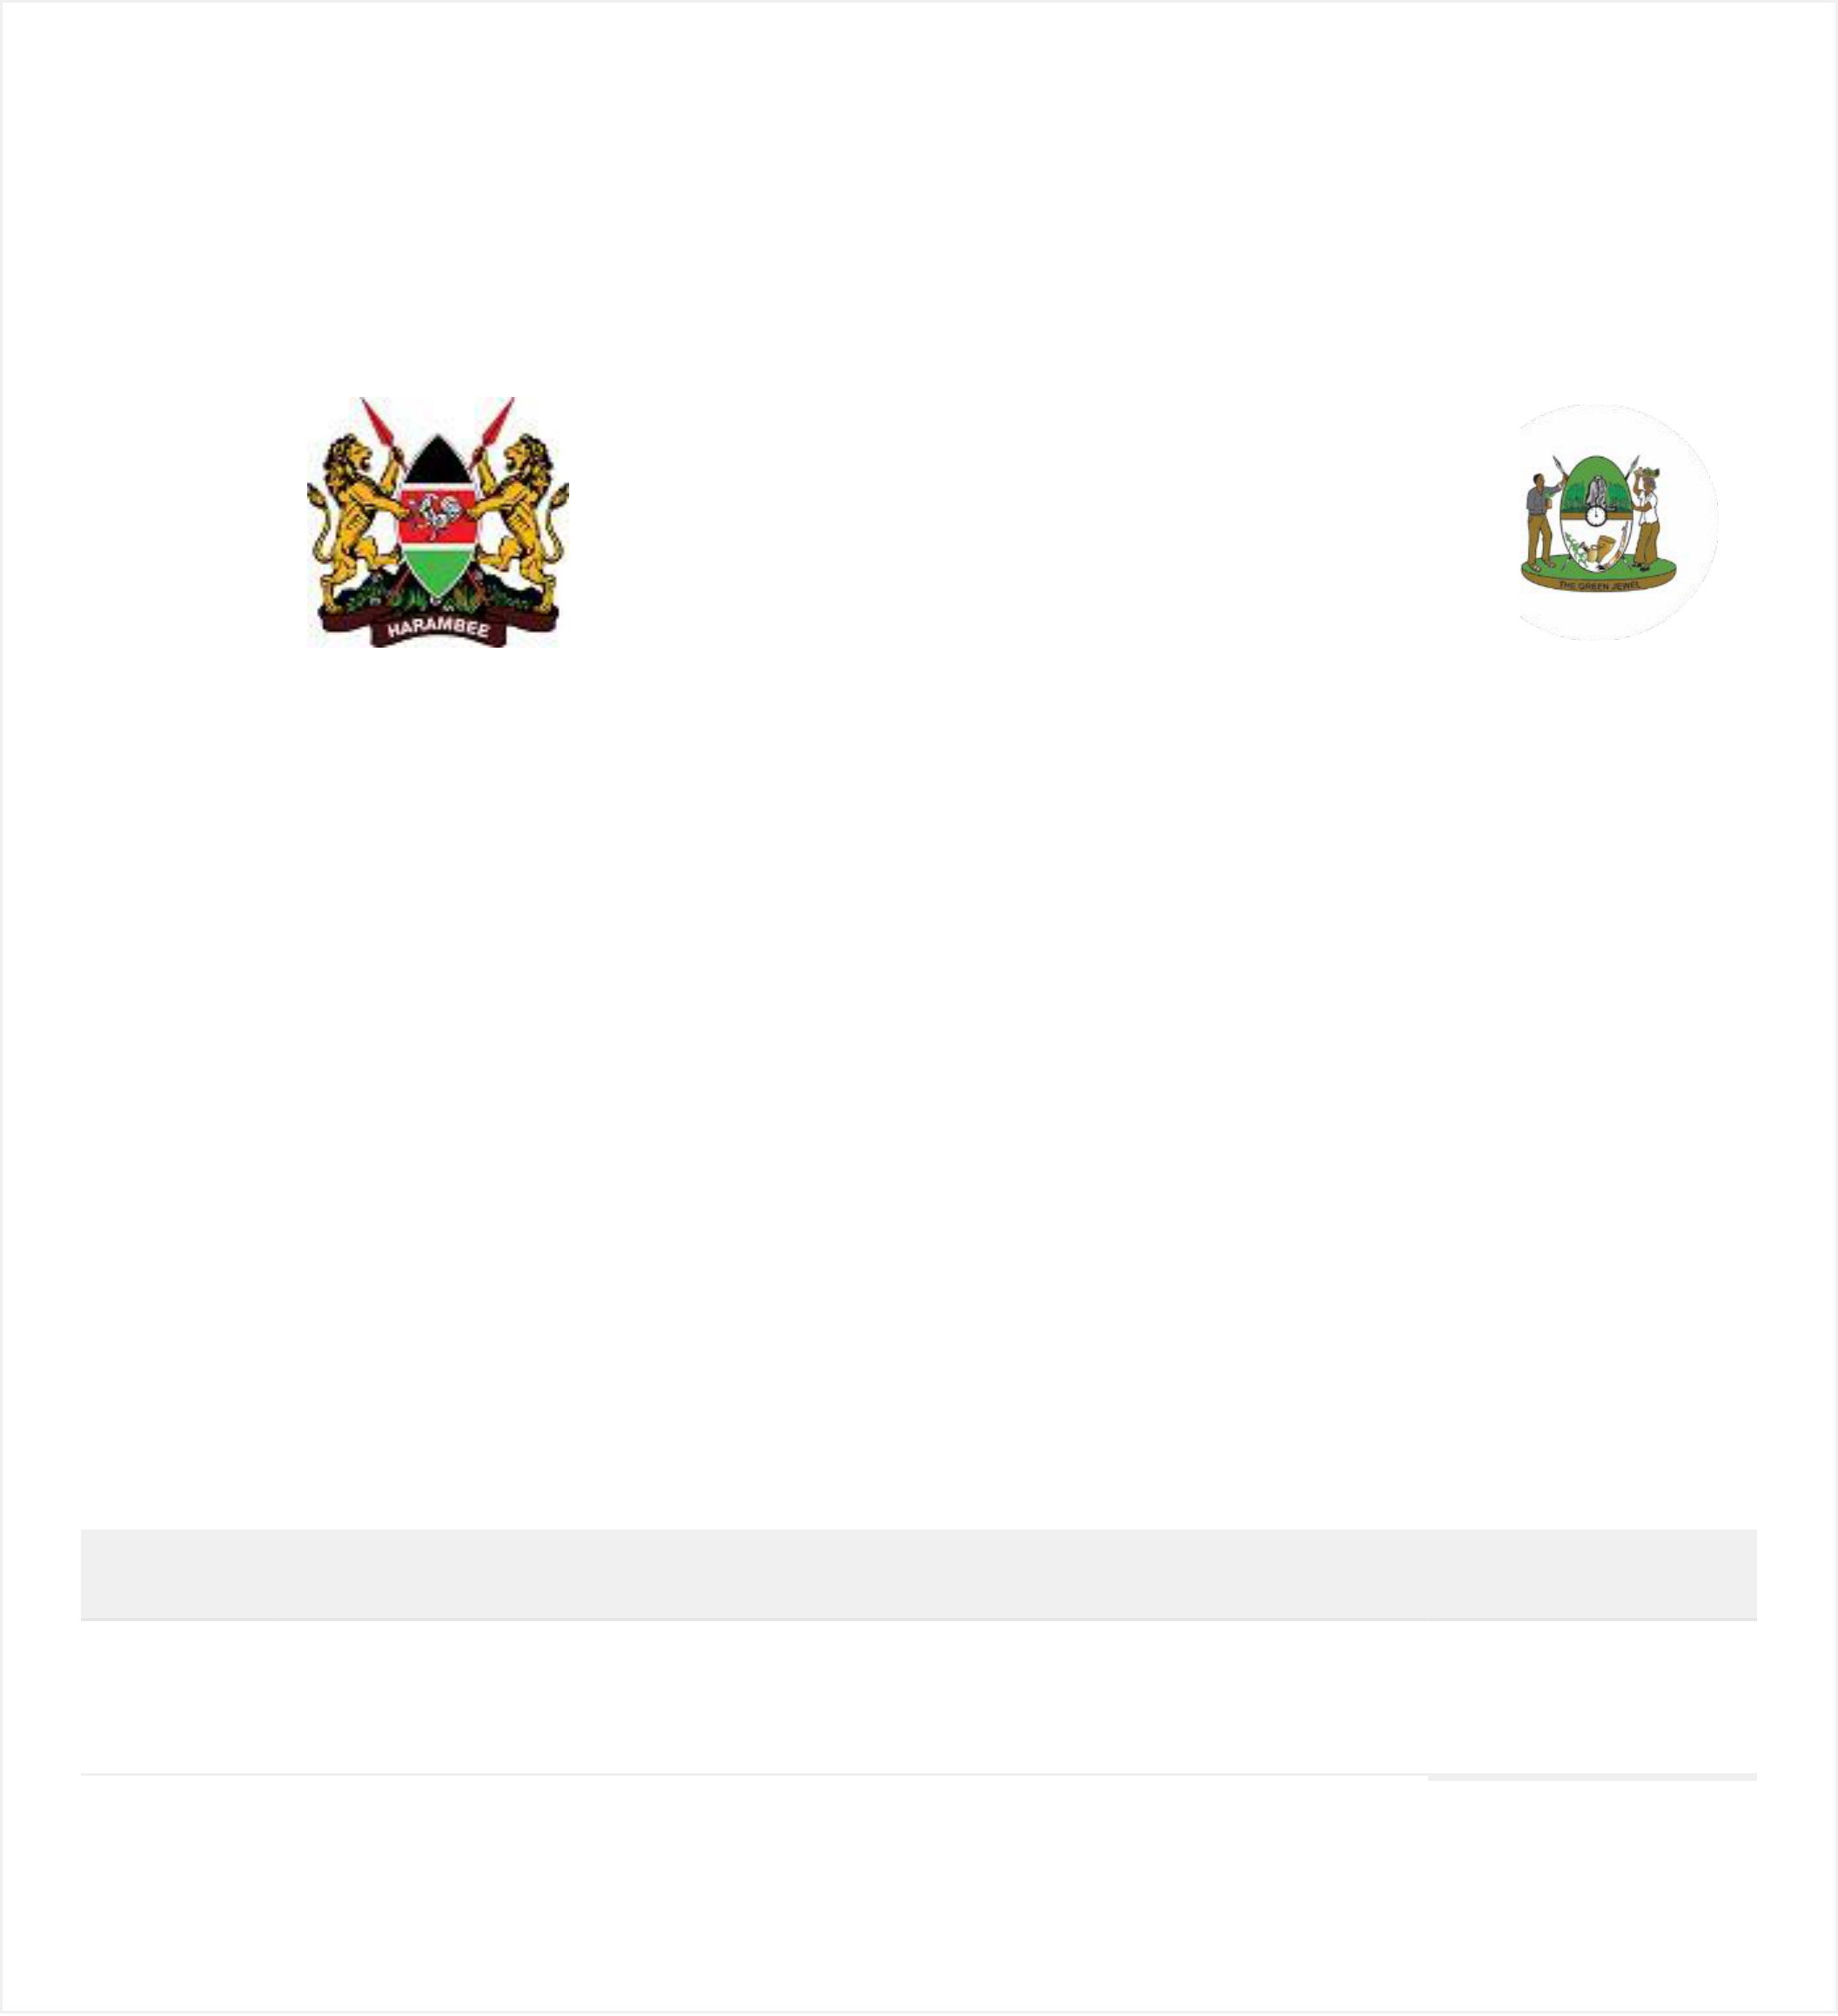

**County Government of**  **Kakamega**

P.O Box: 36 – 50100,   
 Kakamega   
Phone No: 056-31850/1852   
 /31853   
Email: revenue@kakamega.

co.ke

**OFFICIAL**   
**RECEIPT**

Entity Name: TRI-CLOVER INDUSTRIES(K) Receipt #: LTD RC23068Y9Q19

Entity Address:   
Entity Contact: 0-

Created: 09-03-2023 Date Paid: 09-03-2023

**QuantityItem**  **Price**

4 Advertisement Decorations/Branding of motor Vehicles 32,000.00

/containers per each - Canter/Lorries/Buses per year

**Total:**

**32,000.00**