A BLACKCEO PLAYBOOK · HANDOFF BRIEF
The DM Door:
What We Tried to Build, and Where It Went Wrong


ABOUT THIS BRIEF
A handoff brief for a fresh AI reviewer. Written 2026-10-23 by Martin (the assistant who did the work) at Trevor Otts's request, so another AI can analyze the mistakes and find what was missed. Nothing in this document is sales copy. Every claim is labeled with its evidence state.

01 1. What we were trying to accomplish
Build a working door from a Facebook post into a private Messenger conversation run by AI. A reader sees a post, taps one link, lands in a chat with the business's Facebook Page, and is greeted by an automated welcome carrying tap buttons. Each tap routes the reader to one of three doors: a free gift, a community, or a booked call. From there, an AI conversation asks three qualification questions, one at a time, and the tap buttons change at every step to match the question being asked.
The end product was never meant to be a one-off for Trevor. It is one piece of a member system called The Purple Billboard Playbook, and the door had to be simple enough to rebuild identically inside every client's own accounts.
02 2. Why
The system teaches members to post a daily billboard on their personal Facebook profile, with seven comments under it. The seventh comment (the Bonus) carries the call to action. The hard limit that forced this whole design: a personal profile cannot fire any automation. No comment trigger, no keyword trigger, nothing. A Facebook Page can. So the Bonus on a profile post points the reader to the member's business Page, where automation does exist. The link is the bridge between a place with no automation and a place with automation.
03 3. How it was supposed to work
The Bonus comment carries a Messenger link to the member's Page: https://m.me/[PAGE ID]?ref=[code].
The code names the post: pb-[MONTH][DAY]-[YEAR]-[CATEGORY], for example pb-OCT23-2026-GIFT. The category matches the door the post leads to (GIFT, COMMUNITY, APPOINTMENTS, or a named offer). The code names the post inside the link. Whether Convert and Flow ever surfaces that code is unproven; the inspected data did not expose it. Meta offers no pre-filled message, so the code alone cannot start the machine.
The reader sends one routing word (example: GIFT). That word is what the automation listens for.
The automation answers with a welcome message carrying three tap buttons, one per door. Each tap opens that door's next step.
The design rule, set by Trevor and confirmed by him after the build: the buttons are part of the conversation, not furniture on the Page. Every automated message carries its own buttons, matched to that step, and the buttons change as the conversation moves. Nobody should ever have to type when a tap will do.
A static always-there button row on the Page (shown before the reader types anything) was a secondary wish, not the core design.

04 4. How Convert and Flow (GoHighLevel) was supposed to be used
GoHighLevel (branded Convert and Flow) is the automation home. The plan, from a written build plan Trevor approved:
One workflow listens for the routing word: trigger 'Customer Replied', filter Reply Channel = Facebook Messenger, filter Message Body contains the word. On a match, it sends a Facebook Interactive Messenger message (Reply to DM) holding the welcome text plus up to three quick reply buttons. Each button tap creates its own branch in the same action, and each branch sends the next step.
After the door opens, the conversation is run by the Skill 38 conversation brain on OpenClaw; Convert and Flow carries the messages, keeps the records, runs the workflows and holds the appointments. The agreed flow in the next section governs: the promised item is delivered first, in chat, with no email or mobile toll; then additional value and the one-time access pass are offered, mobile first; email is asked once, via SMS with the pass; then a helpful needs-based conversation recommends an appropriate next step.

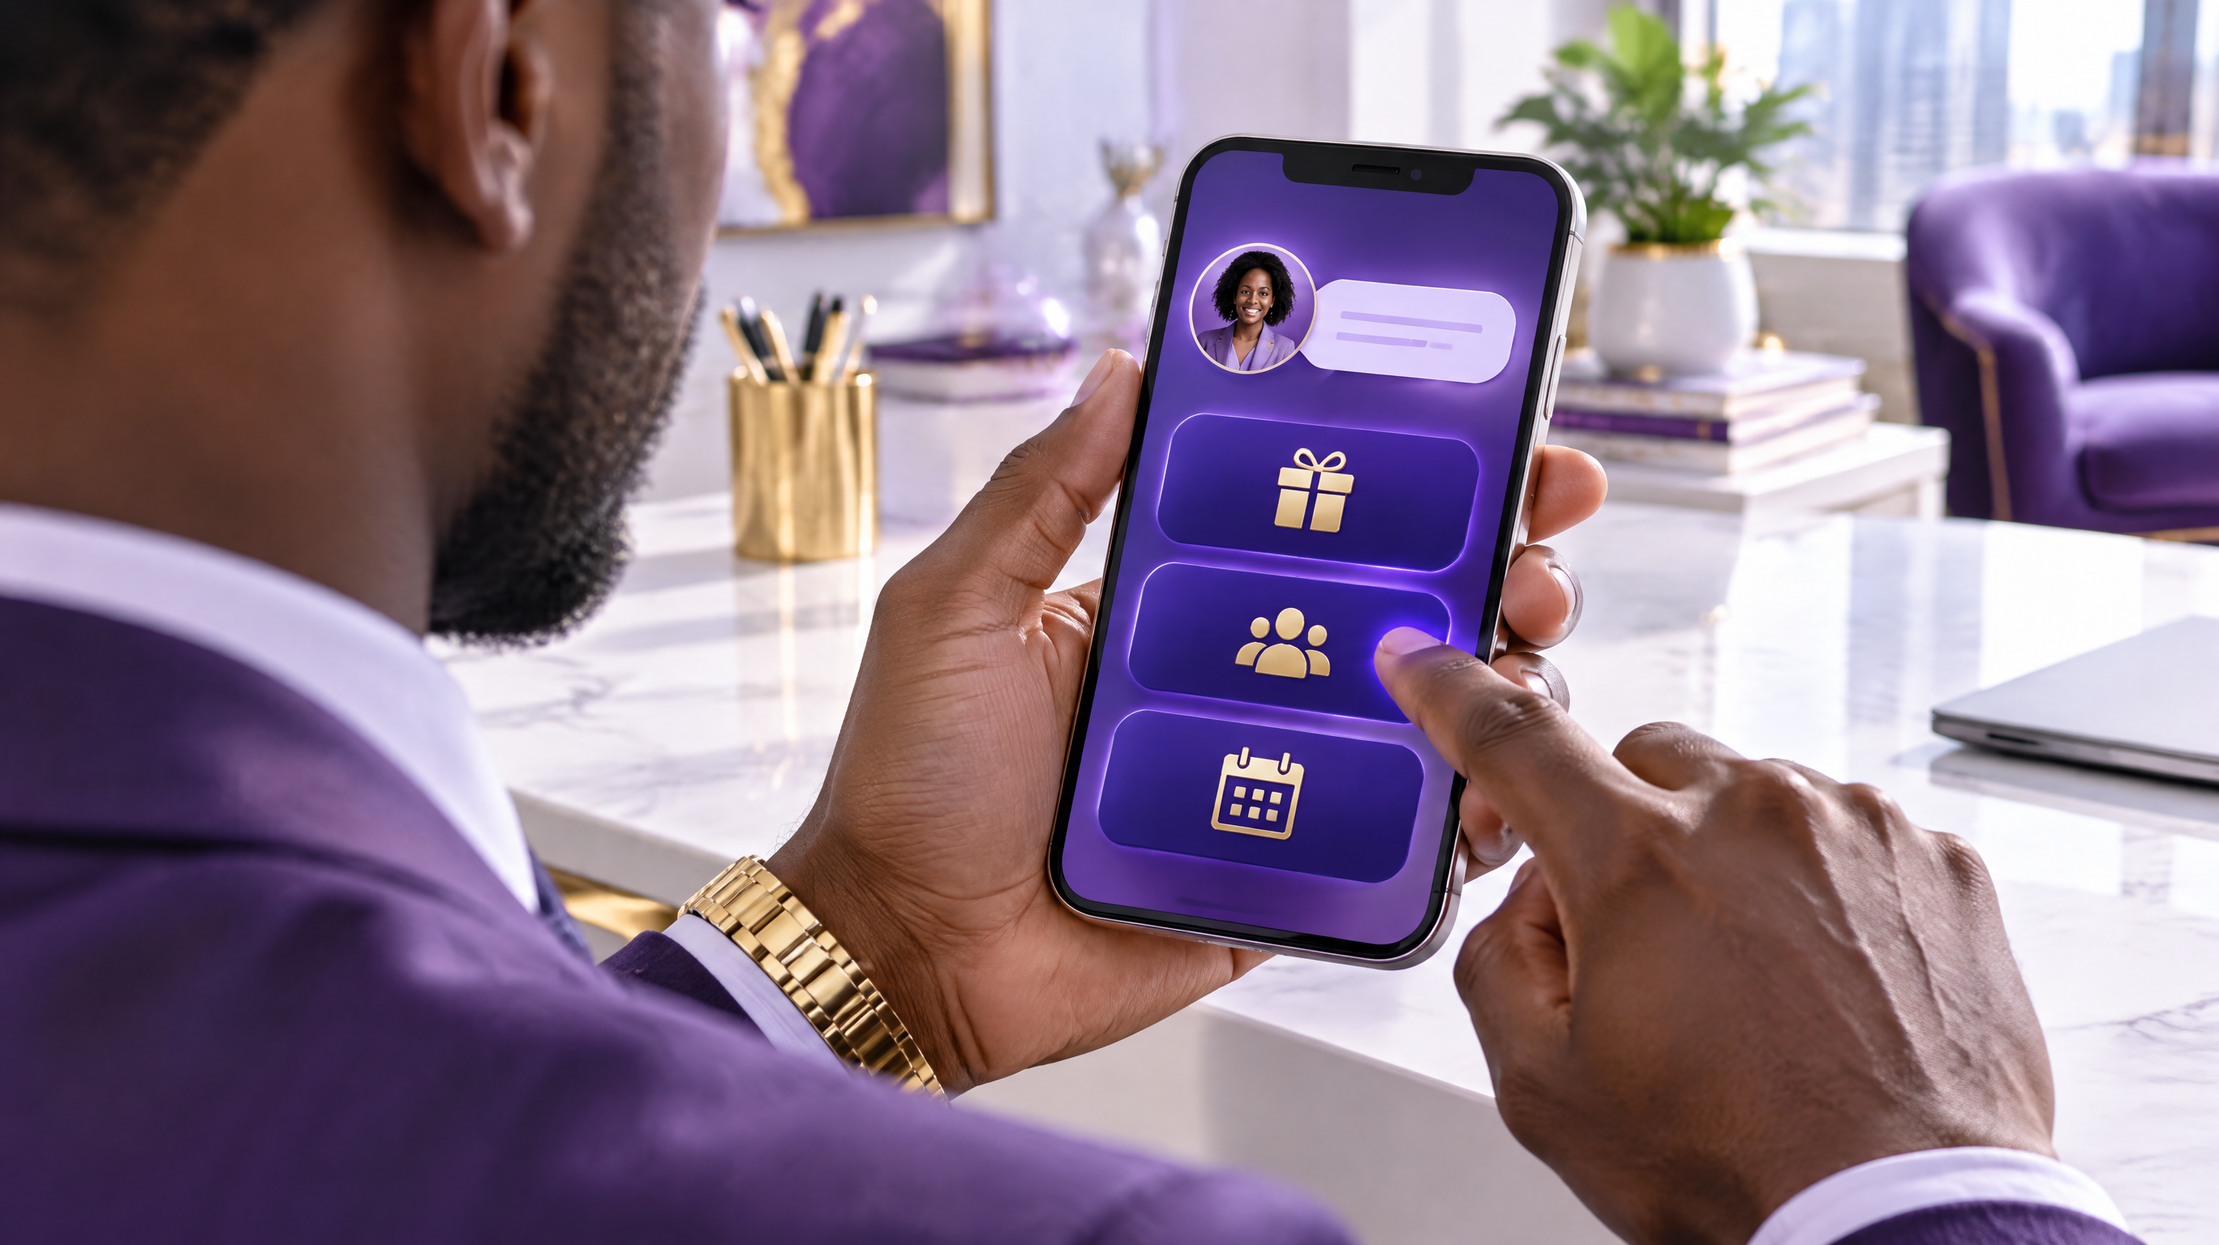
CURRENT AGREED FLOW (added by the correction order; this governs over the design description above wherever they differ. The incident history elsewhere in this document stays as history.)
1. Personal Facebook posts direct people to the business Messenger conversation and name the keyword to send. The link alone is never assumed to identify what they want.
2. Business Page comment-to-DM and Instagram paths are separate, and are not described as identical to personal-profile posting.
3. Unknown item: "Hey! I’m looking forward to sharing what I promised you. What keyword did you see in the post?" If the keyword identifies the item, do not ask again.
4. Deliver the original promised item in chat FIRST; email or mobile is never a surprise requirement.
5. Then offer genuinely available additional value; offer to text a one-time access pass; ask MOBILE FIRST. The pass and collection must actually exist, and the implementation team must provide a return-access method after redemption; it is not claimed as built.
6. EMAIL is asked ONCE, via SMS with the pass, with the benefit stated: backup access plus a guide directory easy to find later or open on a computer. All other email asks stay in the original Messenger or Instagram thread.
7. Follow-up is ONE shared three-reminder sequence across missing contact information at 2, 8 and 20 hours, only while the channel permits messaging, stopping after refusal, capture, or the final unanswered message. The approved final mobile request is: "Let me be direct: do you want these guides, or should I close this out? I offered because I want to help you move forward, but I’m not going to keep asking. If you want access, send me your mobile number and I’ll text your pass. If I don’t hear back, I’ll leave it here. This is my final message about getting you access."
8. Reuse profile name and saved details; ask only for what is missing. After delivery, hold a helpful needs-based conversation and recommend an appropriate next step. OpenClaw Skill 38 is the conversation brain; Convert and Flow handles messaging, records, workflows and appointments.

RESEARCH FINDINGS
Research findings about GoHighLevel, from its own help documentation (high confidence): there is no conversation-opened or arrival trigger. A workflow cannot speak first when someone merely opens a chat. The Interactive Messenger action is real (max 3 buttons, max 13 quick replies, each tap its own branch, a mandatory Wait with a Default Timeout branch). Conversation AI replies only to inbound messages; it cannot send the first message on arrival. The ref code on an m.me link is not documented as readable or stored anywhere in GoHighLevel.

VERIFIED BUILD STATE · 2026-10-23
What is actually built today, verified by reading the workflow and its history on 2026-10-23: a published test workflow named 'Billboard DM Door - Arrival Greeting (TEST)' in the BlackCEO LLC sub-account (location ID Mct54Bwi1KlNouGXQcDX). Trigger and welcome are exactly as planned above. The three button branches each send an honest test reply (the full delivery steps land in the pilot). The Default Timeout branch is empty. Execution history: zero enrollments, zero executions, ever. One trigger evaluation was recorded, an Instagram DM containing the word, rejected by the channel filter. The Conversation AI pilot (the full conversation) has not been built yet.

05 5. How Facebook was supposed to be used
The Page is the automation surface. The m.me link points at it. Meta-side pieces the design wanted:
The link itself (solved: it is a formula, Page ID plus the day's code; the link opens the correct Page chat, verified by the owner tapping it).
A native greeting so the arrival feels answered (the Page already displays a greeting line, 'Hi [name]! Please let us know how we can help you.', seen in the owner's own screenshots).
Optionally, the always-there tap buttons shown before typing (Meta calls the API version Ice Breakers; in the Business Suite interface the same slot appears to be served by the Frequently Asked Questions automation, where a question set to 'Add to Menu' reportedly shows as a tappable suggestion).

VERIFIED ON META · 2026-10-23
What was actually done on the Meta side, verified 2026-10-23 in Meta Business Suite for the Black CEO Page (Page ID 136340370119693, username blackceomovement): Auto reply OFF, Frequently asked questions OFF, Away message was ON overnight and is now OFF at the owner's order (his business runs 24 hours). No Get Started or Ice Breakers control was found in Business Suite Inbox Automations, Inbox Settings, or Page Settings. The Frequently Asked Questions automation was seen in the list and never opened or configured.

06 6. The system, end to end, as designed
Member posts the billboard on their profile. Seven comments land, the seventh (the Bonus) carrying the m.me link with that post's code. A reader taps the link, arrives in the Page's Messenger chat, sees the greeting, sends the routing word, and the GoHighLevel workflow fires the welcome with the three door buttons. The typed word routes the reader; taps are recorded for what they actually do, not assumed to route. The Skill 38 brain delivers the gift first, then converses helpfully, and booking is recorded in Convert and Flow against the live calendar. On business Pages (where the member's OpenClaw and Social Planner post), the same door is printed under the post, and a comment trigger can also open the one private reply Meta allows per comment. The link is built when the post's pack is written, never at posting time, and the member's Page ID is recorded once on a setup sheet so nothing is ever guessed.
07 7. What went wrong: the mistakes, in order
HISTORY · THE INCIDENT RECORD · FACTS UNCHANGED, DESIGN ONLY

These are the assistant's errors, listed so the reviewer can analyze them rather than rediscover them.
Mistake 1: The build was stopped mid-flight for a research pass, then restarted. The stop and restart cost most of an hour of the owner's time and all of his patience. Research should have come before the first build order, or not at all.
Mistake 2: A capability was asserted, then walked back. The owner was told Ice Breaker taps would route like typed words inside GoHighLevel. That is not documented for GoHighLevel. Whether those taps arrive as a matchable message, or as a separate postback event GoHighLevel ignores, is still unproven.
Mistake 3: The builder walked past the one setting that mattered. The Frequently Asked Questions automation sat in the Page's automation list the whole time. It was read as unrelated and left OFF, so the always-there button trial never even ran. The research that identified it as the likely home of the button arrived after the build, from a separate research pass the owner had to demand.
Mistake 4: An unverified negative was stated as fact. The owner was told Facebook does not offer the pre-typing buttons on his Page. The truth was narrower: the setting was not found in the places searched. Absence was declared from a failed search.
Mistake 5: The link was handed over as a deliverable before the machinery behind it was proven. The owner tapped it, arrived in a chat where only Meta's greeting fired, and reasonably concluded he had been given a half-ready thing. Proof should have come first.
Mistake 6: The proof gap was never closed. The one clean test (a reader sends the word in Messenger and the welcome lands) was never run, because the Page owner cannot test his own Page as a customer from the admin seat, and no other reader seat was arranged. The workflow's zero-execution history was only checked after the owner demanded to know whether it works.
Mistake 7: A side failure compounded the day. During the same session, contact lookups for a group send were first run through email and address books instead of the owner's CRM, and one person (Laya Kelley, who also goes by Talaya) existed as two records and was nearly treated as two people. Not part of the door build, but part of why the owner stopped trusting the work.

08 8. Open questions for the reviewer
On this Page, does a Frequently Asked Questions entry with 'Add to Menu' actually render as a tap chip when a fresh visitor opens the chat, and what does its tap deliver to GoHighLevel: a normal message with the question text (matchable by the workflow), or only Meta's own canned answer with nothing reaching GoHighLevel?
Can true Ice Breakers be set on this Page through the Messenger Profile API while GoHighLevel is the connected platform and primary receiver, and if a visitor taps one, does GoHighLevel's Customer Replied trigger see it at all?
Is there any route inside GoHighLevel, documented or not, to put buttons in front of a reader before their first message? (Our research says no arrival trigger exists. Prove us wrong if you can.)
The Page shows a greeting to visitors even though Business Suite reports Auto reply OFF. Where does that greeting live, and can it be edited?
Given the design rule (buttons ride with the conversation), what is the simplest architecture that delivers the full experience (link, welcome with buttons, changing buttons per question, AI conversation, booking) using only tools a non-technical member can be handed?

09 9. Key facts
Facebook Page: Black CEO, ID 136340370119693, username blackceomovement. One Page connected to the sub-account's Messenger integration.
GoHighLevel sub-account: BlackCEO LLC, location ID Mct54Bwi1KlNouGXQcDX. Test workflow 'Billboard DM Door - Arrival Greeting (TEST)', published, zero executions as of 2026-10-23.
Test link: https://m.me/136340370119693?ref=pb-OCT23-2026-GIFT
Code format: pb-[MONTH][DAY]-[YEAR]-[CATEGORY]. The word routes. The code names the post in the link; its identification inside Convert and Flow is UNPROVEN and nothing in the current design depends on it.
Meta facts relied on: one private reply per comment within 7 days; a link tap alone does not open the 24-hour messaging window, a reply does; the first DM must carry the gift link in body text.

THE PURPLE BILLBOARD PLAYBOOK · BY TREVOR OTTS, BLACKCEO
STATUS/ERRATA NOTE - 2026-10-25 (targeted correction order application)
The historical incident record and the verified build state of 2026-10-23 above are preserved as written and remain labeled history and findings. Failures recorded there remain failures: test-flow fulfillment and routing are unfinished, and unattended monthly operation has not been run and remains unproven.
This note is appended, not merged into the record above. The CURRENT AGREED FLOW section and the corrected document set govern.

