**INSTALL AND CONFIGURE FAIL2BAN, EMACS, VIM FOR CENTOS**

First, we must install fail2ban, to do this we will use this command followed by the next command:

**$ yum install epel-release**

**$ yum install fail2ban fail2ban-systemd**

Now that we have run both of those commands we have to enable and start fail2ban. They come disabled at install. To do this we will start with the enable command then the start command:

**$ system enable fail2ban**

**$ system start fail2ban**

We have now installed, enabled, and started the service. We must configure fail2ban. To do this enter this command:

**$ cp /etc/fail2ban/jail.conf /etc/fail2ban/jail.local**

Open the jail.local file in any of the text editors EMACS, VI, or NANO. The file path will be the same as the previous comman file path. Locate the [DEFAULT] section of jail.conf and set these values:

**bantime = 20m**

**findtime = 5m**

**maxrety = 4**

[DEFAULT] Section should look like the image below:

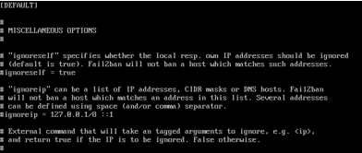

These values are self-explanatory.

* bantime is how long and IP address is banned. The default is 10 mins.
* maxretry is the number of failures until the address is banned
* findtime is mixed with maxretry and bantime, if the host exceeds the maxretry setting determined by the findtime it is banned for the bantime that is entered.

After editing the values above go to [SSHD] section and add the values below:

**enabled = true**

**port = 22**

**filter = sshd**

**logpath = /var/log/auth.log**

SSHD should look like the image below:

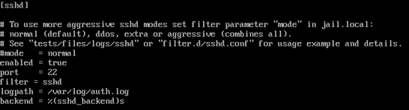

**INSTALLS:**

**TMUX –**

TMUX should already be installed but it is not run this command:

**$ yum install tmux**

**EMACS and VIM –**

Run this command:

**$ yum install emacs**

After being prompted answer with “Y” to confirm installation

**VIM –**

VIM should already be installed but if it is not run this command:

**$ yum install vim**