Install and configure FAIL2BAN, ENACS, VIM for Ubuntu

Ensure Ubuntu is up to date. To do this we will run the commands below:

# sudo apt-get update

# sudo apt-get upgrade

1. Install fail2ban

# sudo apt-get install -y fail2ban

1. Once fail2ban has been installed, we will enable and start the service:

# sudo systemctl enable fail2ban

# sudo systemctl start fail2ban

1. From here we must make a copy on the config file. So that when we make any changes we can still have the original copy without re-installing the application.

# cp /etc/fail2ban/jail.conf /etc/fail2ban/jail.local

1. Open the copied file of the config we just created with any of the editors.

Editors include VI, EMACS, NANO

*Note: If these text editors are not installed on your VM already go to the bottom of the document to install before continuing*

Locate the section the [DEFAULT] section of the file and set the following values:

bantime = 15m

findtime = 5m

maxretry = 3

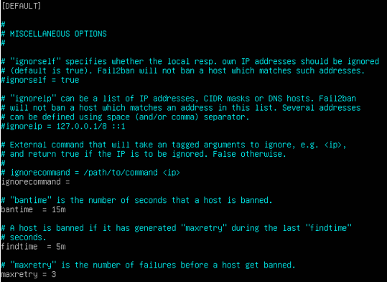

1. Add the following below to the [SSHD] section of the opened file:

enabled = true

port = 22

filter = sshd

logpath = /var/log/auth.log

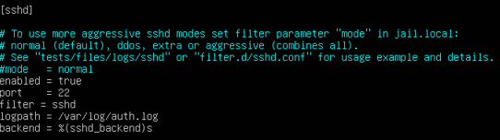

These should already be installed on your OS but if it is not run the following commands to install:

INSTALL TMUX

# sudo apt-get install tmux

INSTALL EMACS

# sudo apt-get install emacs

If prompted, type “y”

INSTALL VIM

# sudo apt-get install vim