**Preparation:**

To create a working Ubuntu and CentOS server you must start with an updated version of VMware. In my process I used version 15.5 PRO. After ensuring you have an updated VMware application, download ISOs from these links…

CentOS: <http://mirrors.mit.edu/centos/8.2.2004/isos/x86_64/>

Ubuntu: <https://ubuntu.com/download/server>

Put them in a folder together that it is easily accessible…



**Ubuntu:**

We will start with the ubuntu install, creating a new virtual machine from the home menu on VMware. Select **installer disc image file (iso):** then select browse and find your Ubuntu ISO.

Take default settings and enter in you name, username, and password. Click next till you get to this screen:

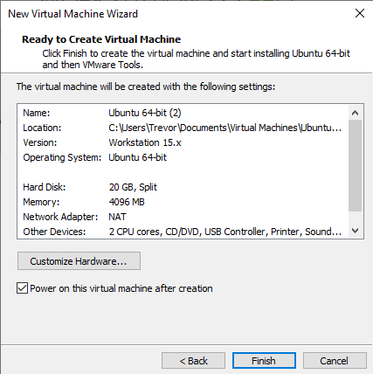

Click Finish and your VM of Ubuntu will boot up. Ubuntu will check its integrity and make sure it is up to date. You can press enter if it is not installing anything.

Once everything has been checked and updated it will bring you to the first setting screen which will be to select your language. Press enter until you get to the network connections tab. Ensure your IP and connection to your network is there. It should look like this with IP next to DHCPv4.

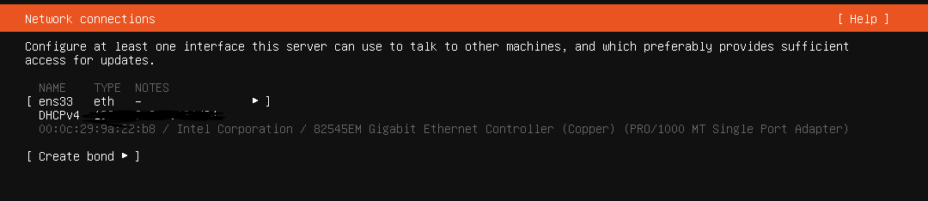

Press enter to configure proxy and archive mirror and ensure you are partitioning the correct amount of your local disc. In addition to your file summary.

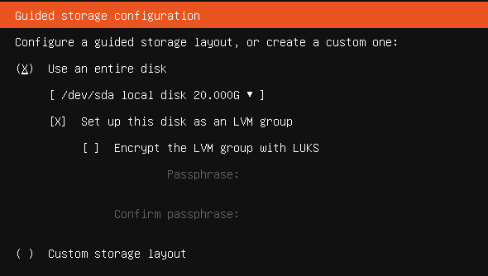

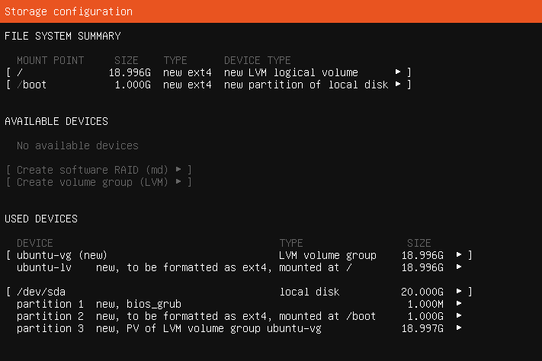

Continue through the menu by pressing enter on **Done**

Once everything has been installed and the disk has been partitioned, login as the user that you created in the setup menu of ubuntu. After getting logged in you will be prompted with your command line in your server. Which will look like this:

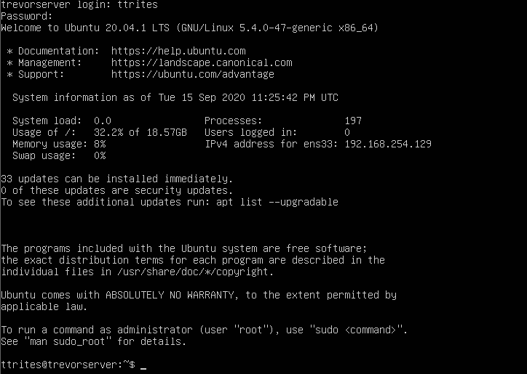

After a successful login, shut down the server and edit the VM settings to change the CD to **Use physical drive** instead of the ISO as usual.

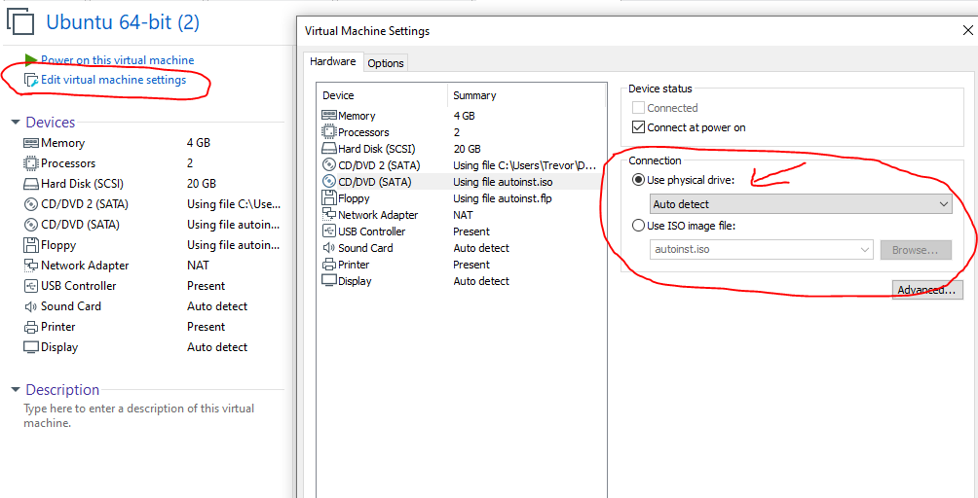

**CentOS:**

Set up CentOS the same way as Ubuntu.

Create another VM from the home tab and ensure you select the CentOS ISO:

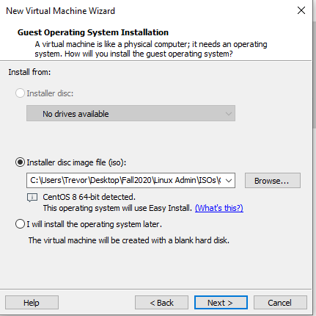

Use the same username, and password for CentOS as you did for Ubuntu. Remember this login.

Click finish and CentOS will boot up. The install will take a little while and will reboot after it installs.

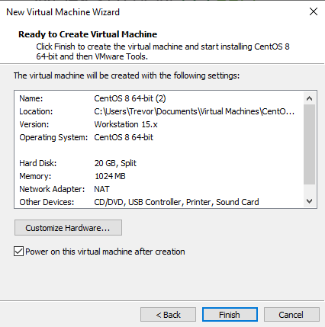

Once the installs are finished you will be prompted with a login screen. You will use what you typed in for your username and password on this screen when you did the set up:

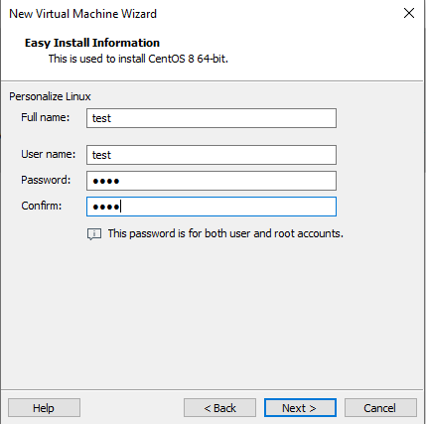

Use command line for any other installs or updates you may have to do. In addition to changing to the physical drive after getting the OS up and running. Also insure both operating systems have internet and fully are fully updated to ensure correct connectivity.



**Resolution:**

Successful setup of CentOS should look as so:

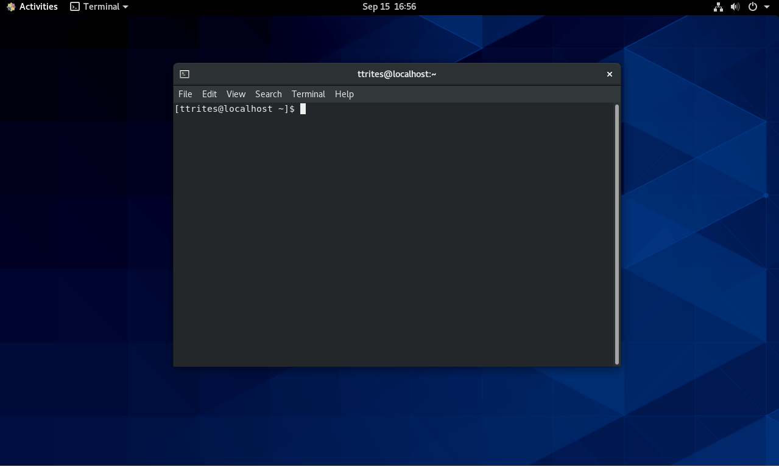

Successful setup of Ubuntu should look as so:

