CAPC License Information for GPSC_2009

Pittsburgh-Erie info: CAP-C purchase from Digital Globe

License:
1) Immediate use by all government agencies and other not for profit
organizations, with the only restriction that distribution to the
commercial sector is disallowed.
2) At 18 months after the data acquisition date, all data uses are allowed
with no restrictions. The next table shows the dates when the data for
each city will become fully unrestricted per DigitalGlobe’s EULA
license. Sunset dates are listed below.

Pittsburgh, PA
Dates of acquisition = 06/2009 and 09/2009
License sunset = 12/2010 and 03/2011

Erie, PA
Dates of acquisition = 06/2009
License sunset = 12/2010

*************************************************

Ohio cities info: CAP-C purchase from Aerials Express
- Data is due for delivery no later than Dec. 01, 2009

License:
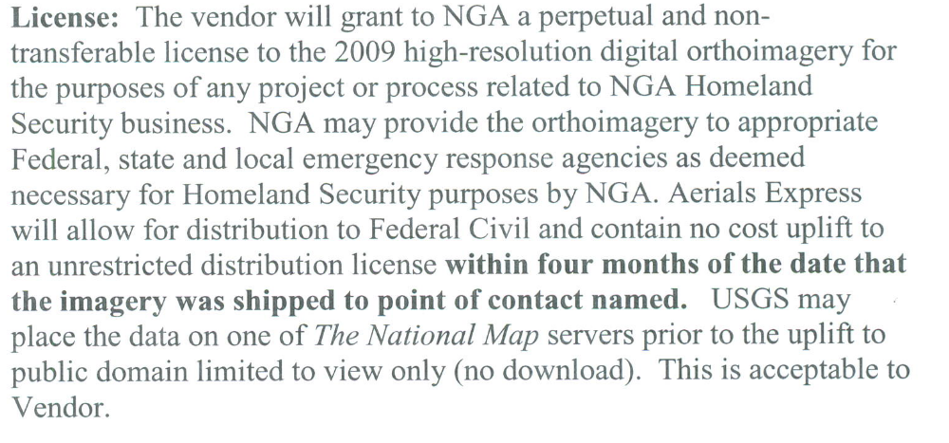
All Ohio cities have an acquisition date of July 2009 or newer.
According to the license agreement above, the license sunset date would be 4 months after Aerials Express ships the data to USGS.
April 1, 2010 since they shipped on 11/30/2009.
Patrick F. Emmett
United States Geological Survey
National Geospatial Technical Operations Center
Commercial Partnership Team-GPSC & CAP-C
1400 Independence Road - MS 666
Rolla, MO 65401
573-308-3587
573-308-3810 FAX
The information contained in this email is procurement sensitive.
It must not be shared with anyone outside the Government.
It may only be shared with those Government employees with a demonstrated "need to know".
If you have received this email in error, please notify the sender, delete and DO NOT distribute.

From: | William E Corey/GEOG/USGS/DOI
To: | Russell L Caton/GEOG/USGS/DOI@USGS, Bryon D.H. Ellingson/GEOG/USGS/DOI@USGS, Kenneth B Fox/GEOG/USGS/DOI@USGS
Cc: | Kim Brown/GEOG/CONT/USGS/DOI@USGS, Patrick F Emmett/GEOG/USGS/DOI@USGS, william.e.nellist@nga.mil
Date: | 12/01/2009 02:01 PM
Subject: | CAPC Imagery Projects

All, I have received three Imagery projects from the GPSC, that are part of the CAPC Project. These are being copied and will be assigned ASAP. These are 30 day turn around and FY09 Monies.
We have received the Pittsburgh North (New Castle) PA, Youngstown Columbus and Toledo Ohio Projects as well.
All have licensing issues with them.

William E. Corey
Data Manager, Image and Elevation Section
National Geospatial Technical Operations Center
1400 Independence Road
Rolla, MO 65401
573-308-3807
wcorey@usgs.gov

