Partnership High-Resolution Ortho Imagery
Quality Assessment Summary

Project: NGA-Ohio (Cleveland) Partnership Data
Producer: Aerials Express
Date: 18Nov09

Delivery Information:
Date: December 7, 2009 Corrections received 1-13-10
Received 947 corrected images 66.2 GB
State Liaison: Patrick Emmett GPSC POC
Format: Geotiff

- Date imagery was collected: September-November, 2009
- Number of image files: 4862
- Percent coverage of applicable NGA Urban Area: 42.35%
- Number of 7.5-minute Quads: 40 partial, 56 complete.
- Validation completion date: 24Dec09
- Software: Global Mapper 10.02
- Viewing Scale: 1:1000
- Project area: 4250 square miles
- Project size: 339 GB

Radiometry: The imagery is True Color in RGB format.

Coordinate System: Coordinate System: UTM: Zone 17, datum: NAD83, ground units: meters)

Pixel Resolution: 0.3 meters

Tile UTM Geographic
Footprint: North: CLZ_R0012C0080 4636000.000 41.87591825°
South: CLZ_R0099C0079 4504000.000 40.68688912°
East: CLZ_R0080C0083 503999.999 80.95247892°
West: CLZ_R0043C0002 381000.000 82.42463372°

The above table was compiled from information gathered from the northwest or southeast corners of the indicated tiles, whichever was needed.

Relative Horizontal Accuracy and Edge Alignment: There are many instances of feature mismatches and feature warping. (See accompanying errata shapefile.)

Horizontal Accuracy: Based on available USGS ground test points, this data has a probable accuracy of 2.002 meters radial RMSE. (See accompanying spreadsheet.) For some points, especially the older points in the inventory, there were errors in excess of 1.5 meters: 9 of 17 (5001-5021) and 2 of 3 (752xxx), as perceived.

Geotiff Information: Tiles are 1500 x 1500 meters, 73.3Mb each.

Metadata: Seems OK.

Image Quality: There is a marked contrast between the early September (green) imagery and the later October (brilliant foliage) and November (leaf-off) imagery. The complete listing is on the errata shapefile. There are approximately 260 items that need attention. The instances noted here are representative of the errors which have occurred.
R0046C0047: Warped buildings and join error (connecting roadway west side by shed). Corrected
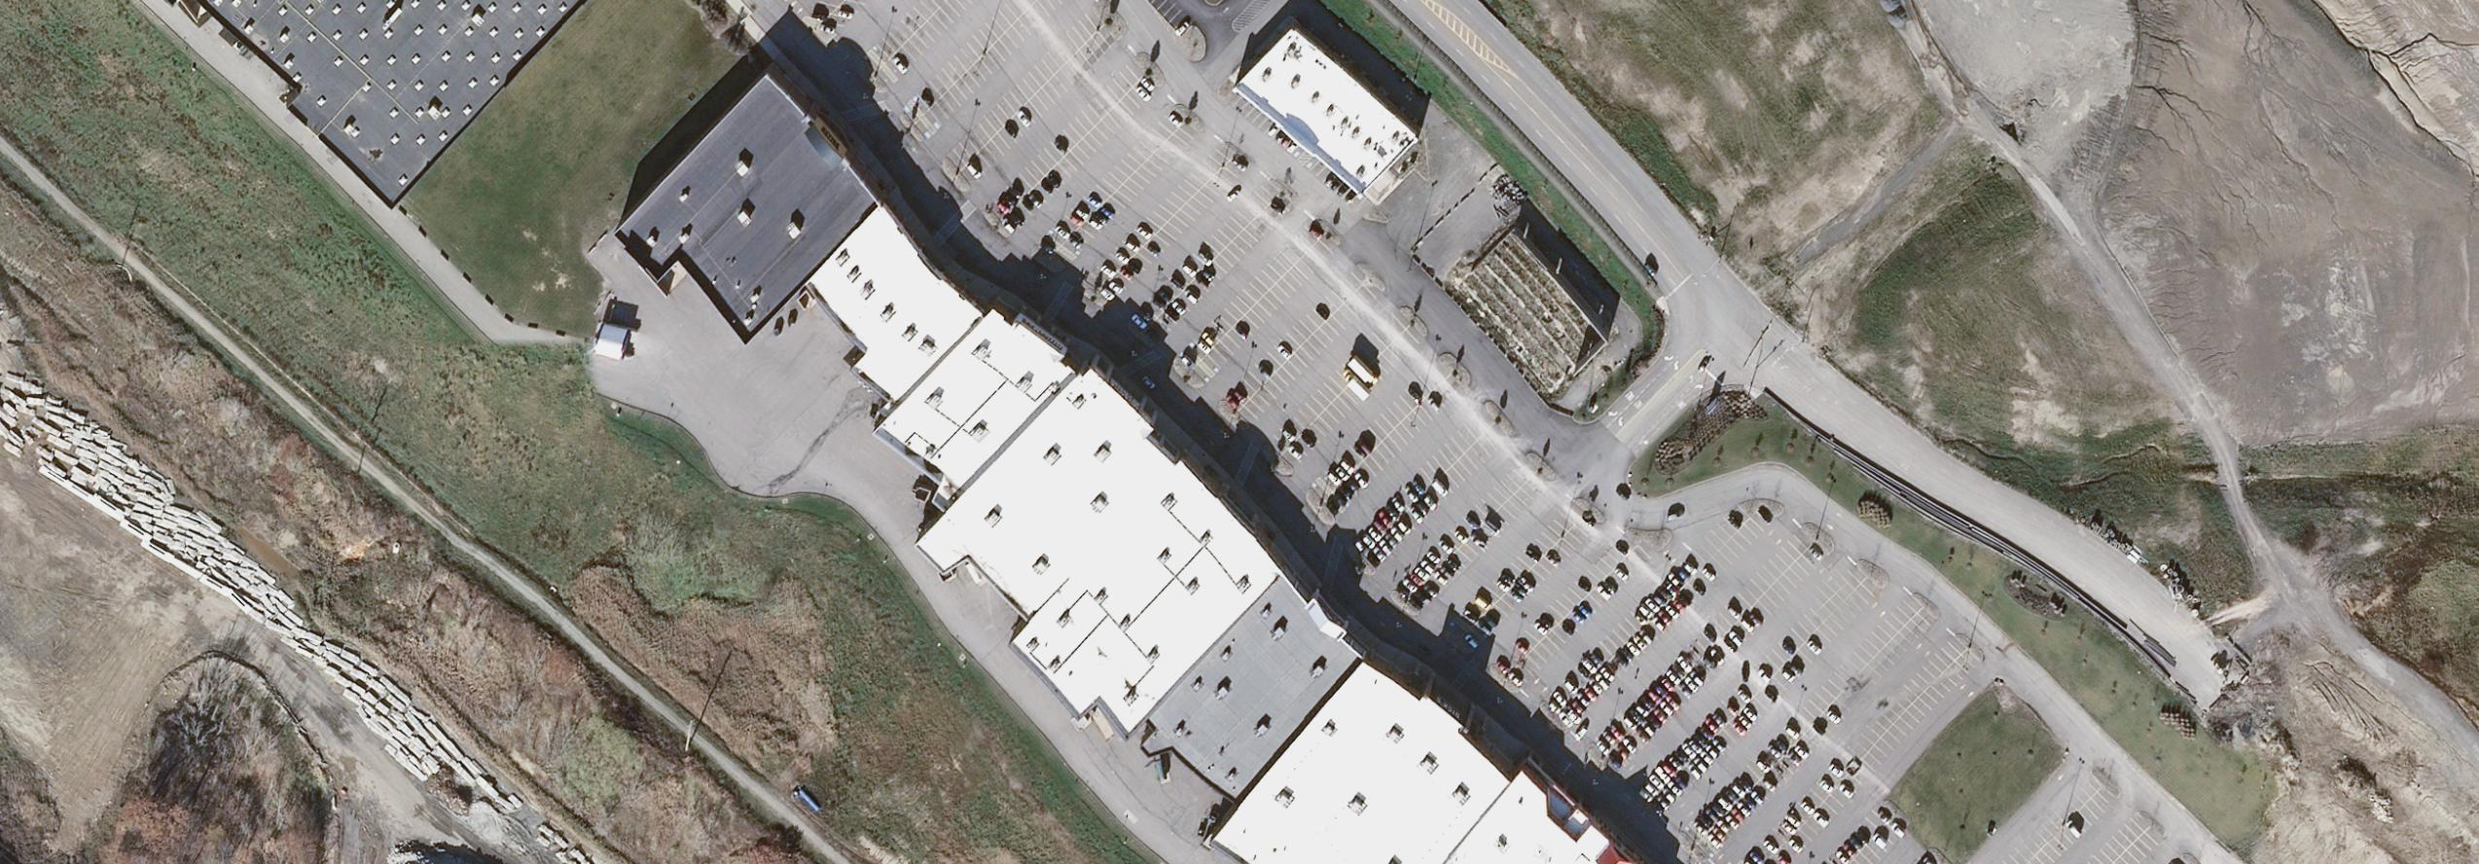

R0038C0019: Data gap. Corrected


R0017C0073: Obscuring emissions from power plant. Fixed as good as possible
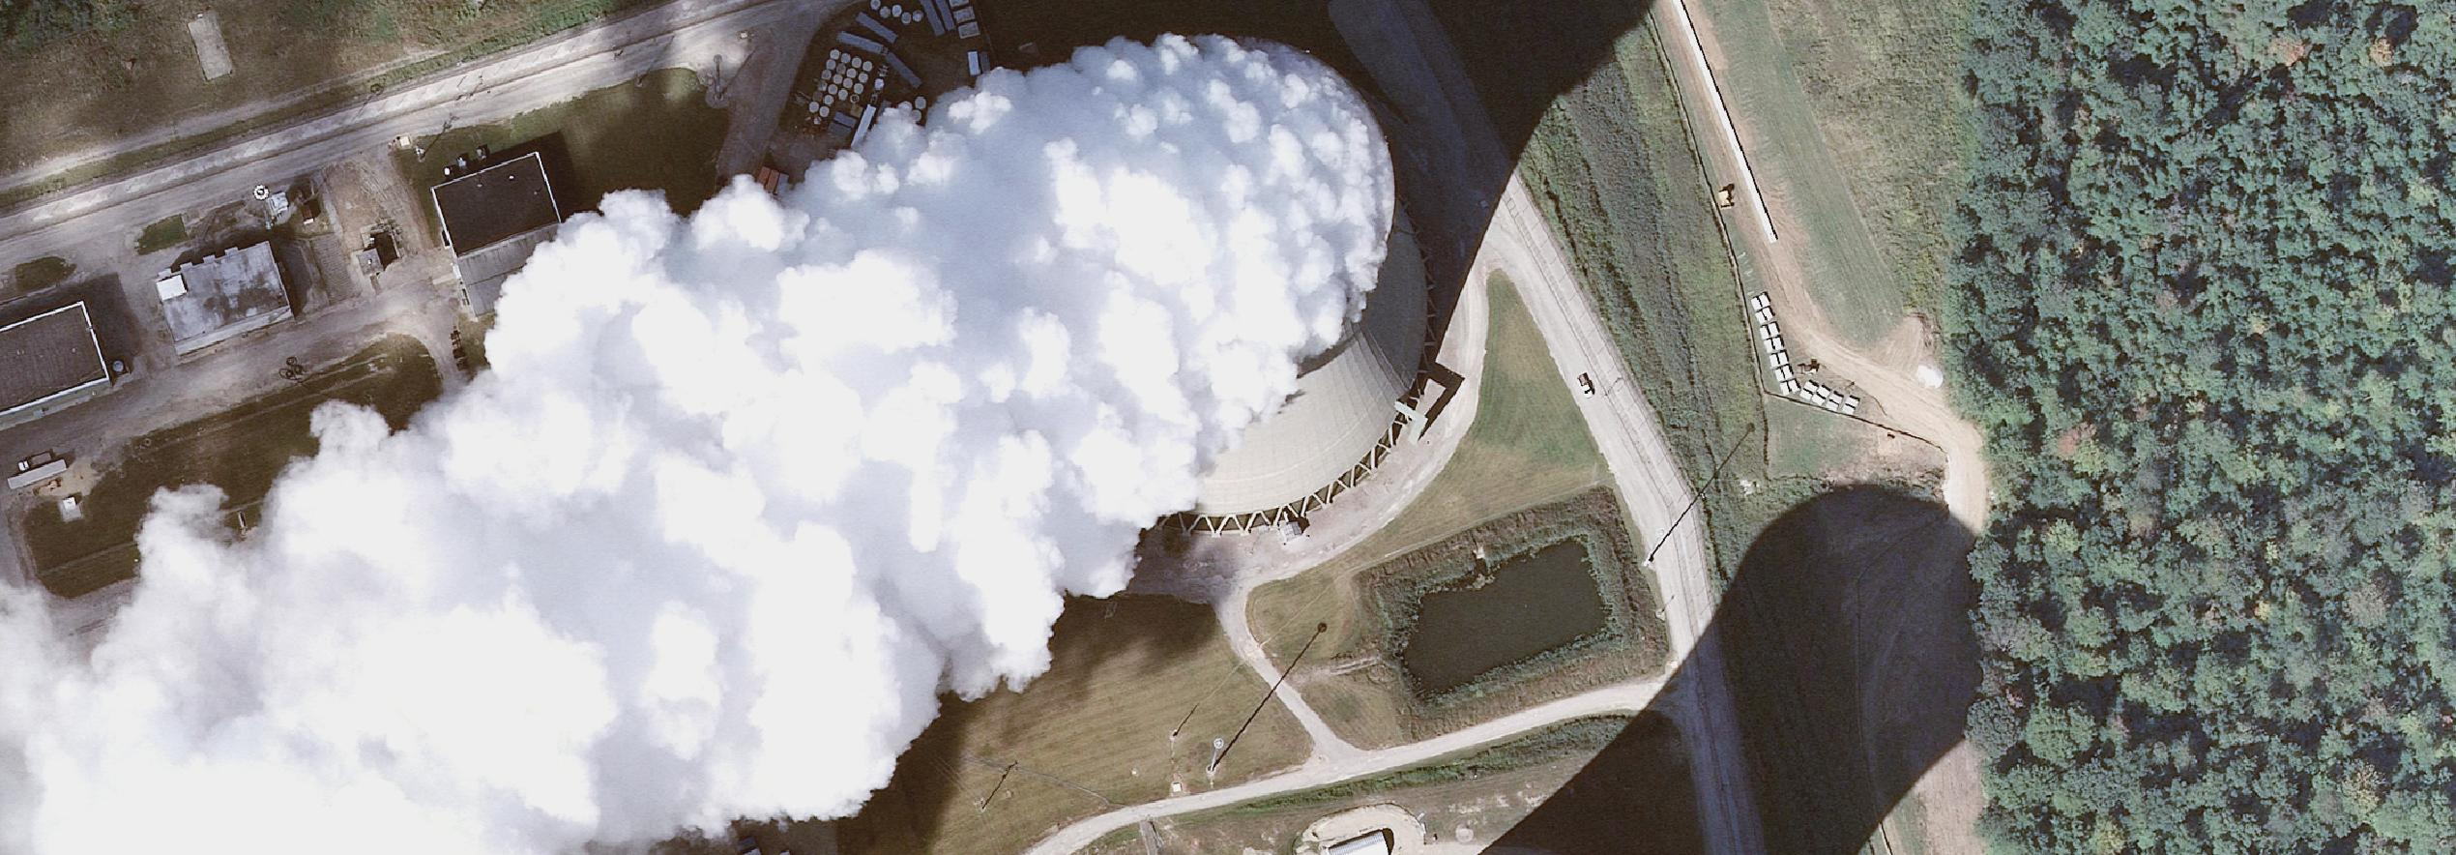

R0049C0002: Data gap along west edge of project. There are numerous such gaps along the northern tier of images. We expect a tile to have complete imagery coverage. Corrected
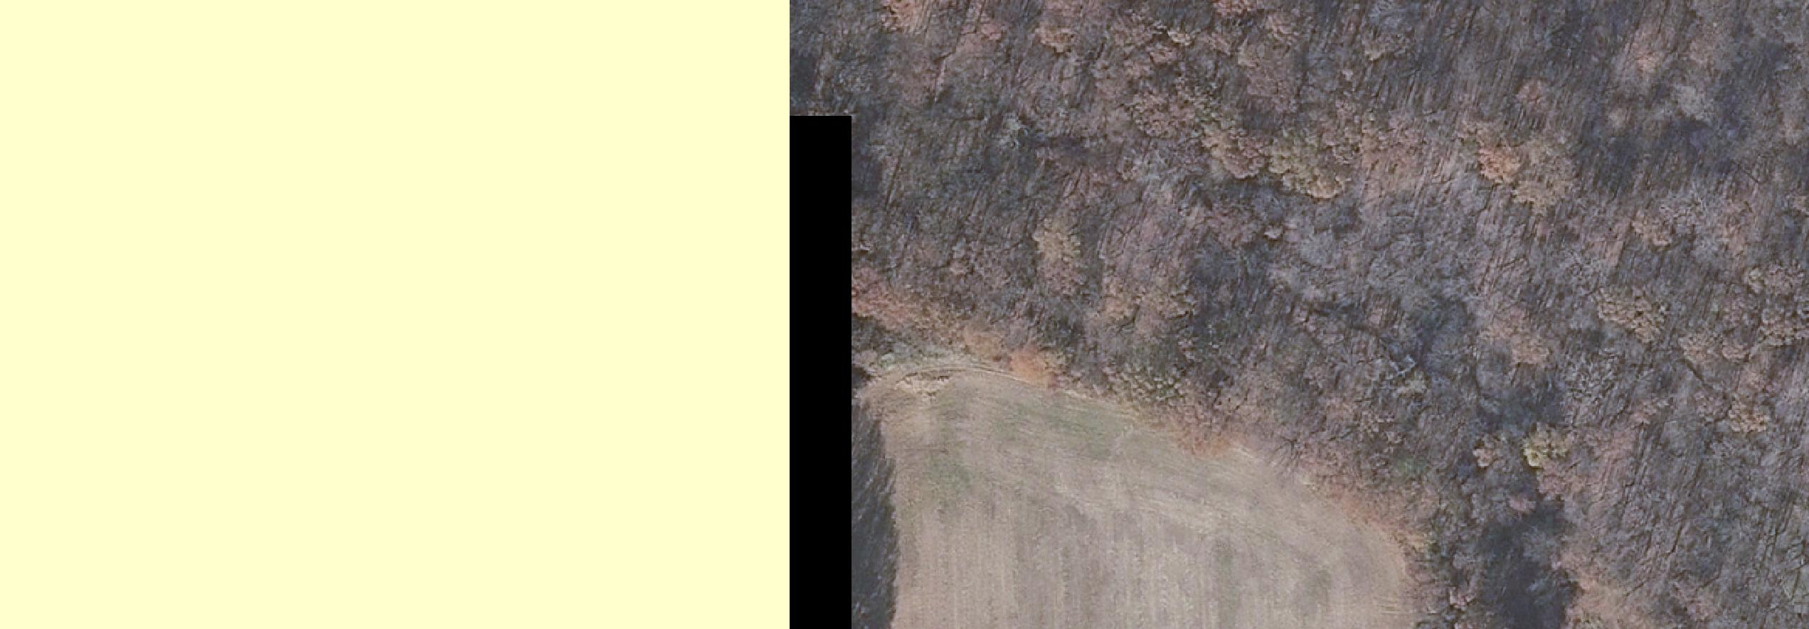
R0023C0068: Railroad warping. Corrected
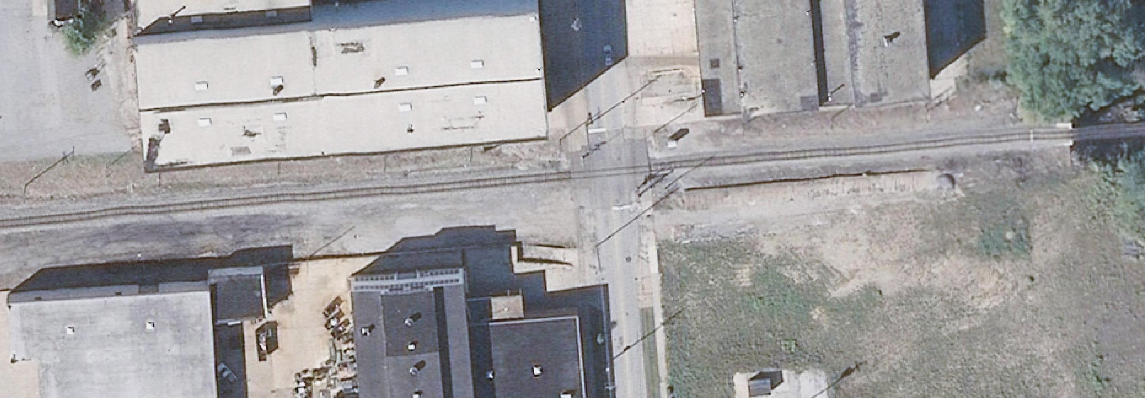
R0043C0040: Interstate warping. Corrected
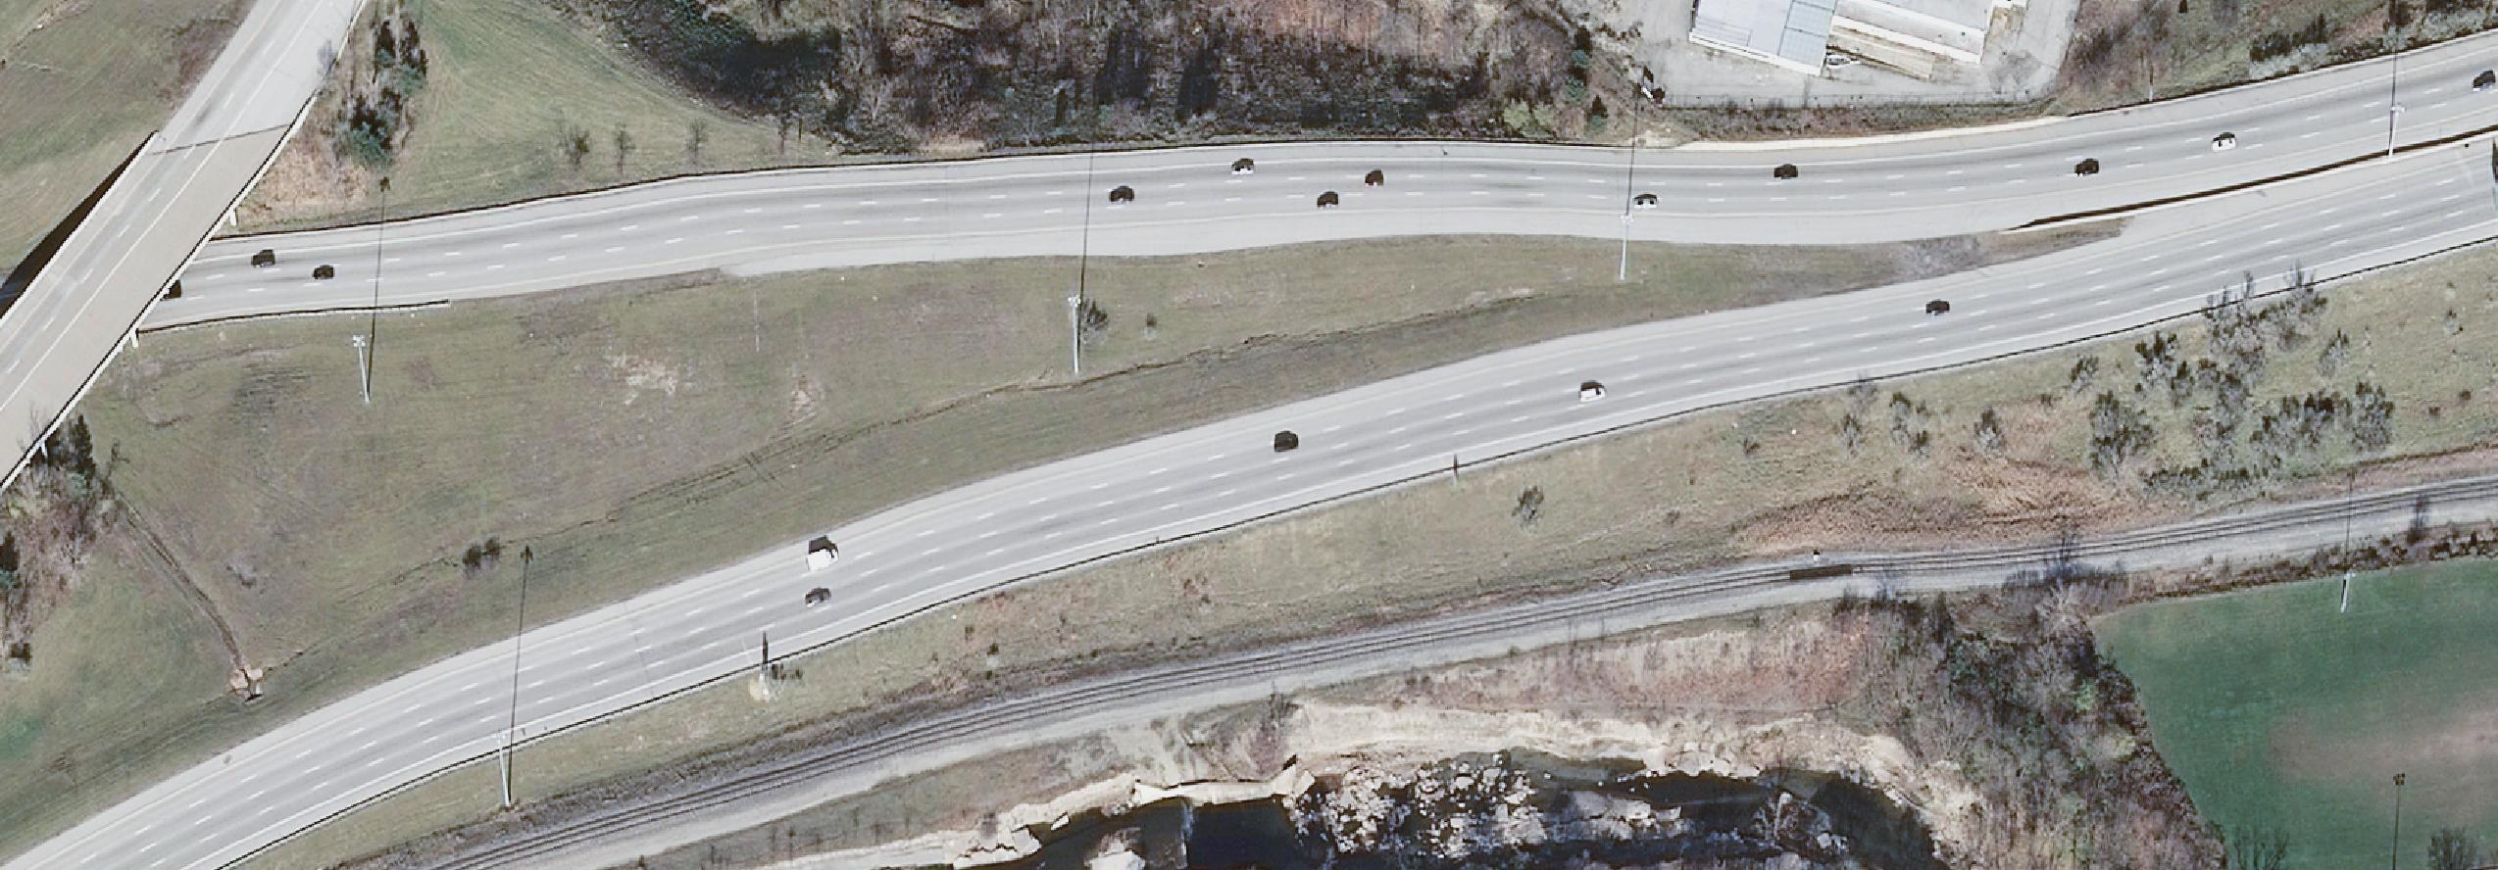
R0063C0042: Double images. This extends north and south of this feature. Corrected
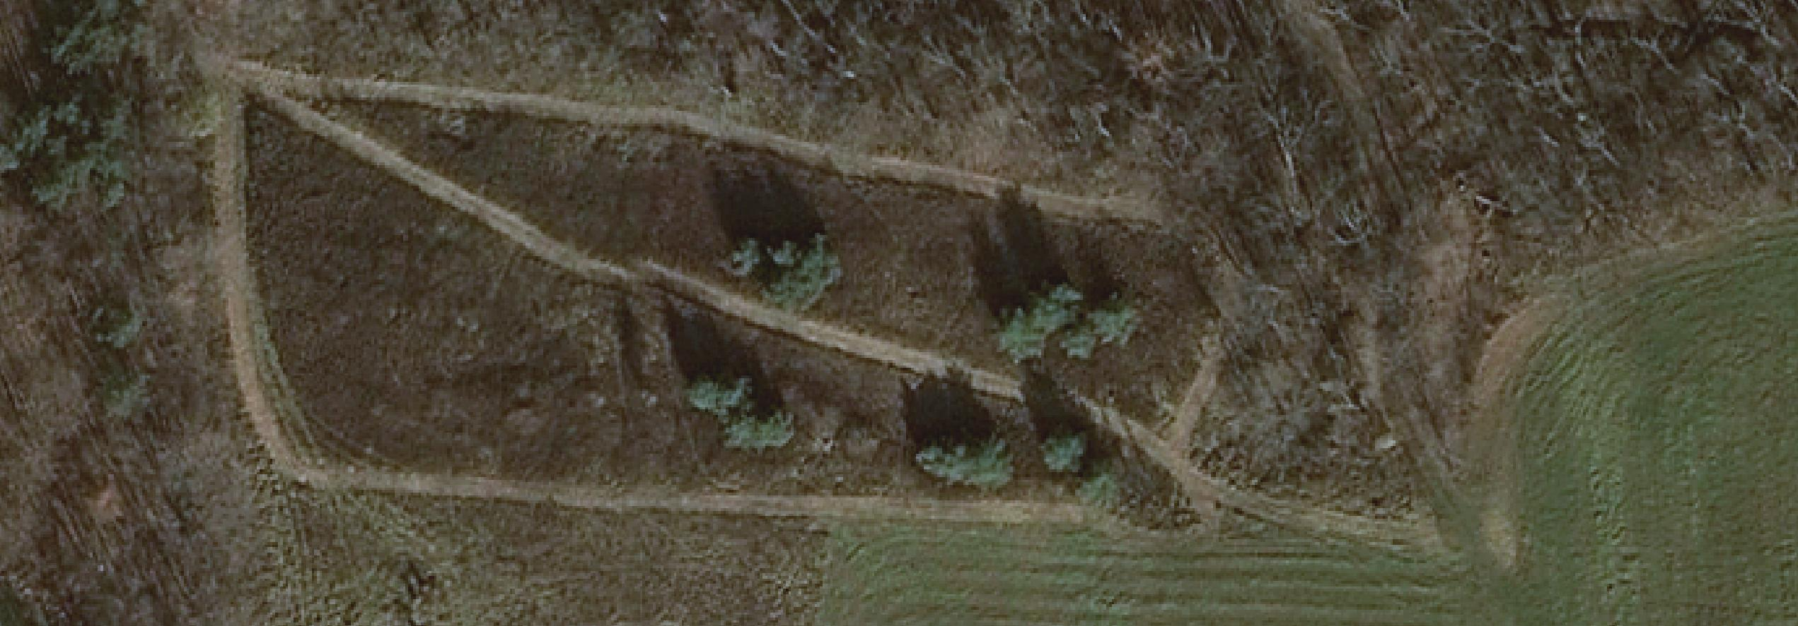
R0065C0042: Buildings clipped and/or mis-joined along seam line. Also note clarity disparity. Corrected
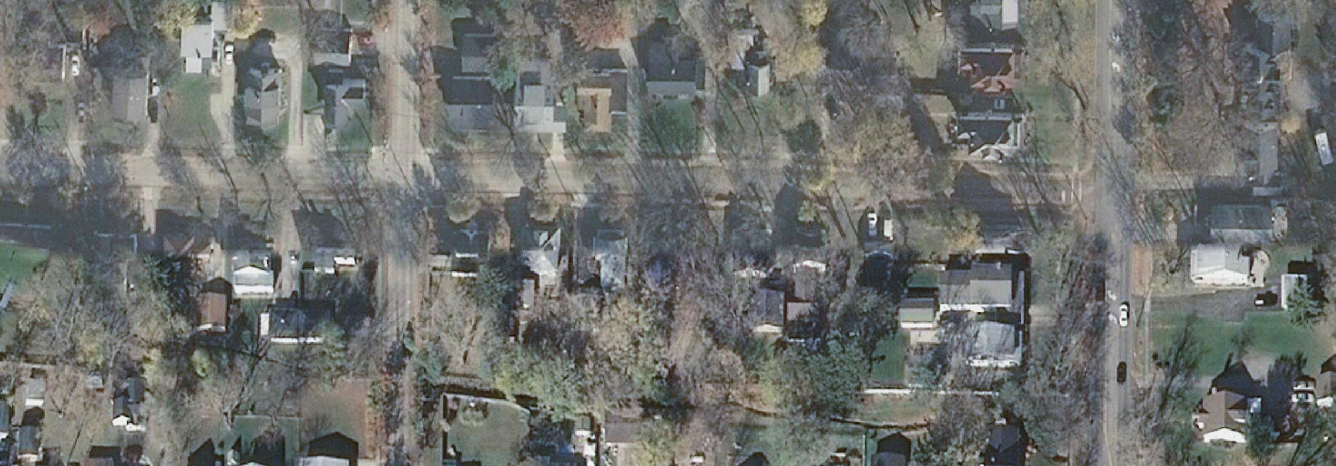

Screen shot of state and shapefile to see where it falls in the state:

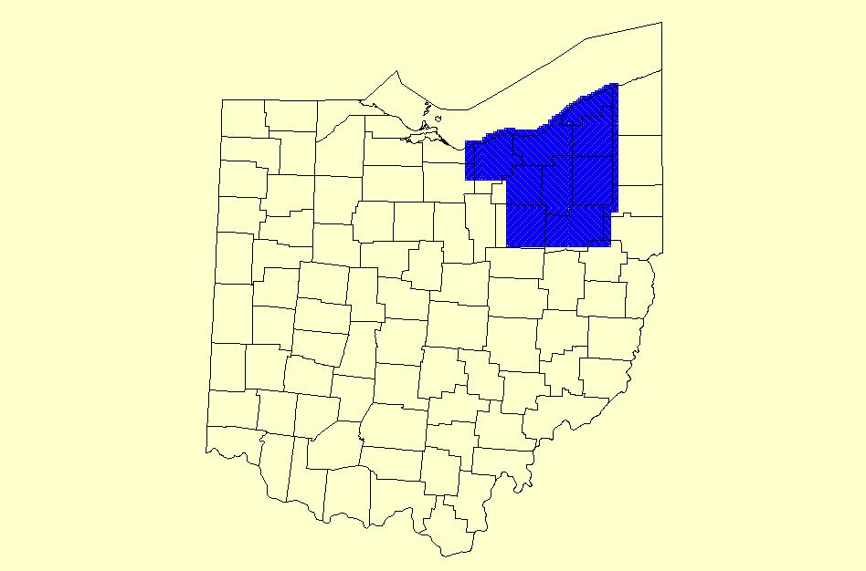

Summary Prepared By: Susan Mills, Cartographic Technician

