Trevor Whitney CSCI 563
Homework #2: Sieve of Eratosthenes
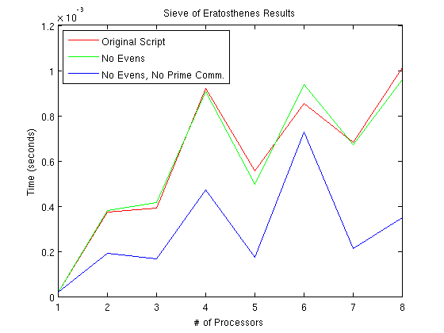
Above are the results from all three Sieve of Eratosthenes scripts, running in parallel in the Alamode lab. The red line is the unmodified version of the script from class. The green line is the modified version of the script from part 1 of the homework that does not allocate memory for even integers. The blue line is the final script, from part 2 of the homework that does not set aside memory for even integers, and also determines all sieving primes on each individual processor through a replicated computation to eliminate broadcasting the new sieving prime to each processor after each iteration. There is not much difference between the computation time for the first two scripts, which was to be expected since the optimizations made to the “No Evens” script were memory optimizations. However, the third iteration, which had reduced communication, shows a considerable improvement in computation resulting from the decreased communications.

I am curious why there was a spike in execution time at 4, and 6 processors. For each script, I calculated the primes up to 1000. Therefore, my guess for the spike in execution time on 6 processors was because 1000 does not divide evenly by 6, therefore requiring an imbalance in the number of tasks across the processors. Because of this, the processors with fewer tasks would have to wait on the processors with more tasks, thus resulting in the increased execution time. However, this logic would not explain why there was a spike in execution time on 4 processors, since 1000 does divide evenly by 4. Therefore, I cannot definitely conclude any reason why the execution time fluctuates as it does.

