

CMPG 325 - Computer Networks

Final Submission — Technical Report

Student | Sithole, T
Student Number | 45485097
Project ID | CMPG325-2026-137
Client ID | CLI-137
Assigned Organisation | Motheo Tyre & Exhaust Centre (Vryburg)
Industry | Automotive
Assigned Networking Challenge | Network Troubleshooting (fault isolation scenario) ,Intermediate
Addressing Block | 192.168.58.0/24
Design Constraint | New server (application or file) planned within six months
Change Request | CR3: Guest Wi-Fi added for visitors, isolated from internal resources

- Project Overview

This project designs and simulates a small automotive-shop network for Motheo Tyre & Exhaust Centre in Cisco Packet Tracer. The network uses a router-on-a-stick topology: a single Cisco 2911 router (Router1) with VLAN sub-interfaces, trunked down through a core switch (SW-Core) to two access switches (SW-Workshop, SW-Office) and a wireless access point (AP-Guest).

Five VLANs are implemented over the assigned 192.168.58.0/24 block using VLSM, giving the shop separate broadcast domains for management, sales, workshop devices, a future server, and isolated guest Wi-Fi (satisfying CR3).

During implementation and testing, three real faults were found and resolved using systematic fault-isolation methodology, not staged faults. These are documented in full in Section 5, satisfying the assigned Network Troubleshooting challenge (brief section 9).

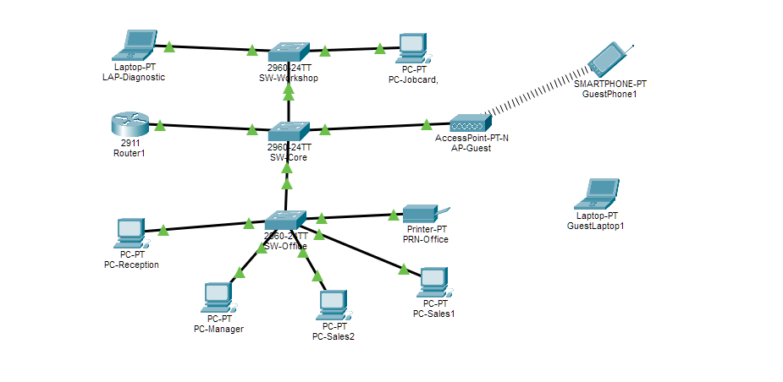
Figure 1. Full logical topology - Router1, SW-Core, SW-Workshop, SW-Office, AP-Guest and all end devices.

2. Client Requirements

2.1 Requirements

Assigned addressing block: 192.168.58.0/24
Provide appropriate connectivity and network services for the assigned scenario.
Accommodate the stated design constraint and change request.
Produce a working, testable Packet Tracer implementation.

2.2 Design Constraint

“New server (application or file) is planned within six months.”

Addressed by a dedicated VLAN (40 -SERVERS) and subnet (192.168.58.96/28) are reserved and routed but left without a live server device. When the server is procured it can be connected on this VLAN with a static address, with no re-addressing of the rest of the network required.

2.3 Change Request

“Guest Wi-Fi must be added for visitors, isolated from internal resources.”

Addressed by a separate VLAN (99-GUEST) and subnet (192.168.58.112/28) serving AP-Guest, combined with an extended ACL applied on the router that denies guest-sourced traffic to every internal subnet. See Section 4.

3. Network Design
3.1 Topology Choice: Router-on-a-Stick

A single router called Router1 which is a Cisco 2911 is used. There is one trunk link connected to SW-Core. This trunk link carries all the VLANs using 802.1Q sub-interfaces. This approach was selected because the client has a small site. The traffic levels are not high. This setup makes the network topology simple to build. It is also simple to configure. It is easy to explain. This is the way to show inter-VLAN routing, in a project of this size.

3.2 Devices

Device | Role
Router1 (Cisco 2911) | Router-on-a-stick; inter-VLAN routing, DHCP, guest ACL
SW-Core (2960-24TT) | Core switch; trunks to Router1, SW-Workshop, SW-Office, AP-Guest
SW-Workshop (2960-24TT) | Access switch for workshop devices (VLAN 30)
SW-Office (2960-24TT) | Access switch for office/management/sales devices (VLANs 10, 20)
AP-Guest | Wireless AP for Guest Wi-Fi (VLAN 99), SSID Motheo-Guest

3.3 IP Addressing Plan (VLSM)

Assigned block: 192.168.58.0/24, subnetted with VLSM so each VLAN's size matches its expected device count.
VLAN | Name | Subnet | Gateway
10 | MGMT | 192.168.58.0/27 | 192.168.58.1
20 | SALES | 192.168.58.32/27 | 192.168.58.33
30 | WORKSHOP | 192.168.58.64/27 | 192.168.58.65
40 | SERVERS | 192.168.58.96/28 | 192.168.58.97
99 | GUEST | 192.168.58.112/28 | 192.168.58.113
The remaining 192.168.58.128/25 is left unused as a reserved block for future VLANs (e.g. a second location, VoIP, CCTV) without redesigning existing addressing.

3.4 DHCP

Dynamic pools are configured on Router1 for MGMT, SALES, WORKSHOP and GUEST, each excluding its own gateway address. VLAN 40 (SERVERS) intentionally has no DHCP pool servers use static addressing, consistent with the design constraint that this VLAN is provisioned ahead of an actual server being deployed.

3.5 Guest Wi-Fi Isolation (CR3)

CR3 is implemented with a dedicated VLAN/subnet for guest traffic plus an extended ACL applied inbound on the router's guest sub-interface:

ip access-list extended GUEST-ISOLATE
deny ip 192.168.58.112 0.0.0.15 192.168.58.0 0.0.0.31 ! -> MGMT
deny ip 192.168.58.112 0.0.0.15 192.168.58.32 0.0.0.31 ! -> SALES
deny ip 192.168.58.112 0.0.0.15 192.168.58.64 0.0.0.31 ! -> WORKSHOP
deny ip 192.168.58.112 0.0.0.15 192.168.58.96 0.0.0.15 ! -> SERVERS
permit ip any any

Applied inbound on Gi0/0.99, this is evaluated the moment guest traffic enters the router before any routing decision toward an internal subnet the correct placement for this kind of isolation. The ACL is stateless, so isolation is enforced in both directions between guest and internal subnets, which is the intended CR3 behaviour.

3.6 Out of Scope

No WAN/internet-facing interface or ISP router is included. Router1's unused physical interfaces (Gi0/1, Gi0/2) are shut down. Internet access for guest and staff devices is outside the scope of this assignment's addressing block.

4. Troubleshooting Log

Three real problems were found and fixed during implementation and testing. None of them planned ahead. Each one is written up with a pattern: symptom, then diagnosis then root cause, then the fix and finally re-verification to make sure it is resolved.

4.1 Fault 1 - Native VLAN Mismatch (SW-Workshop ↔ SW-Core Trunk)
Symptom

%CDP-4-NATIVE_VLAN_MISMATCH: Native VLAN mismatch discovered on
FastEthernet0/1 (1), with SW-Workshop FastEthernet0/24 (30).
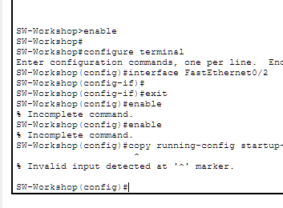
Figure 2. CDP native VLAN mismatch log message, SW-Workshop CLI.

Diagnosis
show running-config on SW-Workshop showed Fa0/24 configured with switchport mode access alongside trunk-only commands (switchport trunk allowed vlan 30). switchport mode access overrides the trunk lines: the port sent all traffic untagged, reporting VLAN 30 as native, while SW-Core's Fa0/1 (a proper trunk) treated untagged frames as VLAN 1.

Root Cause
Inconsistent trunk/access configuration on Fa0/24 - trunk-related commands mixed with switchport mode access.

Fix
interface FastEthernet0/24
switchport mode trunk
switchport trunk allowed vlan 30
no switchport access vlan

Verification

show interfaces trunk on both switches after the fix confirmed matching native VLAN (1) on both ends, VLAN 30 correctly allowed on the trunk, and the CDP mismatch message stopped appearing.
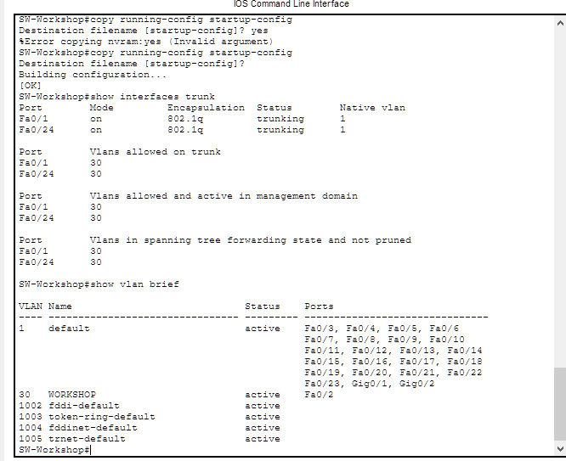
Figure 3. show interfaces trunk after fix Fa0/1 and Fa0/24 trunking, native VLAN 1 on both.

4.2 Fault 2 - No Connectivity: LAP-Diagnostic and PC-Jobcard (Workshop)
Symptom

PC-Jobcard: ipconfig showed 0.0.0.0 for IP, mask, and gateway, no DHCP lease at all. LAP-Diagnostic: obtained a valid WORKSHOP address (192.168.58.70/27, gateway .65) but could not ping its own default gateway (100% loss).
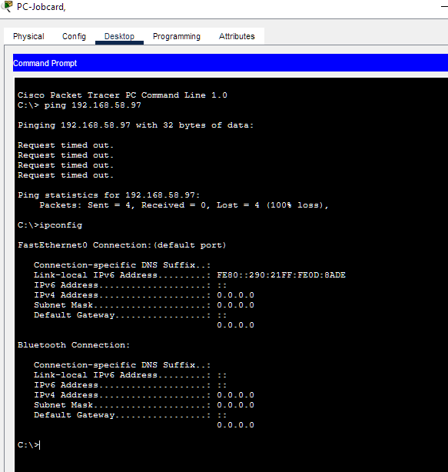
Figure 4. PC-Jobcard failed ping and 0.0.0.0 address before the fix.

Diagnosis

show interfaces status on SW-Workshop showed every port except Fa0/1, Fa0/2 and Fa0/24 as not connect.
show cdp neighbors detail confirmed the only CDP-visible neighbour was SW-Core on Fa0/24, ruling out a switch-to-switch link issue.
ipconfig /all on each PC gave their MAC addresses (LAP-Diagnostic: 0060.7084.BC57; PC-Jobcard: 0090.210D.8ADE).
show mac-address-table on SW-Workshop showed neither MAC anywhere in the table confirming both devices had never sent a single frame to this switch.
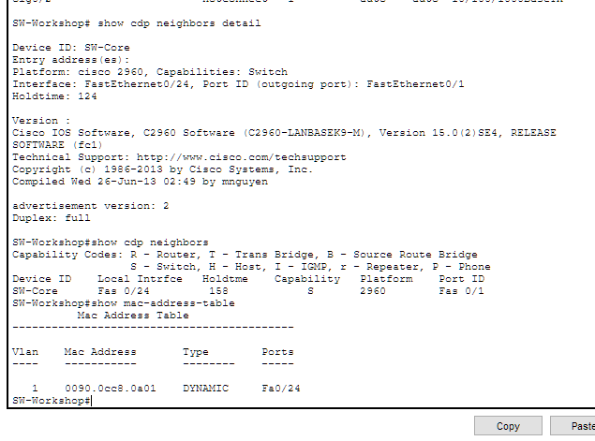
Figure 5. SW-Workshop MAC address table neither device's MAC present, confirming no physical link.

Root Cause

LAP-Diagnostic and PC-Jobcard were not physically connected to SW-Workshop with a working link, despite appearing adjacent to the switch in the topology diagram.

Fix
Verified/redrew the copper straight-through cables to SW-Workshop Fa0/3 and Fa0/4, confirmed solid green link lights, then configured:
interface range FastEthernet0/3 - 4
switchport access vlan 30
switchport mode access

Verification

Both MAC addresses appeared against Fa0/3 and Fa0/4 in the MAC table. Both PCs obtained valid WORKSHOP addresses (192.168.58.67 and .68, gateway .65) and pinged their gateway successfully with 0% loss.
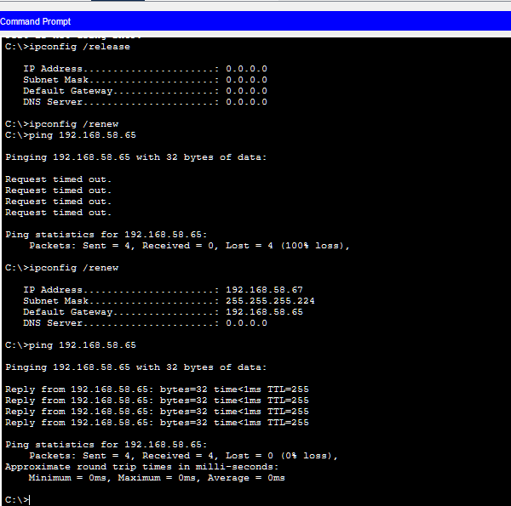
Figure 6. LAP-Diagnostic successful ping to gateway after the fix.
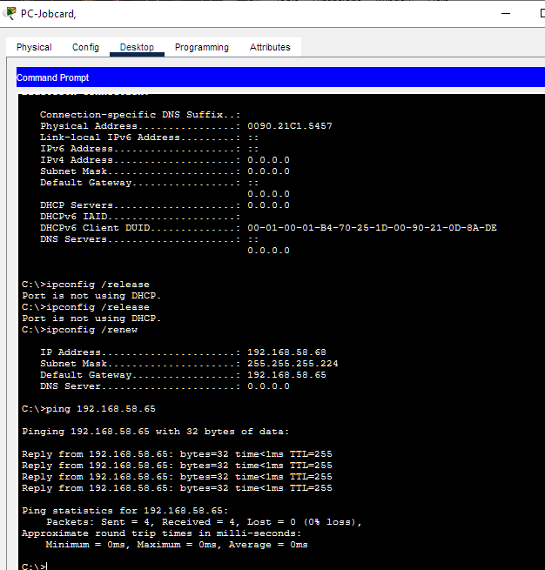
Figure 7. PC-Jobcard successful ping to gateway after the fix.

4.3 Fault 3-Guest Wi-Fi SSID Mismatch (GuestPhone1 ↔ AP-Guest)

Symptom
GuestPhone1 could not obtain a valid IP address, showing a 169.254.x.x APIPA (self-assigned) address with no default gateway indicating it never reached a DHCP server.
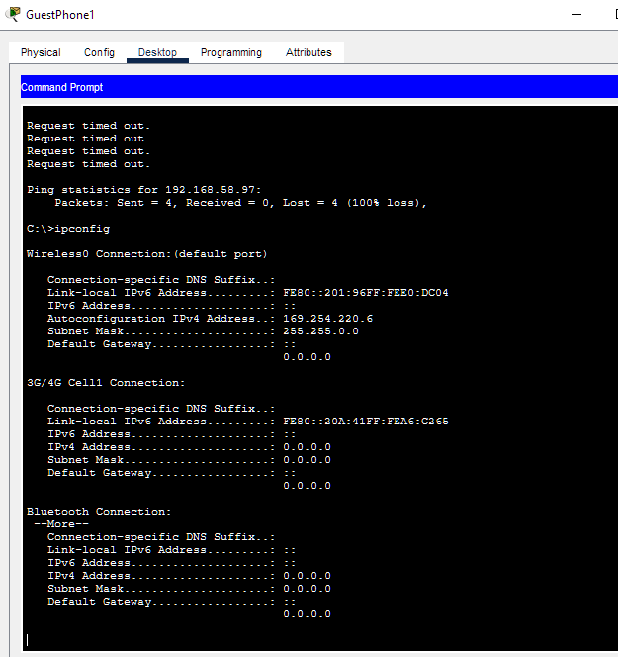
Figure 8. GuestPhone1 APIPA address — device never associated with the AP

.
Diagnosis
Comparing wireless configuration on both ends: GuestPhone1's Wireless0 SSID was set to “Default”, while AP-Guest's Port 1 SSID was set to “Motheo-Guest” (WPA2-PSK, passphrase Vryburg2026). The phone was attempting to associate with a network that did not exist.
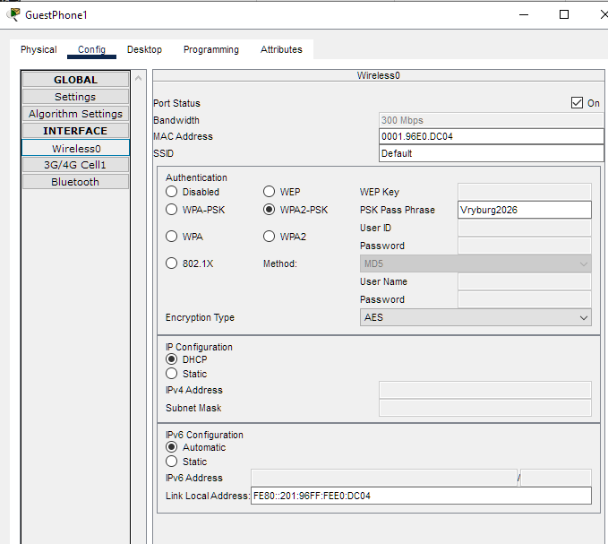
Figure 9. GuestPhone1 wireless config — SSID mismatched to “Default”.
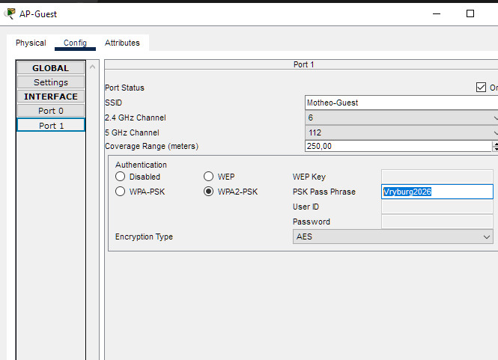
Figure 10. AP-Guest config — correct SSID “Motheo-Guest”.
Root Cause

SSID mismatch between the client device and the access point.

Fix
Changed GuestPhone1's SSID from “Default” to “Motheo-Guest” to match the AP, keeping the existing WPA2-PSK passphrase.
Verification
GuestPhone1 obtained a valid GUEST address (192.168.58.114/28, gateway .113). A ping to the SERVERS VLAN correctly failed, but this time with an active router response “Reply from 192.168.58.113: Destination host unreachable” confirming the router's GUEST-ISOLATE ACL is actively enforcing the deny rule (CR3), not merely that the device lacked connectivity.
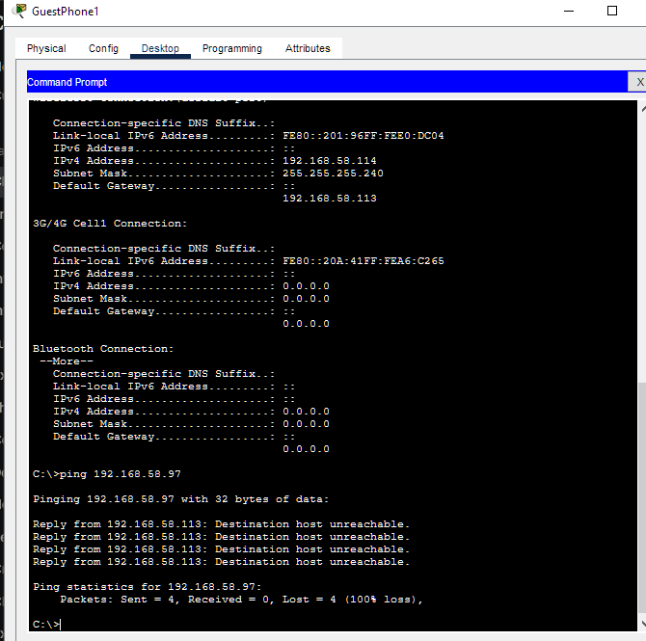
Figure 11. GuestPhone1 valid GUEST address; ping to SERVERS actively blocked by the router ACL.

4.4 Summary

# | Fault | Category | Method Used
1 | Native VLAN mismatch | Switch trunk config | CDP log, show interfaces trunk, show running-config
2 | No physical link (2 devices) | Cabling | show interfaces status, show cdp neighbors, MAC table cross-reference
3 | SSID mismatch | Wireless config | ipconfig (APIPA detection), config comparison

5. Testing Evidence (Brief Section 11)

5.1 DHCP / Addressing
Device | Expected | Result
PC-Manager | 192.168.58.1–.30 (MGMT), gw .1 | Got 192.168.58.6/27, gw .1
LAP-Diagnostic | 192.168.58.65–.94 (WORKSHOP), gw .65 | Got .67/27, gw .65 (post-fix)
PC-Jobcard | 192.168.58.65–.94 (WORKSHOP), gw .65 | Got .68/27, gw .65 (post-fix)
GuestPhone1 | 192.168.58.113–.126 (GUEST), gw .113 | Got .114/28, gw .113 (post-fix)
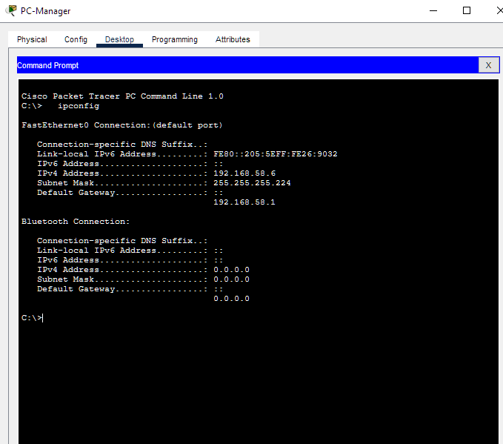
Figure 12. PC-Manager correct MGMT address via DHCP.

5.2 Internal Connectivity
From | To | Expected | Result
PC-Sales2 (SALES) | 192.168.58.97 (SERVERS gw) | Success | 4/4 replies, 0% loss
LAP-Diagnostic (WORKSHOP) | 192.168.58.65 (own gw) | Success | 4/4 replies, 0% loss
PC-Jobcard (WORKSHOP) | 192.168.58.65 (own gw) | Success | 4/4 replies, 0% loss
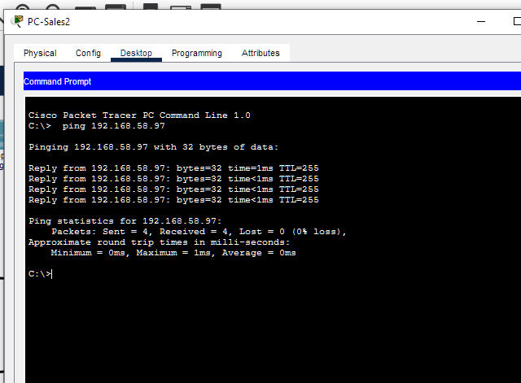
Figure 13. PC-Sales2 successful ping across VLANs to the SERVERS gateway.

5.3 Guest Isolation (CR3)

From | To | Expected | Result
GuestLaptop1 (GUEST) | 192.168.58.97 (SERVERS) | Fail (isolation) | 4/4 timed out
GuestPhone1 (GUEST) | 192.168.58.97 (SERVERS) | Fail (isolation) | 4/4 “Destination host unreachable”
A failed ping from a guest device to an internal subnet is a PASS, not a bug it is the intended behaviour required by CR3.

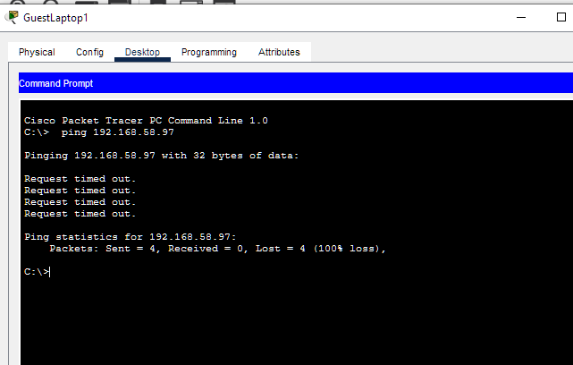
Figure 14. GuestLaptop1 correctly blocked from reaching the SERVERS VLAN.
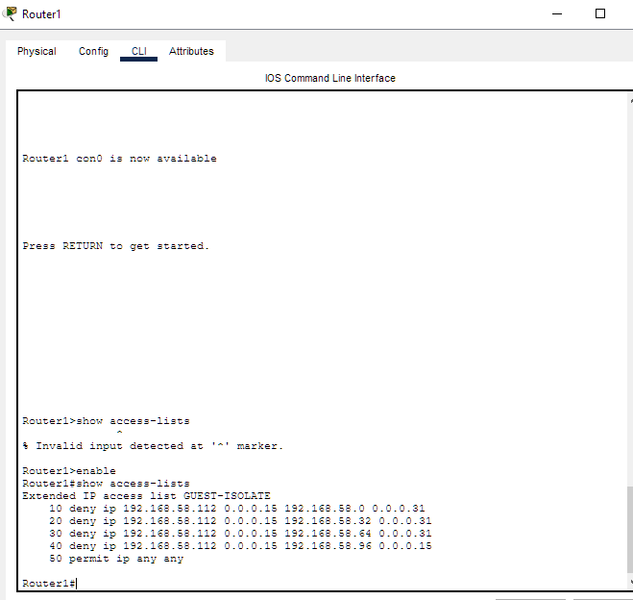
Figure 15. Router1 - GUEST-ISOLATE ACL confirmed present and applied.

5.4 Configuration Persistence

copy running-config startup-config was run and confirmed with [OK] on all four configured devices: Router1, SW-Core, SW-Workshop and SW-Office.

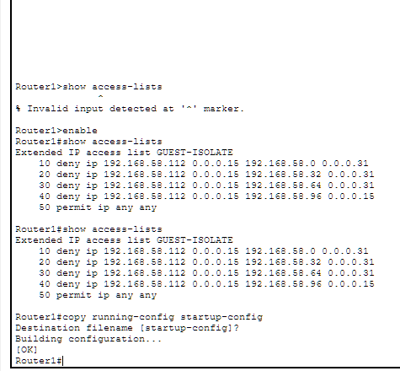
Figure 16. Router1 configuration saved to startup-config.
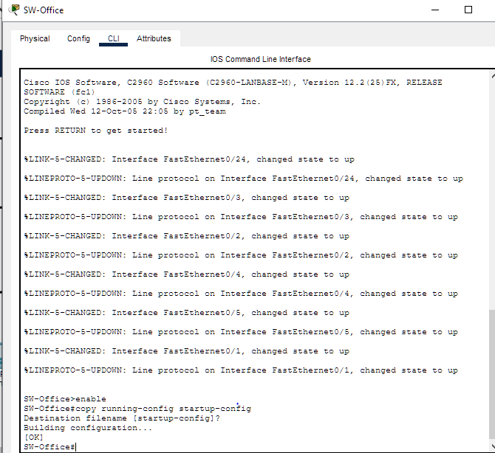
Figure 17. SW-Office configuration saved to startup-config.

6. Final Verification

The final Packet Tracer (.pkt) file was closed, fully reopened, and independently re-tested prior to submission, confirming it reproduces the working solution described in this report without any manual reconfiguration. Key connectivity and isolation tests (DHCP addressing, internal routing, and guest ACL enforcement) were re-run after the reopen to confirm the saved configuration persisted correctly across all four devices (Router1, SW-Core, SW-Workshop, SW-Office).

7. Submission Links

GitHub Portfolio : https://github.com/trevoursithole/CMPG325-MOTHEO-TYRE-NETWORK.git
Video Demonstration:

8. Reflection

Across this project, the VLSM addressing plan fit the client's requirements cleanly, the guest isolation requirement (CR3) was implemented and verified with concrete evidence, and three genuine faults were independently diagnosed and resolved during testing rather than staged in advance. This gave direct practical experience with CDP, MAC address table analysis, interface status checks, and systematic elimination as fault-isolation techniques, rather than following a pre-written troubleshooting script.

9. Academic Integrity
AI assistance was used during this project for design guidance, configuration review, and documentation drafting, in line with the CMPG 325 brief and the NWU AI Policy. All configuration was entered, tested, and verified on the actual devices by the student, including diagnosis of the three faults documented in Section 4. The student remains responsible for the correctness, understanding, and academic integrity of everything submitted.

