Evaluating the performance of visual tracking for ground speed detection on agricultural tractors
ENVB 506 - Quantitative Methods in Ecology
by Trevor Stanhope
Due April 27th, 2016

Abstract
Visual tracking with cameras can be useful for robust, real-time ground speed detection of agricultural tractors. Visual tracking has the potential to provide control feedback for machinery systems during field operations where accurate tracking data may be useful for adjusting operational parameters, such as the responsiveness of a hydraulic steering system. To evaluate the accuracy of monocular visual tracking for ground speed detection in an agricultural environment, the ORB visual tracking algorithm was employed for finding and matching keypoints between consecutive images on a video dataset of consisting of six common agricultural surfaces (gravel, asphalt, seedlings, grass, corn, and pasture), at travel speeds from 0 to 18 km/h, and for five thresholds representing the number of keypoints to track per image: 125, 250, 500, 750, and 1000 keypoints. When comparing visual tracking against RTK GNSS, ORB with a threshold of 250 keypoints (ORB₂₅₀) was determined to be the most practical with respect to real-time applications. Thresholds greater than 250 keypoints had no significant improvement in accuracy and only slowed computational speed. No significant interaction was observed between surface and threshold, but surfaces with low ground coverage (e.g. seedlings) had significantly lower error.

Introduction
Visual tracking is the process of determining the movement of an object by analyzing consecutive images produced by camera(s). Figure 1 illustrates a basic visual tracking system, known as monocular system, and consists of a single camera oriented vertically to the test surface (Stone, 1992). Visual tracking is particularly well suited for ground speed estimation on agricultural tractors because it has a high sampling rate (greater than 20 Hz), is non-contact, and video information can be used for a wide range of additional applications. However, real-time applications of visual tracking require the tracking algorithm to be precise, robust (tolerant of varying environments), and computationally efficient.
In order to identify the motion vectors of an agricultural platform, such as a mechanical cultivator implement, the visual tracking algorithm must find and match distinctive features between images regardless of varying surfaces and travel speeds. Examples of distinct features include blobs, corners, and edges, and can generalized as a sub-region of an image which exhibits maximum variation when the window of consideration is shifted in all directions about the point. The process of searching for distinctive keypoints is known as Feature Detection. After distinct keypoints have been located in an image, the region around each must be described: This process of generating descriptive parameters for a keypoint is known as Feature Description. Once a set of features and their descriptors have been generated for both images, a clustering algorithm such as k-Nearest Neighbors (kNN matching) can be used to find matches between the two sets of feature-descriptors (Altman, 1992). After filtering results for the best matches (Figure 2), the displacement of keypoint pairs between images can be calculated. Using the precise time differential between each image, the camera lens distortion model (Lee, 2009), and the height of the camera from the surface, the motion of the tractor relative to the ground surface can be estimated.
Unfortunately, feature detection / description and kNN matching is computationally expensive, and increasing the number of keypoints detected per image, known as the keypoint threshold, slows the processing speed. However, tracking more keypoints per image theoretically improves the accuracy of visual tracking, albeit to a limit. Oriented FAST and Rotated BRIEF (ORB) was developed by Rublee et al. (2011) as a high-speed feature detection algorithm with faster processing speeds and comparable performance to other state-of-the-art methods. Implementations of ORB have been developed for system-on-a-chip (SoC) devices intended for embedded applications which have reported speeds of 18 ms (~55 Hz) per 640 × 480 pixel image (Lee, 2013). As such, ORB represents an good candidate for low power devices, i.e. systems with restricted computational capacity. However, because ORB uses lower resolution descriptors to boost speed, it may exhibit reduced accuracy when employed on surfaces with a high number of similar or poorly defined edges, e.g. asphalt or pasture.
The objective of this study was to assess the performance of the ORB feature-descriptor algorithm for visual tracking. The ground speed of an agricultural tractor was determined using visual tracking for speeds between 0 and 18 km/h on six surfaces (gravel, asphalt, seedlings, turf grass, corn residue, and pasture) and for five different keypoint thresholds (125, 250, 500, 750, 1000). Specifically, this research is interesting in addressing the following questions:
- Does surface have a significant effect on accuracy?
- Does the number of keypoints (keypoint threshold) have a significant effect on accuracy?
- Under which conditions (both with respect to surface and threshold) does visual tracking exhibit the best overall performance (i.e. both accuracy and speed)?

Materials and Methods
A weatherproof camera with a resolution of 640 × 480 pixels and 25 frames-per-second capture rate was mounted to the front of a John Deere 850D Gator at a height of 1.0 m (Figure 3). A state-of-the-art Trimble AgGPS 542 real-time kinematic global navigation and satellite system (RTK GNSS) receiver was mounted to the test tractor. An application was developed using the Python programming language (version 2.7.11) and OpenCV (version 2.4.9) to capture videos with low-latency, record the accompanying GPS data with high precision time-stamps corresponding to each image, and subsequently use the ORB algorithm and computer vision processing techniques to determine the ground speed of the tractor for each image.
As specified by ISO 12188-2, tests were conducted from 0 to 18 km/h on six different surfaces: asphalt, gravel, turf grass, seedlings, corn residue, and pasture (Figure 4). These surfaces can be classified into three groups by height of ground coverage: Low (asphalt and gravel), Medium (seedlings and grass), and High (corn and pasture) (Table 1). For each surface type, five replicates were conducted lasting approximately 45 seconds long and consisting of 1073 images (on average). Altogether, this resulted in a dataset of 30 different trials on 5 surfaces and a total of 32191 images. Post-processing analysis was conducted on the 30 video datasets using the five keypoint thresholds: 125, 250, 500, 750, and 1000 keypoints per image. With respect to the each surface, threshold, replicate, and frame of video, a total sample size of 160955 vectors was considered in this study.
For this analysis, RTK GNSS was assumed to be the true ground speed, and visual tracking data was considered the observed value, and all subsequent analysis focused on the error between these two measurements. A two-way ANOVA was performed to determine whether there was any interaction between threshold and surface. Next, RMSE and 95th percentile values were calculated for each combination of trial, surface, and threshold. Post-hoc analysis via Tukey's Honest Significant Difference (HSD) multiple comparison test with a confidence of was used to determine the pair-wise relationship with respect each combination of surface and keypoint threshold. This test, based on the studentized range distribution (q), was used to compare the groups with respect to the root-mean-square-error (RMSE) of their respective trials. RMSE and 95th percentile were used instead of a simple mean for two reasons: 1) visual tracking errors were determined to be distributed normally about zero using the Shapiro-Wilks normality test (Royston, 1992), and 2) ISO 12881-2 specifies that RMSE and 95th percentile should be considered when analyzing guidance errors. Regardless of rationale, both metrics are a more rigorous means of assessing the accuracy of visual tracking, and thus strengthen the validity of the results. Additionally, pair-wise t-tests were not used for multiple comparison because the number of samples per surface was not identical (Table 1), and in order to avoid committing a Type I error, i.e. the probability of rejecting a true null hypothesis, which Tukey's HSD accounts for.

Results and Analysis
Table 2 presents the two-way ANOVA table used to determine if there was a significant interaction between Surface (Figure 5) and Threshold (Figure 6). Based on the results, the p-value of 0.146 indicates that there was not a significant interaction between the two factors for a multiplicative model, i.e. Error ~ Surface × Threshold, i.e. the keypoint threshold did not disproportionately affect the accuracy of one surface compared to another. However, based on the results there was a significant effect of both Surface and Threshold on Error when considered independently with an F-value of 50.63 and 18.52 for Surface and Threshold effects, respectively. These findings support the initial assumption that visual tracking may be effected by surface, and that the number of keypoints detected effects the accuracy of the algorithm. As ANOVA found no multiplicative effect, an additive linear model was assumed for subsequent post-hoc analysis.
Table 3 presents the results of a Tukey HSD multiple comparison test of the various keypoint thresholds. Although Table 3 presents all combinations, the combinations most relevant to this analysis are the sequential pairs, e.g. 125-250, 250-500, etc., and these pairs are highlighted in bold. As can be seen, increasing the number of detected keypoints per image from 125 to 250 resulted in a significant positive effect on RMSE. However, apart from 125-250, no other sequential pair exhibited a significant difference of RMSE at a 95% confidence interval. This indicates that only tracking 125 keypoints per image is less accurate than higher thresholds, but further increasing the threshold beyond 250 keypoints per image results in neglible gains. It can be seen from Figure 6 that increasing the threshold beyond 500 keypoints produced no meaningful change, and the 750 and 1000 thresholds exhibited near-identical accuracy. Therefore increasing the number of keypoints per image has a detrimental effect on overall performance when considering the cost-benefit of accuracy vs. processing speed (Figure 7).
Table 4 presents the results of a Tukey HSD multiple comparison of RMSE values of each surface (Figure 8), wherein all of the threshold levels are considered together, for a total of 25 samples per group. This proved to be a useful analysis in determining which surfaces, in general, visual tracking performed best on. Using a 95% confidence interval, RMSE values of Gravel, Asphalt, Seedlings and Grass were not significantly different from one another. Conversely, RMSE values of Pasture and Corn were both significantly different not only from each other, but the other four surfaces as well. When further consolidating trials into groups purely by the height of crop coverage, e.g. Low, Medium and High, it is apparent that the primary factor influencing visual tracking error was ground coverage (Figure 9), and illustrates that Low and Medium are statistically different from High coverage. As seen previously in Figure 5, this differentiation is due to visual tracking overestimating ground speed on surfaces with High ground coverage.
As specified by ISO 12188-2, when evaluating accuracy of guidance systems the 95th percentile of error should be reported, and the results of Tukey HSD using the metric is presented in Table 6. Notably, the primary difference with respect to significance between the two metrics is that Asphalt-Corn and Gravel-Corn were no longer significantly different when using 95th percentile, whereas Seedlings-Corn remained significantly different.

Discussion and Conclusions
In general, there was a significant difference between the 125 keypoint threshold and the higher threshold levels. However, for all combinations of threshold greater than 125 there was no significant difference between treatments. From these results, it can be said that using the ORB visual tracking algorithm with only 125 keypoints per image is significantly less accurate, and there is an insignificant improvement in accuracy when calculating greater than 250 keypoints per image. Similarly, the processing speed is significantly different for each algorithm, and is negatively correlated with the number of keypoints. Therefore, for real-time applications, e.g. for embedded control systems on agricultural implements, detecting between 250 to 500 keypoints per image produces the best balance of accuracy and processing speed.
With respect to the surface, this research has shown that texture / pattern of the surface itself does not seem to be the dominant factor which influences accuracy, and instead the height of ground coverage is more significant. This conclusion is reasonable for monocular visual tracking, wherein the movement of keypoints between images is highly dependent on the distance between the camera lens and the surface: Higher ground coverage results in keypoints appearing to move further between images, thus overestimating ground speed. In conclusion, visual tracking with the ORB algorithm exhibited significantly better performance on Gravel, Asphalt, Grass, and Seedlings, all of which were surfaces with Low to Medium ground coverage. Conversely, visual tracking on the two High coverage surfaces (Pasture and Corn) was significantly less accurate. Overall, the best accuracy was exhibited on seedlings, which is an excellent result because among the surfaces tested, the Seedling surface was the most representative of field conditions where visual tracking might be applied for control feedback. The two most viable applications of visual tracking for adaptive control are mechanical cultivators or pesticide sprayers, both of which would be used for field operations in the early growing season when ground coverage is relatively low.

References
Altman, N. S. (1992). An introduction to kernel and nearest-neighbor nonparametric regression. The American Statistician, 46(3), 175-185.
Hall, R. (1998). Tukey's HSD Post Hoc Test Steps. Accessed April 15, 2016, from, https://web.mst.edu/~psyworld/tukeyssteps.htm
Hayden, R. (2007). Two-Way Analysis of Variance with R. Accessed April 15, 2016, from http://courses.statistics.com/software/R/Rtwoway.htm
Lee, S. H., Lee, S. K., & Choi, J. S. (2009). Correction of radial distortion using a planar checkerboard pattern and its image. IEEE Transactions on Consumer Electronics, 55(1), 27-33.
Lee, K.Y., Byun, K. J. (2013). A hardware design of optimized orb algorithm with reduced hardware cost. Advanced Science and Technology Letters, 43, 58-62.
Royston, P. (1982). An extension of Shapiro and Wilk's W test for normality to large samples. Applied Statistics, 31, 115–124.
Rublee, E., Rabaud, V., Konolige, K., & Bradski, G. (2011). ORB: an efficient alternative to SIFT or SURF. In Computer Vision (ICCV), 2011 IEEE International Conference on (pp. 2564-2571).
Stone, M. L&., & Kranzler, G. A. (1992). Image-based ground velocity measurement. Transactions of the ASAE, 35(5), 1729-1735.
Stevens, J. (1999). Post Hoc Tests in ANOVA. Accessed April 15, 2016, from, http://pages.uoregon.edu/stevensj/posthoc.pdf

Tables
Table 1. Height of ground coverage grouping by surface.
Surface | Height (cm) | Group | Samples
Asphalt | ~ 0 | Low | 6566
Gravel | ~ 0 | Low | 4730
Seedlings | 1 - 10 | Medium | 4513
Grass | 1 - 10 | Medium | 5482
Corn Residue | > 10 | High | 5678
Pasture | > 10 | High | 5222
Table 2. Two-way ANOVA to test interaction between Surface and Threshold.
 | DF | Sum Sq. | Mean Sq. | F-value | Pr(>F)
Surface | 5 | 237.84 | 47.57 | 50.63 | < 2e-16***
Threshold | 1 | 17.4 | 17.4 | 18.52 | 3.17e-05***
Surface × Threshold | 5 | 7.84 | 1.57 | 1.67 | 0.146
Residuals | 138 | 129.65 | 0.94
Significance Codes: 0 ***, 0.01 **, 0.05 *
Table 3. Tukey HSD multiple comparison of RMSE with respect to keypoint threshold (α = 0.95).
Group A | Group B | Mean Differential | Lower | Upper | p-Adjusted
250 | 125 | 0.10 | 0.05 | 0.14 | 0.000***
500 | 125 | 0.12 | 0.08 | 0.17 | 0.000***
750 | 125 | 0.14 | 0.09 | 0.18 | 0.000***
1000 | 125 | 0.13 | 0.09 | 0.18 | 0.000***
500 | 250 | 0.03 | -0.02 | 0.07 | 0.509
750 | 250 | 0.04 | -0.01 | 0.09 | 0.127
1000 | 250 | 0.04 | -0.01 | 0.08 | 0.205
750 | 500 | 0.01 | -0.03 | 0.06 | 0.938
1000 | 500 | 0.01 | -0.04 | 0.06 | 0.982
1000 | 750 | -0.00 | -0.05 | 0.04 | 0.999
Significance Codes: 0 ***, 0.01 **, 0.05 *
Table 4. Tukey HSD multiple comparison of RMSE values with respect to surface (α = 0.95).
Group A | Group B | Mean Differential | Lower | Upper | p-Adjusted
Asphalt | Gravel | -0.432 | -1.279 | 0.416 | 0.683
Asphalt | Seedlings | -0.679 | -1.526 | 0.168 | 0.195
Asphalt | Grass | -0.198 | -1.045 | 0.650 | 0.985
Asphalt | Corn | 1.505 | 0.657 | 2.352 | 0.000***
Asphalt | Pasture | 2.847 | 2.000 | 3.695 | 0.000***
Gravel | Seedlings | -0.247 | -1.095 | 0.600 | 0.959
Gravel | Turf | 0.234 | -0.613 | 1.081 | 0.968
Gravel | Corn | 1.936 | 1.089 | 2.784 | 0.000***
Gravel | Pasture | 3.279 | 2.432 | 4.126 | 0.000***
Seedlings | Grass | 0.481 | -0.366 | 1.329 | 0.573
Seedlings | Corn | 2.184 | 1.336 | 3.031 | 0.000***
Seedlings | Pasture | 3.526 | 2.679 | 4.374 | 0.000***
Grass | Corn | 1.702 | 0.855 | 2.550 | 0.000***
Grass | Pasture | 3.045 | 2.198 | 3.892 | 0.000***
Corn | Pasture | 1.343 | 0.495 | 2.190 | 0.000***
Significance Codes: 0 ***, 0.01 **, 0.05 *
Table 5. Tukey HSD multiple comparison of RMSE with respect to ground coverage (α = 0.95).
Group A | Group B | Mean Differential | Lower | Upper | p-Adjusted
Low | Medium | -0.43 | -1.97 | 1.10 | 0.782
Low | High | 4.87 | 3.33 | 6.40 | 0.000***
Medium | High | 5.30 | 3.77 | 6.83 | 0.000***
Significance Codes: 0 ***, 0.01 **, 0.05 *
Table 6. Tukey HSD multiple comparison of 95th percentile with respect to surface (α = 0.95).
Group A | Group B | Mean Differential | Lower | Upper | p-Adjusted
Asphalt | Gravel | -1.918 | -4.212 | 0.377 | 0.158
Asphalt | Seedlings | -1.740 | -4.035 | 0.555 | 0.249
Asphalt | Grass | -1.044 | -3.339 | 1.250 | 0.777
Asphalt | Corn | 1.220 | -1.074 | 3.515 | 0.641†
Asphalt | Pasture | 6.596 | 4.301 | 8.891 | 0.000***
Gravel | Seedlings | 0.178 | -2.117 | 2.472 | 1.000
Gravel | Grass | 0.873 | -1.421 | 3.168 | 0.881
Gravel | Corn | 3.138 | 0.843 | 5.433 | 0.002**
Gravel | Pasture | 8.514 | 6.219 | 10.808 | 0.000***
Seedlings | Grass | 0.696 | -1.599 | 2.991 | 0.952
Seedlings | Corn | 2.960 | 0.666 | 5.255 | 0.004**
Seedlings | Pasture | 8.336 | 6.041 | 10.631 | 0.000***
Grass | Corn | 2.265 | -0.030 | 4.559 | 0.055†
Grass | Pasture | 7.640 | 5.345 | 9.935 | 0.000***
Corn | Pasture | 5.376 | 3.081 | 7.670 | 0.000***
Significance Codes: 0 ***, 0.01 **, 0.05 *
† No longer significant with respect to 95th percentile compared to RMSE (Table 5)

Figures
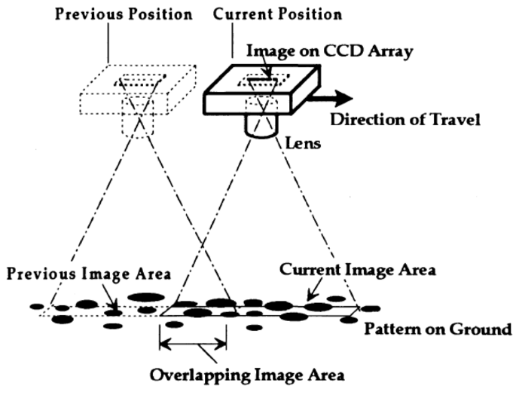
Figure 1. Monocular visual tracking system. Reprinted from Stone et al. (1992).
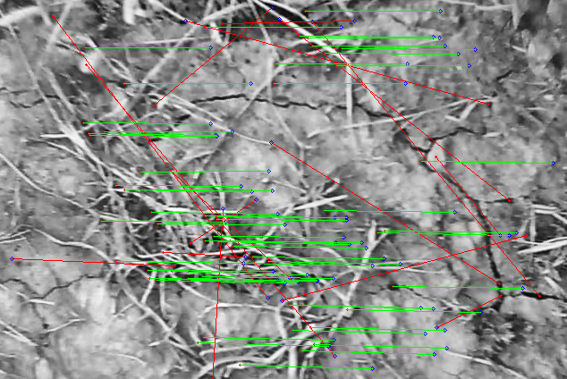
Figure 2. Keypoint matching and outlier vector rejection. Outlier vectors (red) which do not follow the dominant direction and rate of motion are rejected.
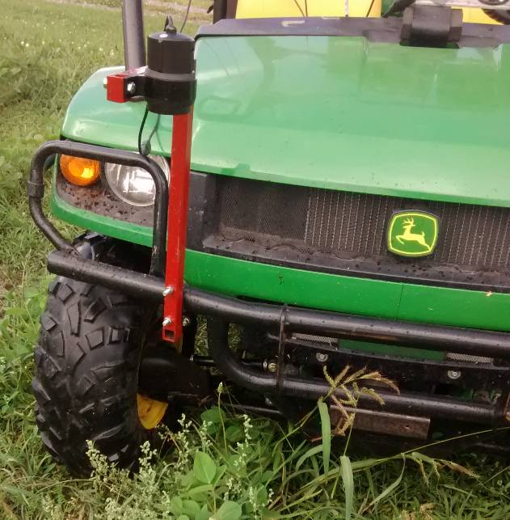
Figure 3. Test tractor and mounting bracket for camera. The camera mounting system was fixed to the crash bar of the tractor via a U-bracket.
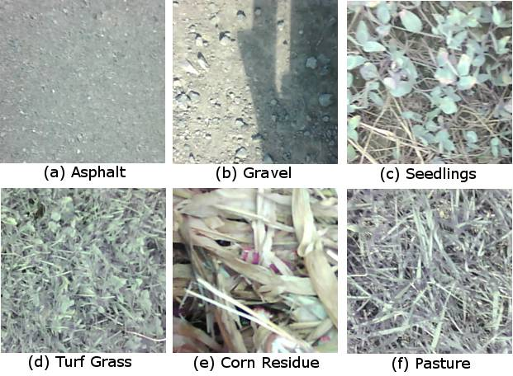
Figure 4. Sample images of the six testing surfaces considered in this study.
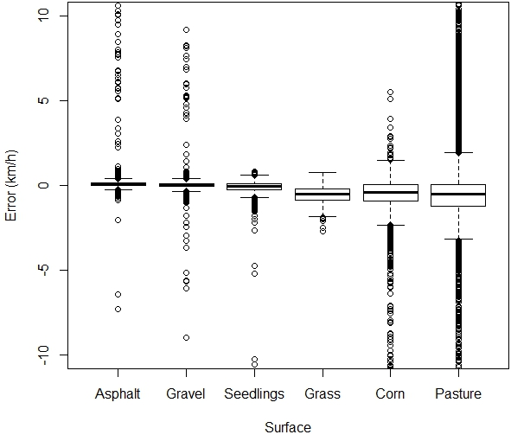
Figure 5. Boxplot distributions of error with respect to the testing surface.
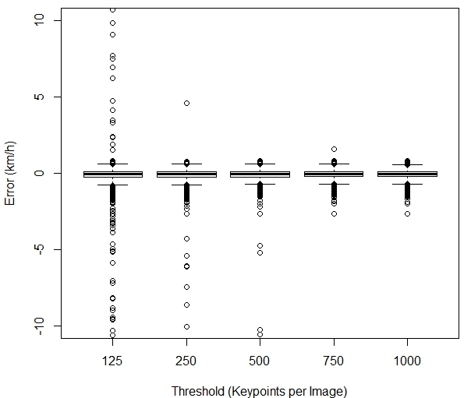
Figure 6. Boxplot distributions of error with respect to the keypoint threshold.
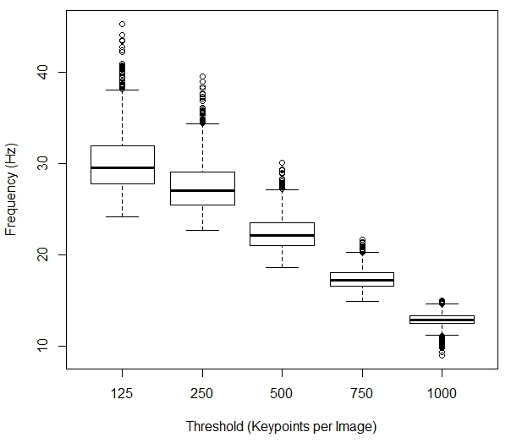
Figure 7. Boxplot distributions of frequency with respect to the keypoint threshold.
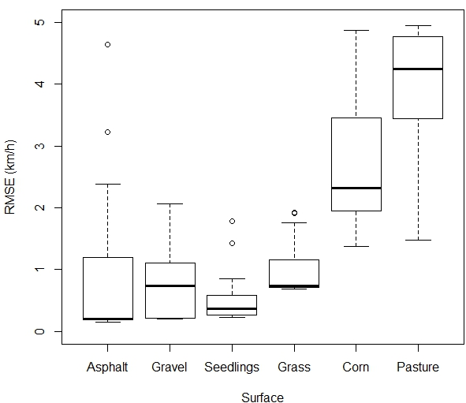
Figure 8. Boxplot distributions of RMSE with respect to surface.
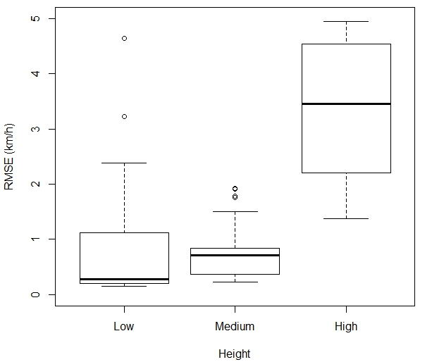
Figure 9. Boxplot distributions of RMSE with respect to height of ground coverage.

