CondorBrain ↔ Gaussian Stack Alignment Report (DevOps Internal)

Purpose & Audience
This document is intended for the internal DevOps and Gaussian-side engineering teams. It serves as a single source of truth describing the current state of the CondorBrain™ / CondorIntelligence™ / Quantor-MTFuzz™ system, the remaining critical-path work required for live trading, and how this system should be used as the benchmarking and integration reference for the Gaussian stack.

Executive Snapshot (TL;DR for DevOps)
- Data integrity, lag alignment, and risk controls are COMPLETE and production-grade.
- Remaining work is deterministic engineering and validation (no research risk).
- CondorBrain defines the execution, risk, and validation baseline the Gaussian stack should align against.
- Live trading is gated by orchestration + end-to-end validation, not model quality.

System Readiness Matrix
✔ COMPLETE: DataFactory, lag-aware alignment, analytics primitives, FIS logic, risk layer
⚠ PARTIAL: Strategy–analytics fusion, FIS integration tests
❌ BLOCKER: Full TradingEngine orchestration, trade routing, E2E tests

Dependency DAG (Phase → Task → Live)
Stages 0–2 (Safety, Realism, Strategy Depth)
→ Phase 1 (DTOs & Analytics)
→ Phase 2 / 2.5 (Data Pipeline + Lag Alignment)
→ Phase 3 (Strategy + Analytics Integration) ❌
→ Phase 4 (FIS Tests) ❌
→ Phase 5 (Risk Layer) ✔
→ Phase 6 (Full Orchestration) ❌
→ Phase 7 (E2E Validation) ❌
→ Paper Trading
→ Live Trading

Go / No-Go Gate (Authoritative)
GO only if ALL conditions below are satisfied:
DATA & SAFETY: GO
STRATEGY + ANALYTICS: NO-GO (pending integration)
FIS + SIZING: NO-GO (pending tests)
ORCHESTRATION: NO-GO (TradingEngine + Router incomplete)
VALIDATION: NO-GO (E2E + regression tests missing)

Paper Trading Alignment
Paper trading is an operational validation phase, not a development sandbox.
Preconditions:
- Phase 3 analytics integration complete
- Phase 4 FIS tests passing
- Phase 6 orchestration complete
- Phase 7 validation complete
Week 1: Stability (latency, fills, disconnects)
Week 2: Economics (P&L, slippage, drawdowns)

DevOps Integration Guidance (Gaussian Team)
CondorBrain should be treated as the reference execution and validation spine.
Gaussian-side components should dovetail at the following seams:
- Feature / signal outputs → Strategy interface
- Distributional forecasts → FIS sizing inputs
- Risk envelopes → RiskManager invariants
Any Gaussian component replacing or augmenting CondorBrain logic must:
- Respect lag alignment metadata
- Pass identical E2E and regression tests
- Match or exceed benchmark latency and stability

Remaining Work & Time Estimate (CondorBrain Side)
Phase 3 completion: ~0.5–1 day
Phase 4 FIS tests: ~0.5 day
Phase 6 orchestration: ~1–2 days
Phase 7 validation: ~1 day
Estimated time to paper-trading readiness once unblocked: ~4–5 days

Bottom Line for Gaussian DevOps
CondorBrain is no longer a research system—it is a near-production execution benchmark.
Gaussian work can proceed in parallel, but live integration should target the completed CondorBrain pipeline to avoid duplicated validation and compliance effort.

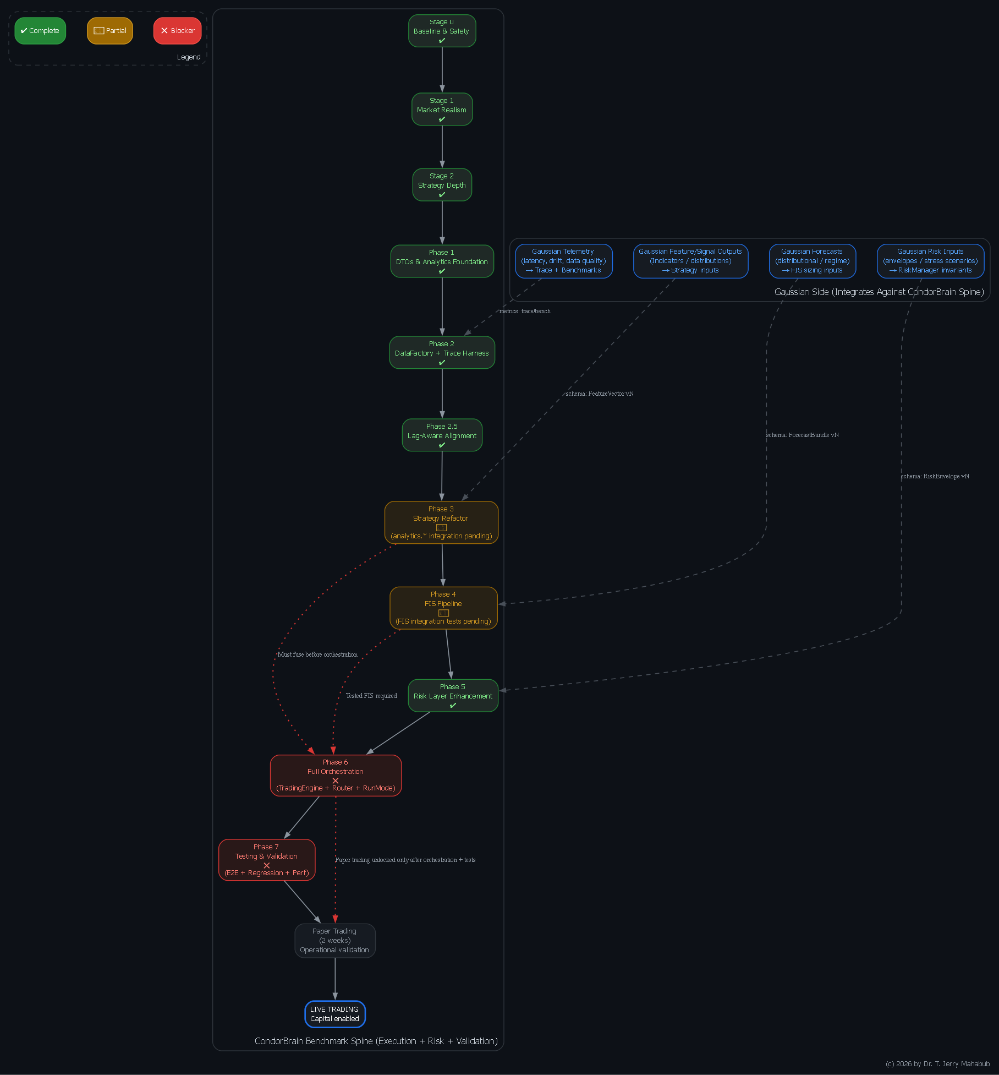
Appendix A — Graphviz DAG (docs/dags/condorbrain_gaussian_dag.dot)
Appendix B — CondorBrain ↔ Gaussian Interface Contract
(Schemas, Invariants, and Operational Guarantees)

Purpose and Scope
This appendix defines the formal integration contract between the CondorBrain execution spine and the Gaussian-side analytics, forecasting, and signal-generation components. Its purpose is to ensure that all Gaussian outputs can be safely, deterministically, and auditably consumed by CondorBrain without compromising execution integrity, risk controls, or regulatory defensibility.
CondorBrain is designated as the benchmark execution system. Gaussian components are treated as producers of signals, forecasts, or auxiliary risk information that must conform to the contracts defined herein.
No live or paper trading is permitted unless all interfaces comply with these contracts and their invariants.

Architectural Principles
- Boundary Enforcement
All Gaussian outputs enter CondorBrain through explicit, versioned interfaces. There are no implicit couplings or side channels.
- Fail-Closed by Default
Any contract violation (schema mismatch, stale data, invalid values) results in trade rejection rather than degraded execution.
- Time-Correctness First
Timestamp alignment, lag detection, and decay policies are first-class constraints, not secondary checks.
- Versioned and Auditable
Every payload declares its schema version and can be replayed, validated, and regression-tested.

Integration Surfaces

Feature-to-Strategy Interface
Gaussian may supply numerical features or probabilistic signals used by CondorBrain’s strategy gating layer. These inputs must be fully numeric, timestamp-aligned, and explicitly marked for validity when partial data exists.

Forecast-to-Sizing Interface
Gaussian may provide distributional forecasts (means, variances, quantiles, regime probabilities) that influence fuzzy inference sizing decisions. Forecast uncertainty must be explicit and internally consistent.

Risk Envelope Interface
Gaussian may supply external risk constraints or stress scenarios. These are treated as hard invariants by CondorBrain’s RiskManager and override internal sizing logic when violated.

Telemetry and Diagnostics Interface
Gaussian services must emit telemetry describing latency, data freshness, and operational health. These metrics feed CondorBrain’s trace harness and benchmarking framework.

Time Semantics and Alignment
All Gaussian payloads must include:
- Event timestamp (the market time being referenced)
- Production timestamp (when the payload was generated)
- Explicit lag in seconds
CondorBrain enforces symbol-specific lag policies (decay, cutoff, or hybrid). Payloads exceeding allowed lag thresholds are either down-weighted or rejected entirely, depending on configuration.

Invariants (Non-Negotiable)
- No NaN or infinite values may enter CondorBrain unless explicitly masked.
- Probability distributions must be normalized and internally ordered.
- Risk limits must be finite and enforceable.
- Latency and lag must be non-negative and monotonic.
- Any invariant violation triggers fail-closed behavior (no new trades).

Operational Guarantees
CondorBrain guarantees:
- Deterministic handling of compliant Gaussian inputs
- Traceability from input payload to final order decision
- Enforcement of all risk and alignment constraints
Gaussian guarantees:
- Schema compliance
- Explicit timestamping and lag reporting
- Stable versioning and backward compatibility discipline

Promotion Requirements
Before Gaussian inputs may be used in paper or live trading:
- Contract conformance tests must pass
- Regression outputs must match golden datasets
- Latency budgets must be met under load
- Fail-closed behavior must be demonstrated

Appendix C — Joint CondorBrain ↔ Gaussian Integration Timeline
(Parallel Workstreams and Promotion Gates)

Objective
This appendix defines a shared execution timeline showing how CondorBrain and Gaussian teams can work in parallel while converging safely toward paper trading and live deployment.
CondorBrain acts as the execution and validation backbone; Gaussian work proceeds independently but docks at defined milestones.

Workstreams
- Workstream A — CondorBrain (Benchmark Spine)
Execution, risk enforcement, orchestration, validation
- Workstream B — Gaussian (Analytics & Forecasting)
Feature generation, probabilistic modeling, regime inference
- Workstream C — DevOps / Infrastructure
CI/CD, deployment, observability, broker connectivity

Milestone 1 — Interface Contract Freeze
Objective: Establish stable schemas and invariants.
- CondorBrain publishes the interface contract and validators.
- Gaussian implements payload emitters conforming to the contract.
- DevOps enforces schema checks in CI.
Outcome:
A mutually accepted, versioned contract with sample payloads.

Milestone 2 — Strategy and FIS Docking
Objective: Fuse Gaussian outputs into CondorBrain intelligence layers.
- CondorBrain completes analytics integration and FIS tests.
- Gaussian delivers stable, timestamp-correct features and forecasts.
- DevOps provisions telemetry pipelines and dashboards.
Outcome:
Single-day end-to-end dry runs with full traceability.

Milestone 3 — Orchestration and Routing
Objective: Transition from research flow to execution flow.
- CondorBrain completes TradingEngine, routing, and run modes.
- Gaussian validates operational stability under execution cadence.
- DevOps deploys paper broker adapters and secrets management.
Outcome:
Multi-day backtests using the same pipeline intended for paper trading.

Milestone 4 — Validation Gates
Objective: Prove correctness, stability, and reproducibility.
- CondorBrain executes end-to-end, regression, and performance tests.
- Gaussian passes contract and latency conformance under load.
- DevOps wires CI/CD promotion gates.
Outcome:
A “Paper-Ready” release artifact.

Milestone 5 — Paper Trading
Week 1: Stability Focus
- Latency, disconnect handling, fail-closed verification
Week 2: Economic Reality
- P&L reconciliation, slippage realism, drawdown behavior
Outcome:
Formal Go / No-Go decision for live trading.

Appendix D — Why CondorBrain Is the Benchmark
(Technical Rationale for Leadership)

Executive Summary
CondorBrain is designated as the benchmarking system because it already embodies the hardest and most failure-prone aspects of institutional trading deployment. Gaussian innovation should be evaluated within this environment, not alongside or outside it.

Benchmarking Requires More Than Model Accuracy
High-quality models frequently fail in production due to:
- stale or misaligned data,
- unrealistic execution assumptions,
- uncontrolled portfolio risk,
- lack of fail-safe behavior,
- absence of reproducible validation.
CondorBrain explicitly addresses these issues. Gaussian models must therefore demonstrate value under the same constraints to be meaningfully benchmarked.

CondorBrain’s Institutional Guardrails
CondorBrain already provides:
- Market realism (slippage, commissions, realized volatility)
- Lag-aware alignment with explicit decay and cutoff policies
- Portfolio-level risk aggregation and invariant enforcement
- Deterministic traceability from data to decision
- Structured validation gates before capital exposure
These controls typically represent the largest hidden cost and risk in deployment.

Auditability and Reproducibility
A true benchmark system must support:
- deterministic replay,
- versioned schemas,
- golden regression datasets,
- measurable latency and stability.
CondorBrain’s architecture is designed around these properties, enabling credible internal and external review.

Organizational Efficiency
Using CondorBrain as the benchmark:
- Prevents duplicated execution and risk infrastructure
- Allows Gaussian teams to focus on signal quality
- Centralizes validation and compliance effort
- Reduces operational risk during iteration

Strategic Conclusion
CondorBrain defines the deployable standard:
realistic execution, enforceable risk, time correctness, and testable guarantees.
Gaussian innovation should integrate through CondorBrain’s contracts and demonstrate measurable improvement under identical execution constraints. This ensures that any observed performance lift is real, repeatable, and safe to deploy.

