CondorBrain ↔ Gaussian Stack Alignment Report
(Executive + DevOps teams)

One-Page Executive Summary

CondorBrain serves as the institutional execution, risk, and validation benchmark for all Gaussian-side model development. The system has completed all foundational safety, realism, alignment, and risk layers. Remaining work is limited to deterministic orchestration, final validation, and controlled paper trading.
There is no remaining research risk. Live trading readiness is gated solely by engineering completion and operational verification.
Estimated time to paper-trading readiness once unblocked: 4–5 engineering days.
Estimated total time to live trading (including mandatory paper trading): ~3-4 weeks.
CondorBrain establishes the authoritative execution spine. Gaussian components integrate only through versioned contracts at the Strategy, FIS, and RiskManager boundaries. No Gaussian component bypasses CondorBrain orchestration or validation gates.

High-level path to real-account live trading
Phase | Description | Owner | Duration | Cumulative Time | Status
Phase 3 | Strategy + Analytics Integration | CondorBrain | 1 day | Day 1 | In Progress
Phase 4 | FIS Integration Tests | CondorBrain | 0.5 day | Day 1.5 | In Progress
Phase 6 | Full Orchestration + Router | CondorBrain | 1–2 days | Day 3–4 | Blocked
Phase 7 | E2E + Regression Validation | CondorBrain | 1 day | Day 4–5 | Blocked
Paper Trading | Operational Validation (No Dev) | All | 2 weeks | Week 3 | Pending
Live Trading | Capital Enabled | All | — | ~Week 3+ | Gate Dependent

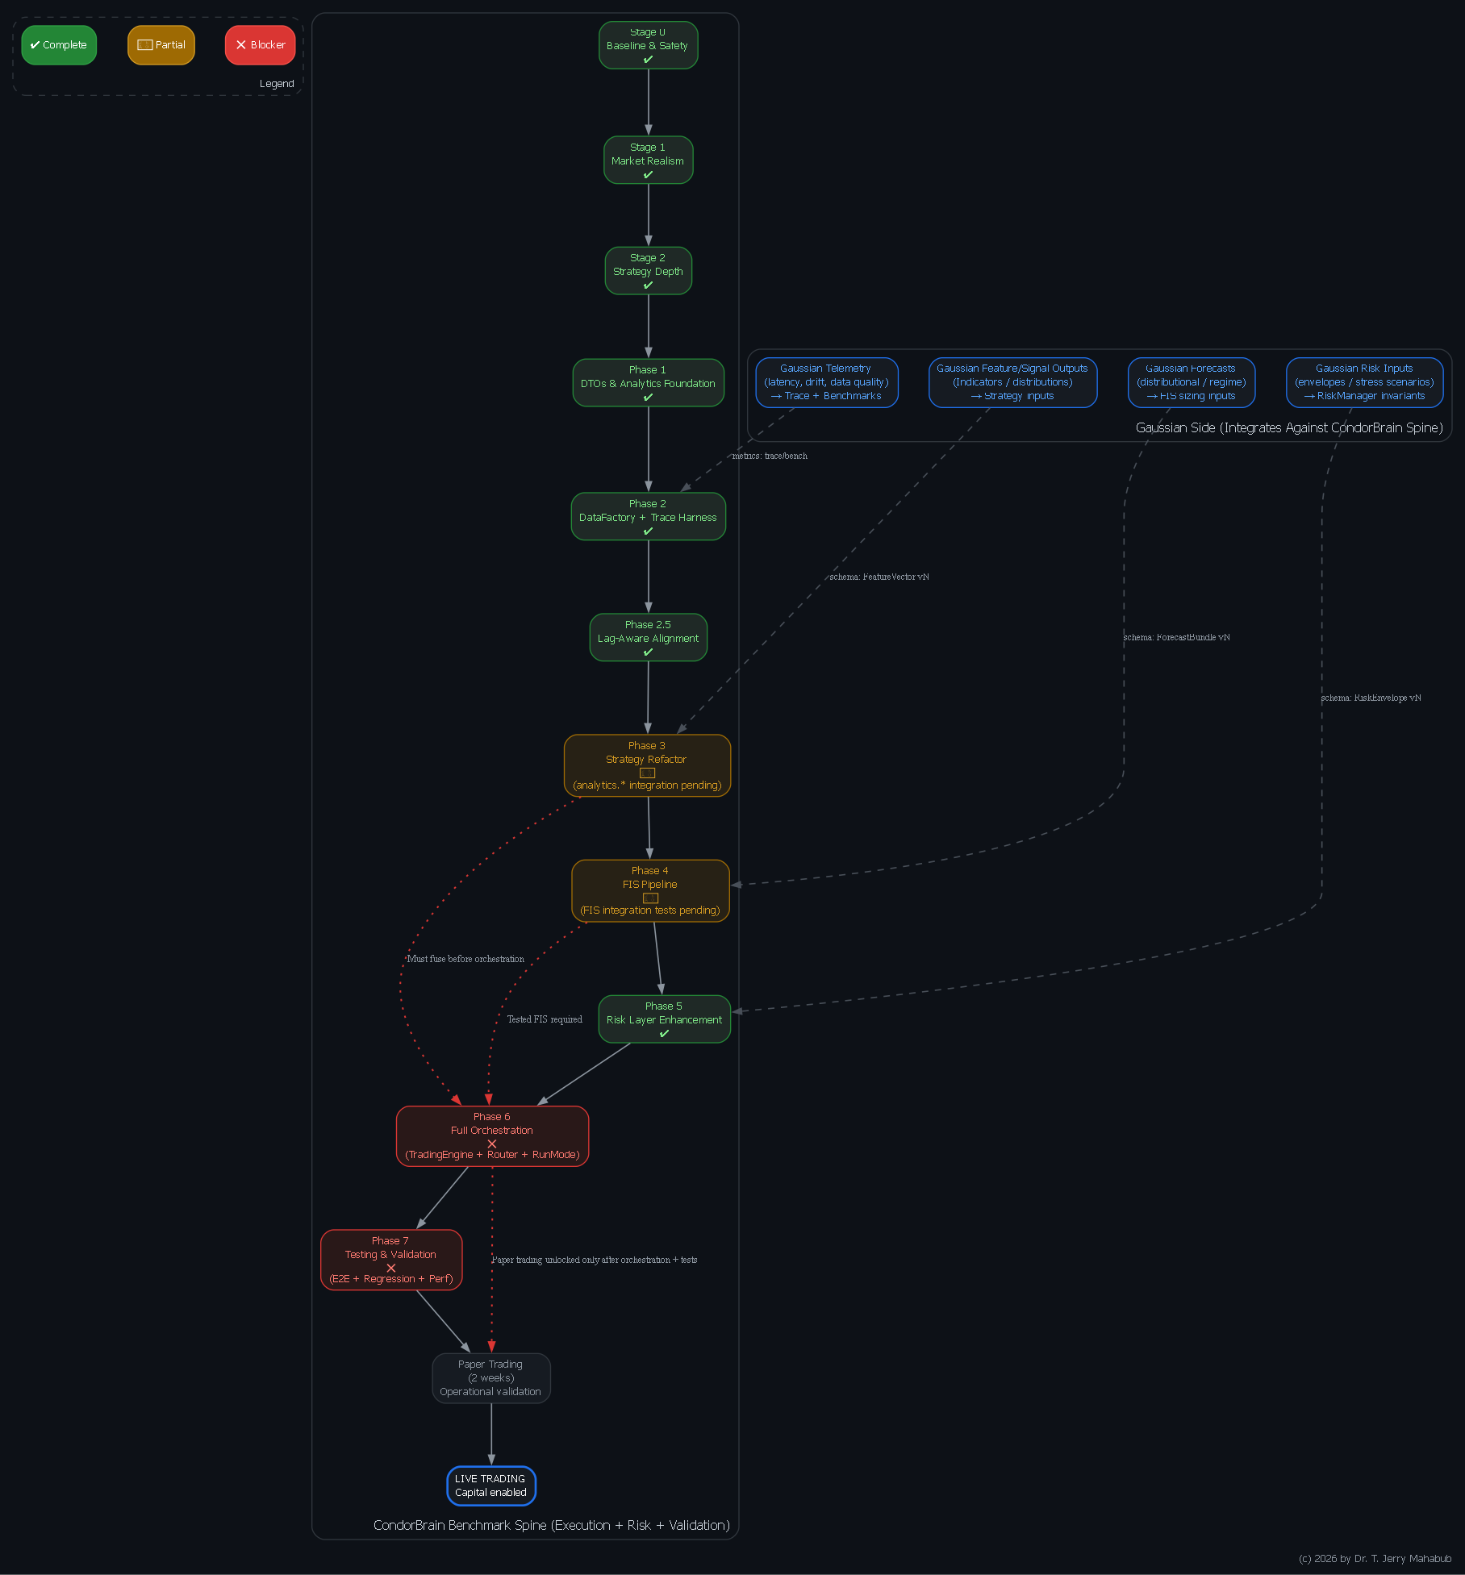
Appendix A — Graphviz DAG
Appendix B — CondorBrain ↔ Gaussian Interface Contract
(Schemas, Invariants, and Operational Guarantees)

Purpose and Scope
This appendix defines the formal integration contract between the CondorBrain execution spine and the Gaussian-side analytics, forecasting, and signal-generation components. Its purpose is to ensure that all Gaussian outputs can be safely, deterministically, and auditably consumed by CondorBrain without compromising execution integrity, risk controls, or regulatory defensibility.
CondorBrain is designated as the benchmark execution system. Gaussian components are treated as producers of signals, forecasts, or auxiliary risk information that must conform to the contracts defined herein.
No live or paper trading is permitted unless all interfaces comply with these contracts and their invariants.

Architectural Principles
- Boundary Enforcement
All Gaussian outputs enter CondorBrain through explicit, versioned interfaces. There are no implicit couplings or side channels.
- Fail-Closed by Default
Any contract violation (schema mismatch, stale data, invalid values) results in trade rejection rather than degraded execution.
- Time-Correctness First
Timestamp alignment, lag detection, and decay policies are first-class constraints, not secondary checks.
- Versioned and Auditable
Every payload declares its schema version and can be replayed, validated, and regression-tested.

Integration Surfaces

Feature-to-Strategy Interface
Gaussian may supply numerical features or probabilistic signals used by CondorBrain’s strategy gating layer. These inputs must be fully numeric, timestamp-aligned, and explicitly marked for validity when partial data exists.

Forecast-to-Sizing Interface
Gaussian may provide distributional forecasts (means, variances, quantiles, regime probabilities) that influence fuzzy inference sizing decisions. Forecast uncertainty must be explicit and internally consistent.

Risk Envelope Interface
Gaussian may supply external risk constraints or stress scenarios. These are treated as hard invariants by CondorBrain’s RiskManager and override internal sizing logic when violated.

Telemetry and Diagnostics Interface
Gaussian services must emit telemetry describing latency, data freshness, and operational health. These metrics feed CondorBrain’s trace harness and benchmarking framework.

Time Semantics and Alignment
All Gaussian payloads must include:
- Event timestamp (the market time being referenced)
- Production timestamp (when the payload was generated)
- Explicit lag in seconds
CondorBrain enforces symbol-specific lag policies (decay, cutoff, or hybrid). Payloads exceeding allowed lag thresholds are either down-weighted or rejected entirely, depending on configuration.

Invariants (Non-Negotiable)
- No NaN or infinite values may enter CondorBrain unless explicitly masked.
- Probability distributions must be normalized and internally ordered.
- Risk limits must be finite and enforceable.
- Latency and lag must be non-negative and monotonic.
- Any invariant violation triggers fail-closed behavior (no new trades).

Operational Guarantees
CondorBrain guarantees:
- Deterministic handling of compliant Gaussian inputs
- Traceability from input payload to final order decision
- Enforcement of all risk and alignment constraints
Gaussian guarantees:
- Schema compliance
- Explicit timestamping and lag reporting
- Stable versioning and backward compatibility discipline

Promotion Requirements
Before Gaussian inputs may be used in paper or live trading:
- Contract conformance tests must pass
- Regression outputs must match golden datasets
- Latency budgets must be met under load
- Fail-closed behavior must be demonstrated

Appendix C — Joint Integration Timeline
(Parallel Workstreams and Promotion Gates)

Objective
This appendix defines a shared execution timeline showing how CondorBrain and Gaussian teams can work in parallel while converging safely toward paper trading and live deployment.
CondorBrain acts as the execution and validation backbone; Gaussian work proceeds independently but docks at defined milestones.

Workstreams
- Workstream A — CondorBrain (Benchmark Spine)
Execution, risk enforcement, orchestration, validation
- Workstream B — Gaussian (Analytics & Forecasting)
Feature generation, probabilistic modeling, regime inference
- Workstream C — DevOps / Infrastructure
CI/CD, deployment, observability, broker connectivity

Milestone 1 — Interface Contract Freeze
Objective: Establish stable schemas and invariants.
- CondorBrain publishes the interface contract and validators.
- Gaussian implements payload emitters conforming to the contract.
- DevOps enforces schema checks in CI.
Outcome:
A mutually accepted, versioned contract with sample payloads.

Milestone 2 — Strategy and FIS Docking
Objective: Fuse Gaussian outputs into CondorBrain intelligence layers.
- CondorBrain completes analytics integration and FIS tests.
- Gaussian delivers stable, timestamp-correct features and forecasts.
- DevOps provisions telemetry pipelines and dashboards.
Outcome:
Single-day end-to-end dry runs with full traceability.

Milestone 3 — Orchestration and Routing
Objective: Transition from research flow to execution flow.
- CondorBrain completes TradingEngine, routing, and run modes.
- Gaussian validates operational stability under execution cadence.
- DevOps deploys paper broker adapters and secrets management.
Outcome:
Multi-day backtests using the same pipeline intended for paper trading.

Milestone 4 — Validation Gates
Objective: Prove correctness, stability, and reproducibility.
- CondorBrain executes end-to-end, regression, and performance tests.
- Gaussian passes contract and latency conformance under load.
- DevOps wires CI/CD promotion gates.
Outcome:
A “Paper-Ready” release artifact.

Milestone 5 — Paper Trading
Week 1: Stability Focus
- Latency, disconnect handling, fail-closed verification
Week 2: Economic Reality
- P&L reconciliation, slippage realism, drawdown behavior
Outcome:
Formal Go / No-Go decision for live trading.

Appendix D — Why CondorBrain Is the Benchmark
(Technical Rationale)

Executive Summary
CondorBrain is the benchmark because it already encapsulates the hardest institutional deployment problems: market realism, lag-aware alignment, deterministic risk enforcement, traceability, and auditability. Gaussian innovation is measured under identical execution constraints to ensure observed performance improvements are real, repeatable, and safe to deploy.

Benchmarking Requires More Than Model Accuracy
High-quality models frequently fail in production due to:
- stale or misaligned data,
- unrealistic execution assumptions,
- uncontrolled portfolio risk,
- lack of fail-safe behavior,
- absence of reproducible validation.
CondorBrain explicitly addresses these issues. Gaussian models must therefore demonstrate value under the same constraints to be meaningfully benchmarked.

CondorBrain’s Institutional Guardrails
CondorBrain already provides:
- Market realism (slippage, commissions, realized volatility)
- Lag-aware alignment with explicit decay and cutoff policies
- Portfolio-level risk aggregation and invariant enforcement
- Deterministic traceability from data to decision
- Structured validation gates before capital exposure
These controls typically represent the largest hidden cost and risk in deployment.

Auditability and Reproducibility
A true benchmark system must support:
- deterministic replay,
- versioned schemas,
- golden regression datasets,
- measurable latency and stability.
CondorBrain’s architecture is designed around these properties, enabling credible internal and external review.

Organizational Efficiency
Using CondorBrain as the benchmark:
- Prevents duplicated execution and risk infrastructure
- Allows Gaussian teams to focus on signal quality
- Centralizes validation and compliance effort
- Reduces operational risk during iteration

Strategic Conclusion
CondorBrain defines the deployable standard:
realistic execution, enforceable risk, time correctness, and testable guarantees.

Gaussian innovation should integrate through CondorBrain’s contracts and demonstrate measurable improvement under identical execution constraints. This ensures that any observed performance lift is real, repeatable, and safe to deploy.

Visual Gantt Chart – Path to Live Trading
The chart below provides a visual timeline from engineering completion through paper trading.
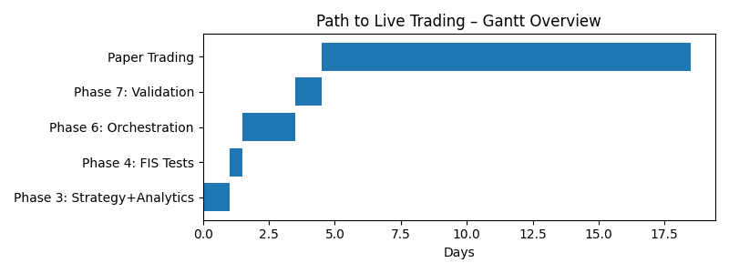

Schema Summary Table (Gaussian ↔ CondorBrain)
Schema | Primary Purpose | Key Required Fields | Hard Invariants
FeatureVector | Strategy gating & signals | features, event_ts, produced_ts, lag_sec | No NaN/Inf, lag policy enforced
ForecastBundle | Sizing & regime inference | mean, stdev, quantiles, regime_probs | Quantile ordering, probs sum to 1
RiskEnvelope | Portfolio risk limits | Greek caps, max loss, stress scenarios | Fail-closed on violation

Go / No-Go Sign-Off Page
Live trading authorization requires unanimous approval from the following roles, confirming that all engineering, risk, and validation gates have passed.
Role | Name | Signature / Date
Lead Quant / Architect | Chris Peters | ________________
DevOps Lead | John Draper | ________________
Risk & Compliance Lead | Jerry Mahabub | ________________
Executive Sponsor | Shawn ? | ________________

Gaussian Value Measurement Framework
Gaussian-side contributions are evaluated strictly on incremental value added relative to the CondorBrain benchmark, under identical execution, risk, and data constraints.
Primary lift metrics include:
- Risk-adjusted return improvement (Δ Sharpe, Δ Sortino)
- Drawdown reduction under identical exposure
- Stability metrics (lower variance of P&L, fewer tail events)
- Latency and freshness compliance
All lift claims must be demonstrated through paired backtests, paper trading comparison, and regression reproducibility.

