**CMSC/CIS 255 Fall 2016**

**JOIN Exercise**

Use TSQL2012.

1. Show the customer-id, order-id, order-date, product-id and product unit-price information for all orders placed on March 6 2008.

select Orders.custid, Orders.orderid, Orders.orderdate, OrderDetails.productid, OrderDetails.unitprice

from Sales.Orders as Orders inner join Sales.OrderDetails as OrderDetails

on Orders.orderid = OrderDetails.orderid

where orderdate = '2008-03-06';

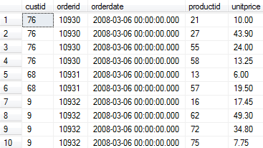

1. Find the employee who placed the biggest single customer order on March 6 2008.

select top(1) E.empid, E.firstname, E.lastname, O.orderid, sum(unitprice * qty) as Total

from Sales.OrderDetails as OD inner join Sales.Orders as O

on OD.orderid = O.orderid

join HR.Employees as E

on E.empid = O.empid

where O.orderdate = '2008-03-06'

group by O.orderid, E.empid, E.firstname, E.lastname

order by Total DESC;



1. Show, for all customers living in the USA, their customer-id, total number of orders, and total quantity ordered.

select O.custid, count(distinct O.orderid) as NumberofOrders, SUM(OD.qty) as TotalQtyOrderd

from Sales.OrderDetails as OD inner join Sales.Orders as O

on OD.orderid = O.orderid

where shipcountry = 'USA'

group by O.custid

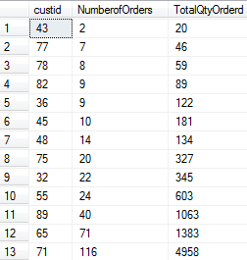

1. We are considering sending each employee involved in Sales to the office of one of the shippers. Create a table showing all the possible combinations of employee first and last name and shipper company name.
2. Display the company name and customer-id of each customer, together with a column containing a Yes if they have ever placed an order in February of any year, and a No otherwise.
3. Find the cities from which the 5 most expensive products are supplied.
4. Which of the following are generally true for all tables? Justify your answer.
5. Is INNER JOIN commutative? i.e. x INNER JOIN y = y INNER JOIN x

YES

1. Is INNER JOIN associative?

i.e. is (x INNER JOIN y) INNER JOIN z = x INNER JOIN (y INNER JOIN z)

YES

1. Is OUTER JOIN commutative? i.e. x LEFT OUTER JOIN y = y LEFT OUTER JOIN x

NO

1. Fill in the blank: x LEFT OUTER JOIN y = y RIGHT OUTER JOIN x
2. Is OUTER JOIN associative?

i.e. (x LEFT OUTER JOIN y) LEFT OUTER JOIN z =

x LEFT OUTER JOIN (y LEFT OUTER JOIN z =

NO