**CMSC/CIS 255 Fall 2016**

**Entity Relationship Modeling Exercise**

1. Identify each relationship type and write all of the business rules, given the diagram below.

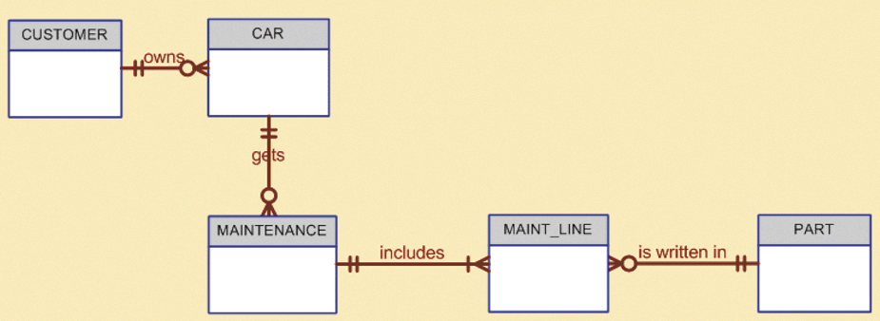

Each car is owned by one customer.

Each customer may own many cars, but also doesn’t have to own a car.

Car does not have to get maintenance.

A car can get maintenance many times.

Each maintenance procedure is for exactly one car.

Each maintenance procedure icludes one or more maintenance line.

Each maintenance line goes to one spefic maintenance procedure.

Each maintenance line contains exactly one part.

Each part could be written in many maintenance lines.

1. Given the following business rules for school teams, create a Crow’s Foot ERD using Visio. Make sure each relationship is appropriately labelled. **State any additional assumptions you make** during the design process.

* A team generally has many players; a newly formed team may have no players.
* A player can play for only one team; each player must have permission from one of their parents.
* A team may have zero, one, or more than one coach; a coach coaches only one team.
* Each player must have permission from a parent.

Entities: Team, Player, Coach,

Attributes:

Having permission can be thought of a relationship between Player and Parent.

Assume that a player might get permission from both parents, then since a parent may give permission to many players, this is a many to many relationship.

Its mandatory at the parent end, optional at the player end if it is possible for someine to be a parent without having a player to give permission.

The relationship between Team and Coach is 1-Many, optional coach end, mandatory team end assume a coach must be coaching a team.

Relationship between Team and Player is 1-Many, optional player end, optional team end because a player may not be on a team.

1. Consider the following information.

|  |  |  |  |  |
| --- | --- | --- | --- | --- |
| Person_ID | First Name | Last Name | College | Hobbies |
| 1639 | George | Barnes | Simpson | Reading |
| 2552 | Susan | Noble | Luther | Hiking, Movies |
| 3117 | Erwin | Star | Coe | Movies, Skiing, Cooking |
| 9404 | Alice | Buck | Simpson |  |
| 6543 | Frank | Borders | Wartburg | Travel, Art, Movies |
| 7777 | Hanna | Diedrich | Simpson | Reading, Cooking |

Design a good relational database to store this information.

|  |  |  |  |
| --- | --- | --- | --- |
| Person_ID | First Name | Last Name | College |
| 1639 | George | Barnes | Simpson |
| 2552 | Susan | Noble | Luther |
| 3117 | Erwin | Star | Coe |
| 9404 | Alice | Buck | Simpson |
| 6543 | Frank | Borders | Wartburg |
| 7777 | Hanna | Diedrich | Simpson |

|  |  |
| --- | --- |
| Activity Table | |
| Person_ID | Hobby_ID |
| 1639 | 1 |
| 2552 | 2 |
| 2552 | 3 |
| 3117 | 3 |
| 3117 | 4 |
| 3117 | 5 |
| 6543 | 6 |
| 6543 | 7 |
| 6543 | 3 |
| 7777 | 1 |
| 7777 | 5 |

|  |  |
| --- | --- |
| Hobby Table | |
| Hobby_ID | Hobby |
| 1 | Reading |
| 2 | Hiking |
| 3 | Movies |
| 4 | Skiing |
| 5 | Cooking |
| 6 | Travel |
| 7 | Art |