CMSC/CIS 255 Fall 2016
Homework 4 Solution – JOIN
(150 points)
Deadline: Midnight MON SEP 26

- Compute manually the inner join, left outer join, right outer join, and full outer join of the tables below, using as condition equality of the ClassID column. (20 points)

Student Table
Name | Class ID
Jerry Attrick | CIS 255
Tommy Gunn | CMSC 250
Hedda Lettuce | NULL
Rose Bush | CMSC 250
Cara Van | CIS 255

Course Table
Class ID | Instructor
CIS 255 | Brodie
CMSC 250 | Sinapova
NULL | Schellhorn
NULL | Brittingham

NOTE: The order of rows in the output is IRRELEVANT.
Also, the duplicated ClassID column is not shown.

Inner Join
Name | Class ID | Instructor
Jerry Attrick | CIS 255 | Brodie
Tommy Gunn | CMSC 250 | Sinapova
Rose Bush | CMSC 250 | Sinapova
Cara Van | CIS 255 | Brodie

Left Outer Join:
Name | Class ID | Instructor
Jerry Attrick | CIS 255 | Brodie
Tommy Gunn | CMSC 250 | Sinapova
Rose Bush | CMSC 250 | Sinapova
Cara Van | CIS 255 | Brodie
Hedda Lettuce | NULL | NULL

Right Outer Join:
Name | Class ID | Instructor
Jerry Attrick | CIS 255 | Brodie
Tommy Gunn | CMSC 250 | Sinapova
Rose Bush | CMSC 250 | Sinapova
Cara Van | CIS 255 | Brodie
NULL | NULL | Schellhorn
NULL | NULL | Brittingham

Full Outer Join:
Name | Class ID | Instructor
Jerry Attrick | CIS 255 | Brodie
Tommy Gunn | CMSC 250 | Sinapova
Rose Bush | CMSC 250 | Sinapova
Cara Van | CIS 255 | Brodie
NULL | NULL | Schellhorn
NULL | NULL | Brittingham
Hedda Lettuce | NULL | NULL

32 – 37: Use AdventureWorks 2014.

- Show the city name, state/province name, and country/region code of all addresses in the Person.Address table. Note that the state/province name and country/region code are in the Person.StateProvince table. Show distinct results only, ordered by city. (10 points)

SELECT DISTINCT A.City, SP.Name, SP.CountryRegionCode
FROM Person.Address AS A JOIN Person.StateProvince AS SP
ON A.StateProvinceID = SP.StateProvinceID
ORDER BY City;

613 rows
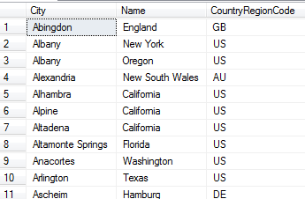

- Find the name, list-price, and total number of sales of the 10 most-often-sold products in the Sales.SalesOrderDetail table. Note that the name and list-price of each product are in the Production.Product table. Display the results in descending order by how often each product is sold. (10 points)

As in HW2, this requires interpreting “most-often-sold”. Does it count the number of times the product was sold or the total quantity of the product that was sold?
Note that an aggregate function must be applied to the list-price to avoid the “column … is invalid in the select list” error. Either AVG, MIN or MAX can be used.

Solution 1: “most-often-sold” counts the number of times the product was sold.

SELECT TOP 10 P.Name, AVG(P.ListPrice) AS AveragePrice,
COUNT(OD.ProductID) AS TotalCount
FROM Sales.SalesOrderDetail AS OD JOIN Production.Product AS P
ON OD.ProductID = P.ProductID
GROUP BY OD.ProductID, P.Name
ORDER BY TotalCount DESC;

10 rows
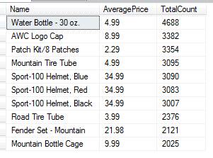

Solution Two: “most-often-sold” counts the total quantity of product that was sold.

SELECT P.Name, AVG(P.ListPrice) AS AveragePrice, SUM(OD.OrderQty) AS TotalSold
FROM Sales.SalesOrderDetail AS OD INNER JOIN Production.Product AS P
ON OD.ProductID = P.ProductID
GROUP BY OD.ProductID, P.Name
ORDER BY TotalSold DESC;

10 rows
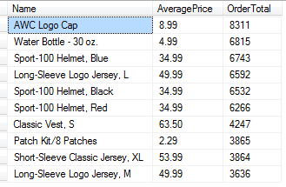

- (a) Each production technician in the HumanResources.Employee table can work any of the 3 shifts in the HumanResources.Shift table. Show all the possible combinations of the production technician’s nationalIDnumber, jobtitle, and the shift name. Make sure to include only production technicians, not all employees. (10 points)

NOTE: Although it’s not necessary to rename the Shift.Name column, it does clarify the output.

Solution 1:

SELECT E.NationalIDNumber, S.Name AS ShiftName, E.JobTitle
FROM HumanResources.Employee AS E CROSS JOIN HumanResources.Shift AS S
WHERE E.JobTitle LIKE 'Production Technician%';

Solution 2: An Inner Join also works, and it’s important to understand why. An Inner Join IS a Cross Join followed by keeping the rows that satisfy the ON clause. Therefore, a Cross Join followed by a WHERE clause is the same as an Inner Join where the condition is placed in the ON clause.

In this example:

SELECT E.NationalIDNumber, S.Name AS ShiftName, E.JobTitle
FROM HumanResources.Employee AS E INNER JOIN HumanResources.Shift AS S
ON E.JobTitle LIKE 'Production Technician%';

471 rows
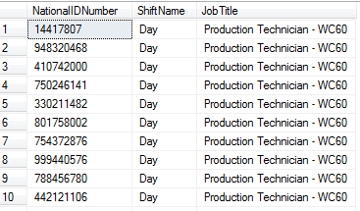

(b) Extend the above result by including each production technician’s first and last name as listed in the Person.Person table. (10 points)

There are many solutions, depending on the order of the joins.

Solution 1:

SELECT E.NationalIDNumber, S.Name AS ShiftName, E.JobTitle, P.FirstName, P.LastName
FROM HumanResources.Employee AS E CROSS JOIN HumanResources.Shift AS S
INNER JOIN Person.Person AS P
ON E.BusinessEntityID = P.BusinessEntityID
WHERE E.JobTitle LIKE 'Production Technician%';

Solution 2:

SELECT E.NationalIDNumber, S.Name AS ShiftName, E.JobTitle, P.FirstName, P.LastName
FROM HumanResources.Employee AS E INNER JOIN Person.Person AS P
ON E.BusinessEntityID = P.BusinessEntityID
CROSS JOIN HumanResources.Shift AS S
WHERE E.JobTitle LIKE 'Production Technician%';

471 rows
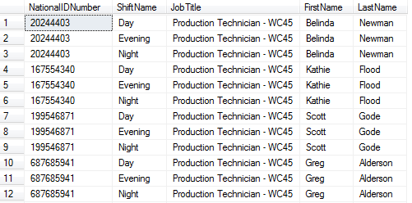

- Show the product-id and name of all products that need to be re-ordered. A product needs to be re-ordered if the Quantity (found in Production.ProductInventory) is below the ReorderPoint (found in Production.Product). Each product should appear only once in the result. (10 points)

This requires interpreting “needs to be re-ordered if the quantity is below the reorder-point”.
Does this mean (1) the quantity at ANY location is below the re-order point, or (2) the total quantity over ALL locations is below the re-order point?

Two solutions for interpretation 1. Note that the minimum quantity and reorder-point don’t have to be included, but are useful for validation.

Interpretation 1, Solution 1 – use GROUP BY.

SELECT P.ProductId, P.Name,
MIN(PI.Quantity) AS MinimumQuantity, P.ReorderPoint
FROM Production.ProductInventory AS PI JOIN Production.Product AS P
ON P.ProductID = PI.ProductID
WHERE PI.Quantity < P.ReorderPoint
GROUP BY P.ProductID, P.Name, P.ReorderPoint;

347 rows
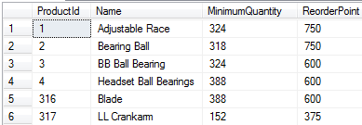

Interpretation 1, Solution 2 – use DISTINCT.

SELECT DISTINCT P.ProductID, P.Name
FROM Production.ProductInventory AS PI JOIN Production.Product AS P
ON PI.ProductID = P.ProductID
WHERE PI.Quantity < P.ReorderPoint;

347 rows
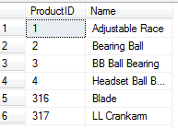

For Interpretation 2, we need to SUM the quantity. Since an aggregate function cannot appear in the WHERE clause, we need to GROUP BY and put it in the HAVING clause, so there is only one solution here.

SELECT P.ProductId, P.Name, SUM(PI.Quantity) AS TotalQuantity, P.ReorderPoint
FROM Production.ProductInventory AS PI JOIN Production.Product AS P
ON P.ProductID = PI.ProductID
GROUP BY P.ProductID, P.Name, P.ReorderPoint
HAVING SUM(PI.Quantity) < P.ReorderPoint;

7 rows
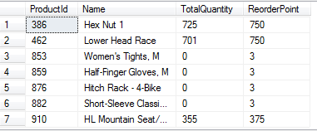

- Show the names of all products in Production.Product. Products that have a product-model ID, product-model name, and catalog description should have that information included in the result. It can be found in the Production.ProductModel table. (10 points)

NOTE: An OUTER JOIN is needed here, to include the products which have no product-model ID, product-model name, or catalog description.
Use a LEFT OUTER JOIN if the Product table is first; use a RIGHT OUTER JOIN if the ProductModel table is first.

Solution 1:

SELECT P.Name, P.ProductModelID, PM.Name, PM.CatalogDescription
FROM Production.Product AS P
LEFT OUTER JOIN Production.ProductModel AS PM
ON P.ProductModelID = PM.ProductModelID;

Solution 2:

SELECT P.Name, P.ProductModelID, PM.Name, PM.CatalogDescription
FROM Production.ProductModel AS PM
RIGHT OUTER JOIN Production.Product AS P
ON P.ProductModelID = PM.ProductModelID;

504 rows
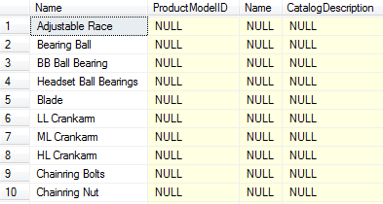

If you got 295 rows, you probably used an INNER JOIN.

- Show the first and last names of the customers who have placed the 5 largest orders, together with the amount of the order.
Hint: Proceed similarly to Join Exercise #2. First find the 5 biggest orders using the data in Sales.SalesOrderDetail. Then add the CustomerID, found in Sales.SalesOrderHeader. Get each customer’s PersonID from Sales.Customer. The customers’ names are in Person.Person; which column in Person.Person links to PersonID in Sales.Customer? (20 points)
SELECT TOP (5) OD.SalesOrderID,
SUM(OrderQty * UnitPrice) AS TotalAmount,
OH.CustomerID, P.FirstName, P.LastName
FROM Sales.SalesOrderDetail AS OD JOIN Sales.SalesOrderHeader AS OH
ON OD.SalesOrderID = OH.SalesOrderID
JOIN Sales.Customer AS C ON C.CustomerID = OH.CustomerID
JOIN Person.Person AS P ON P.BusinessEntityID = C.PersonID
GROUP BY OD.SalesOrderID, OH.CustomerID, P.FirstName, P.LastName
ORDER BY TotalAmount DESC;
5 rows
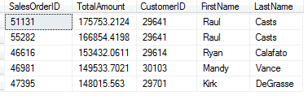
- Use a SQL query to show all Pythagorean triangles whose sides are integers from 1 to 5. The hypotenuse, computed as sqrt(sqr(side1) + sqr(side2)), should be shown to 2 decimal places. Display the results in 2 ways:

- Each number from 1 to 5 occurs twice – 25 rows in total. (15 points)
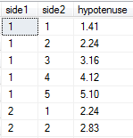
…..
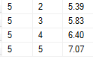
[Hint: The dbo.Nums table in TSQL2012 may be useful. There is a further hint on the last page.]

NOTE:
- To get exactly 2 decimal places, use CAST or FORMAT, as shown below. It’s ok to use ROUND instead; the different is that ROUND will display less than 2 places in some cases, e.g. 5.10 will display as 5.1.
- As usual, either a CROSS JOIN with WHERE or an INNER JOIN with ON can be used.
- Of course SQUARE(blah) can be replaced by blah * blah.
Solution 1 (CROSS JOIN with CAST):

SELECT N1.n AS side1, N2.n AS side2,
CAST(SQRT(SQUARE(N1.n) + SQUARE(N2.n)) AS NUMERIC(5,2)) AS hypotenuse
FROM dbo.Nums AS N1 CROSS JOIN dbo.Nums AS N2
WHERE N1.n <= 5 AND N2.n <= 5
ORDER BY side1;

Solution 2 (INNER JOIN with FORMAT):

SELECT C2.n AS [Side 1], C1.n AS [Side 2],
FORMAT(SQRT(SQUARE(C2.n) + SQUARE(C1.n)),'#.00') AS Hypotenuse
FROM dbo.Nums AS C1 JOIN dbo.Nums AS C2
ON C1.n >= 1 AND C1.n <= 5 AND C2.n >= 1 AND C2.n <= 5;

Many other solutions are possible.

- Notice that some rows are really the same triangle; e.g. row 2 and row 6 both have one side = 1, other side = 2, and hypotenuse = 2.24. Change the query to show each triangle once only. This gives 15 rows in total, as shown below. (5 points)
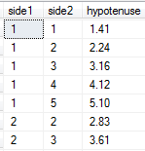
…
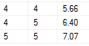
Solution One: One way to do this is to notice that the rows we want have side2 >= side1.

SELECT N1.n AS side1, N2.n AS side2,
CAST(SQRT(SQUARE(N1.n) + SQUARE(N2.n)) AS NUMERIC(5,2)) AS hypotenuse
FROM dbo.Nums AS N1 CROSS JOIN dbo.Nums AS N2
WHERE N1.n <= 5 AND N2.n <= 5 AND N1.n <= N2.n
ORDER BY side1;

Solution Two: GROUP BY the hypotenuse. Then apply an appropriate aggregate function to side1 and side2.
SELECT MIN(N1.n) AS side1, MAX(N2.n) AS side2,
CAST(SQRT(SQUARE(N1.n) + SQUARE(N2.n)) AS NUMERIC(5,2)) AS hypotenuse
FROM dbo.Nums AS N1 CROSS JOIN dbo.Nums AS N2
WHERE N1.n <= 5 AND N2.n <= 5
GROUP BY CAST(SQRT(SQUARE(N1.n) + SQUARE(N2.n)) AS NUMERIC(5,2))
ORDER BY side1, side2;

- Associativity of INNER JOIN. We will do a particular example of joining 3 tables in 2 different orders, and verify that the result is the same (See In-class Join Exercise, #7(b)). Consider the following 3 tables. We will compute Student INNER JOIN Class INNER JOIN Teacher in 2 different orders, and see if we get the same result. Do all calculations by hand. (20 points total)

Student Table
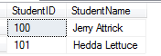

Teacher Table
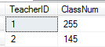

Class Table (Note that Jerry Attrick is taking 2 classes and Hedda Lettuce is taking 1 class.) 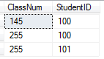

- Compute Student INNER JOIN Class, with Student ID as the matching column. (4 points)

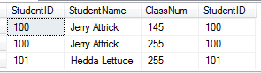

- Using the result of (a), compute (Student INNER JOIN Class) INNER JOIN Teacher, with ClassNum as the matching column for the 2nd JOIN. (4 points)

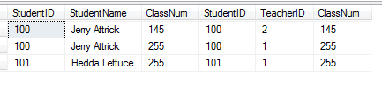
- Compute Class INNER JOIN Teacher, with ClassNum as the matching column. (4 points)

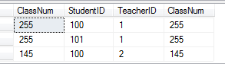

- Using the result of (c), compute Student INNER JOIN (Class INNER JOIN Teacher), with Student ID as the matching column for the 1st JOIN. (4 points)

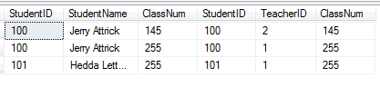
- Are the results of (b) and (d) the same? (1 point)

Yes.
(For Inner Join the results are always the same.)

- Would the same hold for OUTER JOIN, for these particular tables? Explain why. You do not need to perform the calculations. (3 points)

Yes, for these particular tables. Since there are no rows in either table which don’t satisfy the ON condition, Outer Join is the same as Inner Join in this case.

NOTE: It is possible to create tables for which Outer Join will not give the same results; i.e. is not associative.

- Dana Data wants to find all orders in AdventureWorks2014 where the shipping-date is more than a week after the order-date (see HW3, #27(b)).

First she looks for sales more than 7 days apart, using this query:

SELECT SalesOrderID, OrderDate, DueDate, ShipDate
FROM Sales.SalesOrderHeader
WHERE DATEDIFF(day, OrderDate, ShipDate) > 7;

This query produces 9 rows.

Then she looks for sales more than 1 week apart, using the following query. She expects the result will be the same.

SELECT SalesOrderID, OrderDate, DueDate, ShipDate
FROM Sales.SalesOrderHeader
WHERE DATEDIFF(week, OrderDate, ShipDate) > 1;

But this query produces no output.

Dana is very confused. Which result is correct? Help her by explaining why this difference occurs. You will need to research how the DATEDIFF function actually works. (10 points)

DATEDIFF uses date-boundaries to determine the difference between dates using a particular unit of time. For example, Dec-31 of any year has a DATEDIFF of 1 year from Jan-1 of the next year, even though they are only 1 day apart, not 1 year apart. This is because the year-boundary lies between the 2 dates.

Week differences work similarly. The week difference is determined by the number of week-boundaries (Sundays) between the 2 dates, not how many days apart they are. For example, Jan-28 and Feb-10 are more than 7 days apart. But they are NOT more than 1 week apart, because there is only one Sunday between them. All the 9 rows that are more than 7 days apart turn out to be only 1 week apart.

Which query is correct? That depends on what is meant in the original query by “the shipping-date is more than a week after the order-date.” Most likely, a business would be concerned if more than 7 days had passed. Whether there was 1 Sunday or 2 Sundays between the dates is probably not relevant. So the “days > 7” query is probably correct.
___________________________________________________________________________

Hint for #38:

TSQL2012 has a table called dbo.Nums containing the integers from 1 to 1,000,000.
Use a WHERE to take the integers from 1 to 5, and use the appropriate JOIN, together with ORDER BY, to create 2 columns that look like this:

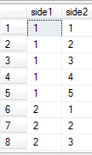
……..
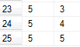

Add a third column which computes the hypotenuse and displays it to 2 decimal places. That does 38(a).

For 38(b), add a restriction (i.e. something more in the WHERE) to avoid the repeating triangles.

