CMSC/CIS 255 Fall 2016
Homework 5 – Entity Relationship Diagrams
(130 points)
Deadline: Midnight MON Oct 3

- Self-Joins. Use TSQL2012.
We want to pair employees together for a bonding exercise, but we don’t want anyone paired with their manager. (The mgrid column in HR.Employees specifies each employee’s manager.) We want the output shown below - a list of all possible pairings, showing the last-name only of each employee, with each valid pairing occuring only once.

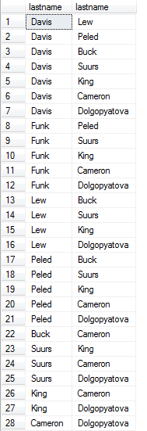

- Use a cross-join, followed by a WHERE, to create the output above. (10 points)
- Use an inner-join to create the output above. Do NOT use a WHERE in the inner-join; put the condition in the ON clause. (10 points)
- Now change the inner-join to a full outer-join. Explain why the result is NOT the same; specifically, for every row that is in the outer-join but not in the inner-join, explain why it didn’t match the ON condition. (10 points)

- Identify each relationship type and write all of the business rules given the diagram below.
(15 points)

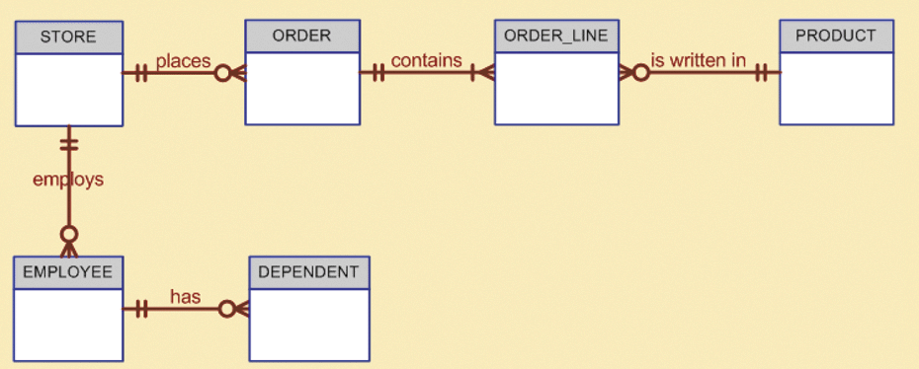

NOTE: All Visio diagrams should be pasted into your hand-in document. Do NOT upload them separately.

- Create a Crow’s Foot ERD using Visio for the following description. It is not necessary to show any attributes. Make sure each relationship is appropriately labelled. (15 points)

Each division is composed of many departments. Each of those departments has many employees assigned to it; each employee works for only one department. Each department is managed by one employee; each manager can manage only one department at a time.

NOTE: Managers are also employees, so it would be a mistake to create a separate table for
managers.

- Identify each relationship type and write all of the business rules for the relational diagram below. Don’t forget to specify relationship type (1-1, 1-Many, Many-Many) and whether each end is optional or mandatory. Then create a Crow’s Foot ERD using Visio. Show attributes for each table. Make sure each relationship is appropriately labelled. (25 points)

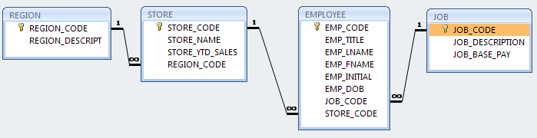

- Design a good relational database structure to store the following data. You do not need to draw an ERD in Visio; just show the new tables and what data would be in them. Make sure to minimize data duplication. (10 points)
ID | Name | Location | Degrees
1 | Jerry Attrick | Vintage Hills | BA_Maths
2 | Hedda Lettuce | HyVee | BA_Maths, Masters_Maths
3 | Tommy Gunn | Armory
4 | Rose Bush | Shrubbery | BA_English
5 | John von Neumann | Los Alamos | BA_Maths, Masters_Math, Masters_ComputerScience, PhD_ComputerScience

- This question will be needed in future homeworks.
- Write business rules for a class registration system. Each class has a class-number, starting-date, title, instructor, and a (possibly empty) list of students. Each student and instructor has an ID-number, date-of-birth and name. A student may register for more than one class and an instructor may teach more than one class. A student may be assigned a letter-grade (‘A’, ‘B’, ‘C’, ‘D’ or ‘F’) in any class they are registered in.

State any additional assumptions you make. For each relationship, state the connectivity (1-1, 1-Many, or Many-Many) and participation (optional or mandatory at each end). Make sure that your rules are written in correct English with no mistakes in grammar, spelling, language, or clarity. (10 points)

- Using the above business rules, create an ERD in Visio using Crow’s Foot notation.
Check off each of the following items from the data-modeling checklist to confirm that you have done it.

- All attribute names are descriptive.
- All attributes names include the entity name as a prefix, if appropriate.
- The type of each attribute is specified.
- Whether attributes are required or not is specified.
- PK attributes end in _ID, _NUM or _CODE.
- Entity names are singular.
- The connectivity of each relationship is labelled at both ends.
- The participation (optional or not) of each relationship is labelled at both ends.
- Each relationship is labelled with descriptive text.

Include a clear, readable, screen-capture of your ERD in your hand-in document. (25 points)

