CMSC/CIS 255 Fall 2016
Homework 6 – Database Creation & Querying
(150 points)
Deadline: Midnight MON Oct 10

- Create the database shown below by writing SQL script(s). The database should be called HW6_YourNameHere.
The Employee table’s PK is EmployeeID, and should be an IDENTITY column.
DepartmentID is the PK in the Department table (it should NOT be an IDENTITY column) and is an FK in the Employee table.
Both tables should be in a schema called Admin.
Hand in the script(s) and a screen-shot of both tables. (25 points)

Employee Table
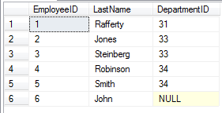

Department Table
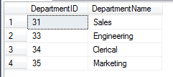

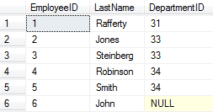
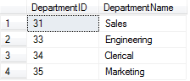
IF DB_ID('HW6_TreyModdelmog') IS NULL
CREATE DATABASE HW6_TreyModdelmog;

USE HW6_TreyModdelmog;

GO
IF SCHEMA_ID('Admin') IS NULL
BEGIN
EXEC ('CREATE SCHEMA Admin AUTHORIZATION dbo')
END;
GO

GO
IF OBJECT_ID('Admin.Department') IS NOT NULL
DROP TABLE Admin.Department;

IF OBJECT_ID('Admin.Employee') IS NOT NULL
DROP TABLE Admin.Employee;

CREATE TABLE Admin.Department
( DepartmentID INT NOT NULL PRIMARY KEY,
DepartmentName VARCHAR(20) NOT NULL,
);

CREATE TABLE Admin.Employee
( EmployeeID INT NOT NULL PRIMARY KEY IDENTITY,
LastName VARCHAR(20) NOT NULL,
DepartmentID INT NULL FOREIGN KEY REFERENCES Admin.Department,
);
GO

GO
INSERT INTO Admin.Employee(LastName, DepartmentID)
VALUES('Rafferty', 31);
INSERT INTO Admin.Employee(LastName, DepartmentID)
VALUES('Jones', 33);
INSERT INTO Admin.Employee(LastName, DepartmentID)
VALUES('Steinberg', 33);
INSERT INTO Admin.Employee(LastName, DepartmentID)
VALUES('Robinson', 34);
INSERT INTO Admin.Employee(LastName, DepartmentID)
VALUES('Smith', 34);
INSERT INTO Admin.Employee(LastName, DepartmentID)
VALUES('John', NULL);

INSERT INTO Admin.Department(DepartmentID, DepartmentName)
VALUES(31, 'Sales');
INSERT INTO Admin.Department(DepartmentID, DepartmentName)
VALUES(33, 'Engineering');
INSERT INTO Admin.Department(DepartmentID, DepartmentName)
VALUES(34, 'Clerical');
53
GO

- Write a script to create database tables based on the ERD below (From HW5, #46).
Name the database Registration_YourNameHere; it is not necessary to create a schema.
Use constraints to make sure that only valid grades can be entered and that primary key values are positive (using IDENTITY is fine but not required). Add constraints for all attributes that should be unique. (25 points)

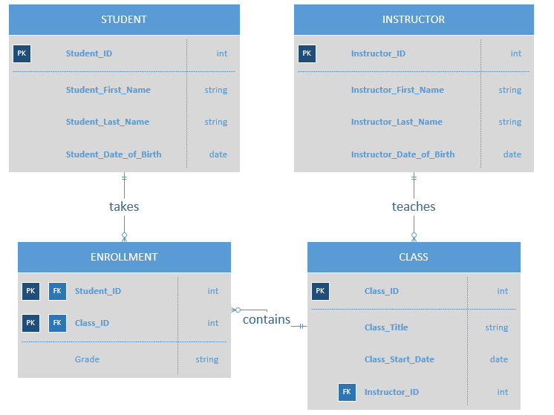

IF DB_ID('Registration_TreyModdelmog') IS NULL
CREATE DATABASE Registration_TreyModdelmog;

USE Registration_TreyModdelmog;

GO
CREATE TABLE Student
( StudentID INT NOT NULL PRIMARY KEY IDENTITY,
Student_FirstName VARCHAR(20) NOT NULL,
Student_LastName VARCHAR(20) NOT NULL,
Student_DateOfBirth DATE NOT NULL,
);

CREATE TABLE Instructor
(Instructor INT NOT NULL PRIMARY KEY IDENTITY,
Instructor_FirstName VARCHAR(20) NOT NULL,
Instructor_LasstName VARCHAR(20) NOT NULL,
Instructor_DateOfBirth DATE NOT NULL,
);

CREATE TABLE Class
(ClassID INT NOT NULL PRIMARY KEY,
Class_Title VARCHAR(20) NOT NULL,
Class_StartDate DATE NOT NULL,
InstructorID INT NOT NULL,
FOREIGN KEY(InstructorID) REFERENCES Instructor
);

CREATE TABLE Enrollment
( StudentID INT NOT NULL PRIMARY KEY,
ClassID INT NOT NULL,
Grade VARCHAR(2) NULL,
FOREIGN KEY(StudentID) REFERENCES Student,
FOREIGN KEY(ClassID) REFERENCES Class,
CHECK(Grade LIKE '[A-D]' or Grade LIKE 'F')
);
GO

- Insert the following data into the database.
If the tables and data are created in the same script, separate them with a GO statement to ensure that table creation is completed before any data is inserted. (15 points)

There are 4 instructors, 6 students, and 5 classes.
The class-titles are, in order by class-id, ‘CS’, ‘Math’, “Physics’, ‘Chemistry’ and ‘Religion’ (i.e. class 1 is ‘CS’, class 2 is ‘Math’, and so on). The first 3 classes start on Aug 30, Chemistry starts on Aug 31, and Religion on Sep 1, all in 2016.

Students (ID-numbers from 1 to 6 in the order shown):
- Jerry Attrick, born Sep 26 1986, has C in class1, B’s in class2 and 3, and no grade in class4.
- Rose Bush, born June 4 1996, has B in class1, A in class5, and no grade in class3.
- Tommy Gunn, born Dec 11, 1995, has C in class1 and no grade in class2 and class4.
- Hedda Lettuce, born Feb 29, 1996, has A’s in class1, 2, 3 and 5.
- Joe Soap, born Aug 8, 1997, has no grade in class1 and 4.
- Pat Smith, born June 5, 1996, takes no classes.

Instructors (ID-numbers from 1 to 4 in the order shown):
- Steve Wozniak, born Aug 11 1950, teaches class 3.
- Mark Andreessen, born July 9 1971, teaches classes 4 and 5.
- Sheryl Sandburg, born Aug 28 1969, teaches classes 1 and 2.
- Larry Page, born March 26 1973, teaches no classes.

USE Registration_TreyModdelmog;

INSERT INTO dbo.Class(ClassID, Class_Title, Class_StartDate, InstructorID)
VALUES (1,'CS', '8-30-2016', 3),
(2, 'Math', '8-30-2016', 3),
(3, 'Physics', '8-30-2016', 1),
(4, 'Chemistry', '8-31-2016', 2),
(5, 'Religion', '9-1-2016', 2);

INSERT INTO dbo.Student(Student_FirstName, Student_LastName, Student_DateOfBirth)
VALUES ('Jerry', 'Attrick', '9-26-1986'),
('Rose', 'Bush', '6-4-1996'),
('Tommy', 'Gunn', '12-11-1995'),
('Hedda', 'Lettuce', '2-29-1996');

INSERT INTO dbo.Instructor(Instructor_FirstName, Instructor_LasstName, Instructor_DateOfBirth)
VALUES ('Steve', 'Wozniak', '8-11-1950'),
('Mark', 'Andreessen', '6-9-1971'),
('Sheryl', 'Sandburg', '8-28-1969'),
('Larry', 'Page', '3-26-1973')

INSERT INTO dbo.Enrollment(StudentID, ClassID, Grade)
VALUES (1, 1, 'C'),
(1, 2, 'B'),
(1, 3, 'B'),
(1, 4, NULL),
(2, 1, 'B'),
(2, 5, 'A'),
(2, 3, NULL),
(3, 1, 'C'),
(3, 2, NULL),
(3, 4, NULL),
(4, 1, 'A'),
(4, 2, 'A'),
(4, 3, 'A'),
(4, 5, 'A'),
(5, 1, NULL),
(5, 4, NULL);

- Once the above data has been correctly inserted, test each constraint from #52 by showing that invalid data cannot be inserted. (Put each invalid insert and the resulting error message in your document.) (10 points)

- Perform the following queries on your database. The queries must be written so that they would work even if the amount of data was much larger. Hand in each query and a screen capture of the complete result set. Explicitly validate the results of each query. Remember that you have to decide whether duplicates should be allowed in each result or not.

- Show the ids and names of all students taking a class whose title starts with a letter in the 2nd half of the alphabet. (10 points)

SELECT S.StudentID, S.Student_FirstName, S.Student_LastName,
FROM dbo.Student AS S INNER JOIN dbo.Class AS C
ON C.Class_Title LIKE '[N-Z]’;

- Show the class-title and student-last-name for all classes where a grade of ‘B’ has been given. The output should be sorted by instructor-id, from smallest to largest. Classes with the same instructor should be ordered alphabetically by class-title.
(10 points)

SELECT E.Class_Title, S.Student_FirstName + ', ' + S.Student_LastName AS Student_Fullname,
FROM dbo.Student AS S OUTER JOIN dbo.Enrollment AS E
ON E.Grade LIKE 'B';

- Show each student’s name and how many courses they are taking, in alphabetical order by last-name. The student’s name should be a single column showing their full-name. Students taking no courses should appear in the output with a zero as their course-count. (10 points)

SELECT S.Student_FirstName + ', ' + S.Student_LastName AS Student_Fullname,
COUNT(ClassID)
FROM dbo.Student AS S OUTER JOIN dbo.Enrollment AS E
ORDER BY Student_FullName;

- Show each instructor’s name, together with how many courses and how many students they are teaching, ordered in descending order by number of courses. The instructor’s name should be 2 separate columns, first-name then last-name.
If an instructor teaches the same student in 2 different classes, that student should be counted twice. Instructors teaching the same number of courses should be in descending order by number of students. Instructors teaching no courses should NOT appear in the output. (15 points)
SELECT I.Instructor_FirstName, I.Instructor_LastName, COUNT(E.ClassID) AS NumberOfClasses,
COUNT(E.StudentID) AS NumberOfStudents
FROM dbo.Instructor AS I CROSS JOIN dbo.Enrollment AS E
ORDER BY NumberOfStudents;

- Show the student-last-name and instructor-last-name for all cases where a student is taking a class from an instructor less than 25 years older than themselves. (15 points)

SELECT S.Student_LastName, I.Instructor_LastName
FROM dbo.Instructor AS I INNER JOIN dbo.Student AS S
ON DATEDIFF(YEAR, S.Student_DateOfBirht, I.Instructor_DateOfBirth) <= 25;

- Show each pair of student-ids taking more than one course in common. Each pair of student-ids should appear only once. The result should be ordered in increasing order by the number of common courses. (15 points)

The result should look as follows:

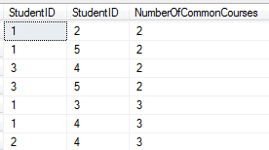

SELECT E1.StudentID, E2.StudentID, AS NumberOfCommonCourses
FROM dbo.Enrollment AS E1 JOIN dbo.Enrollment AS E2
ON E1.ClassID = E2.ClassID
ORDER BY NumberOfCommonCourses ASC;

