CMSC/CIS 255 Fall 2016
Homework 9 – Subqueries (165 points available)
Deadline: Midnight MON Oct 31

- Use AdventureWorks2014 (except for the last 2 questions).
- For each question:
- Paste the query from Management Studio into the document.
- State the total number of rows in the result.
- Include a readable screen capture of the top part of the result. DON’T screen-capture the entire window. Use the Snipping Tool to capture just the top part of the result.

- Make sure each column is appropriately named.
- Use subqueries unless otherwise stated.
- Put table names or aliases in front of all column names in subqueries.

- Find all orders placed on the FIRST day of activity in the Purchasing.PurchaseOrderHeader table. Show the PurchaseOrderID, OrderDate, EmployeeID and VendorID for each order. You MUST use a subquery. (10 points)

SELECT P1.PurchaseOrderID, P1.OrderDate, P1.EmployeeID, P1.VendorID
FROM Purchasing.PurchaseOrderHeader AS P1
WHERE P1.OrderDate = (SELECT MIN(P2.OrderDate)
FROM Purchasing.PurchaseOrderHeader AS P2);

4 rows
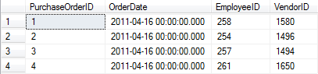

- Show the BusinessEntityID, FirstName, and LastName of everyone in the Person.Person table who placed a purchase order before July 24, 2011. Note that the BusinessEntityID column in Person.Person provides the same information as the EmployeeID column in Purchasing.PurchaseOrderHeader.

Solve this in 2 ways:
(a) A subquery. (10 points)

SELECT Per.BusinessEntityID, Per.FirstName, Per.LastName
FROM Person.Person AS Per
WHERE Per.BusinessEntityID IN (SELECT Pur.EmployeeID
FROM Purchasing.PurchaseOrderHeader AS Pur
WHERE Pur.OrderDate < '2011-06-24');

8 Rows
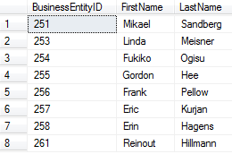

(b) A join. (10 points)

SELECT DISTINCT Per.BusinessEntityID, Per.FirstName, Per.LastName
FROM Purchasing.PurchaseOrderHeader AS Pur
INNER JOIN Person.Person AS Per
ON Pur.EmployeeID = Per.BusinessEntityID
WHERE Pur.OrderDate < '2011-06-24';

8 Rows
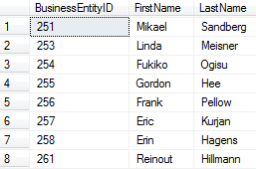

Make sure both methods yield the same result!

- Find the ProductID, product-name (the Name column in Production.Product), ProductModelID, and product-model-name (the Name column in Production.ProductModel) of all silver products that are ordered from only 1 vendor (the BusinessEntityID column in Purchasing.ProductVendor is the vendor each product was ordered from). Products with no product-model-id should be included.
NOTE: You MUST use a subquery; you may use a join as well. (10 points)

SELECT P1.ProductID, P1.Name, M.ProductModelID, M.Name
FROM Production.Product AS P1 CROSS JOIN Production.ProductModel AS M
WHERE P1.ProductID IN (SELECT P2.ProductID
FROM Purchasing.ProductVendor AS V
INNER JOIN Production.Product AS P2
ON V.ProductID = P2.ProductID
WHERE P2.Color = 'Silver' AND V.BusinessEntityID = 1514);

256 Rows
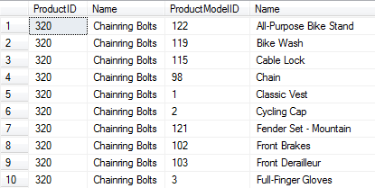

- Find all street-addresses in Person.Address which are in a US state. (The states and countries are in Person.StateProvince.) Show AddressLine1 and City in the result.

Solve this in 2 ways:
(a) A subquery. (10 points)

SELECT DISTINCT A.AddressLine1, A.City
FROM Person.Address AS A
WHERE A.StateProvinceID IN (SELECT S.StateProvinceID
FROM Person.StateProvince AS S
WHERE S.CountryRegionCode = 'US');

8658 Rows
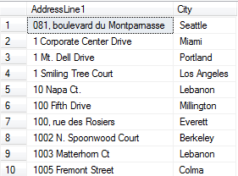
(b) A join. (10 points)
Make sure both methods yield the same result!

- Show the BusinessEntityID and full name for each employee in Person.Person for whom the bonus in Sales.SalesPerson is at least $3,000.

Solve this in 2 ways:
(a) A self-contained subquery with a WHERE … IN statement. (10 points)

SELECT P.BusinessEntityID, P.FirstName + ' ' + P.LastName AS FullName
FROM Person.Person AS P
WHERE P.BusinessEntityID IN (SELECT S.BusinessEntityID
FROM Sales.SalesPerson AS S
WHERE S.Bonus >= 3000.00);

9 Rows
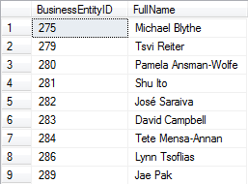

(b) A correlated subquery with a WHERE EXISTS statement. (10 points)
Make sure both methods yield the same result!

SELECT S.BusinessEntityID, P.FirstName + ' ' + P.LastName AS FullName
FROM Sales.SalesPerson AS S
INNER JOIN Person.Person AS P
ON S.BusinessEntityID = P.BusinessEntityID
WHERE S.Bonus >= 3000.00
AND EXISTS
(SELECT *
FROM Person.Person AS P
WHERE S.BusinessEntityID = P.BusinessEntityID);

9 Rows

- Find all the credit-card numbers that were used in 2011 but not in 2012. (The credit-card-id’s for each order are in Sales.SalesOrderHeader. The corresponding credit-card-numbers are in Sales.CreditCard.) (10 points)

SELECT C.CardNumber
FROM Sales.CreditCard AS C
WHERE C.CreditCardID IN (SELECT DISTINCT S.CreditCardID
FROM Sales.SalesOrderHeader AS S
WHERE YEAR(S.OrderDate) = '2011' AND YEAR(S.OrderDate) <> '2012');

1356 Rows
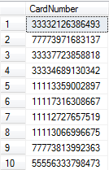

- Show each tax-rate together with the next largest tax-rate in Sales.SalesTaxRate. Display the results in ascending order, with each tax-rate appearing only once per column, as shown below. (10 points)

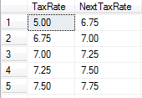
and so on ….

SELECT DISTINCT S2.TaxRate, (SELECT MIN(S1.TaxRate)
FROM Sales.SalesTaxRate AS S1
WHERE S2.TaxRate < S1.TaxRate) AS NextTaxRate
FROM Sales.SalesTaxRate AS S2
ORDER BY S2.TaxRate ASC;

15 Rows
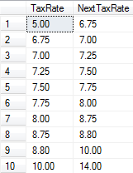

- For all productsIDs in Production.Product, show ProductID, productName, and the total quantity in stock over all rows for that product in Production.ProductInventory.

Solve this in 2 ways:
(a) A subquery. (10 points)

SELECT P2.ProductID, PR.Name, (SELECT SUM(P1.Quantity)
FROM Production.ProductInventory AS P1
WHERE P1.Quantity <= P2.Quantity
AND P1.ProductID = P2.ProductID) AS Quantity
FROM Production.ProductInventory AS P2
INNER JOIN Production.Product AS PR
ON P2.ProductID = PR.ProductID
ORDER BY ProductID;

1069 Rows
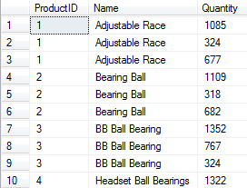

(b) A join. (10 points)
Make sure both methods yield the same result!

- For each customer and each order by that customer, show the CustomerID, OrderDate, SalesOrderID and the the SalesOrderID of the previous order made by the same customer. Display the results in ascending order by CustomerID; each customer’s results should be ordered by SalesOrderID in descending order. Each customer’s first order-id should have NULL as the previous order-id. (10 points)

For the last 2 questions, use the student-course database of HW6, #53.

- Show the full-name of the student or students taking the most classes.
Solve this in 2 ways:
(a) A subquery. (10 points)
(b) A join. (10 points)
Make sure both methods yield the same result!

- Compute the average number of students per class, averaged over all classes. The result should be one number, shown to one decimal place. Verify the result manually. (10 points)

NOTE: It is very important that this query work correctly if there were classes with no students. To test this, after you think you have the query correct, insert a new class into the Class table and run the query again. Verify that the new average is correct. (5 points)

