CMSC/CIS 255 Fall 2016
Homework 4 – JOIN
(150 points)
Deadline: Midnight MON SEP 26

- Compute manually the inner join, left outer join, right outer join, and full outer join of the tables below, using as condition equality of the ClassID column. (20 points)

Student Table
Name | Class ID
Jerry Attrick | CIS 255
Tommy Gunn | CMSC 250
Hedda Lettuce | NULL
Rose Bush | CMSC 250
Cara Van | CIS 255

Course Table
Class ID | Instructor
CIS 255 | Brodie
CMSC 250 | Sinapova
NULL | Schellhorn
NULL | Brittingham
Inner Join
Name | Class ID | Instructor | Class ID
Jerry Attrick | CIS 255 | Brodie | CIS 255
Tommy Gun | CMSC 250 | Sinapova | CMSC 250
Rose Bush | CMSC 250 | Sinapova | CMSC 250
Cara Van | CIS 255 | Brodie | CIS 255

Left outer join
Name | Class ID | Instructor | Class ID
Jerry Attrick | CIS 255 | Brodie | CIS 255
Tommy Gun | CMSC 250 | Sinapova | CMSC 250
Rose Bush | CMSC 250 | Sinapova | CMSC 250
Cara Van | CIS 255 | Brodie | CIS 255
Hedda Lettuce | NULL | NULL | NULL

Right outer join
Name | Class ID | Instructor | Class ID
Jerry Attrick | CIS 255 | Brodie | CIS 255
Tommy Gun | CMSC 250 | Sinapova | CMSC 250
Rose Bush | CMSC 250 | Sinapova | CMSC 250
Cara Van | CIS 255 | Brodie | CIS 255
NULL | NULL | Schellhorn | NULL
NULL | NULL | Brittingham | NULL

Full outer join
Name | Class ID | Instructor | Class ID
Jerry Attrick | CIS 255 | Brodie | CIS 255
Tommy Gun | CMSC 250 | Sinapova | CMSC 250
Rose Bush | CMSC 250 | Sinapova | CMSC 250
Cara Van | CIS 255 | Brodie | CIS 255
Hedda Lettuce | NULL | NULL | NULL
NULL | NULL | Schellhorn | NULL
NULL | NULL | Brittingham | NULL

32 – 37: Use AdventureWorks 2014.

- Show the city name, state/province name, and country/region code of all addresses in the Person.Address table. Note that the state/province name and country/region code are in the Person.StateProvince table. Show distinct results only, ordered by city. (10 points)

SELECT DISTINCT A.City, S.Name, S.CountryRegionCode
FROM Person.Address AS A CROSS JOIN Person.StateProvince AS S
ORDER BY A.City;

104075 Rows
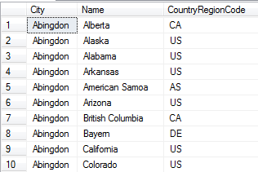

- Find the name, list-price, and total number of sales of the 10 most-often-sold products in the Sales.SalesOrderDetail table. Note that the name and list-price of each product are in the Production.Product table. Display the results in descending order by how often each product is sold. (10 points)

- (a) Each production technician in the HumanResources.Employee table can work any of the 3 shifts in the HumanResources.Shift table. Show all the possible combinations of the production technician’s nationalIDnumber, jobtitle, and the shift name. Make sure to include only production technicians, not all employees. (10 points)

SELECT E.NationalIDNumber, E.JobTitle, S.Name
FROM HumanResources.Employee AS E CROSS JOIN HumanResources.Shift AS S
WHERE E.JobTitle LIKE '%Production Technician%';

471 Rows
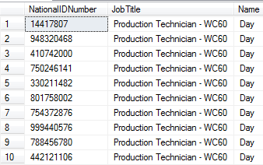

(b) Extend the above result by including each production technician’s first and last name as listed in the Person.Person table. (10 points)

- Show the product-id and name of all products that need to be re-ordered. A product needs to be re-ordered if the Quantity (found in Production.ProductInventory) is below the ReorderPoint (found in Production.Product). Each product should appear only once in the result. (10 points)

SELECT DISTINCT Inventory.ProductID
FROM Production.ProductInventory AS Inventory
INNER JOIN Production.Product AS Product
ON Inventory.ProductID = Product.ProductID
WHERE Inventory.Quantity < Product.ReorderPoint;

347 Rows
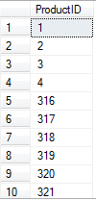
- Show the names of all products in Production.Product. Products that have a product-model ID, product-model name, and catalog description should have that information included in the result. It can be found in the Production.ProductModel table. (10 points)

SELECT Prodcut.ProductModelID, Prodcut.Name, Model.Name, Model.CatalogDescription
FROM Production.Product AS Prodcut
INNER JOIN Production.ProductModel AS Model
ON Prodcut.ProductModelID = Model.ProductModelID;

295 Rows
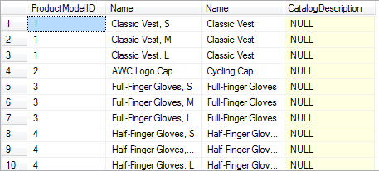

- Show the first and last names of the customers who have placed the 5 largest orders, together with the amount of the order.
Hint: Proceed similarly to Join Exercise #2. First find the 5 biggest orders using the data in Sales.SalesOrderDetail. Then add the CustomerID, found in Sales.SalesOrderHeader. Get each customer’s PersonID from Sales.Customer. The customers’ names are in Person.Person; which column in Person.Person links to PersonID in Sales.Customer? (20 points)

Sales.customer
SELECT TOP(5) Details.OrderQty, Header.CustomerID, Customer.PersonID, Person.FirstName, Person.LastName
FROM Sales.SalesOrderDetail AS Details

INNER JOIN Sales.SalesOrderHeader AS Header
ON Details.SalesOrderID = Header.SalesOrderID

INNER JOIN Sales.Customer AS Customer
ON Header.CustomerID = Customer.CustomerID

INNER JOIN Person.Person AS Person
ON Customer.CustomerID = Person.BusinessEntityID

ORDER BY Details.OrderQty;

5 rows
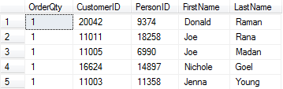

- Use a SQL query to show all Pythagorean triangles whose sides are integers from 1 to 5. The hypotenuse, computed as sqrt(sqr(side1) + sqr(side2)), should be shown to 2 decimal places. Display the results in 2 ways:

- Each number from 1 to 5 occurs twice – 25 rows in total. (15 points)
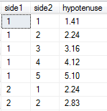
…..
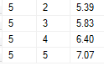
[Hint: The dbo.Nums table in TSQL2012 may be useful. There is a further hint on the last page.]

- Notice that some rows are really the same triangle; e.g. row 2 and row 6 both have one side = 1, other side = 2, and hypotenuse = 2.24. Change the query to show each triangle once only. This gives 15 rows in total, as shown below. (5 points)
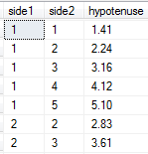
…
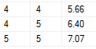

- Associativity of INNER JOIN. We will do a particular example of joining 3 tables in 2 different orders, and verify that the result is the same (See In-class Join Exercise, #7(b)). Consider the following 3 tables. We will compute Student INNER JOIN Class INNER JOIN Teacher in 2 different orders, and see if we get the same result. Do all calculations by hand. (20 points total)

Student Table
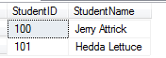

Teacher Table
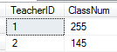

Class Table (Note that Jerry Attrick is taking 2 classes and Hedda Lettuce is taking 1 class.) 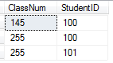

- Compute Student INNER JOIN Class, with Student ID as the matching column. (4 points)

- Using the result of (a), compute (Student INNER JOIN Class) INNER JOIN Teacher, with ClassNum as the matching column for the 2nd JOIN. (4 points)

- Compute Class INNER JOIN Teacher, with ClassNum as the matching column. (4 points)

- Using the result of (c), compute Student INNER JOIN (Class INNER JOIN Teacher), with Student ID as the matching column for the 1st JOIN. (4 points)

- Are the results of (b) and (d) the same? (1 point)

- Would the same hold for OUTER JOIN, for these particular tables? Explain why. You do not need to perform the calculations. (3 points)

- Dana Data wants to find all orders in AdventureWorks2014 where the shipping-date is more than a week after the order-date (see HW3, #27(b)).

First she looks for sales more than 7 days apart, using this query:

SELECT SalesOrderID, OrderDate, DueDate, ShipDate
FROM Sales.SalesOrderHeader
WHERE DATEDIFF(day, OrderDate, ShipDate) > 7;

This query produces 9 rows.

Then she looks for sales more than 1 week apart, using the following query. She expects the result will be the same.

SELECT SalesOrderID, OrderDate, DueDate, ShipDate
FROM Sales.SalesOrderHeader
WHERE DATEDIFF(week, OrderDate, ShipDate) > 1;

But this query produces no output.

Dana is very confused. Which result is correct? Help her by explaining why this difference occurs. You will need to research how the DATEDIFF function actually works. (10 points)

___________________________________________________________________________

Hint for #38:

TSQL2012 has a table called dbo.Nums containing the integers from 1 to 1,000,000.
Use a WHERE to take the integers from 1 to 5, and use the appropriate JOIN, together with ORDER BY, to create 2 columns that look like this:

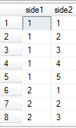
……..
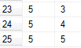

Add a third column which computes the hypotenuse and displays it to 2 decimal places. That does 38(a).

For 38(b), add a restriction (i.e. something more in the WHERE) to avoid the repeating triangles.

