CMSC/CIS 255 Fall 2016
Homework 2 – SELECT
(100 points available)
DUE: Midnight MON SEPT 12

- Use AdventureWorks2014.
  - NOTE: If you are using your own computer, you need to install AdventureWorks. There are instructions (including a video) on the Internet. If you encounter problems let me know and I will help.

- For each question:
- Paste the query from Management Studio into the document.
- State the total number of rows in the result.
- Include a readable screen capture of the top part of the result. DON’T screen-capture the entire window. Use the Snipping Tool to capture just the top part of the result.

- Make sure each column is appropriately named.

- Show the product name and list-price of all products in the Production.Product table whose standard cost is less than $10.00, in descending order by list-price. (10 points)

SELECT Name, ListPrice
FROM production.Product
WHERE StandardCost < 10.00
ORDER BY ListPrice DESC;

223 rows
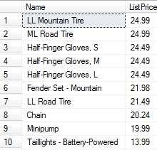

- Return the following four columns from the Sales.SalesOrderDetail table:
- ProductID and UnitPrice.
- A column named Quantity to represent OrderQty.
- A column named TotalBeforeDiscount which shows OrderQty multiplied by UnitPrice (NOTE: Do NOT use the LineTotal column – this gives the Total AFTER the discount).
(10 points)

SELECT ProductID, UnitPrice, OrderQty AS Quantity,
(OrderQty * UnitPrice) AS TotalBeforeDiscount
FROM Sales.SalesOrderDetail

121317 Rows
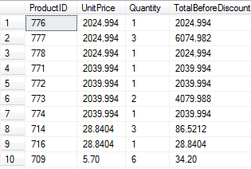

- Display the results of question 12 in (a) ascending (b) descending order of TotalBeforeDiscount, filtered so that only rows where TotalBeforeDiscount is greater than $1000.00 are returned. (10 points)

A SELECT ProductID, UnitPrice, OrderQty AS Quantity,
(OrderQty * UnitPrice) AS TotalBeforeDiscount
FROM Sales.SalesOrderDetail
WHERE (OrderQty * UnitPrice) > 1000.00
ORDER BY TotalBeforeDiscount ASC;

32180 Rows
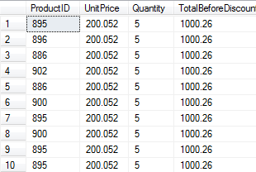

B SELECT ProductID, UnitPrice, OrderQty AS Quantity,
(OrderQty * UnitPrice) AS TotalBeforeDiscount
FROM Sales.SalesOrderDetail
WHERE (OrderQty * UnitPrice) > 1000.00
ORDER BY TotalBeforeDiscount DESC;

32180 Rows
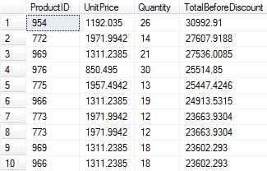

- Determine the 5 products (i.e. ProductIDs) which have been ordered most often in Sales.SalesOrderDetail. Show how often each has been ordered, in descending order. (10 points)
SELECT TOP(5) COUNT(ProductID) AS OrderCount
FROM Sales.SalesOrderDetail
GROUP BY ProductID
ORDER BY OrderCount DESC;

5 Rows
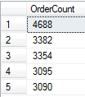

- Show the full-name of each customer in the Person.Person table in the form LastName, comma, FirstName, in alphabetical order by last name and then first name. (NOTE: You will find that some people occur more than once. See if you can explain why by examining the data in the table.) (10 points)

SELECT LastName + ', ' + FirstName AS Name
FROM Person.Person
ORDER BY LastName;

19972 Row
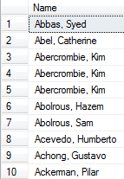

SELECT LastName + ', ' + FirstName AS Name
FROM Person.Person
ORDER BY FirstName;

19972 Rows
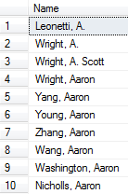

- Filter the result for question 15 so that only rows with last names beginning with B, C, D or G are returned. (10 points)

SELECT LastName + ', ' + FirstName AS Name
FROM Person.Person
WHERE LastName LIKE '[BCDG]%'
ORDER BY LastName;

4501 Rows
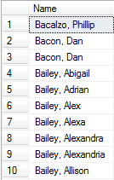

- Find all the addresses in the Person.Address table where AddressLine1 starts with a number larger than or equal to 1000. Display just the AddressLine1 column, and show distinct values only. The same AddressLine1 should not occur more than once.(15 points)

SELECT DISTINCT AddressLine1
FROM Person.Address
WHERE AddressLine1 LIKE '[1-9][0-9][0-9][0-9]%'
ORDER BY AddressLine1

9759 Rows
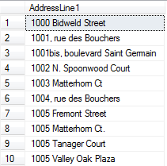

- We want to investigate which color products are the most expensive. Compute the average ListPrice for the products in the Production.Product Table of each color and display the results in descending order by ListPrice. Make sure products with no color are excluded. (15 points)

SELECT AVG(ListPrice) AS AvgListPrice, Color
FROM Production.Product
WHERE Color IS NOT NULL
GROUP BY Color
ORDER BY AvgListPrice DESC;

- Danny Data claims that the following query finds the customer-ids of all customers who placed orders in 2014 but not in 2013. Explain why Danny is NOT correct. (10 points)

SELECT DISTINCT CustomerID
FROM Sales.SalesOrderHeader
WHERE YEAR(OrderDate) = '2014' AND YEAR(OrderDate) <> '2013'

Hint: Consider a customer who ordered in 2014 and, in another row of the table, also ordered in 2013.

The customer that ordered in both 2014 and 2013 would show up because going through line by line when the customer ordered in 2014 he would pass all the criteria and be put into the results, but when the search gets to the customer’s order from 2013 it would not match and he should not be put in the results. But the customer is already in the list and would not be removed.

