CMSC/CIS 255 Fall 2016
Homework 2 – SELECT
(100 points available)
DUE: Midnight MON SEPT 12

- Use AdventureWorks2014.
  - NOTE: If you are using your own computer, you need to install AdventureWorks. There are instructions (including a video) on the Internet. If you encounter problems let me know and I will help.

- For each question:
- Paste the query from Management Studio into the document.
- State the total number of rows in the result.
- Include a readable screen capture of the top part of the result. DON’T screen-capture the entire window. Use the Snipping Tool to capture just the top part of the result.
- Make sure each column is appropriately named.

- Show the product name and list-price of all products in the Production.Product table whose standard cost is less than $10.00, in descending order by list-price. (10 points)

SELECT Name, ListPrice
FROM Production.Product
WHERE StandardCost < 10
ORDER BY ListPrice DESC

223 rows
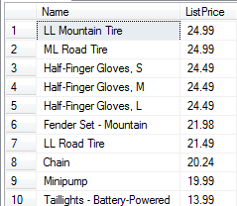

- Return the following four columns from the Sales.SalesOrderDetail table:
- ProductID and UnitPrice.
- A column named Quantity to represent OrderQty.
- A column named TotalBeforeDiscount which shows OrderQty multiplied by UnitPrice (NOTE: Do NOT use the LineTotal column – this gives the Total AFTER the discount). (10 points)

SELECT ProductID, OrderQty AS Quantity, UnitPrice,
OrderQty * UnitPrice AS TotalBeforeDiscount
FROM Sales.SalesOrderDetail;

121317 rows
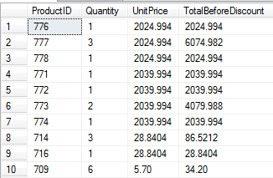

- Display the results of question 12 in (a) ascending (b) descending order of TotalBeforeDiscount, filtered so that only rows where TotalBeforeDiscount is greater than $1000.00 are returned. (10 points)

(a)
SELECT ProductID, OrderQty AS Quantity, UnitPrice,
OrderQty * UnitPrice AS TotalBeforeDiscount
FROM Sales.SalesOrderDetail
WHERE OrderQty * UnitPrice > 1000
ORDER BY TotalBeforeDiscount

32180 rows
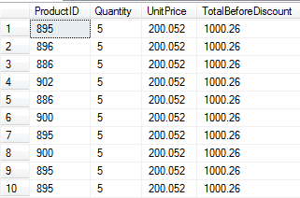

(b)

SELECT ProductID, OrderQty AS Quantity, UnitPrice,
OrderQty * UnitPrice AS TotalBeforeDiscount
FROM Sales.SalesOrderDetail
WHERE OrderQty * UnitPrice > 1000
ORDER BY TotalBeforeDiscount DESC;

32180 rows
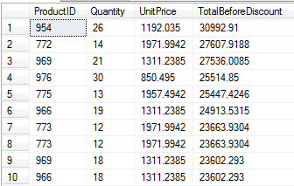

- Determine the 5 products (i.e. ProductIDs) which have been ordered most often in Sales.SalesOrderDetail. Show how often each has been ordered, in descending order. (10 points)

This requires interpreting “ordered most often”. Does it count the number of times the product was ordered or the total quantity of the product that was ordered?

Solution One: “ordered most often” counts the number of times the product was ordered.

SELECT TOP 5 ProductID, COUNT(ProductID) AS TotalCount
From Sales.SalesOrderDetail
GROUP BY ProductID
ORDER BY TotalCount DESC

5 rows
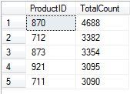

Solution Two: “ordered most often” counts the total quantity of product that was ordered.

SELECT TOP 5 ProductID, SUM(OrderQty) AS TotalQuantity
From Sales.SalesOrderDetail
GROUP BY ProductID
ORDER BY TotalQuantity DESC

5 rows
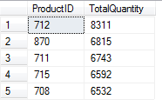

- Show the full-name of each customer in the Person.Person table in the form LastName, comma, FirstName, in alphabetical order by last name and then first name. (NOTE: You may find that some people occur twice. See if you can explain why by examining the data in the table.) (10 points)

SELECT LastName + ',' + FirstName AS Full_Name
FROM Person.Person
ORDER BY LastName, FirstName;

19,972 rows
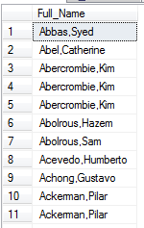

I will grade the second part of the question. Here is one approach.
To see why some names occur twice, pick one of the repeating names and examine their details:

SELECT *
FROM Person.Person
WHERE LastName = 'Abercrombie'

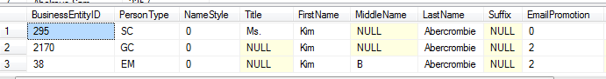

Note that SC = Store Contact, GC = General Contact, and EM = Employee.
Notice that the Title and MiddleName also differ.
Possibly this data represents one person in 3 different roles, but it’s possibly 2 people or even 3 different people.

- Filter the result for question 15 so that only rows with last names beginning with B, C, D or G are returned. (10 points)

There are many solutions. Here are some:

(1)
SELECT LastName + ',' + FirstName AS Full_Name
FROM Person.Person
WHERE LastName LIKE '[BCDG]%'
ORDER BY LastName, FirstName;

(2)
SELECT LastName + ',' + FirstName AS Full_Name
FROM Person.Person
WHERE LastName LIKE '[B-D,G]%'
ORDER BY LastName, FirstName;

(3)
SELECT LastName + ', ' + FirstName AS Full_Name
FROM Person.Person
WHERE LastName LIKE 'B%' or LastName LIKE 'C%'
or LastName LIKE 'D%' or LastName LIKE 'G%'
ORDER BY LastName, FirstName

4501 rows
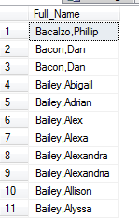

- Find all the addresses in the Person.Address table where AddressLine1 starts with a number larger than or equal to 1000. (10 points)

There are many solutions. Perhaps the simplest is this one:

SELECT AddressLine1
FROM Person.Address
WHERE AddressLine1 LIKE '[1-9][0-9][0-9][0-9]%'

14274 rows
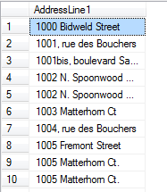

However, the following is NOT correct:
SELECT AddressLine1
FROM Person.Address
WHERE AddressLine1 >= '1000%'

- We want to investigate which color products are the most expensive. Compute the average ListPrice for the products in the Production.Product Table of each color and display the results in descending order by ListPrice. Make sure products with no color are excluded. (15 points)

SELECT Color, AVG(ListPrice) AS AveragePrice
FROM Production.Product
WHERE Color IS NOT NULL
GROUP BY Color
ORDER BY AveragePrice DESC

9 rows
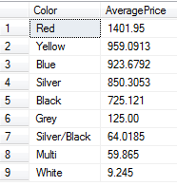

- Danny Data claims that the following query finds the customer-ids of all customers who placed orders in 2014 but not in 2013. Explain why Danny is NOT correct. (10 points)

SELECT DISTINCT CustomerID
FROM Sales.SalesOrderHeader
WHERE YEAR(OrderDate) = '2014' AND YEAR(OrderDate) <> '2013'

Hint: Consider a customer who ordered in 2014 and, in another row of the table, also ordered in 2013.

It fails, because WHERE does a row-by-row check of the condition. For any customer who ordered in 2014, the WHERE will be True and so the customer will be included, even if there is another row where the same customer ordered in 2013.

For example, suppose the data is as follows:

CustomerID OrderID OrderDate
- 100 2014-09-02
- 101 2013-04-23
- 102 2014-02-01
- 103 2012-10-14

The desired output is just customer 2, since they ordered in 2014 but not in 2013. Neither customer 1 nor customer 3 should appear in the output. But customer1 WILL appear in the output, because row1 matches the condition.

