CMSC/CIS 255 Fall 2016
Homework 7 – Normalization
(145 points)
Deadline: Midnight Mon OCT 17

NOTE: With mid-term grades coming up, if you want an accurate grade make sure to hand-in any self-check documents for previous homeworks that you haven’t handed in.

- Consider the following table structure. EMP_NUM is the primary key.

EMP_NUM | EMP_RANK | EMP_NAME | DEPT_CODE | DEPT_NAME | EMP_OFFICE
12345 | Associate Professor | Brodie | CMSC | Computer Science | CS 201
98765 | Associate Professor | Czarneski | Math | Mathematics | CS 331A
2468 | Professor | Sinapova | CMSC | Computer Science | CS 235

- Draw the dependency diagram and identify all dependencies. Is the table in 2NF? Explain why or why not. (10 points)

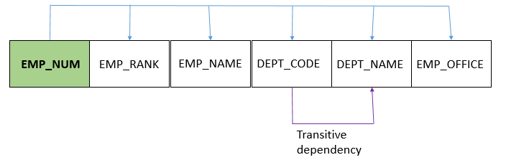

The table is in 2NF because there are no partial dependencies.

- Convert the table to 3NF. Show the dependency diagrams for all tables, showing all PKs and FKs. (10 points)

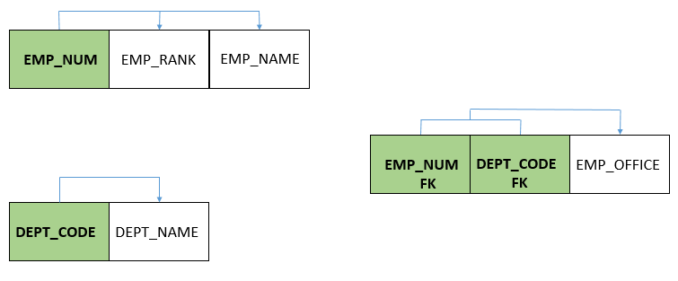

- Consider the following table structure. Note that:

- Each invoice is issued on a specific date, but may contain more than one product.
- Each product is supplied by a single vendor at a specific price.
- A vendor can supply many products.

INV_NUM | PROD_NUM | SALE_DATE | PROD_DESCRIPTION | VEND_CODE | VEND_NAME | NUM_SOLD | PROD_PRICE
211347 | AA-E3422 | 15-Jan-2010 | Rotary sander | 211 | NeverFail, Inc. | 1 | $49.95
211347 | QD-30093 | 15-Jan-2010 | 0.25-in.drill bit | 211 | NeverFail, Inc. | 8 | $3.45
211347 | RU-995748 | 15-Jan-2010 | Band saw | 309 | BeGood, Inc. | 1 | $39.99
211348 | AA-E3422 | 15-Jan-2010 | Rotary sander | 211 | NeverFail, Inc. | 2 | $49.95
211349 | GH-77834 | 16-Jan-2010 | Power drill | 157 | ToughGo, Inc. | 1 | $87.75

- Draw the dependency diagram; identify all dependencies as well as the PK. (10 points)

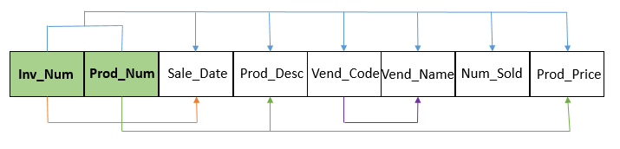

- Convert the table to 2NF. Show the dependency diagrams for all tables. (10 points)

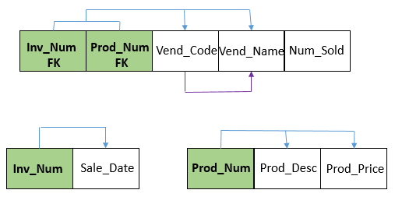

- Convert the table to 3NF. Show the dependency diagrams for all tables, showing all PKs and FKs. (10 points)

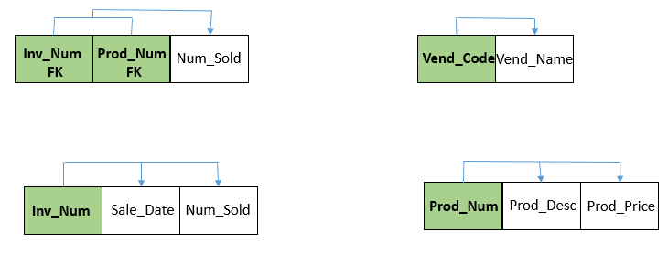

- A database table for appointments has the following columns: Appointment_Num, Appointment_Date, Appointment_Time, Patient_ID, Patient_Name, Patient_Street, Patient_City, Patient_State, Patient_Zip, Doctor_ID, Doctor_Name, Doctor_Phone.

- Draw a dependency diagram, identifying the PK and all dependencies. (10 points)

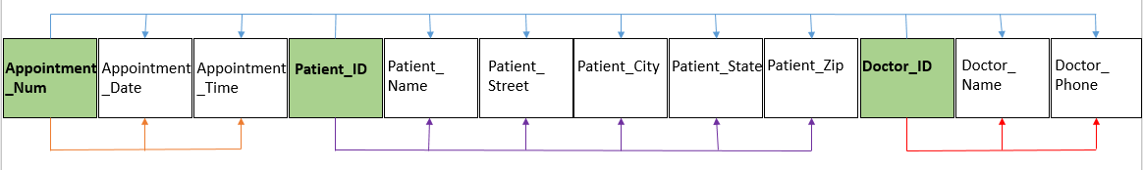

- Modify the dependency diagram so that it is in 3NF. Show all PKs and FKs. (10 points)
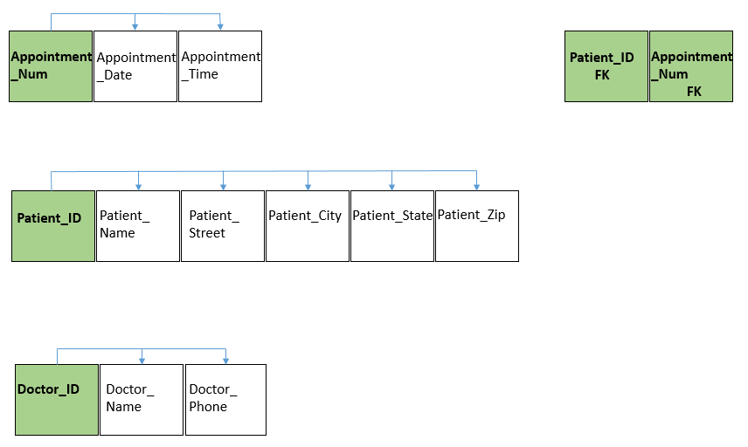

- Consider the following dependency diagram. The primary key is (A, B).
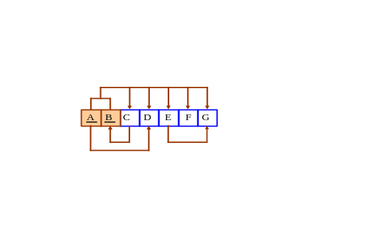

- Convert this dependency diagram into a set of dependency diagrams that are in 3NF. Make sure to remove only partial and transitive dependencies, not all the “bad” dependencies. (10 points)

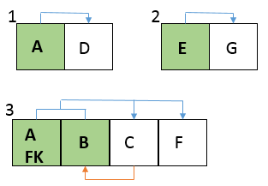

- One of the tables in (a) is NOT in BCNF. Which one, and why? (5 points)

Table 3 is not BCNF because the C attribute determines B, a PK.

- Modify the dependency diagrams in (a) to produce dependency diagrams that are all in BCNF. (10 points)

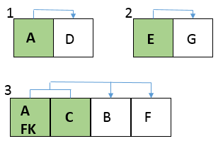

- For both Person.StateProvince and Sales.SalesOrderDetail in AdventureWorks2014, do the following: (10 points each)

- State the PK (look under the Columns folder, not the Keys folder).

Person.StateProvince: StateProvinceID
Sales.SalesOrderDetail: SalesOrderID, SalesOrderDetailID

- Explain whether or not the table is in 3NF. Justify each answer.
If you think it’s in 3NF, explain why each attribute is determined by the PK, the whole PK and nothing but the PK.
If you think it’s NOT in 3NF, describe at least one dependency which violates 3NF. Explain whether it’s a partial or transitive dependency, and why.
Where needed, use queries, as in HW3, #29, to determine which column(s) are dependent on what.
Remember that a dependency on a candidate key is not a partial or transitive dependency.

Person.StateProvince is in 3NF because each attribute is dependent on the PK and the PK only.

Sales.SalesOrderDetail is in 3NF because each attribute is dependent on the PK and the PK only.

- Perform the following queries on the database of HW6, #53. The queries must be written so that they would work even if the amount of data was much larger. Hand in each query and a screen capture of the complete result set. Explicitly validate the results of each query.

- Show the ids of all students with exactly one class in which they don’t have a grade.
(10 points)
SELECT S.StudentID
FROM Student AS S
OUTER JOIN Enrollment AS E
HAVING E.Grade = NULL;

- Show the class-title and instructor-last-name for the class or classes with the smallest number of students. (10 points)
SELECT COUNT(E.StudentID) AS NumberOfStudents, C.Class_Title, I.Instructor_Lastname
FROM Enrollment AS E
JOIN Class AS C
ON E.ClassID = C.ClassID
JOIN Instructor AS I
ON I.InstructorID = C.InstructorID
GROUP BY C.Class_Title, I.Instructor_Lastname, E.StudentID
ORDER BY E.StudentID ASC;

- Show the student data (ids, names, date-of-births) together with a column that shows the season of each student’s date-of-birth. The season should be Spring if they were born in March – May, Summer if they were born in June – August, Fall if they were born in September – November, and Winter if they were born in December – February.(10 points)

SELECT Student_FirstName + ' ' + Student_LastName AS StudentName, StudentID,
CASE MONTH(Student_DateOfBirth)
WHEN 03 THEN 'Spring'
WHEN 04 THEN 'Spring'
WHEN 05 THEN 'Spring'
WHEN 06 THEN 'Summer'
WHEN 07 THEN 'Summer'
WHEN 08 THEN 'Summer'
WHEN 09 THEN 'Fall'
WHEN 10 THEN 'Fall'
WHEN 11 THEN 'Fall'
ELSE 'Winter'
END AS 'BirthSeason'
FROM Student;

