CMSC/CIS 255 Fall 2016
Homework 3 – SELECT (150 points available)
Deadline: Midnight MON SEP 19

- Find the highest and lowest StandardPrice in Purchasing.ProductVendor. (10 points)

SELECT MAX(StandardPrice) AS HighestStandardPrice,
MIN(StandardPrice) AS LowestStandardPrice
FROM Purchasing.ProductVendor;

1 Row
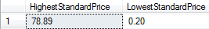

- Show the number of employees and the average vacation time for married men, married women, single men, and single women in HumanResources.Employee. List the results in ascending order by average vacation time. (15 points)

- Find the customer IDs of all customers in Sales.Customer who have not shopped at a store with StoreID larger than 500. Customers whose StoreID is not known should be included. (10 points)

SELECT CustomerID
FROM Sales.Customer
WHERE StoreID > 500 OR StoreID IS NULL

16628 Rows
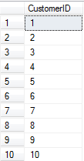

- Find all the products in Production.Product whose name contains:
- The word ‘Tire’. (10 points)
- The words ‘Hex Nut’ followed by a two-digit number. (10 points)

SELECT Name
FROM Production.Product
WHERE Name LIKE '%Tire%';

10 Rows
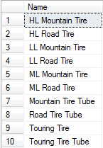

SELECT Name
FROM Production.Product
WHERE Name LIKE '%Hex Nut [0-9][0-9]%’;

21 Rows
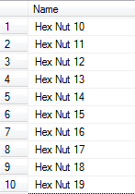

- (a) Use the Purchasing.ProductVendor table to find all products (i.e. ProductIDs) purchased from only one vendor. The vendor is shown by the BusinessEntityID column.
(10 points)
(b) Now show all the BusinessEntityIDs of vendors who supply only one product.
(10 points)

SELECT ProductID
FROM Purchasing.ProductVendor
WHERE BusinessEntityID = 1562;

23 Rows
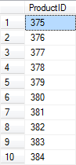

SELECT BusinessEntityID
FROM Purchasing.ProductVendor
WHERE ProductID = 317;

2 Rows
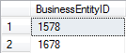

- Show the Name, CountryRegionCode, and Continent of all rows in the table Person.StateProvince.
The Continent column depends on the CountryRegionCode in the following way: it should be ‘North America’ if the CountryRegionCode is either US or CA, otherwise it should be ‘Outside North America’. (15 points)

SELECT Name, CountryRegionCode,
CASE CountryRegionCode
WHEN 'US' THEN 'North America'
WHEN 'CA' THEN 'North America'
ELSE 'Outside North America'
END AS Continent
FROM Person.StateProvince;

181 Rows
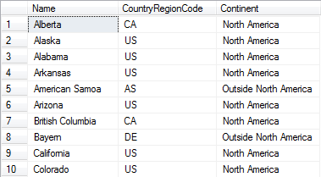

- (a) Show the SalesOrderID, OrderDate, DueDate and ShipDate of all orders in the
Sales.SalesOrderHeader table which were ordered in either February or September of
any year from 2011 to 2013. (10 points)
- Show the SalesOrderID, OrderDate, DueDate and ShipDate of all orders in the Sales.SalesOrderHeader table that were shipped more than 1 week after they were ordered. (10 points)
Hint: The DATEDIFF function may be useful.

- Show all the credit-card-numbers in Sales.CreditCard that start with either a 1 or a 9 and whose second-last-number is even. (10 points)

- Determining determining.

To select the primary key (and to handle normalization later in the semester), we want to determine if one column (or set of columns), determines another column (or set of columns). For example, consider the Purchasing.ProductVendor table. We notice from rows 4 and 5 that ProductID does NOT determine BusinessEntityID. But rather than relying on visual observation, we need a query to determine this.

- Write a query that shows how many different BusinessEntityIDs each ProductID has. Then add a filter to show only the ProductIDs that have more than one corresponding BusinessEntityID. Because the query has a non-empty result, we can conclude that ProductID does not determine BusinessEntityID. (10 points)

- Write a similar query that shows all the ProductIDs that have more than one corresponding MinOrderQty. Because the query has an EMPTY result, we can conclude that ProductID DOES DETERMINE MinOrderQty. (10 points)

- Using a similar approach, work out whether BusinessEntityID determines AverageLeadTime. (5 points)

- Using a similar approach, work out whether ProductID and BusinessEntityID combined determine AverageLeadTime. (5 points)

