Platform architecture overview
Working title: School Intelligence Platform
For the internal team and development partners · Draft 4.0
Purpose
This document sets out how the platform is structured, so that everyone building it works to one shared model. It stays at a high level. It describes what each part does and why it exists, not how it is built.
The model in one idea
Every school already runs accounting software, a student information system, payroll, HR, donor management, document storage, spreadsheets, email and calendars. The difficulty is not a shortage of software. It is that none of these systems work together to help leaders run the institution.
The platform does not replace those systems. It orchestrates them. It sits above the tools a school already uses, connects their information, captures decisions, moves work along, keeps the institution's knowledge in one place, and gives leaders a single place to run the school from.
The five engines
The platform is built on five engines. An engine is a part of the platform that does one kind of work and powers the applications built on top of it. Each engine has a set of subsections, listed below.
Financial intelligence engine. Everything financial: turning the systems a school already runs into one trusted set of numbers.
- Source connections: data pulled in from accounting, payroll and donor systems
- Mapping and normalisation: each school's chart of accounts aligned to one common structure
- Validation and reconciliation: the checks and tie-outs that flag anything that does not agree
- Budgeting: budgets built and tracked against actuals
- Cash and forecasting: the current cash position and the projection ahead
- Reporting: board and management financial reports
- Audit trail: every figure traceable back to its source

Planning engine. The forward-looking work of the institution, tied to the figures that show whether plans are on track.
- Strategic plan: the multi-year goals and objectives
- Annual budget planning: the budget cycle, drawing on the financial engine
- Improvement plans: school improvement and academic plans
- Facilities and capital planning: capital projects and the maintenance roadmap
- Progress tracking: each plan and initiative measured against where it should be

Governance engine. The record of how the institution is governed, and the decisions that come out of it.
- Boards and committees: structure, membership and terms
- Meetings and agendas: scheduling and agenda preparation
- Minutes and decisions: the record of what was decided and by whom
- Policies: the policy register, with review cycles and versions
- Board packets: the assembled meeting pack, drawing on workflow and knowledge

Workflow engine. The movement of work through the institution, so recurring tasks run on a schedule rather than on memory.
- Tasks: who owes what, and by when
- Approvals and sign-offs: routing items to the right people for a decision
- Reminders and deadlines: nudges before things fall due
- Document routing: sending documents out for review or signature
- Recurring processes: renewals and periodic obligations that repeat on a cycle

Knowledge engine. The institution's memory, kept findable so it stays when people move on.
- Document store: the central place documents live
- Templates: standard forms and reusable documents
- Accreditation evidence: evidence gathered through everyday operations
- Institutional memory: the history of plans, decisions and the people behind them
- Search: finding anything across the platform

The diagram below shows the five engines with their subsections, the systems that feed them, and the intelligence layer they roll up to.
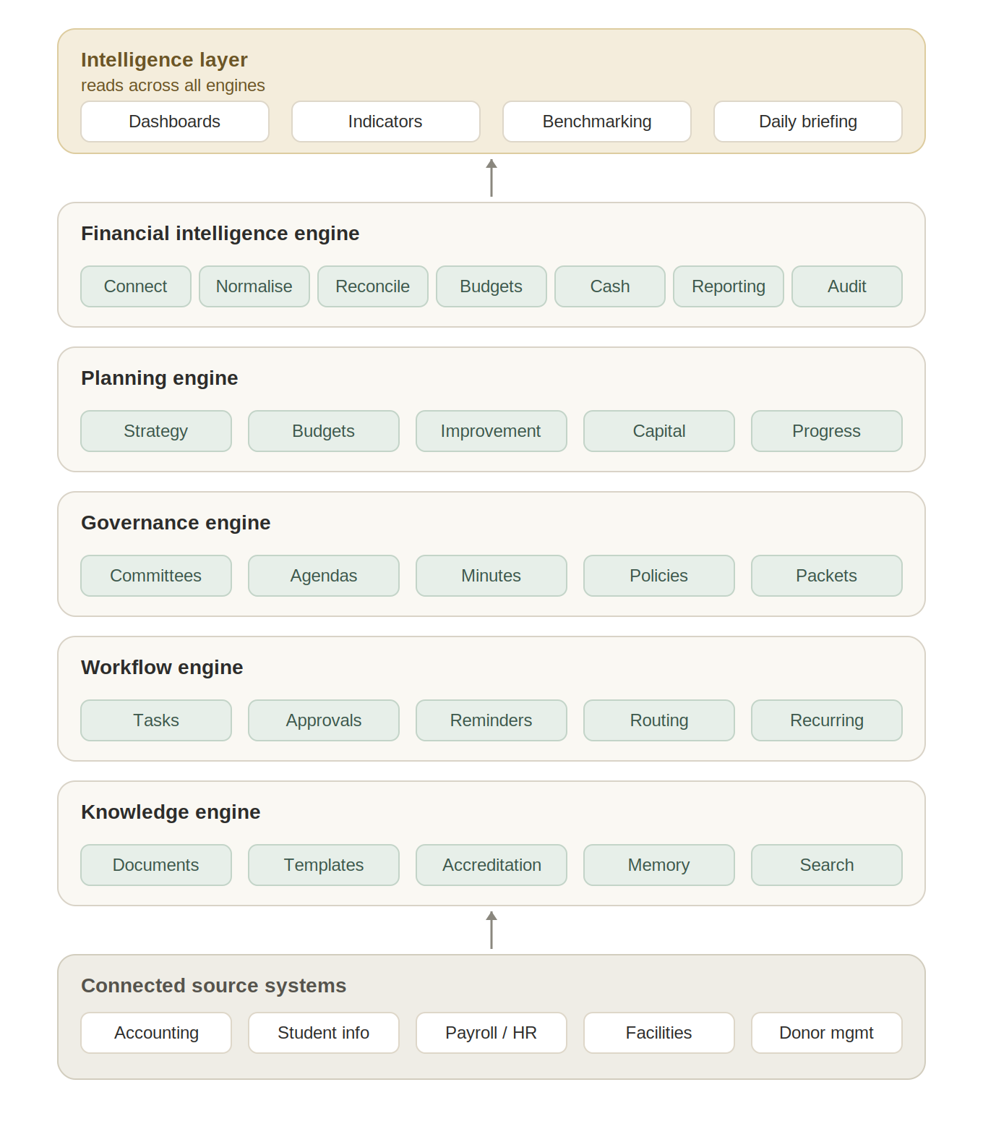
Figure 1. Each engine with its subsections, the source systems feeding in, and the intelligence layer above.
What the system knows
The engines are how the platform works. Across them, the platform holds or connects to information about eight areas of institutional life:
- Finances — income, spending, cash position and the audit trail behind them.
- Enrolment — students enrolled, projected and lost, measured against plan.
- Human resources — staffing, contracts and the cost that follows them.
- Facilities — buildings, maintenance and capital needs.
- Governance — boards, committees, policies and decisions.
- Advancement — fundraising, donors and the funds they support.
- Accreditation — the evidence and the standards a school is held to.
- Strategic planning — the institution's goals and whether they are on track.
For some of these, the platform is the system of record: finance, strategic planning, governance and accreditation evidence live inside the engines above. For the rest, enrolment, human resources, facilities and advancement, the platform reads from and writes back to the systems a school already runs, in keeping with the principle that it connects systems rather than replacing them. The workflow and knowledge engines run across all eight. Either way the information lands in one place, which is what makes the next part possible.
The intelligence layer, and what it produces
Intelligence sits across the engines rather than beside them, which is why it is not counted as a separate engine. Dashboards, key indicators, benchmarking and forecasting are what the engines produce once their information is connected. The clearest expression of it is the screen a leader sees first thing in the morning.
Picture a Monday. The superintendent logs in, and the opening screen reads:
Good morning. Three things require your attention.
Enrolment is down six students from projection.
Cash flow will fall below target in November.
Three board policies require review before accreditation.
Finance committee meeting is Thursday.
Board packet is 92% complete.
Seven supporting documents are still outstanding.
One committee chair has not approved the minutes.
Two strategic initiatives are behind schedule.
A reporting tool would show the superintendent these numbers and leave the thinking to them. This screen has already done the prioritising, telling the leader which items need a decision today and what is standing between the institution and Thursday's meeting. This is the digital chief operating officer described in the founding document: the platform reading across all eight areas overnight and presenting judgement, not just data, at the start of the day.
Delivering this is the point of the architecture. Every engine and every connection exists so that this briefing is accurate, current and worth acting on. The diagram below shows how the engines link to one another and up to the briefing.
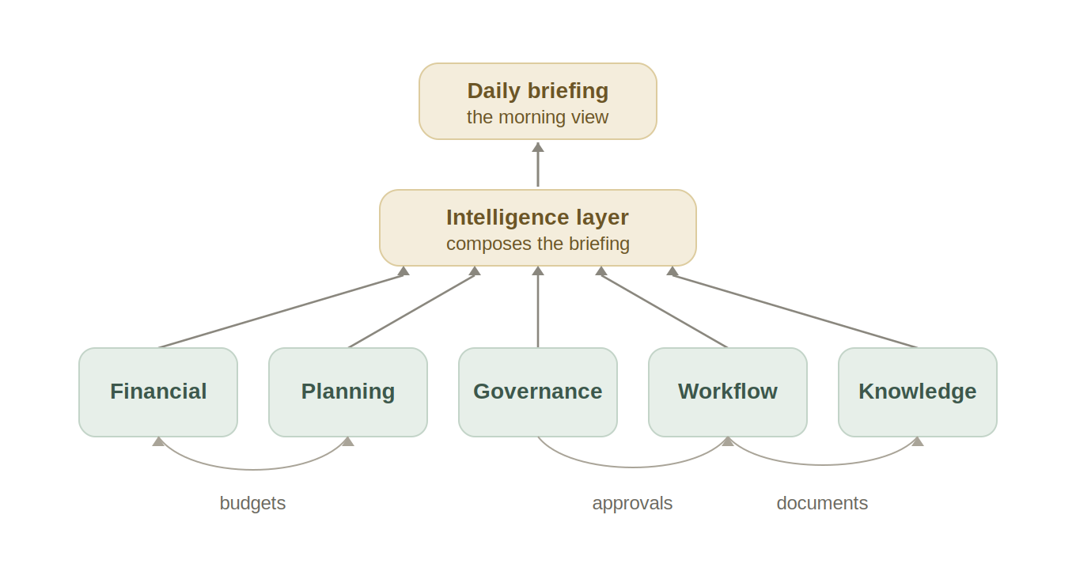
Figure 2. How the engines connect to one another and feed up through the intelligence layer to the daily briefing.
The main cross-engine links are these. Finance and planning share budget figures both ways. Governance hands approvals to workflow, and writes its minutes and policies into knowledge. Workflow files completed documents into knowledge. Above the row, every engine feeds the intelligence layer.
The briefing changes with the reader
The Monday-morning screen is not one view for everyone. The intelligence layer builds it for the person reading it, from the same connected information, so that two people never see figures that disagree. Two things decide what each person's briefing contains.
Scope. How much of the organisation a person is responsible for. A principal sees one school. A diocesan finance director sees finances across every school. A superintendent sees the whole system. Scope is also a boundary: each person sees only what their role entitles them to, and it follows the organisational hierarchy that the solution pack defines.
Lens. Which decisions, and which of the eight areas, sit with that person. A finance director's briefing centres on money. A principal's covers the running of their school. A superintendent's reaches across all eight areas.
The same engines and the same figures produce each of these:
Principal. Their school only: enrolment against plan, budget against actual, staffing gaps, facilities items awaiting sign-off, and what is due for the next board or committee meeting.
Diocesan finance director. Finances across all schools: cash positions, budget variances, schools trending below target, consolidated reporting, and any audit or compliance items outstanding.
Superintendent. The whole system: risks that cut across the eight areas, what needs a decision today, and where a meeting or an accreditation deadline is at risk.
One architecture, several kinds of institution
The same five engines serve very different organisations without a different platform underneath. What changes from one to another is the organisational hierarchy, the compliance rules that apply, the templates, and the reporting packages. We package those differences as solution packs, so each type of institution gets a configuration that fits it while the architecture stays the same.
The solution packs we are designing for:
- Catholic schools and the dioceses that oversee them
- Independent schools
- Charter schools
- Private school networks
- Small colleges
Build sequence
Finance comes first. We start with the financial intelligence engine because it delivers value on its own and gives every later engine a base of trusted data to build on. The other engines come online in phases, each one added when it is ready rather than all at once.
The test every part has to pass
Every feature, on any engine, has to answer one question: does this help leaders make better decisions? If a proposed addition does not save time, improve a decision, strengthen accountability, preserve institutional knowledge, or reduce risk, it does not belong in the platform. That single test keeps the product focused and gives everyone building it a clear way to judge whether new work fits.

