Project:
We created the “BC Ballot Builder”. It is a web application that lets users browse municipalities in British Columbia. They can also view the candidates of those municipalities and add those candidates to a list they can refer back to, helping them decide what to vote for. If they wish, they can also export this list and physically bring it with them when they go to vote.

ERD:
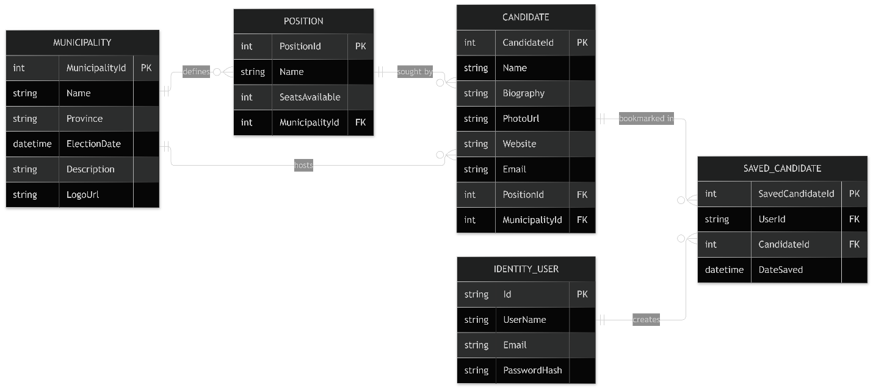

Application screenshots:
Home page:
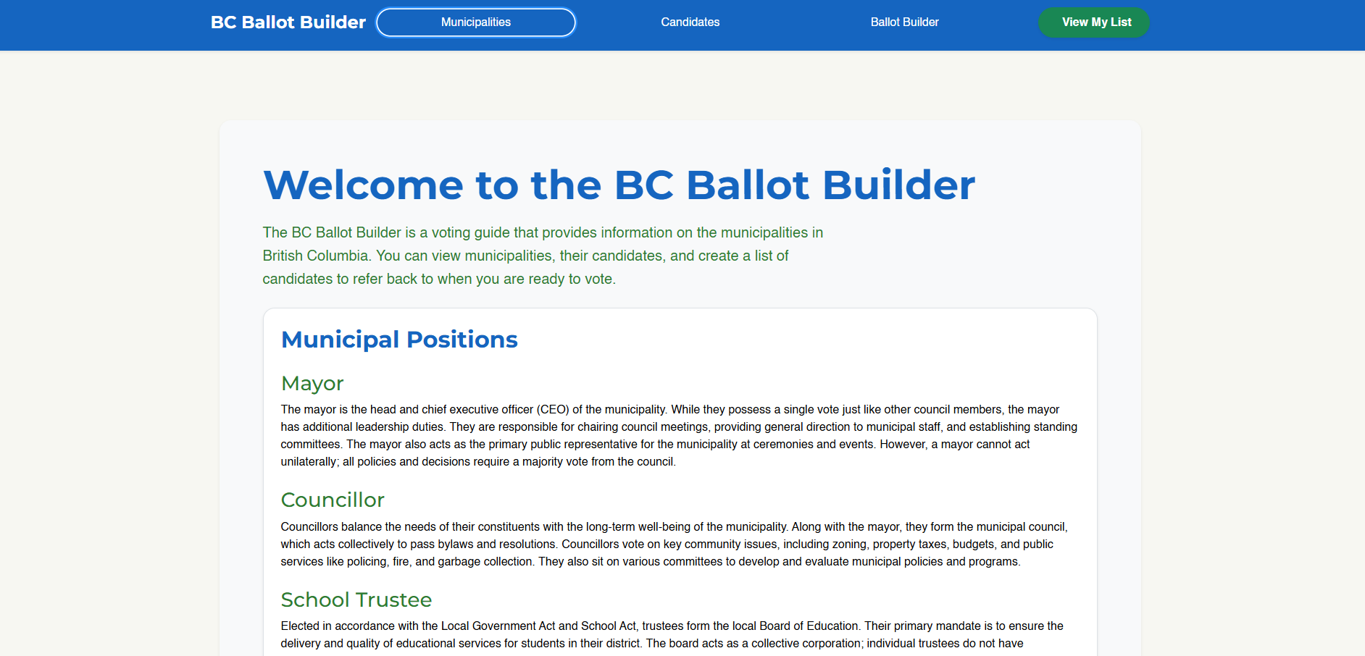
Municipalities page:
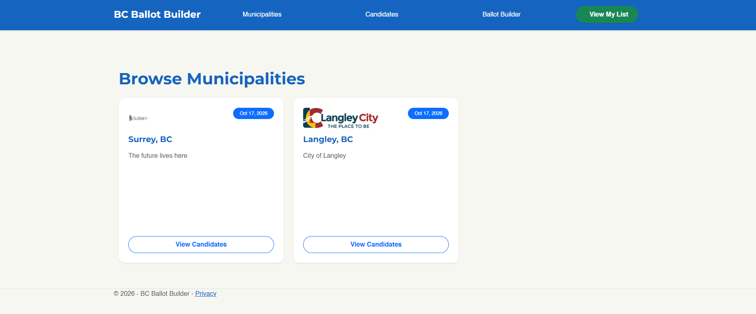

Municipality details page:
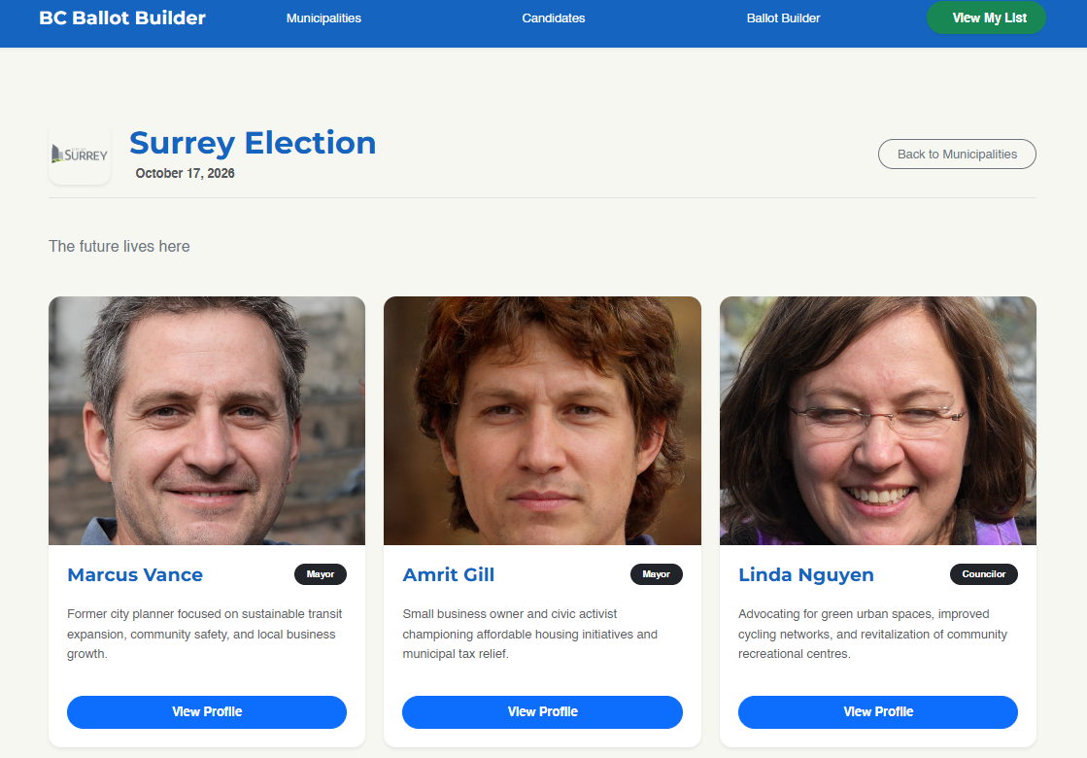

Candidate browser:
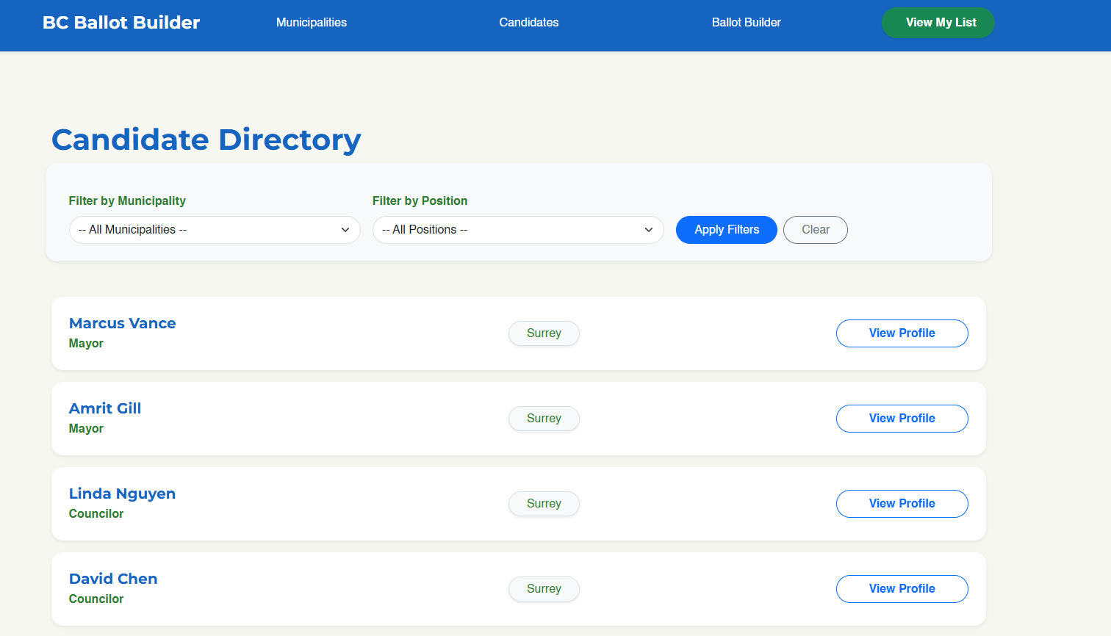

Candidate profile (accessed by clicking view profile)
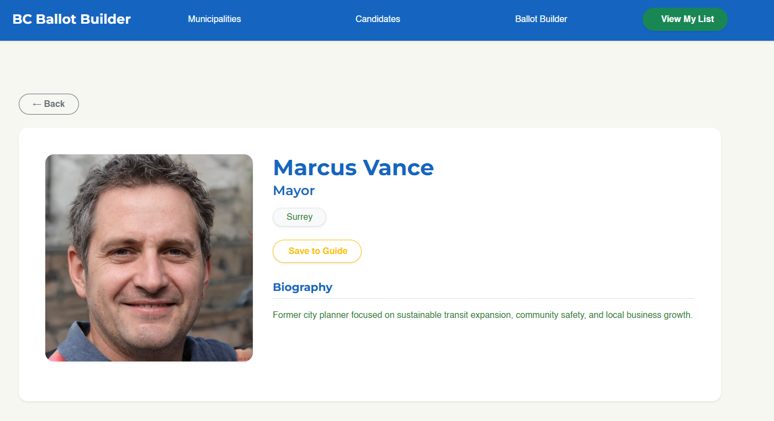

Side bar: (opens after clicking “Save to Guide”, can be opened by clicking “View my Guide”)
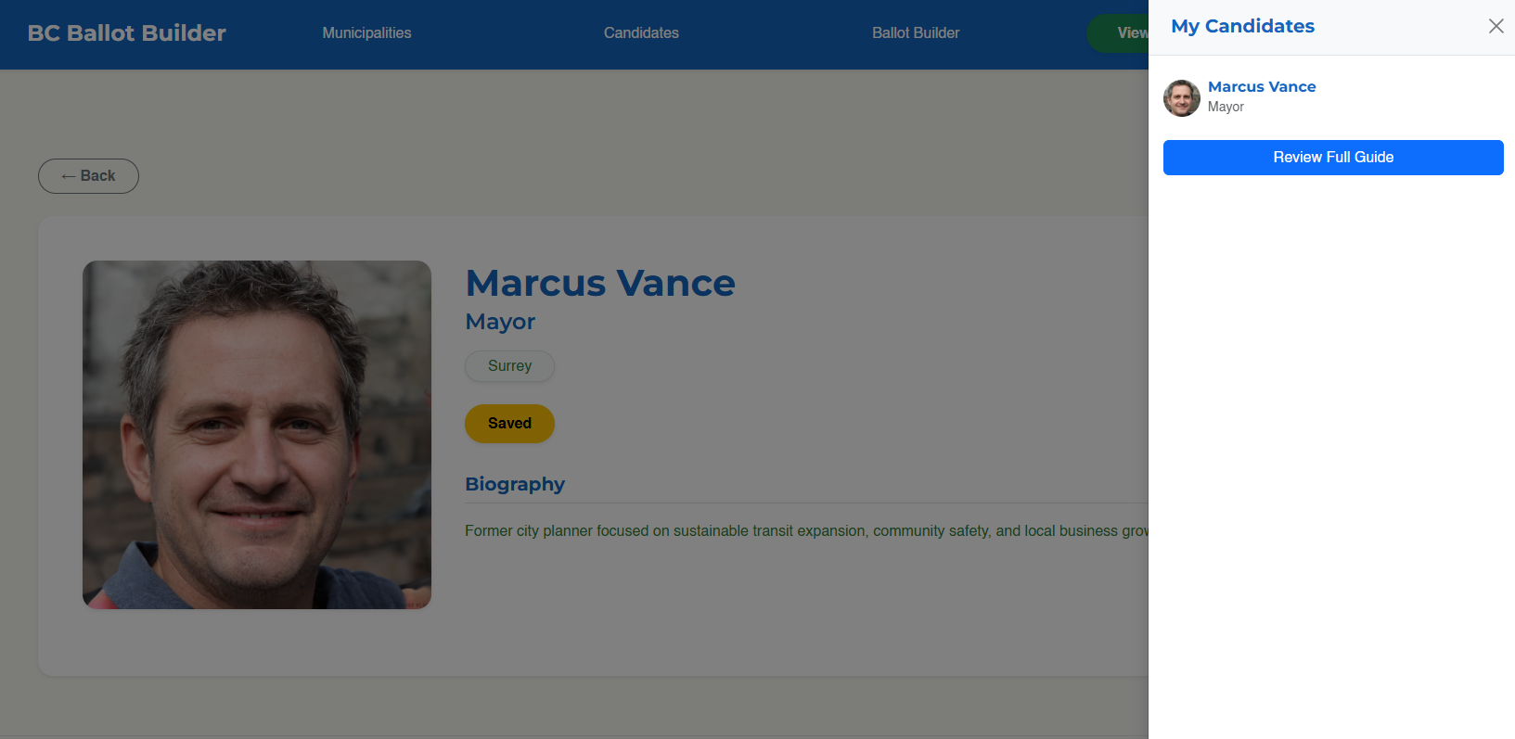

Ballot builder page:
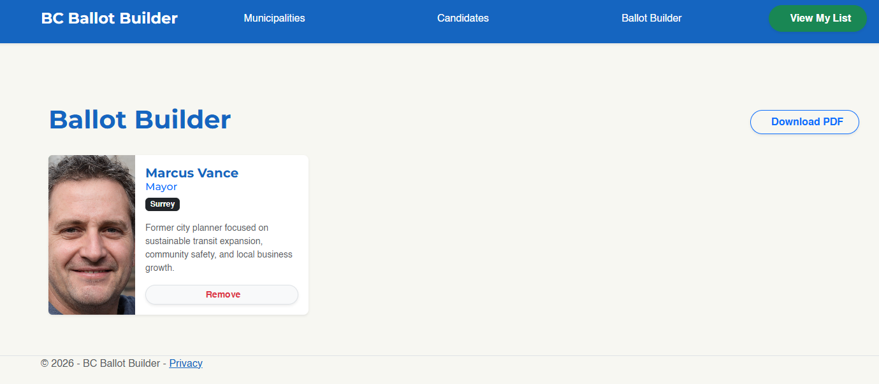

Admin login page:
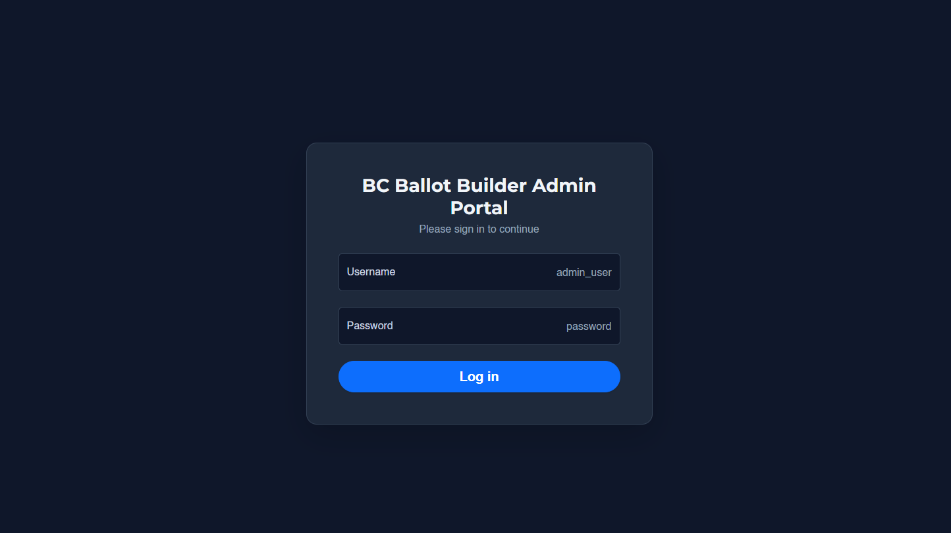

Admin dashboard as super admin:
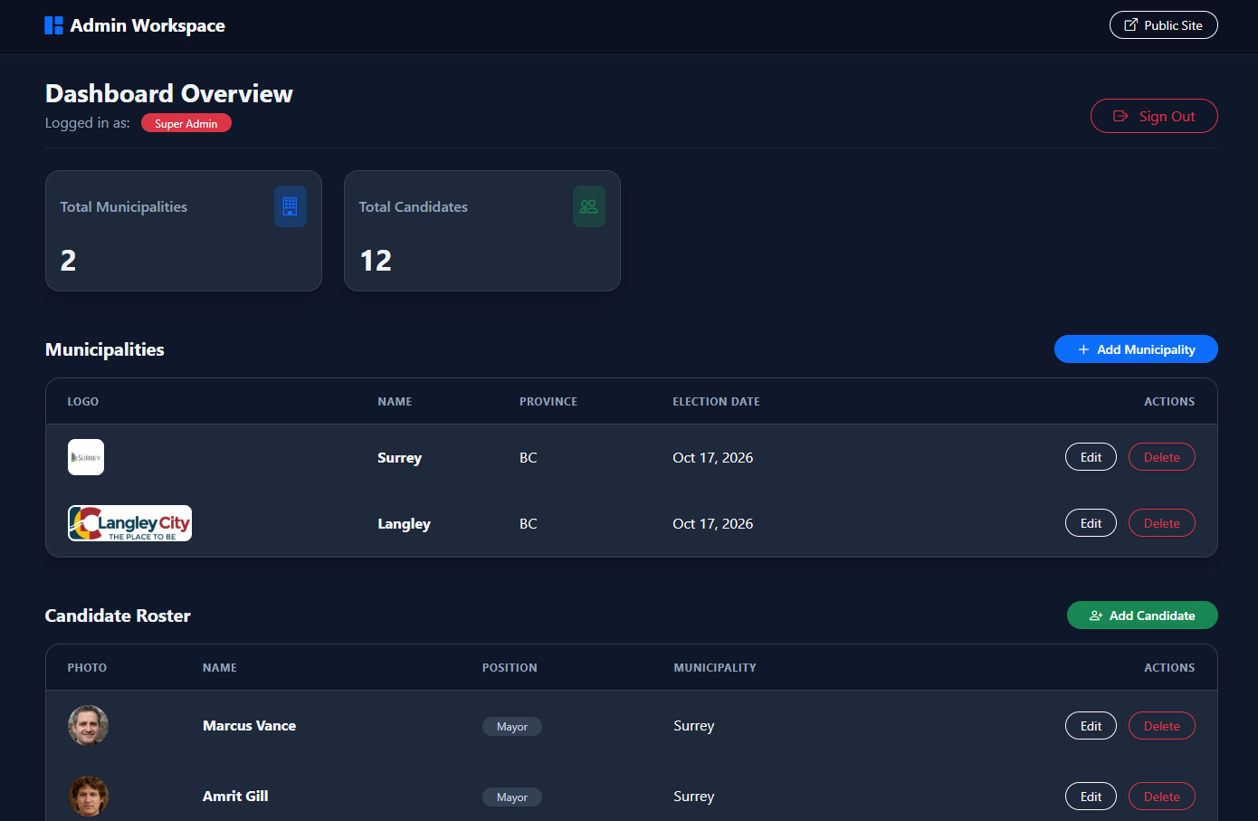
Admin dashboard as municipality admin (no municipalities and only candidates in respective municipality):
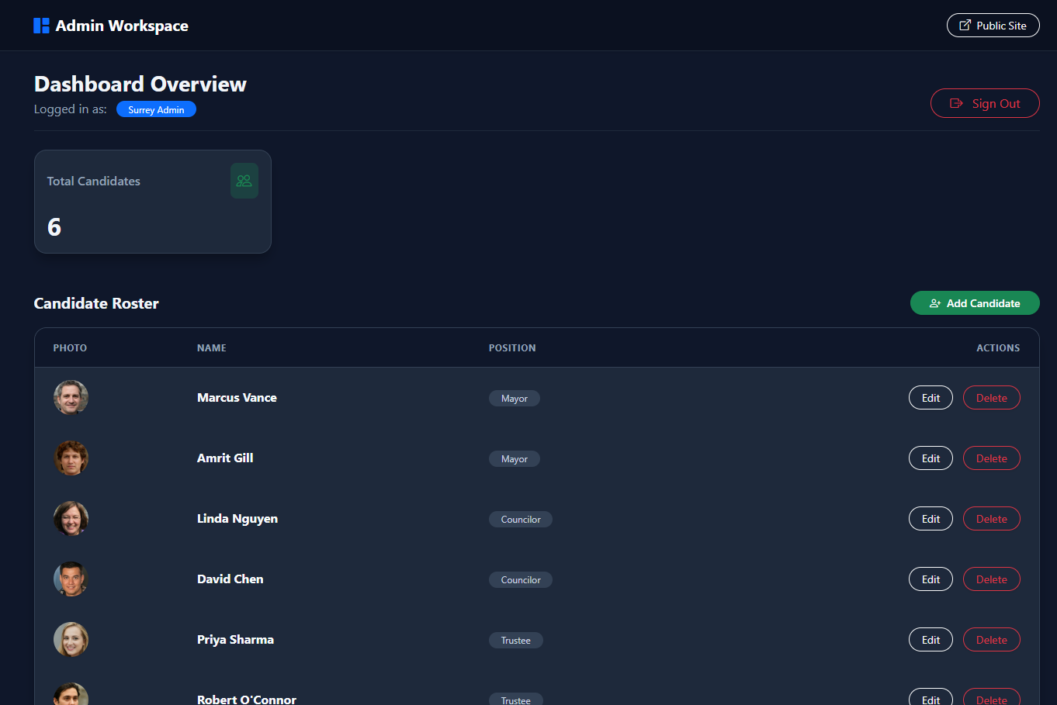

Add municipality and candidate pages:
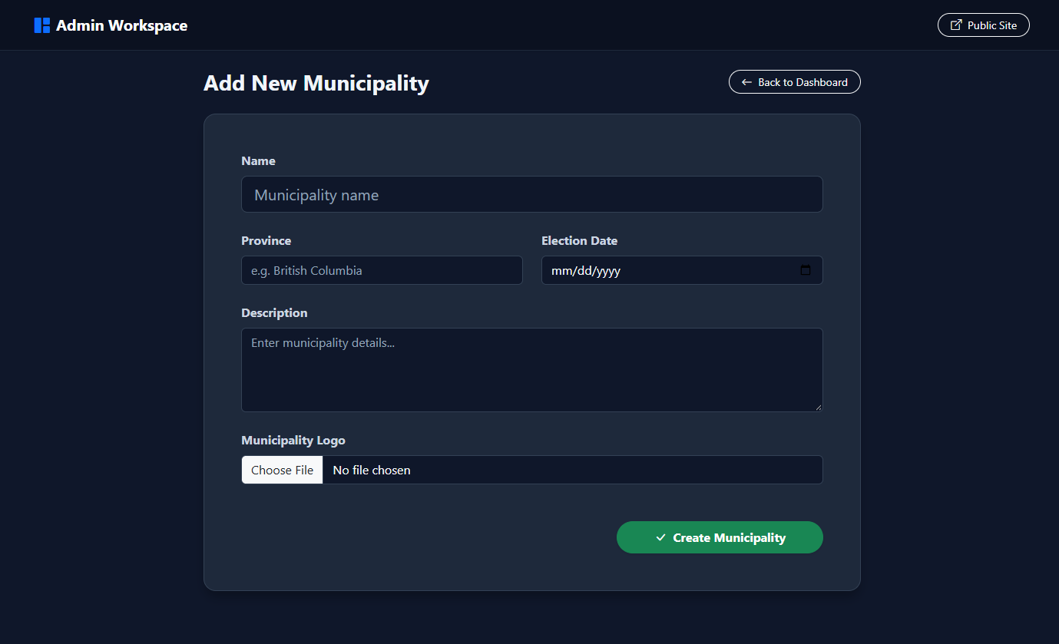
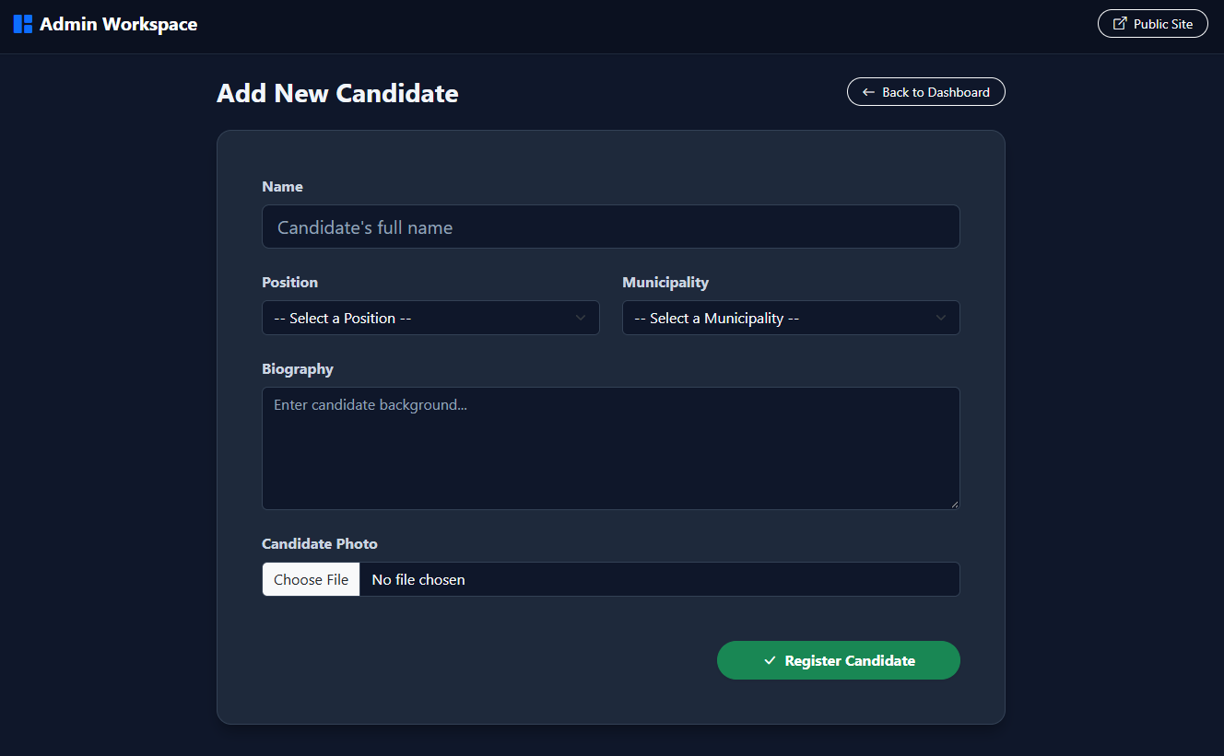

Edit municipality:
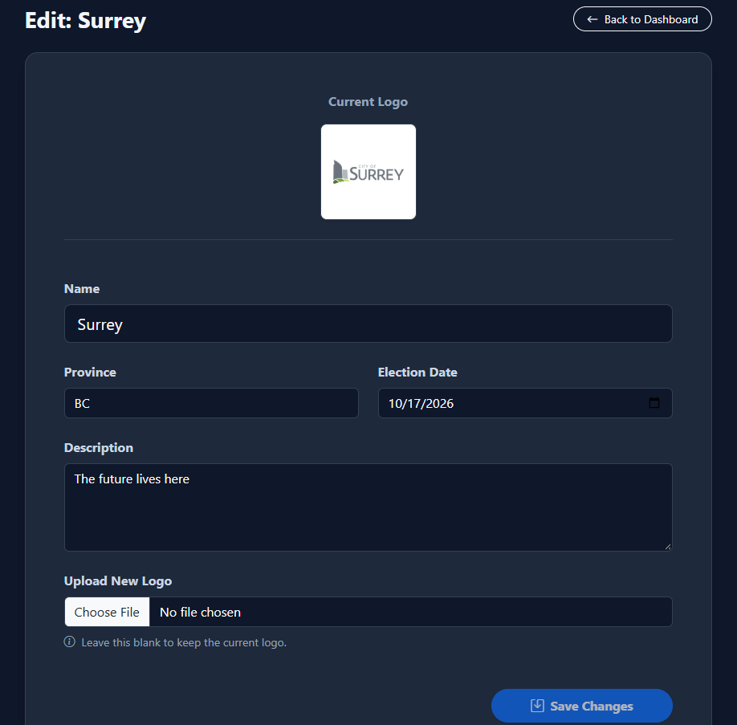
Edit candidate:
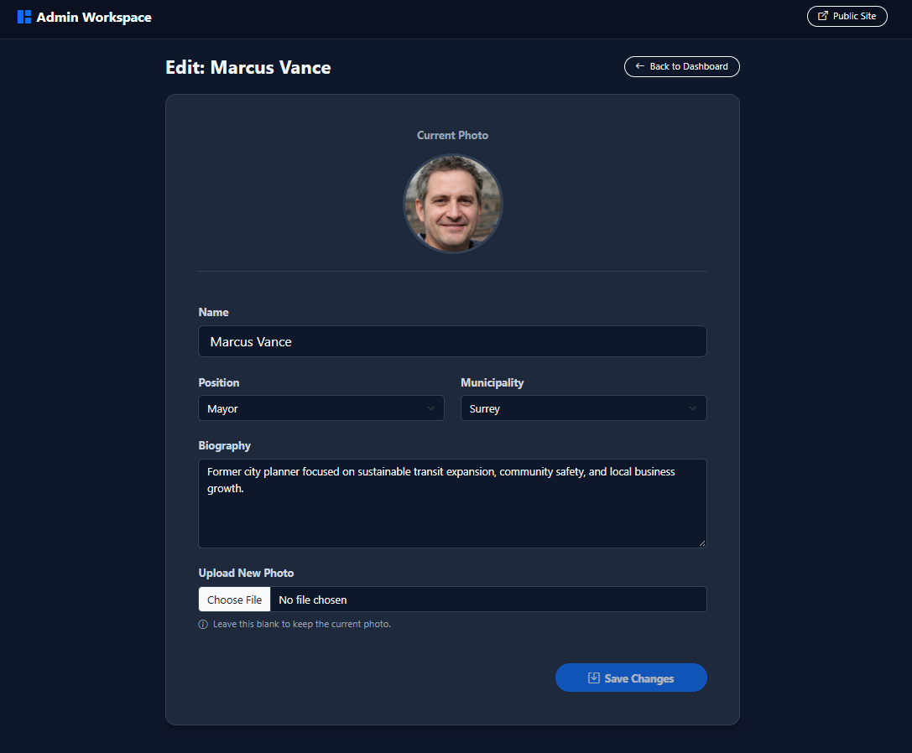

GitHub repo: https://github.com/trey1212/municipal-election-web

